Submission to special section of Soil C and N by LUMC in Journal of Soil Science & Plant Nutrition **Title: Azolla incorporation and dual cropping influences CH4 and N2O emissions from flooded paddy ecosystems**

Samuel Munyaka Kimania, Putu Oki Bimantarab, Satoshi Hattorib, Keitaro Tawarayab, Shigeto Sudoc and Weiguo Chenga,b





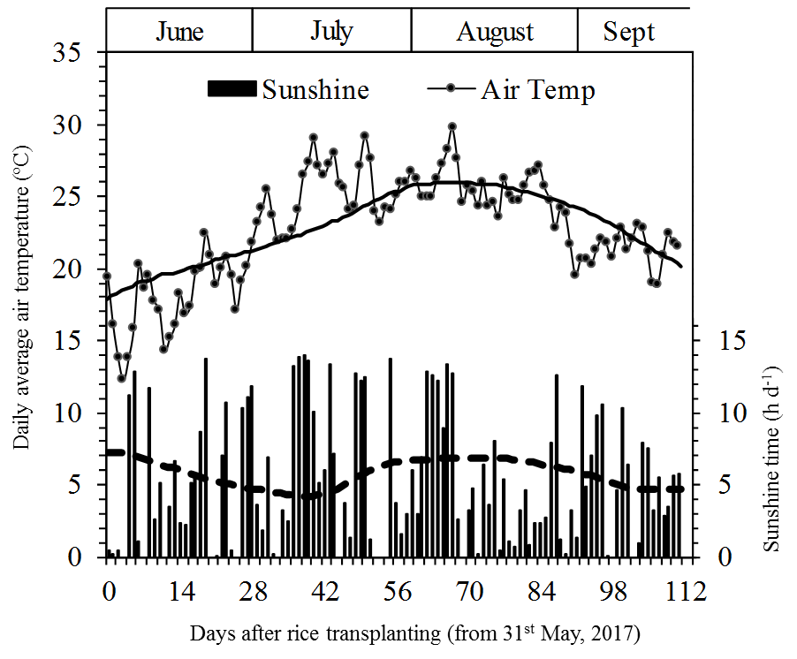

Figure S1. Daily sunshine time (■), and average air temperature (●) during the experiment period from 31st May to 20th September 2017, in Tsuruoka, Japan. The bold and dashed lines crossing Air temperature and Sunshine time, respectively, are the average values for 1981-2010 (Av. 30 years). Data from Japan Meteorological Agency.

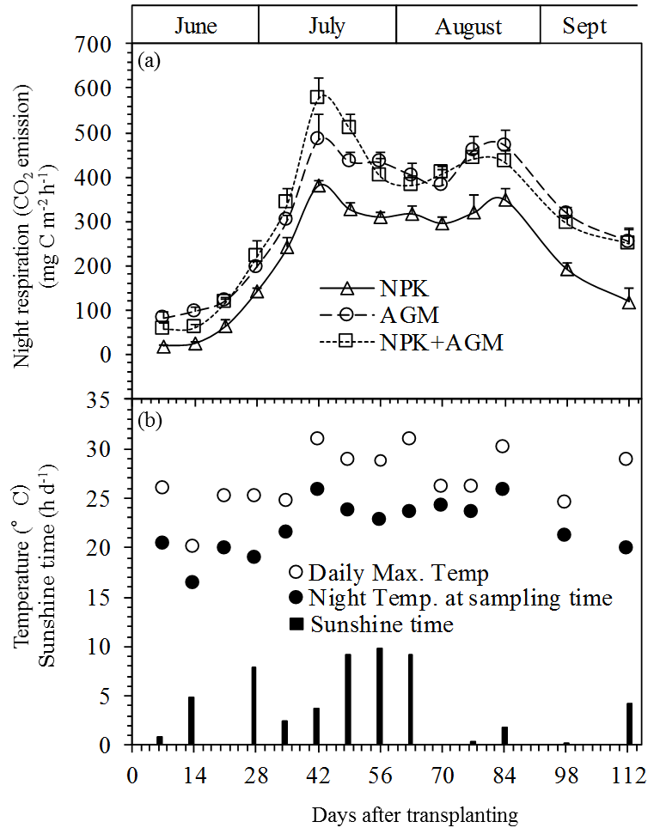

**Figure S2**. Changes in night respiration (CO2 emission) of rice plants grown in the pots among the treatments throughout the experiment period (a). Bars indicate standard deviation (n=4). The daily maximum temperature and temperature at sampling time (2100hrs), and sunshine time on the day of gas sampling are shown in (b).

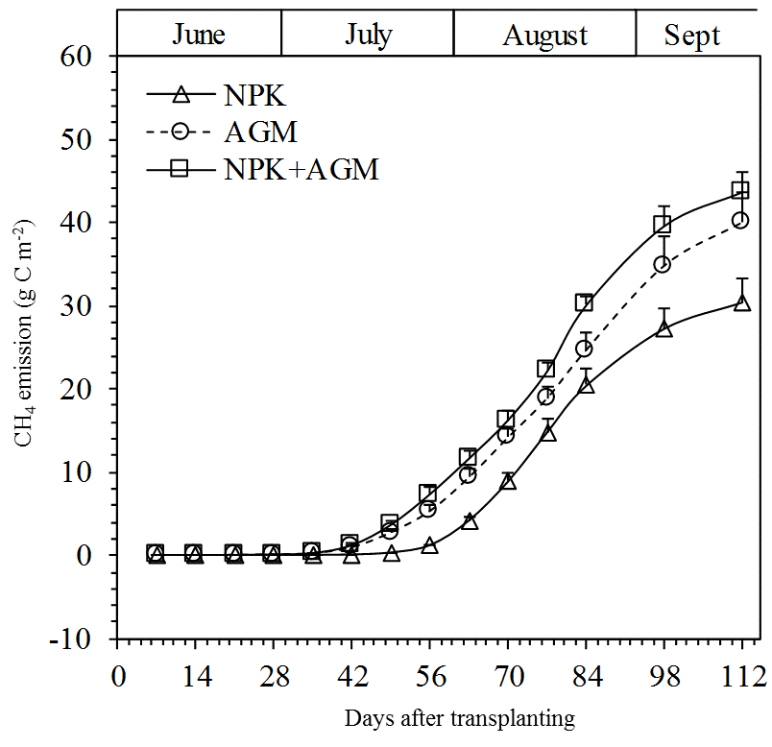

**Figure S3**. Changes in accumulated CH4 emissions from the three treatments throughout the experiment period. Bars indicate standard deviation (n=4).

Division of the manuscript: 8. Environment; Special Section “Soil C and N by LUMC”