Supporting information
Investigation on thermal behaviour and optical properties of non-symmetric cholesterol-based twin liquid crystals with thioester linkages
Zhiming Fang and Changcheng Wu*
School of Material Science and Engineering, Tianjin Polytechnic University, Tianjin 300387, People’s Republic of China

*Corresponding author:
Tel: +86-22 83955055; E-mail address: ccwu@tjpu.edu.cn

1. Structural analysis
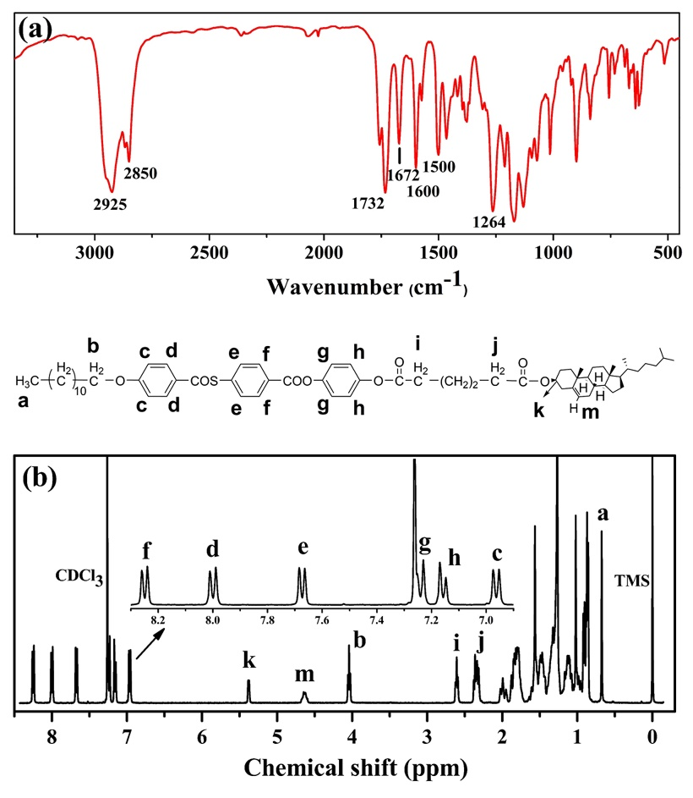
Figure S1. (Colour online) (a) FT-IR spectrum of C6SAR; (b) ¹H NMR spectrum of C6SAR.
FT-IR and ¹H NMR are powerful tools for confirming molecular structure. The ¹H-NMR and IR spectra of C6SAR are shown in Figure S1 as an example. Figure S1(a) is the infrared spectrum of C6SAR, some strong peaks of vibration absorption can be observed, such as absorption double peaks of methyl and methylene at 2925-2850 cm⁻¹, a vibration peak of carboxylate unit at 1732 cm⁻¹ and a vibration peak of thioester group at 1672 cm⁻¹. Meanwhile, the absorption bands at 1600 and 1500 cm⁻¹ indicate the presence of benzene rings in the structure.
Figure S1(b) shows the ¹H NMR spectrum of C6SAR. In the low field region of NMR, there are six sets of double peaks at the chemical shift of 6.96-8.25 ppm, which are the resonance signals of twelve hydrogen atoms exposed by three benzene rings of the compound. Two hydrogen atoms on the cholesterol exhibit characteristic signals at δ = 5.38 ppm and δ = 4.63 ppm, respectively. The peak at δ = 4.04 ppm is the triplet signal of the hydrogen atom of the methylene group closest to the oxygen atom in the alkoxy tail chain. Between the high field region δ = 2.61-0.68 ppm are the resonance signals generated by other hydrogen atoms in the structure of the compound. The detailed correspondence between the hydrogen atom signal and the hydrogen atoms of different chemical environments in the structure is identified in Figure S1(b).
The molecular structures of these oligomers were characterised by ¹H NMR and IR spectra, which confirmed our molecular design.
2. Table and figures
Table S1. Phase types, transition temperatures (°C), corresponding enthalpy values (ΔH, kJ mol⁻¹) and entropy changes (ΔS/R) for final compounds.
Transition temperatures (°C), enthalpy values (ΔH, kJ mol⁻¹) and entropy changes (ΔS/R)
Sample | Heating ΔT(°C) |  | ΔS₁/R
C4SAR | Cr 114.2(23.952) SmC* 166.9(0.756) N* 245.2(5.309) I | 131.0 | 1.232
C5SAR | Cr₁71.0(2.311) Cr₂ 113.9(23.035) SmC* 202.6(4.269) N* 230.6(2.828) I | 116.7 | 0.675
C6SAR | Cr 116.9(28.300) SmC* 195.7(2.507) N* 259.4(6.512) I | 142.5 | 1.471
C7SAR | Cr 111.2(29.639) SmC* 167.5(5.435) N* 219.7(3.705) I | 108.5 | 0.904
C8SAR | Cr 106.6(34.110) SmC* 170.2(2.184) N* 235.5(5.424) I | 128.9 | 1.280
C9SAR | Cr 123.9(44.583) SmC* 148.3(3.743) N* 214.9(2.680) I | 91.0 | 0.660
C10SAR | Cr 101.0(22.121) SmC* 142.2(1.348) N* 221.9(5.158) I | 120.9 | 1.253
C6OAR | Cr 96.50(16.362) SmC* 171.2(0.857) N* 238.4(4.859) I | 141.9 | 1.165
 | Cooling |  | ΔS₂/R
C4SAR | I 239.0(-5.376) N* 157.0(-0.711) SmC* 57.4(-3.983) Cr | 181.6 | 1.263
C5SAR | I 226.2(-3.025) N* 197.5(-3.873) SmC* 99.0(-3.756) Cr₁ 60.4(-3.973) Cr₂ | 127.2 | 0.729
C6SAR | I 249.0(-7.316) N* 178.4(-1.505) SmC* 65.2(-18.218) Cr | 183.8 | 1.685
C7SAR | I 213.4(-3.705) N* 154.8(-4.864) SmC* 78.3(-5.724) Cr | 135.1 | 0.916
C8SAR | I 228.0(-5.055) N* 157.4(-1.723) SmC* 71.3(-21.381) Cr | 156.7 | 1.213
C9SAR | I 212.3(-2.884) N* 145.2(-5.100) SmC* 83.1(-33.917) Cr | 129.2 | 0.715
C10SAR | I 217.8(-6.229) N* 138.2(-1.958) SmC*67.4(-20.631) Cr | 150.4 | 1.526
C6OAR | I 234.8(-4.505) N* 167.5(-0.832) SmC* 60.5(-14.687) Cr | 174.3 | 1.067
Abbreviation: ΔS₁/R = ΔS_{N*-I}/R = N*-Isotropic entropy change; ΔS₂/R = ΔS_{I-N*}/R = Isotropic-N* entropy change; ΔT = T_{i} - T_{Cr}; Cr = Crystal; SmC* = chiral Smectic C phase; N*= chiral nematic phase; I = Isotropic.
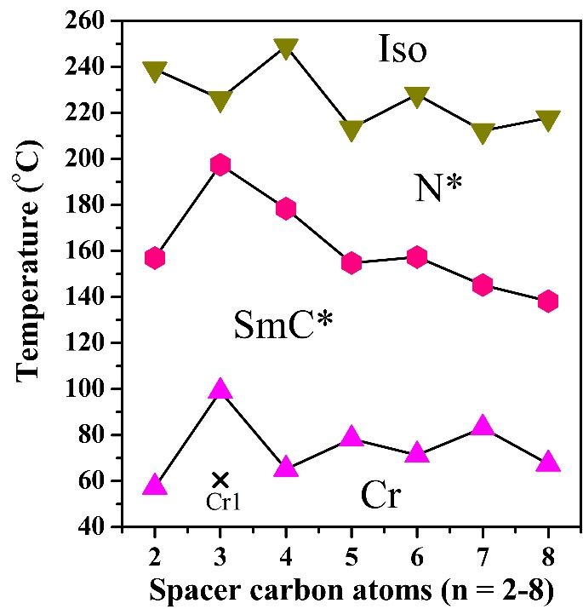
Figure S2. (Colour online) The curves of phase transition temperatures versus the carbon atom numbers of inner flexible spacer during cooling for CNSAR.
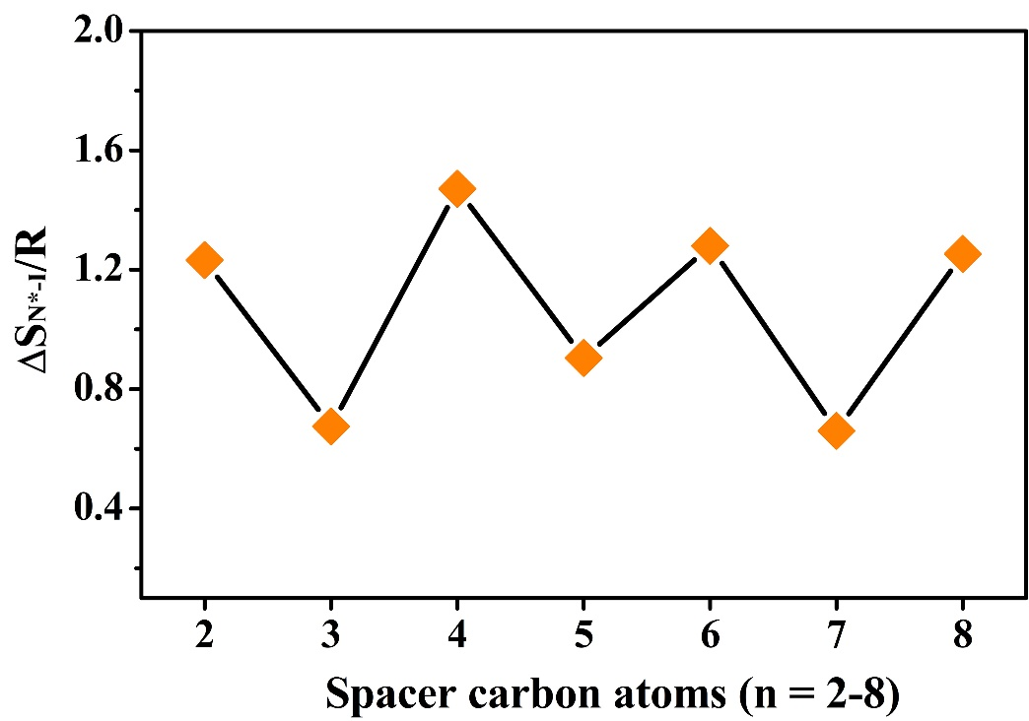
Figure S3. (Colour online) Entropy changes (ΔS_{N*-I}/R) as a function of the carbon atoms in the internal flexible spacer upon heating.
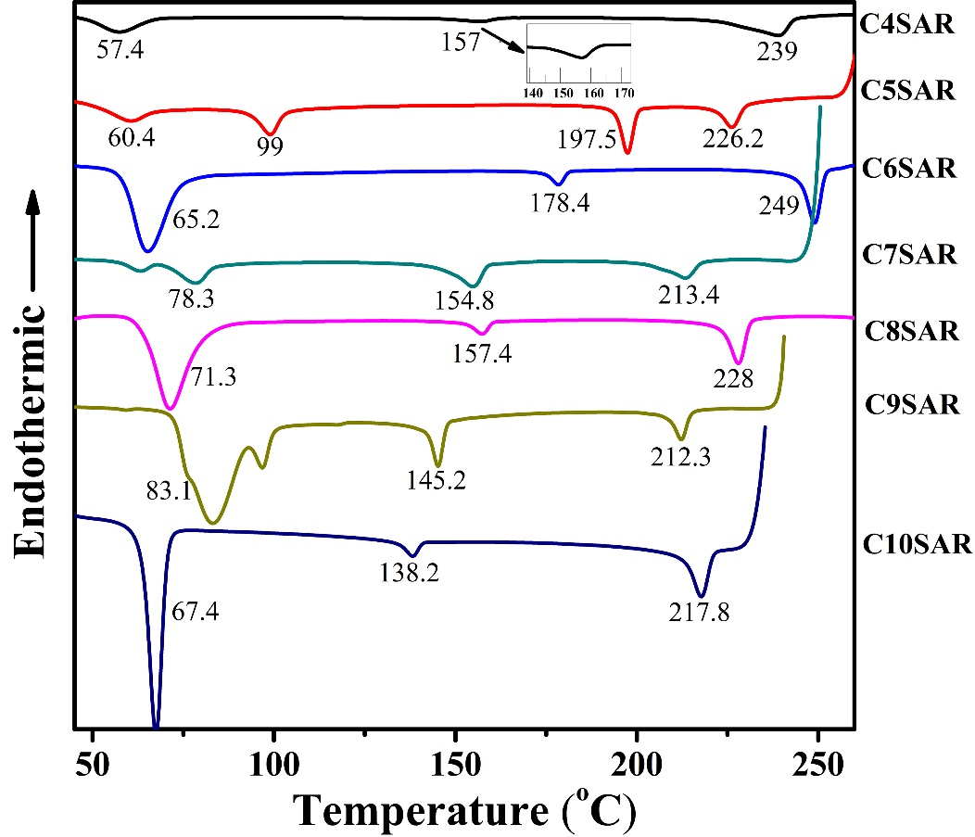
Figure S4. (Colour online) Summary of DSC curves of the target products in the cooling process.

