Supplemental Material
Tables
Table S1. Number of patient-months analyzed for prescription rates in each year.
A. Number of patient-months with prescribed antihypertensive drugs in the MDV database (for Figure 1, Figure S1)
 | 2009 | 2010 | 2011 | 2012 | 2013 | 2014 | 2015
Hypertensive patients | 313,512 | 922,554 | 1,507,579 | 1,858,503 | 2,917,533 | 3,890,561 | 4,191,666
with heart failure | 92,814 | 267,242 | 430,379 | 553,565 | 926,689 | 1,281,787 | 1,404,008
<65 years | 22,013 | 60,069 | 96,782 | 121,585 | 195,137 | 266,107 | 280,051
≥65, <75 years | 26,785 | 74,650 | 115,190 | 147,143 | 250,359 | 349,917 | 387,193
≥75 years | 44,016 | 132,523 | 218,407 | 284,837 | 481,193 | 665,763 | 736,764

B. Number of patient-months with prescribed antihypertensive drugs in the JMDC database (for Figure 1, Figure S2)
 | 2010 | 2011 | 2012 | 2013 | 2014 | 2015
Hypertensive patients | 410,713 | 574,914 | 712,991 | 1,208,118 | 1,382,924 | 1,382,732
with heart failure | 38,490 | 55,721 | 70,483 | 119,084 | 143,501 | 148,194
hospitals | 18,444 | 25,464 | 31,375 | 52,444 | 61,978 | 62,549
clinics | 20,630 | 31,088 | 40,133 | 68,265 | 83,551 | 87,717

C. Number of patient-months with first-line treatment with antihypertensive drugs, as single or plural classes, in the JMDC database (for Figure 2, Figure S3)
 | 2010 | 2011 | 2012 | 2013 | 2014 | 2015
Hypertensive patients | 2325 | 5927 | 10,509 | 16,271 | 20,476 | 19,914
with heart failure | 127 | 316 | 656 | 919 | 1306 | 1310
<65 years | 117 | 277 | 596 | 826 | 1132 | 1142
≥65, <70 years | 9 | 39 | 60 | 93 | 173 | 167
hospitals | 76 | 198 | 429 | 557 | 831 | 799
clinics | 51 | 118 | 227 | 362 | 475 | 511

D. Number of patient-months with prescribed diuretics in the MDV database (for Figure 3, Figure S4)
 | 2009 | 2010 | 2011 | 2012 | 2013 | 2014 | 2015
Hypertensive patients | 79,819 | 238,125 | 392,852 | 491,771 | 779,787 | 1,021,772 | 1,074,335
with heart failure | 42,327 | 119,315 | 194,285 | 247,460 | 407,698 | 553,274 | 594,255
<65 years | 8799 | 23,277 | 37,497 | 46,485 | 73,689 | 99,590 | 103,220
≥65, <75 years | 10,935 | 29,163 | 45,334 | 57,211 | 95,259 | 131,092 | 140,840
≥75 years | 22,593 | 66,875 | 111,454 | 143,764 | 238,750 | 322,592 | 350,195

E. Number of patient-months with prescribed diuretics in the JMDC database (for Figure 3, Figure 4)
 | 2010 | 2011 | 2012 | 2013 | 2014 | 2015
Hypertensive patients | 56,462 | 83,983 | 104,482 | 166,482 | 180,520 | 171,007
with heart failure | 10,921 | 16,038 | 19,458 | 31,664 | 35,972 | 35,941
hospitals | 5950 | 8460 | 10,199 | 16,754 | 19,163 | 18,716
clinics | 5116 | 7703 | 9396 | 15,157 | 17,110 | 17,481

F. Number of patient-months with first-line treatment with prescribed diuretics in the JMDC database (for Figure S5)
 | 2010 | 2011 | 2012 | 2013 | 2014 | 2015
Hypertensive patients | 79 | 193 | 397 | 517 | 754 | 672
with heart failure | 14 | 29 | 85 | 92 | 156 | 139
JMDC, Japan Medical Data Center; MDV, Medical Data Vision.
Figure legends
Figure S1. Prescription rate of antihypertensive drugs for each age group in the MDV database. The five most frequently prescribed classes for all hypertensive patients (dashed line: - -) and those with heart failure (solid line: ―) in each age group of (A) <65 years, (B) 65 years to <75 years, and (C) ≥75 years. ACEI, angiotensin-converting enzyme inhibitor; ARB, angiotensin II receptor blocker; BETA, ß-blocker; CCB, calcium channel blocker; DIU, diuretic; MDV, Medical Data Vision.
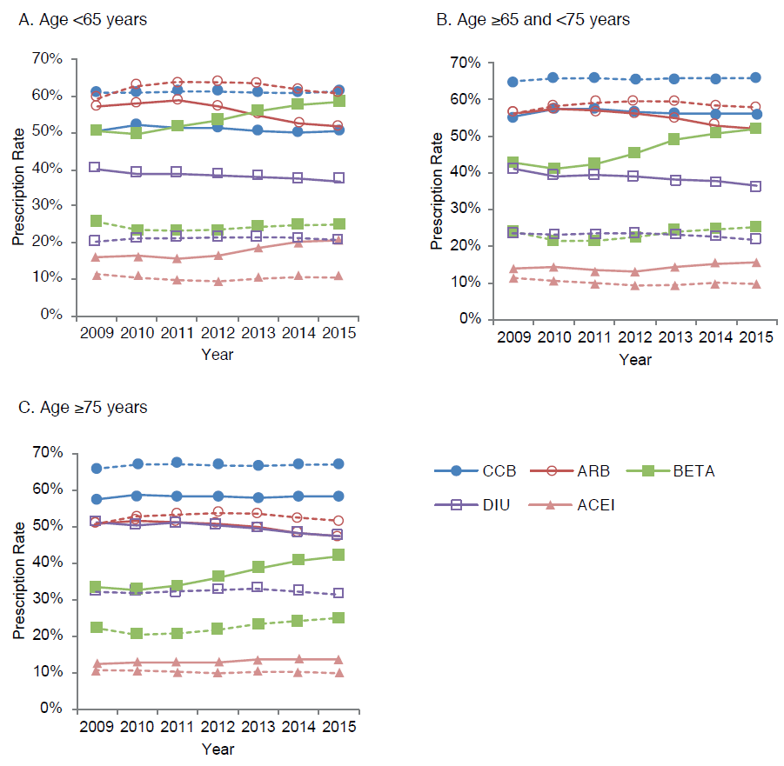
Figure S2. Prescription rate of antihypertensive drugs for each medical institution in the JMDC database. The five most frequently prescribed classes for all hypertensive patients (dashed line: - -) and those with heart failure (solid line: ―) in (A) hospitals and (B) clinics. ACEI, angiotensin-converting enzyme inhibitor; ARB, angiotensin II receptor blocker; BETA, ß-blocker; CCB, calcium channel blocker; DIU, diuretic; JMDC, Japan Medical Data Center.
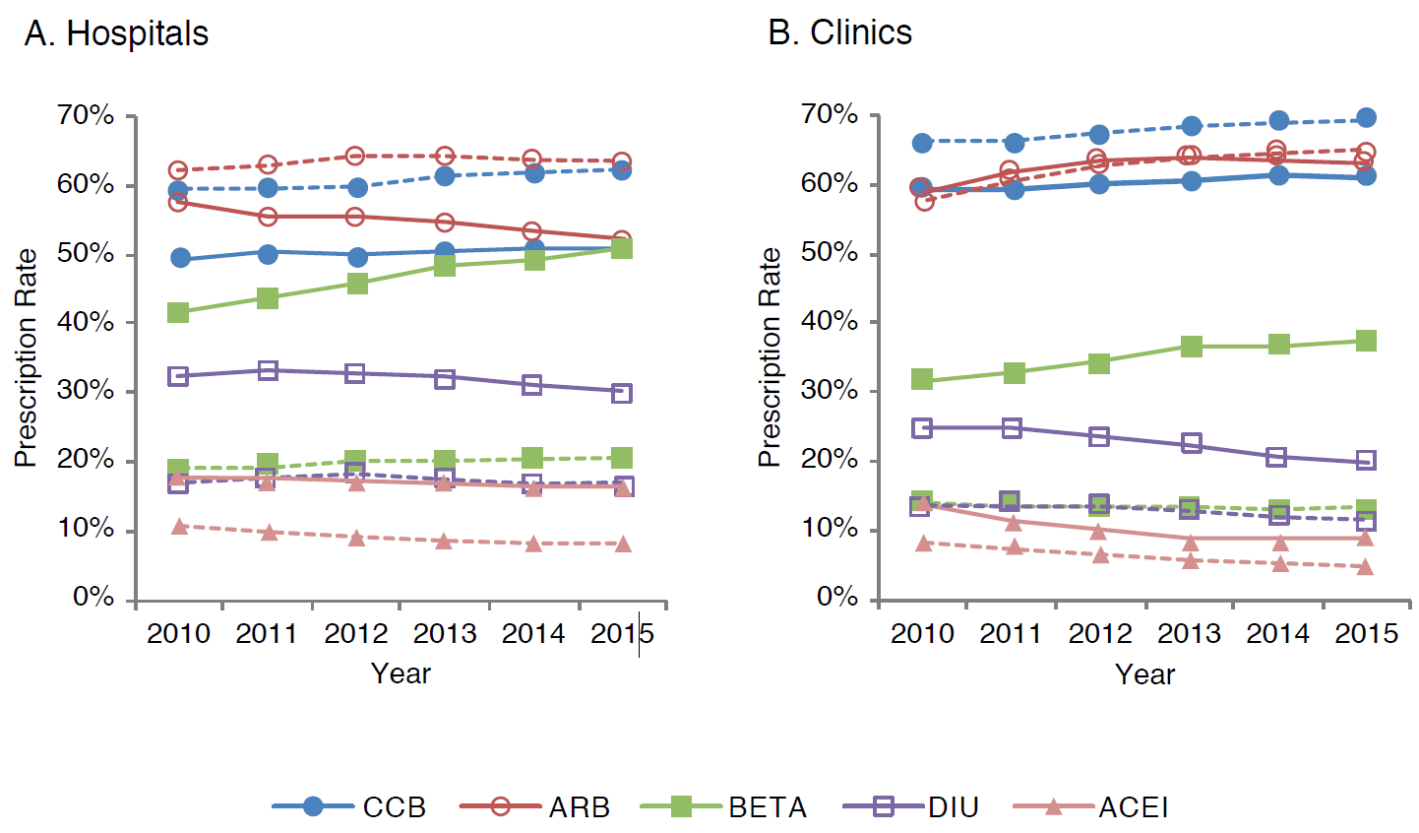
Figure S3. Prescription rate of first-line antihypertensive drug class for each age group and medical institution in the JMDC database. The five most frequently prescribed classes for all hypertensive patients (dashed line: - -) and those with heart failure (solid line: ―) in each age group of (A) <65 years, and (B) 65 years to <75 years, and those in (C) hospitals and (D) clinics. ACEI, angiotensin-converting enzyme inhibitor; ARB, angiotensin II receptor blocker; BETA, ß-blocker; CCB, calcium channel blocker; DIU, diuretic; JMDC, Japan Medical Data Center.
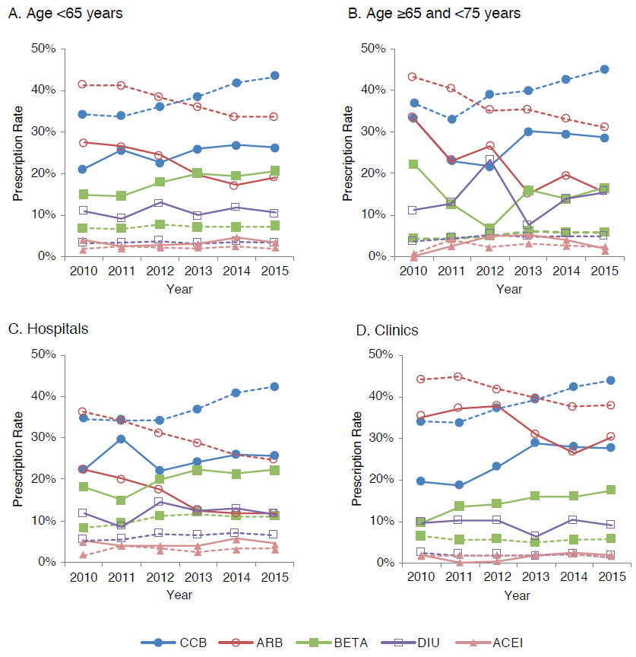

Figure S4. Prescription rate of each diuretic category for each age group in the MDV database. All hypertensive patients (dashed line: - -) and those with heart failure (solid line: ―) in each age group of (A) <65 years, (B) 65 years to <75 years, and (C) ≥75 years. AA, aldosterone antagonist; MDV, Medical Data Vision.
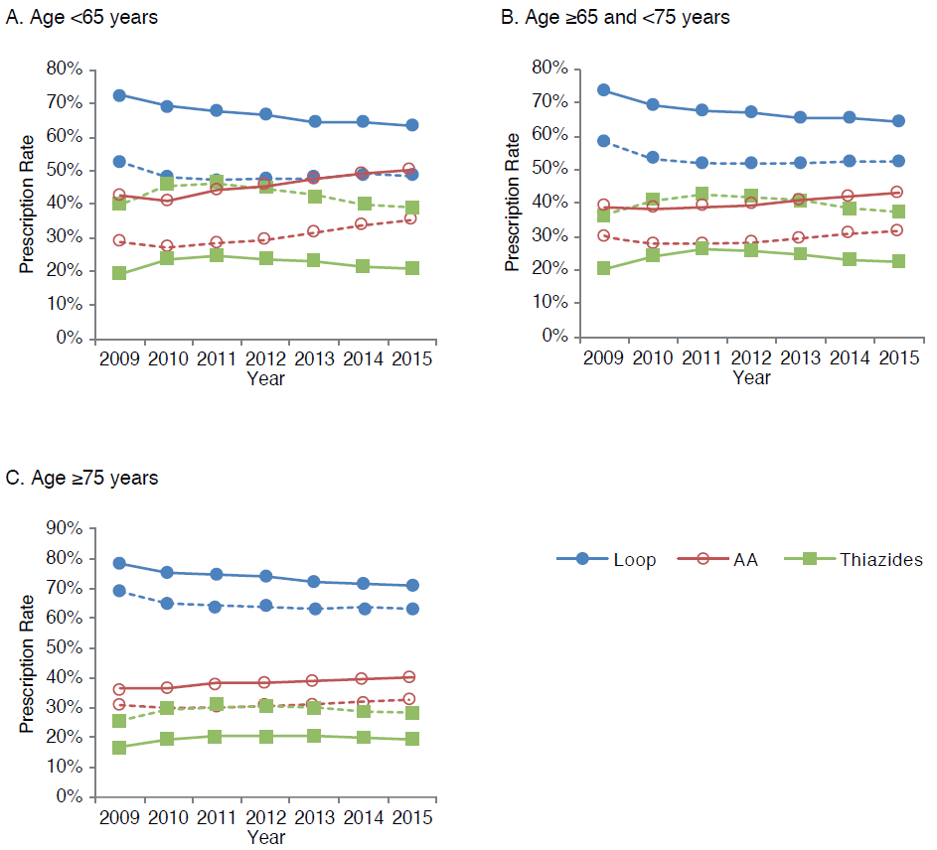
Figure S5. Prescription rate of each diuretic category as first-line antihypertensive drugs in the JMDC database. All hypertensive patients (dashed line: - -) and those with heart failure (solid line: ―). AA, aldosterone antagonist; JMDC, Japan Medical Data Center.
