Table S1. Diagnoses and anatomical therapeutic classification codes used for defining outcomes, comorbidities, and drug exposure.
Diagnosis | Definition | ICD codes
Cancer | Hospitalization/hospital contact ever prior to the index date | ICD10ª: C00-97
Heart failure | Hospitalization/hospital contact ever prior to the index date | ICD10ª: I110, I42, I50, J819; ICD8^{b}: 425, 4270, 4271
Chronic kidney disease | Hospitalization/hospital contact ever prior to the index date | ICD10ª: E102, E112, E132, E142, I120, M3215, M300, M313, M319, N02-N08, N11-N12, N14, N158-N160, N162-N164, N168, N18-N19, N26, Q612-Q613, Q615, Q619,
Chronic obstructive pulmonary disease | Hospitalization/hospital contact ever prior to the index date | ICD10ª J42-44
Hypertension | Hospitalization/hospital contact ever prior to the index date | ICD10ª: I10, I11, I12, I13, I15
Hypertension, overall | Defined from combination treatment with a least two classes of antihypertensive drugs. This definition of hypertension has a positive predictive value of 80.0% and a specificity of 94.7%. | Treatment: Adrenergic α-antagonist, non-loop-diuretics, vasodilators, beta-blockers, calcium channel blockers, and renin-angiotensin system inhibitors.
Hyperthyroidism | Hospitalization/hospital contact ever prior to the index date or at least two dispensed prescriptions of anti-thyroid medications | ICD10ª: E05–E05.9  ATC=H03B
Peripheral arterial disease | Hospitalization/hospital contact ever prior to the index date | ICD10ª: I700, I702, I709
Stroke | Hospitalization/hospital contact ever prior to the index date | ICD10ª: I63, I64, G45.8, G45.9
Pulmonary embolism | Hospitalization/hospital contact ever prior to the index date | ICD10ª: I74
Arterial embolism | Hospitalization/hospital contact ever prior to the index date | ICD10ª: I63, I64, I26, I74, G458, G459
Atrial fibrillation | As comorbidity: hospitalization/hospital contact ever prior to the index date  As study outcome: hospitalization/hospital contact ever within 90 days following the index date | ICD10ª: I48
Ventricular fibrillation | Hospitalization/hospital contact ever prior to the index date | ICD10ª: I49
Diabetes mellitus type 2 | Hospitalization/hospital contact ever prior to the index date | ICD10ª: E10, E11, E12, E13, E14
Cerebrovascular disorders | Hospitalization/hospital contact ever prior to the index date | ICD10ª: I60, I62, I69
Acute myocardial infarction | As comorbidity: hospitalization/hospital contact ever prior to the index date  As study outcome: hospitalization/hospital contact ever within 90 days following the index date | ICD10ª: I21, I22
Fractures | As comorbidity: hospitalization/hospital contact ever prior to the index date  As study outcome: hospitalization/hospital contact ever within 90 days following the index date | ICD10ª: S42, S52, S62, S72
Ventricular arrhythmia | As study outcome: hospitalization/hospital contact ever within 90 days following the index date | ICD10ª: I472, I490
Drug class/active ingredient | Definition | ATC^{b} codes
Lipid modifying agents | Redemption of a prescription within 90 days prior to the index date | C10
Glucose-lowering agents | Redemption of a prescription within 90 days prior to the index date | A10
Opioids | Redemption of a prescription within 90 days prior to the index date | N02A
Benzodiazepines | Redemption of a prescription within 90 days prior to the index date | N05BA
Steroids | Redemption of a prescription within 90 days prior to the index date | H02A. H02B
Antidepressants | Redemption of a prescription within 90 days prior to the index date | N06A
Antipsychotics | Redemption of a prescription within 90 days prior to the index date | N05A
Barbiturates | Redemption of a prescription within 90 days prior to the index date | N05CA, N05CB
Pro-arrhythmic drugs | Time-dependent covariate | Defined according to ²⁰
Promethazine | First redeemed prescription during the study period | R06AD02,R06AD52
Loratadine | First redeemed prescription during the study period | R06AX13
Domperidone | First redeemed prescription during the study period | A03FA03
Betahistine | First redeemed prescription during the study period | N07CA01
Triazolam | First redeemed prescription during the study period | A03FA01
ªICD10: 10th revision of the International Classification of Diseases system; ^{b}ATC: Anatomical Therapeutic Classification

Figure S1. Power calculation – atrial fibrillation hospitalizations.

Figure S2. Power calculation – acute myocardial infarction (AMI) hospitalizations.

Figure S3. Power calculation – fractures hospitalizations.

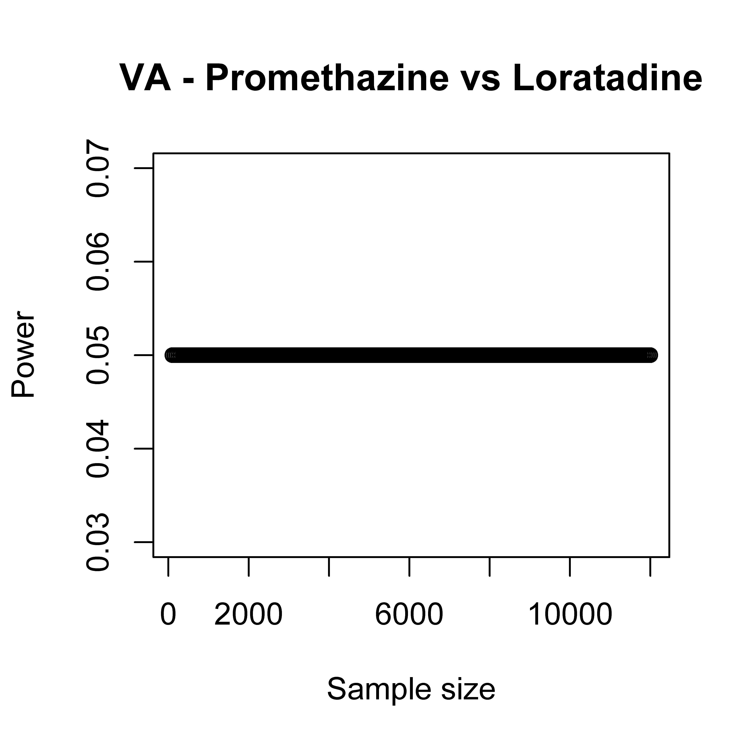
Figure S4. Power calculation – ventricular arrhythmia (VA) hospitalizations.

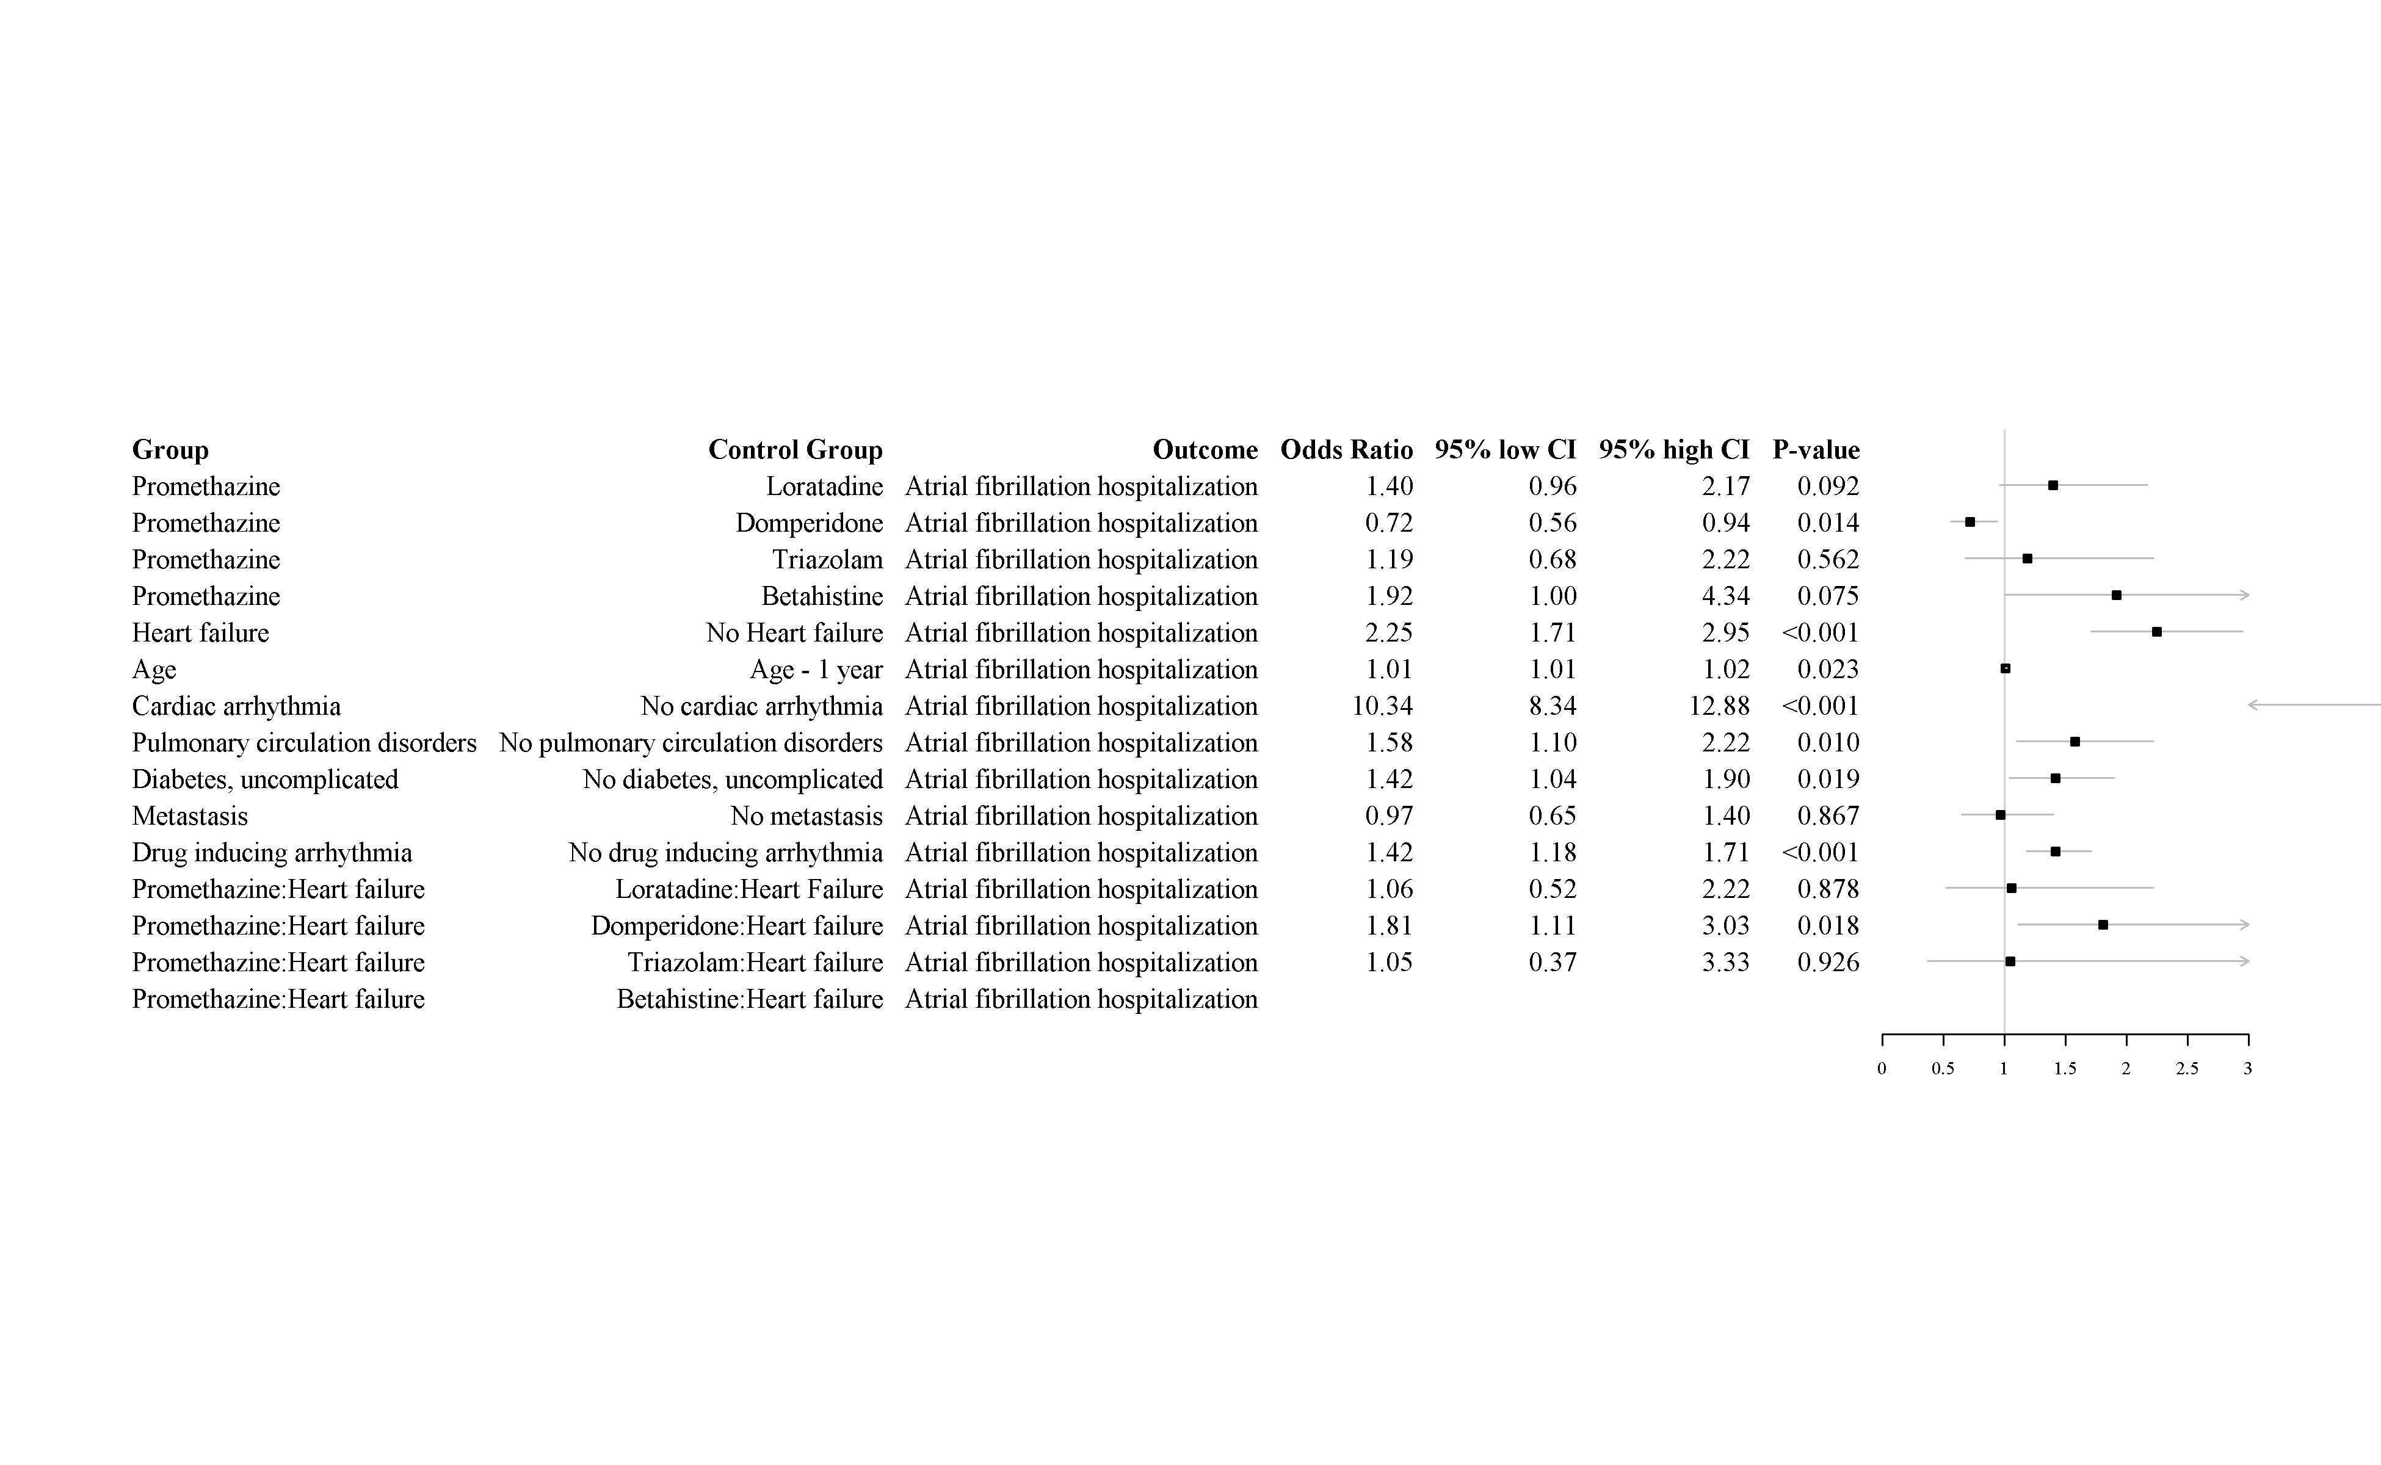
Figure S5. Results of the second sensitivity analysis.

Figure S6. Results of the third sensitivity analysis.

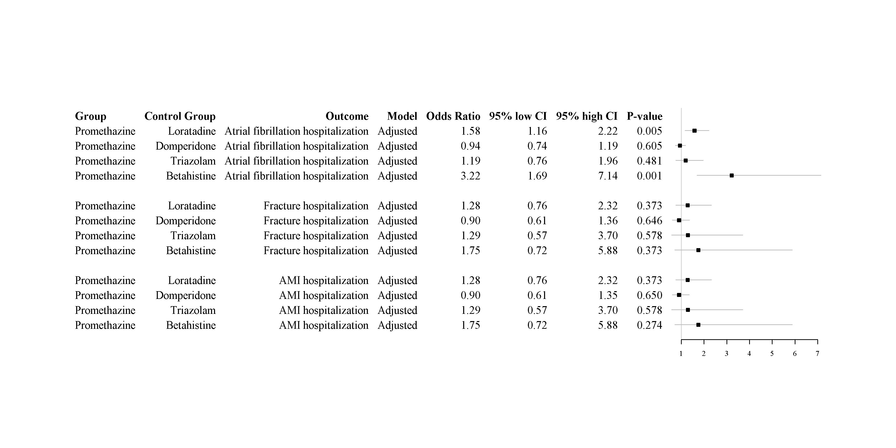
Figure S7. Results of the fourth sensitivity analysis.

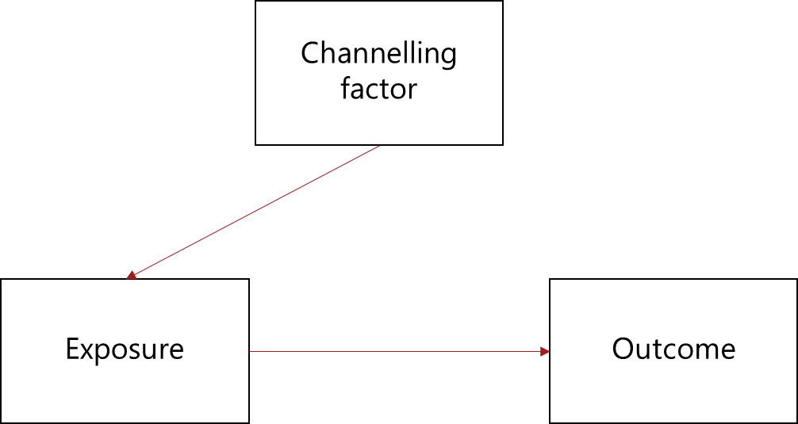
Figure S8. Channeling bias in the interpretation of drug effects.

