Online Appendix

Table 1. Summary Statistics
 | Minimum |  | Maximum |  | Median |  | Standard Deviation
Outcome Variables
Number of Articles |  | 0 |  | 48 |  | 11 |  | 10.61
ID Law |  | 0 |  | 100 |  | 1 |  | 16.78
Voter Registration |  | 0 |  | 60 |  | 3 |  | 11.36
Voter ID |  | 0 |  | 109 |  | 7 |  | 21.30
Predictor Variables
Battleground |  | 0 |  | 1 |  | - |  | -
Restrictive Voting Law |  | 0 |  | 1 |  | - |  | -
Number of Fraud Cases |  | 0 |  | 9 |  | 0 |  | 1.76
% ALEC |  | 1.41 |  | 37.78 |  | 16.37 |  | 9.41
Pres Vote Difference |  | -17.46 |  | 21.85 |  | 1.15 |  | 9.50
% Black |  | .680 |  | 30.43 |  | 8.81 |  | 9.12
% Hispanic |  | .766 |  | 38.45 |  | 6.71 |  | 8.14
Newspaper Circulation |  | 12 |  | 657.47 |  | 142.90 |  | 132.13
Note: For outcome variables, cells are counts of articles and phrases. All outcome variables are at the newspaper level. For predictor variables, presidential vote difference is Obama vote – McCain vote. Presidential vote difference, percent black, and percent Hispanic are at the media market level. Battleground, restrictive voting law, number of fraud cases, and percent ALEC are at the state level. Newspaper circulation is in the thousands.

Table 2. State Newspapers
State | Newspaper | State | Newspaper
Alabama | Birmingham News | Montana |  |  | Billings Gazette
Alaska | Anchorage Daily News | Nebraska |  |  | Omaha World-Record
Arizona | Arizona Republic | Nevada |  |  | Las-Vegas Review-Journal
Arkansas | Arkansas Democrat Gazette | New Hampshire |  |  | Union-Leader
California | Los Angeles Times | New Jersey |  |  | Star Ledger
Colorado | Denver Post | New Mexico |  |  | Albuquerque Journal
Connecticut | Hartford Courant | New York |  |  | Daily News
Delaware | Delaware State News | North Carolina |  |  | Charlotte Observer
Florida | Tampa Bay Times | North Dakota |  |  | Bismarck Tribune
Georgia | Atlanta Journal & Const | Ohio |  |  | Plain Dealer
Hawaii | Honolulu Star-Bulletin | Oklahoma |  |  | Daily Oklahoman
Idaho | Idaho Statesmen | Oregon |  |  | Oregonian
Illinois | Chicago Sun-Times | Pennsylvania |  |  | Philadelphia Inquirer
Indiana | Indianapolis Star | Rhode Island |  |  | Providence Journal
Iowa | Quad-City Times | South Carolina |  |  | Post and Courier
Kansas | Wichita Eagle | South Dakota |  |  | Aberdeen American News
Kentucky | Lexington Herald-Leader | Tennessee |  |  | Knoxville News Sentinel
Louisiana | Times-Picayune | Texas |  |  | Dallas Morning News
Maine | Bangor Daily News | Utah |  |  | Salt Lake Tribune
Maryland | Baltimore Sun | Vermont |  |  | Rutland Herald
Massachusetts | Boston Herald | Virginia |  |  | Richmond Times-Dispatch
Michigan | Detroit Free Press | Washington |  |  | Seattle Post-Intelligencer
Minnesota | Star Tribune | West Virginia |  |  | Charleston Gazette
Mississippi | Sun Herald | Wisconsin |  |  | Milwaukee Journal Sentinel
Missouri | St. Louis Post-Dispatch | Wyoming |  |  | Wyoming Tribune-Eagle

Table 3. Battleground and New Restrictive Law States in 2012
Battleground States |  | New Restrictive Law States
Colorado |  | Alabama
Florida |  | Florida
Iowa |  | Georgia
Nevada |  | Illinois
North Carolina |  | Iowa
Ohio |  | Kansas
Virginia |  | Maine
Wisconsin |  | Mississippi
 |  | New Hampshire
 |  | Ohio
 |  | Pennsylvania
 |  | Rhode Island
 |  | South Carolina
 |  | South Dakota
 |  | Tennessee
 |  | Texas
 |  | Virginia
 |  | West Virginia
 |  | Wisconsin
 |  | Vermont
 |  | Virginia
 |  | Washington
 |  | West Virginia
 |  | Wisconsin
 |  | Wyoming

Table 4. State Newspaper Total Counts
Newspaper | Battleground | Total Count
Birmingham News | N | 6
Anchorage Daily News | N | 11
Arizona Republic | N | 11
Arkansas Democrat Gazette | N | 24
Los Angeles Times | N | 20
Denver Post | Y | 23
Hartford Courant | N | 3
Delaware State News | N | 9
Tampa Bay Times | Y | 48
Atlanta Journal & Const | N | 20
Honolulu Star-Bulletin | N | 15
Idaho Statesmen | N | 2
Chicago Sun-Times | N | 3
Indianapolis Star | N | 4
Quad-City Times | Y | 22
Wichita Eagle | N | 29
Lexington Herald-Leader | N | 13
Times-Picayune | N | 4
Bangor Daily News | N | 15
Baltimore Sun | N | 16
Boston Herald | N | 7
Detroit Free Press | N | 11
Star Tribune | N | 16
Sun Herald | N | 4
St. Louis Post-Dispatch | N | 7
Billings Gazette | N | 9
Omaha World-Record | N | 5
Las-Vegas Review-Journal | Y | 25
Union-Leader | N | 11
Star Ledger | N | 20
Albuquerque Journal | N | 4
Daily News | N | 7
Charlotte Observer | Y | 27
Bismarck Tribune | N | 12
Plain Dealer | Y | 14
Daily Oklahoman | N | 2
Oregonian | N | 5
Philadelphia Inquirer | N | 41
Providence Journal | N | 24
Post and Courier | N | 28
Aberdeen American News | N | 13
Knoxville News Sentinel | N | 7
Dallas Morning News | N | 7
Salt Lake Tribune | N | 3
Rutland Herald | N | 4
Richmond Times-Dispatch | Y | 23
Seattle Post-Intelligencer | N | 3
Charleston Gazette | N | 25
Milwaukee Journal Sentinel | Y | 18
Wyoming Tribune-Eagle | N | 0

Table 5. Top Five Keywords Per Topic Between States
Battleground | “VOTER ID” | “VOTER/ELEC” | “OBAM/ROM” | “REGISTER” |  | “APPLIED”
 | ID | ELEC | OBAMA | ALLI |  | APPLI
 | LAW | BALLOT | PRESID | CONSULT |  | NOTE
 | PHOTO | REGISTR | BARACK | FORM |  | MEDIA
 | REQUIR | VOTER | ROMNEY | FLORIDA |  | SERVICE
 | JUDG | CAST | MITT | PUBLICATION |  | DOE
Non-Battleground | “ROM/OBAM” | “SUPREME COURT” | “PHOTO ID” |  | “ELEC/VOTER” |  | “STRATEG ALLI”
 | ROMNEY | COURT | DRIVER |  | BALLOT |  | STRATEG
 | MITT | LAW | LICENS |  | NEWSPAP |  | ALLI
 | OBAMA | SIMPSON | CARD |  | PUBLICATION |  | CONSULT
 | PRESID | SUPREM | CERTIF |  | TYPE |  | PALM
 | TURZAI | RUL | BIRTH |  | ELEC |  | BEACH
Restrictive Law | “VOTER ID” | “SUPREME COURT” | “ROM/OBAM” |  | “CONSULT” |  | “APPLI”
 | LICENS | COURT | ROMNEY |  | ALLI |  | ITEM
 | DRIVER | LAW | OBAMA |  | CONSULT |  | NOTIC
 | CARD | SIMPSON | - |  | PALM |  | NOTE
 | BIRTH | SUPREM | - |  | BEACH |  | APPLI
 | REQUIR | JUDG | - |  | FORM |  | MEDIA
No Restrictive Law | “BALLOT” | “VOTER ID” | “OBAM/ROM” |  | “SUPREME COURT” |  | “STRATEG ALLI”
 | BALLOT | ID | OBAMA |  | COURT |  | STRATEG
 | ELEC | PHOTO | ROMNEY |  | RUL |  | ALLI
 | CAST | REQUIR | PRESID |  | SUPREM |  | CONSULT
 | ABSENTE | LICENS | MITT |  | TEXA |  | FORM
 | VOT | DRIVER | BARACK |  | LAW |  | REGISTR
Note: Entries are top five keywords for five estimated topics using factor analysis topic modelling for newspaper coverage of voter fraud. All words shown have a factor loading of at least >.30.

Table 6. Regression Analysis of Voter Fraud Coverage
Variables | Number of Articles | ID Law | Voter Registration | Voter ID
Battleground | .670**  (.264) | .277  (1.14) | 2.29**  (.693) | -.197  (1.05)
Restrictive Voting Law | .612**  (.250) | 1.20*  (.637) | .989**  (.500) | 1.08**  (.437)
Number of Fraud Cases | -.111  (.083) | .073  (.319) | -.116  (.254) | -.028  (.166)
% ALEC | -.005  (.016) | -.021  (.050) | -.067  (.042) | -.018  (.028)
Presidential Vote  Diff | .007  (.018) | .021  (.048) | -.009  (.040) | .013  (.026)
% Black | .008  (.012) | .035  (.034) | -.020  (.029) | .045**  (.021)
% Hispanic | .001  (.019) | -.043  (.054) | -.018  (.054) | -.012  (.043)
Newspaper Circulation | .001  (.001) | -.001  (.003) | -.001  (.003) | -.002  (.002)
Constant | 2.11  (.311) | 1.54  (.852) | 2.62  (.723) | 2.18  (.558)
Alpha | .300 | 4.62 | 2.73 | 1.89
Log-likelihood | -166.85 | -123.46 | -137.90 | -166.95
AIC | 353.82 | 266.93 | 295.79 | 353.91
N | 50 | 49 | 49 | 49
Notes: For the number of articles, the cell entries are negative binomial coefficients with bootstrapped standard errors in parentheses. For the ID Law, Voter Registration, and Voter ID columns, the cell entries are Poisson inverse Gaussian coefficients with bootstrapped standard errors in parentheses. All the bootstrapped standard errors are estimated with 1000 replications. Analyses of phrases had one less observation because one state 0 articles.
** p < .05, * p < .10

Figure 1. Co-Occurrence Analysis on Topics Associated with Battleground States
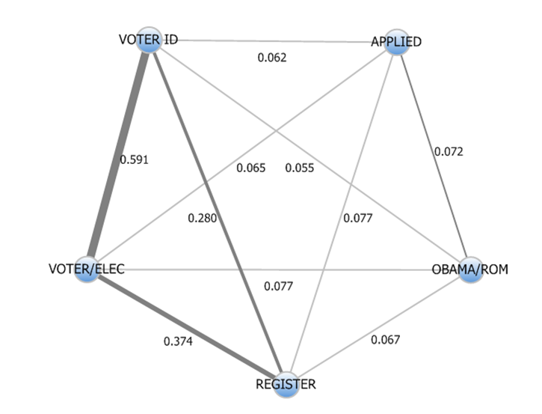

Figure 2. Co-Occurrence Analysis on Topics Associated with Non- Battleground States
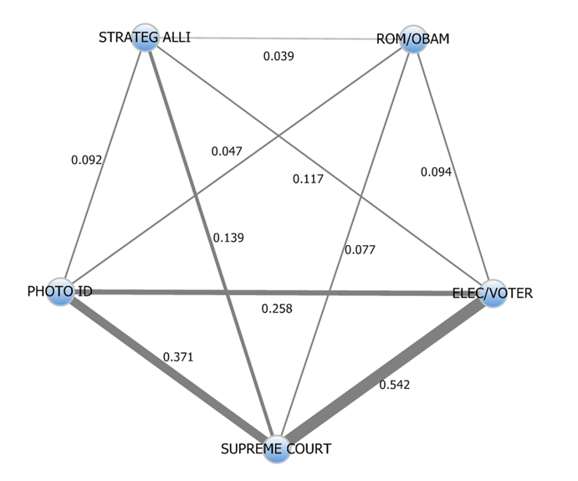

Figure 3. Co-Occurrence Analysis on Topics Associated with States with Restrictive Laws

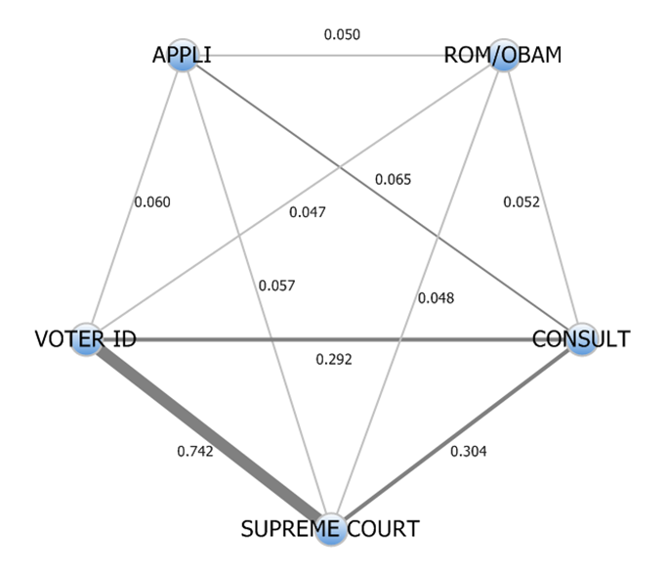

Figure 4. Co-Occurrence Analysis on Topics Associated with States without Restrictive Laws

