# **Supplemental Figures**

Supplemental Figure 1: Average monthly surface temperature profiles across Glaciar Norte (top) with the elevation of the profile (bottom). Shaded bands represent the associated standard error (typically ± a few degrees). Horizontal cyan line is the freezing temperature of water.



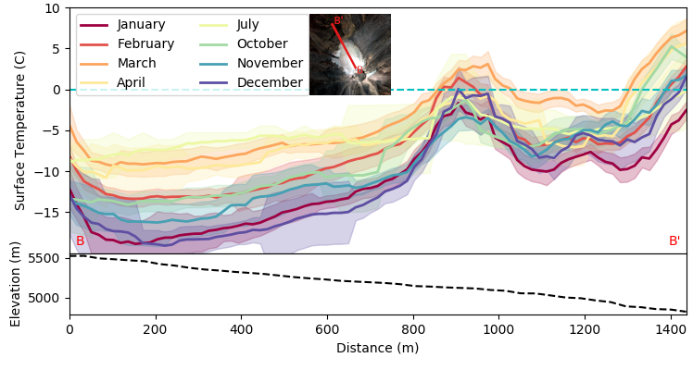

Supplemental Figure 2: Average monthly surface temperature profiles down Glaciar Norte (top), starting at the summit crater and extending to the northwest, with the elevation of the profile (bottom). Shaded bands represent the associated standard error. Horizontal cyan line is the freezing temperature of water.

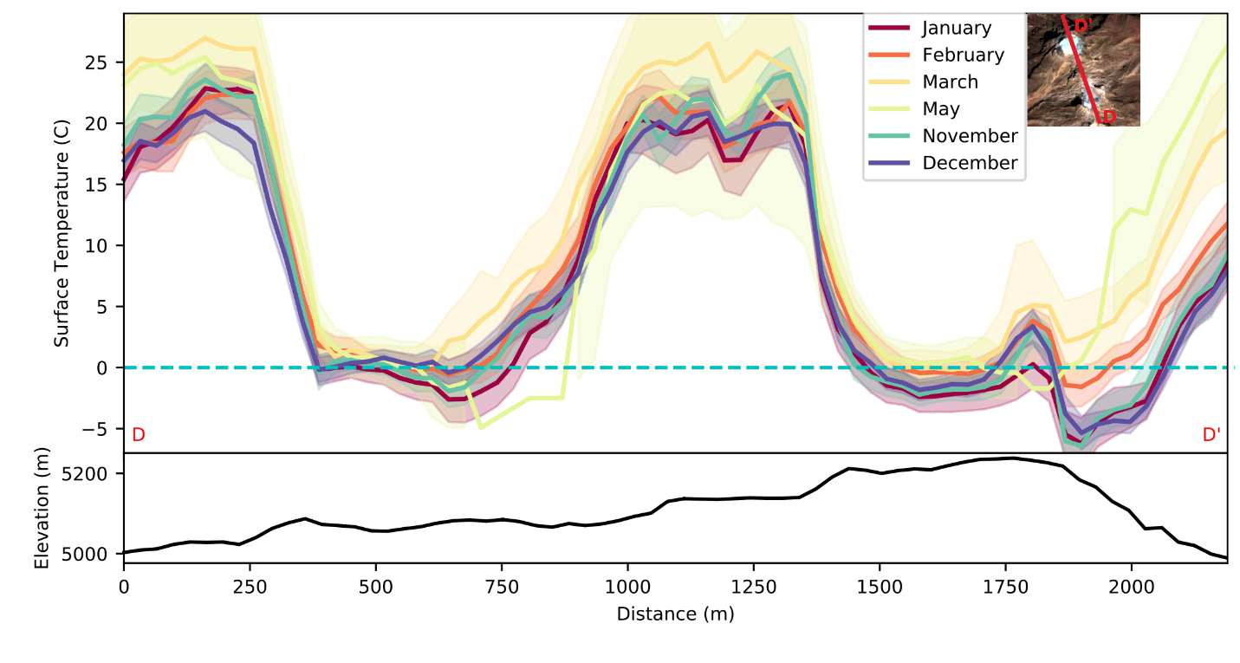

Supplemental Figure 4: Average monthly surface temperature profiles through the two glaciers on Iztaccíhuatl, where shaded bands around each line represent the standard error. Bottom plot shows the associated elevation profile. Horizontal cyan line is the freezing point of water.

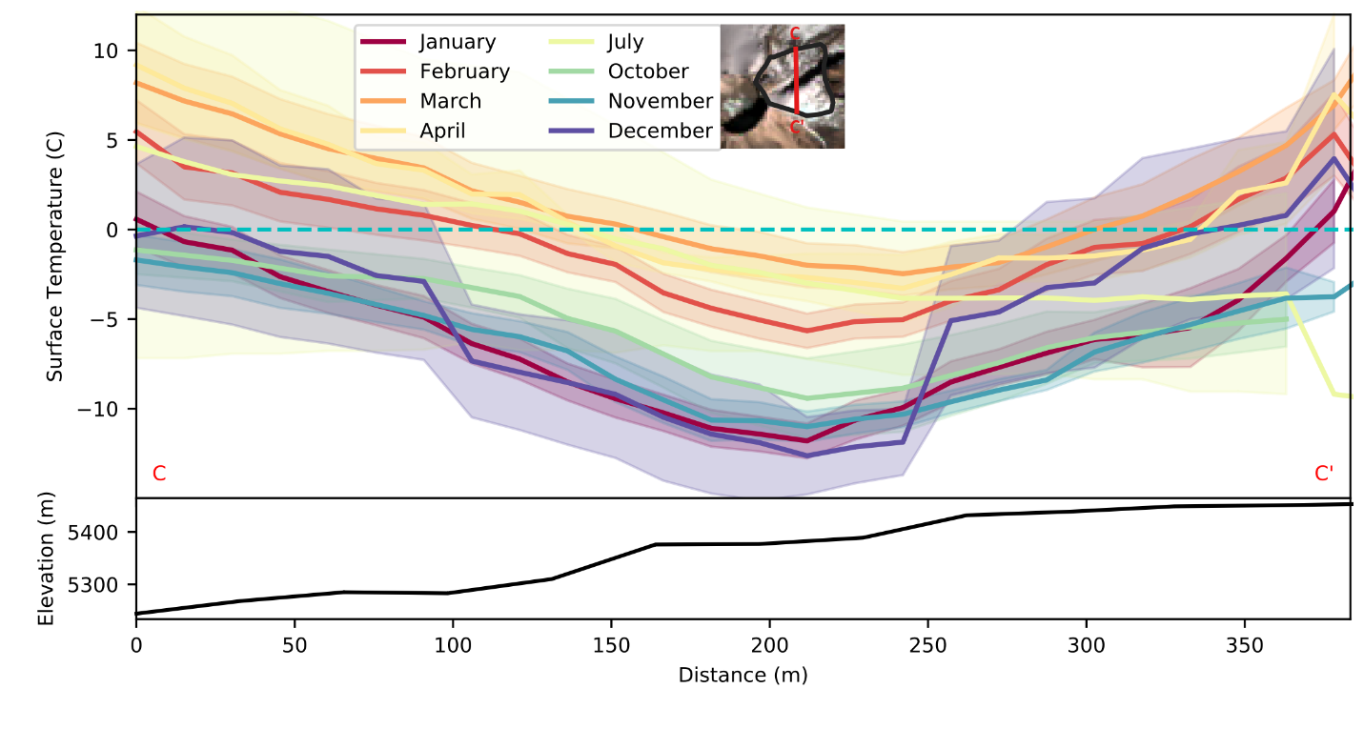

Supplemental Figure 3: Average monthly surface temperature across Glaciar Oriental (top) and associated elevation profile (bottom). Shaded bands represent the associated standard error. Since there were fewer usable thermal-band images in this case, the typical error is significantly higher than for the other glaciers discussed. The horizontal cyan line represents the freezing point of water.