Supporting Information for:
Star-shaped Oligomers with Truxenone Center and Triphenylene Branches: Mesomorphism, Optical and Electronic Properties

Wen Zhang ª, Wen-Hao Yu ª, Chun Feng ª, Shi-Kai Xiang ª, Bi-Qin Wang ª , Ke-Qing Zhao ª, Hai-Liang Ni ^{a,}* and Ping Hu ^{a,}*
ª College of Chemistry and Material Sciences, Sichuan Normal University, Chengdu, 610066, P.R. China.
*E-mail: nihl@sicnu.edu.cn; hp_x@163.com

Contents:
TGA curves of three oligomers............................................................................. S2
DSC curves of three oligomers..............................................................................S3
POM images of three oligomers.............................................................................S4
X-ray Diffractograms................................................................................................S5
Cyclic Voltammetry Results. ..................................................................................S8
UV-Vis and Fluorescence Data .............................................................................S8
¹H and ¹³C NMR Spectra..........................................................................................S11
HRMS of three oligomers…………………………….………………………………………………………S21

- TGA
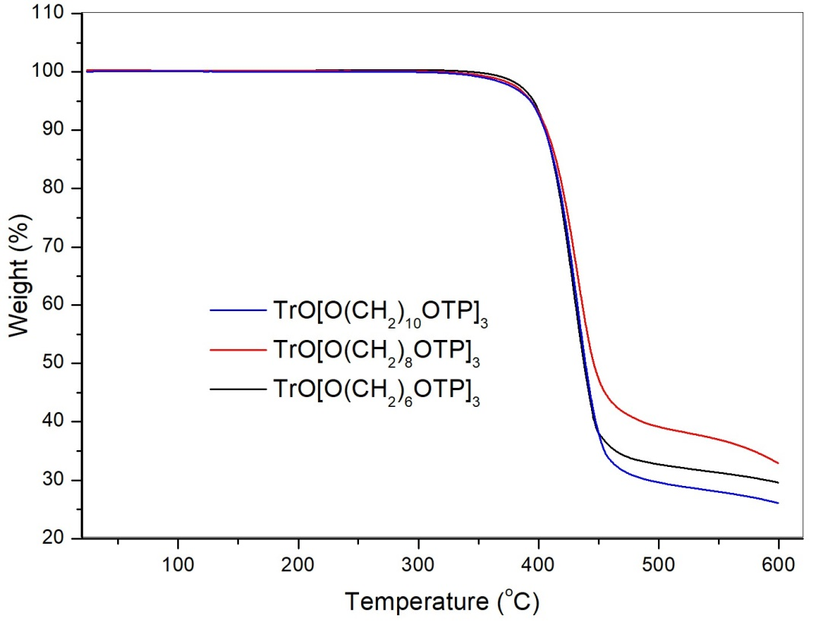

Fig. S1. TGA curves of three oligomers. The measurements were performed under a nitrogen atmosphere, with heating and cooling rates of 10 ºC min⁻¹.

- Differential scanning calorimetry (DSC) curves of three oligomers
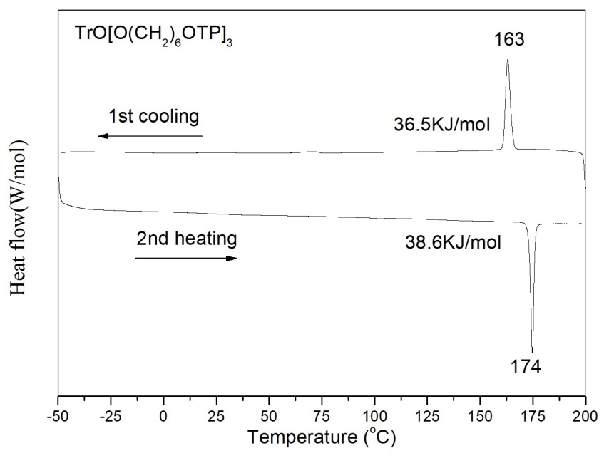
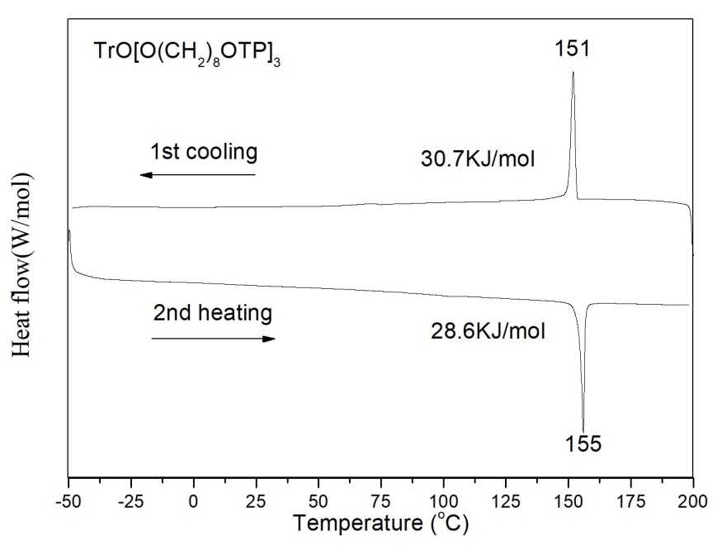
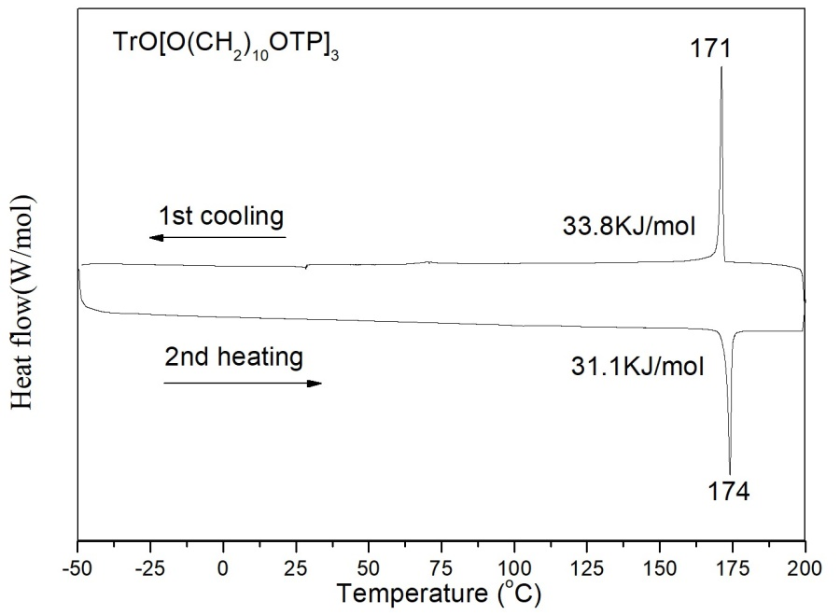

Fig. S2. DSC curves of three oligomers. The measurements were performed under a nitrogen atmosphere, with heating and cooling rates of 10 ºC min⁻¹.

- Polarizing optical microscopy images
(a)
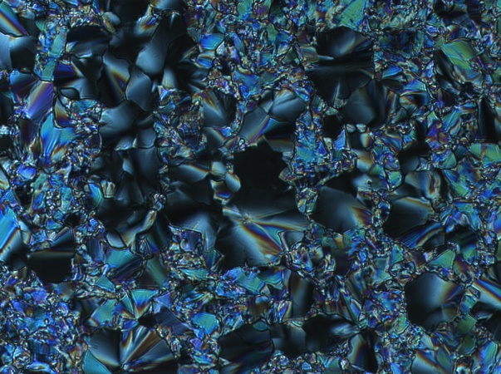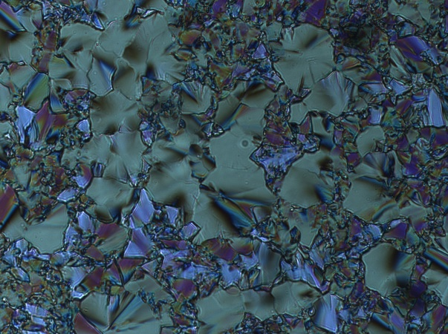

(b)
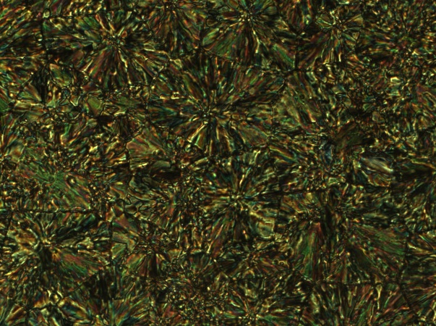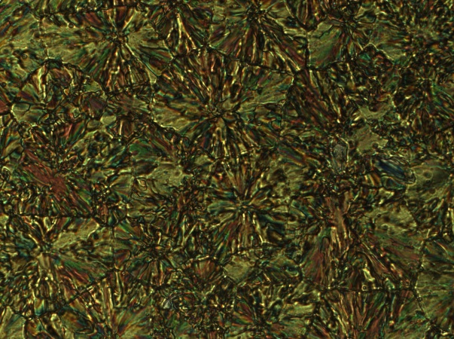

(c)
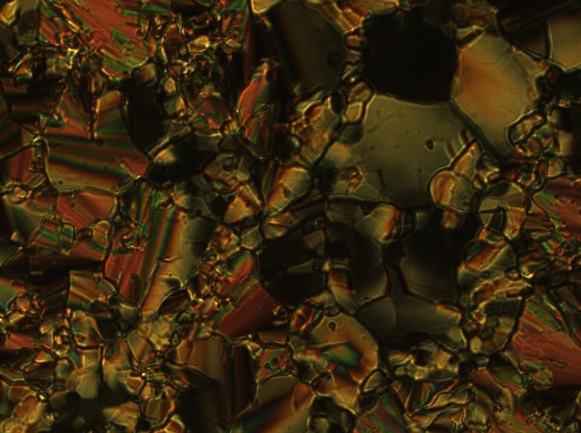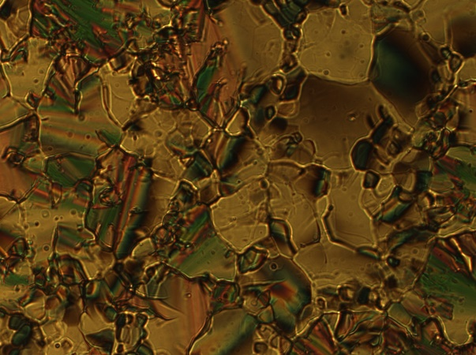

Fig. S3. Polarized optical microscopy (POM) images of the drop-casted thin film of three oligomers between two glass slides observed under two crossed polarizers upon slow cooling (1-2 ºC min⁻¹) from the isotropic phase: (a) TrO[O(CH₂)₆OTP]₃ at 168 ºC; (b) TrO[O(CH₂)₈OTP]₃ at 158 ºC; (c) TrO[O(CH₂)₁₀OTP]₃ at 147 ºC.

- X-ray diffraction (XRD)
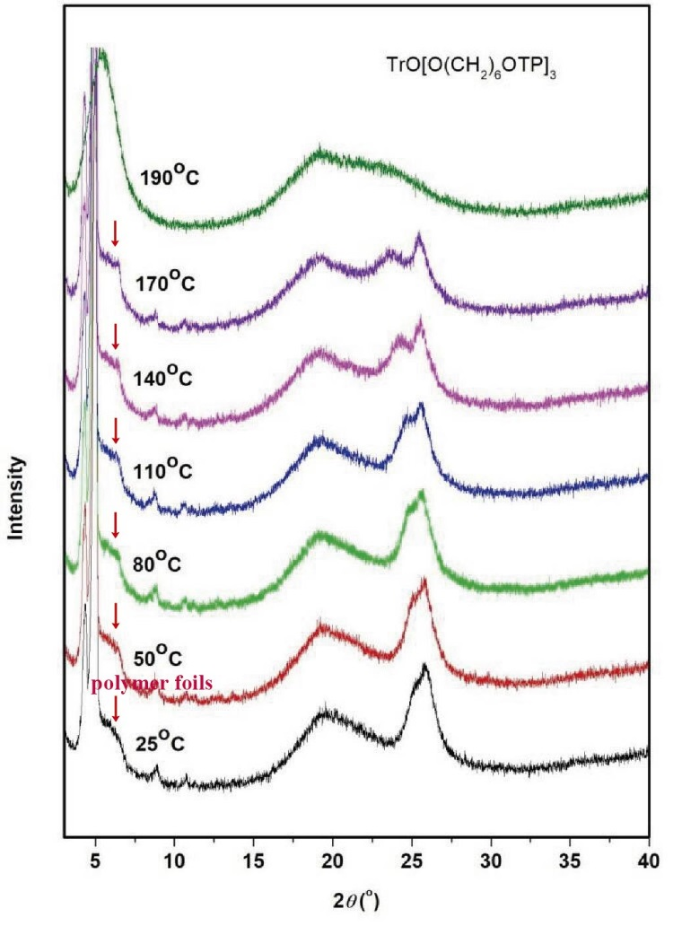
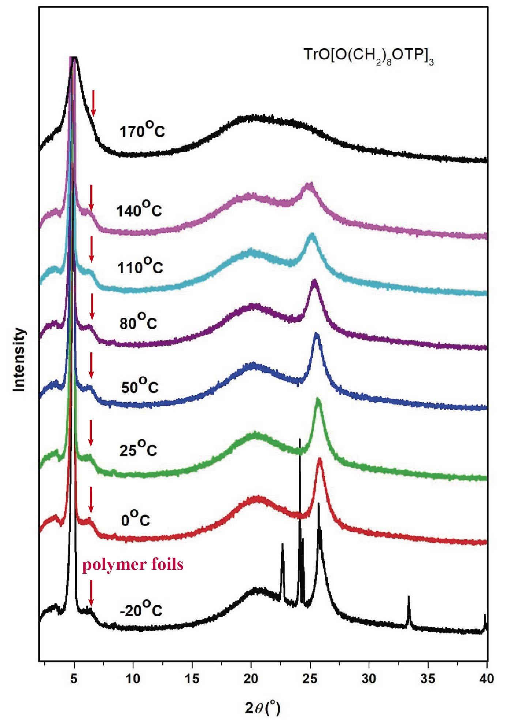
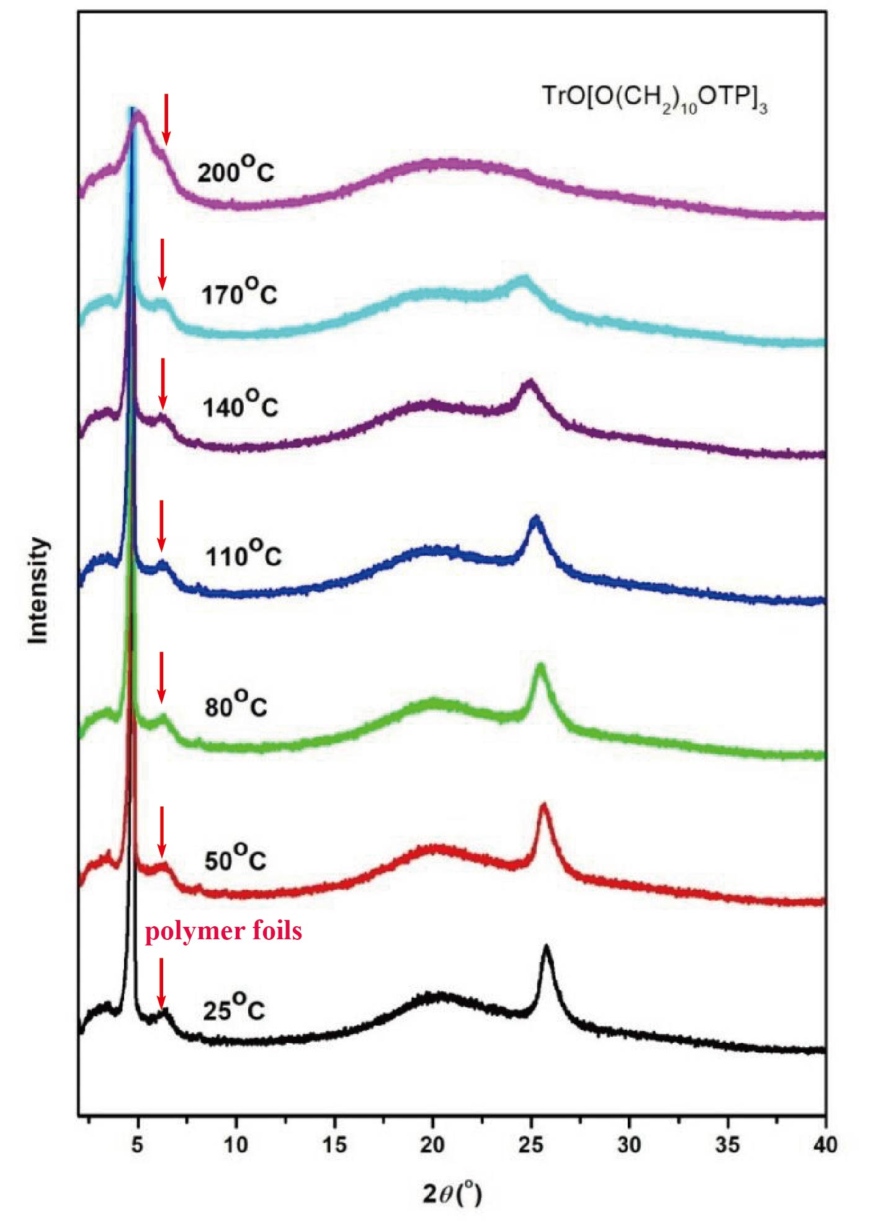
Fig. S4. XRD data for three oligomers.

5. Cyclic Voltammogram

Fig. S5. Cyclic Voltammogram of three oligomers (2 mM) in dry DCM with 0.1 M Bu₄NPF₆ as the electrolyte with a scan rate of 100 mV s⁻¹.

6. UV-Vis and Fluorescence Data

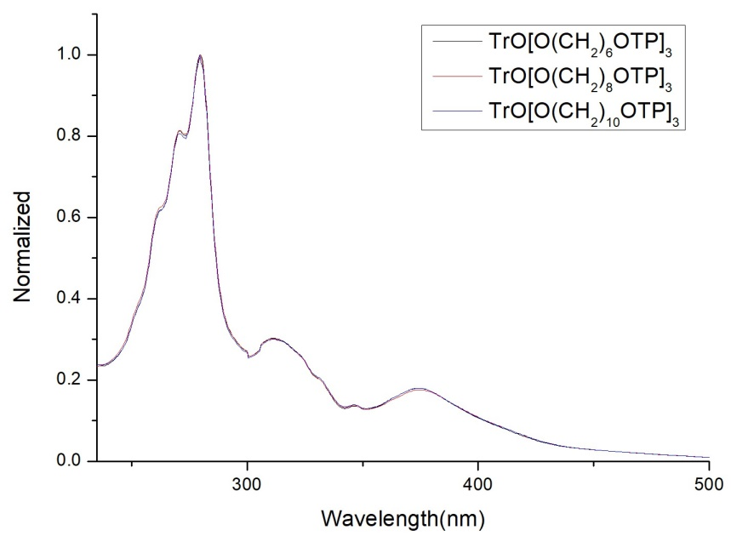
Fig. S6. UV-Vis absorbance spectra of 10⁻⁵ M solutions of three oligomers.

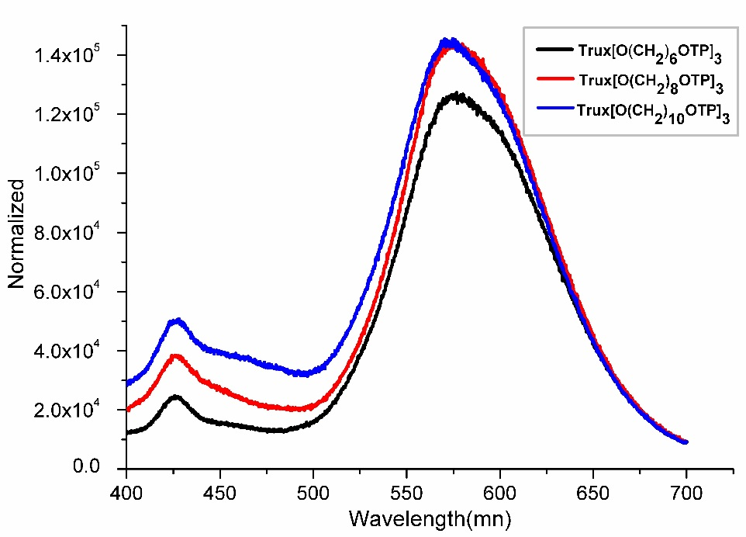
Fig. S7. Emission spectra of 10⁻⁵ M solutions of three oligomers (λ_{exc} = 350 nm).

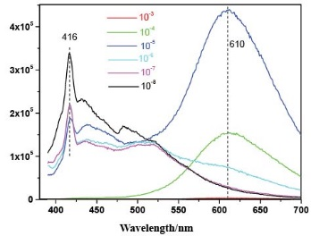

Fig. S8. Fluorescence emission of TrO[O(CH₂)₆OTP]₃ in different concentrations of DCM solution (λ_{exc} = 350 nm).

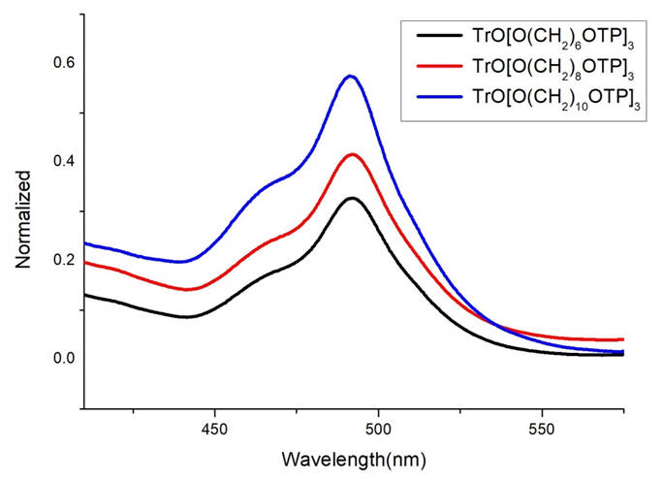
Fig. S9. Emission spectra of three oligomers in thin film (λ_{exc} = 350 nm).

7. ¹HNMR and ¹³C NMR of 1, 2a-c and three oligomers
¹H NMR spectrum of compound 1
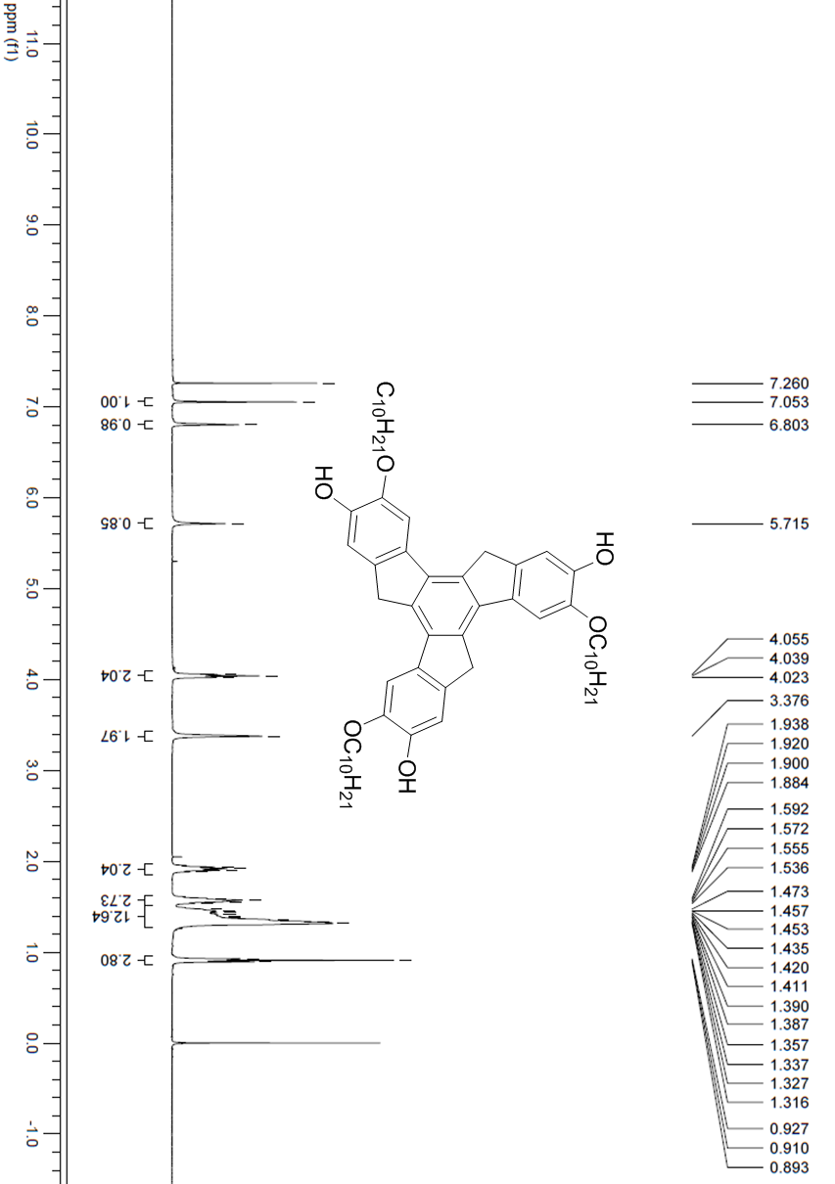

¹H NMR spectrum of compound 2a

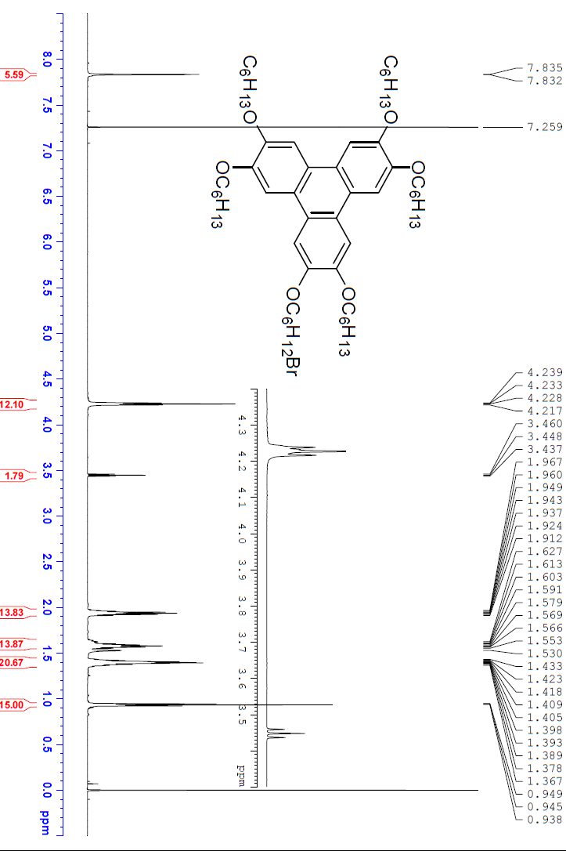

¹H NMR spectrum of compound 2b
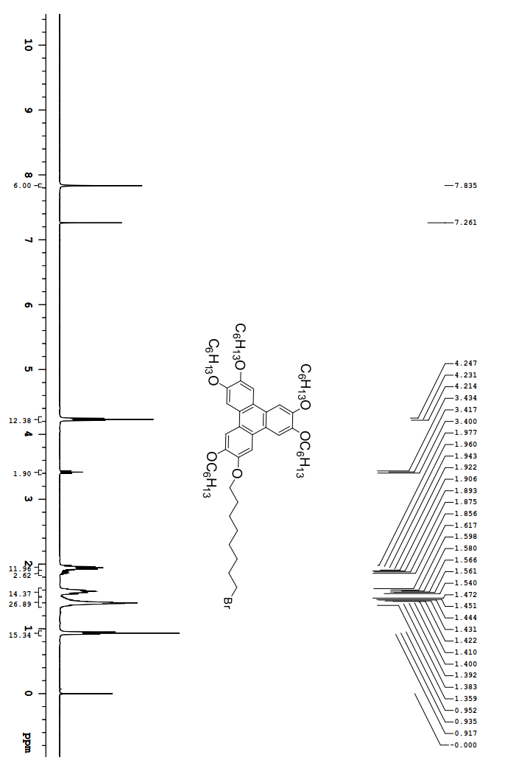
¹H NMR spectrum of compound 2c
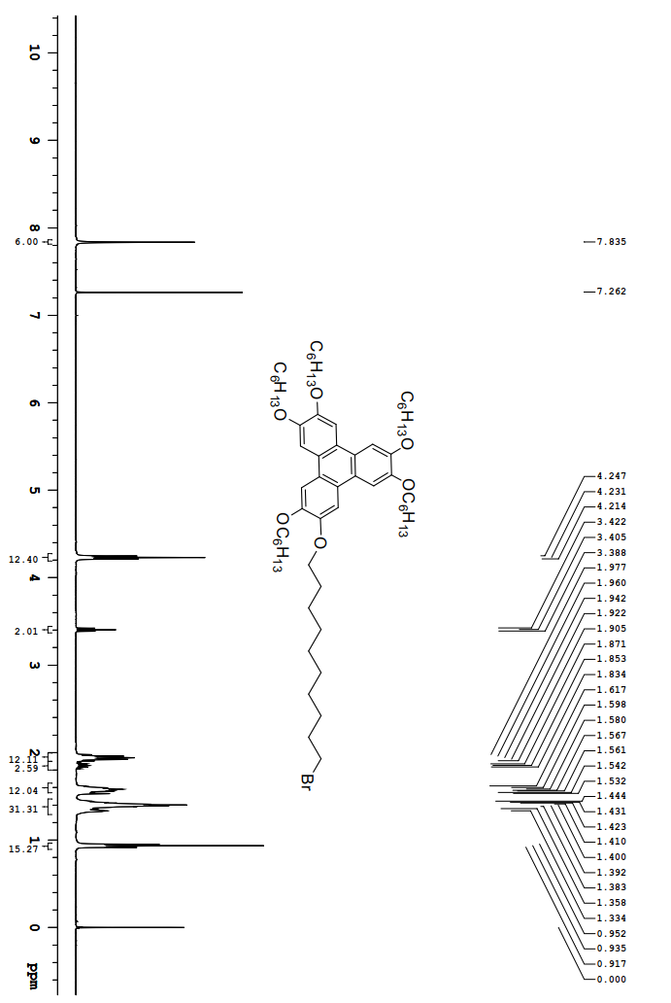

¹H NMR spectrum of compound TrO[O(CH₂)₆OTP]₃
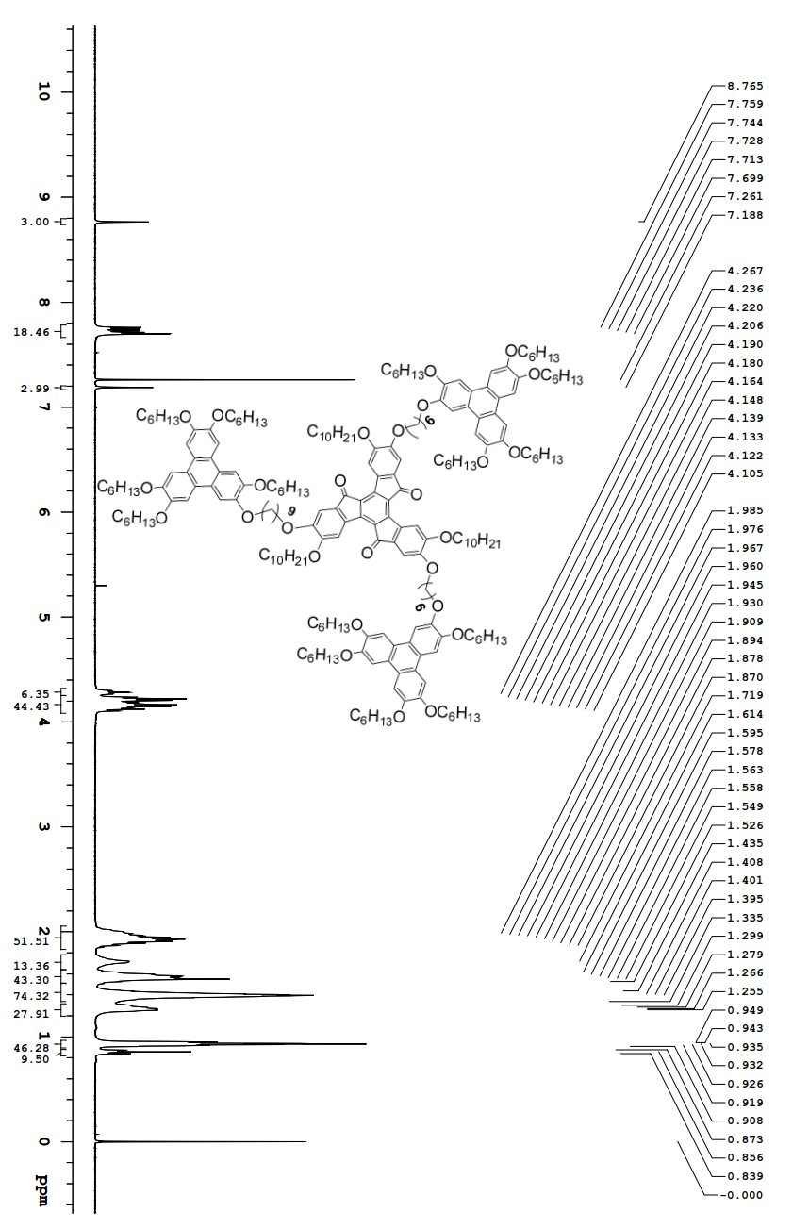

¹³C NMR spectrum of compound of TrO[O(CH₂)₆OTP]₃
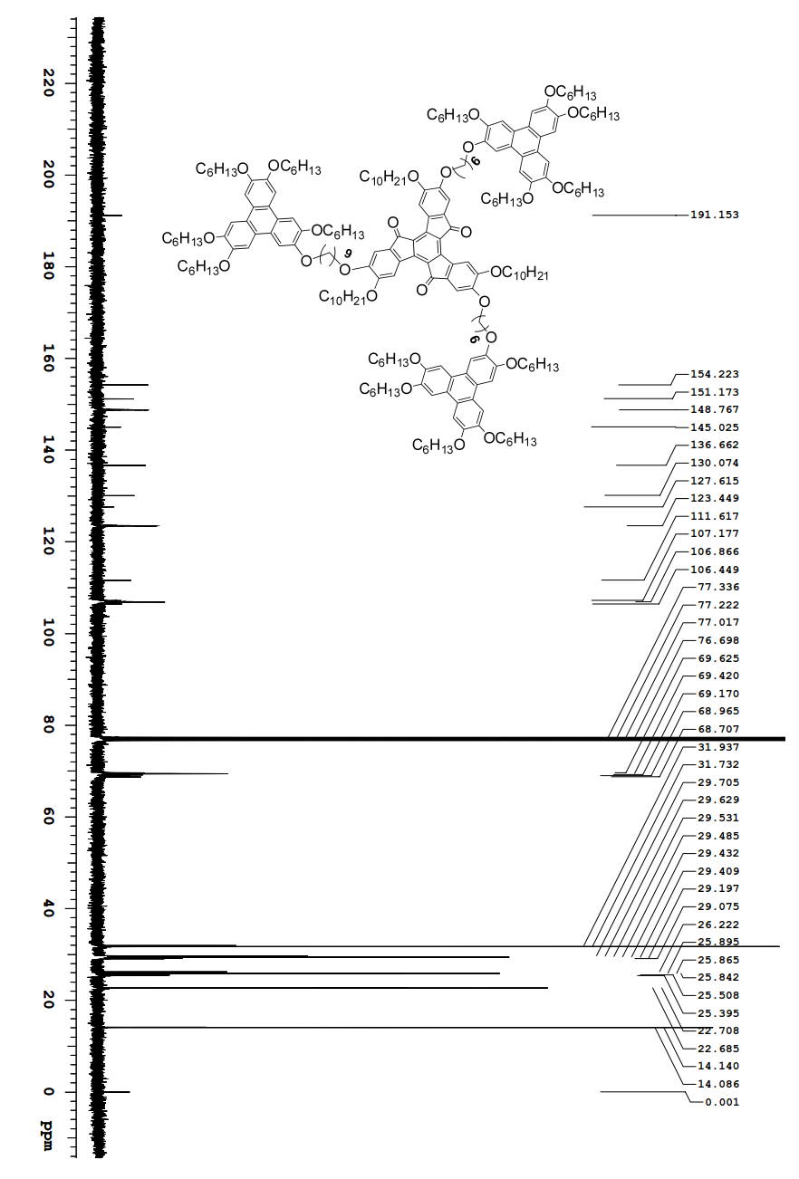

¹H NMR spectrum of compound TrO[O(CH₂)₈OTP]₃
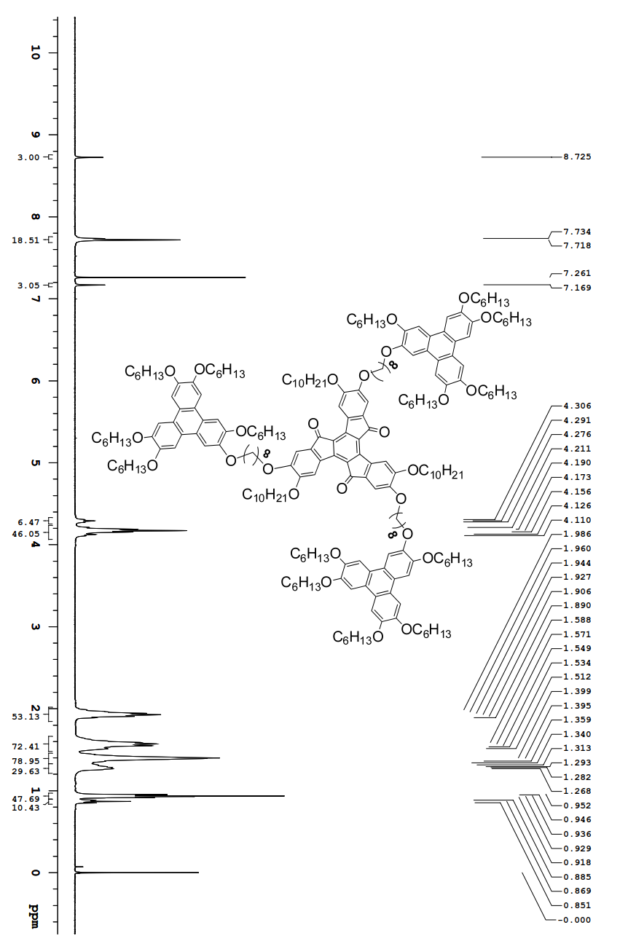

¹³C NMR spectrum of compound of TrO[O(CH₂)₈OTP]₃

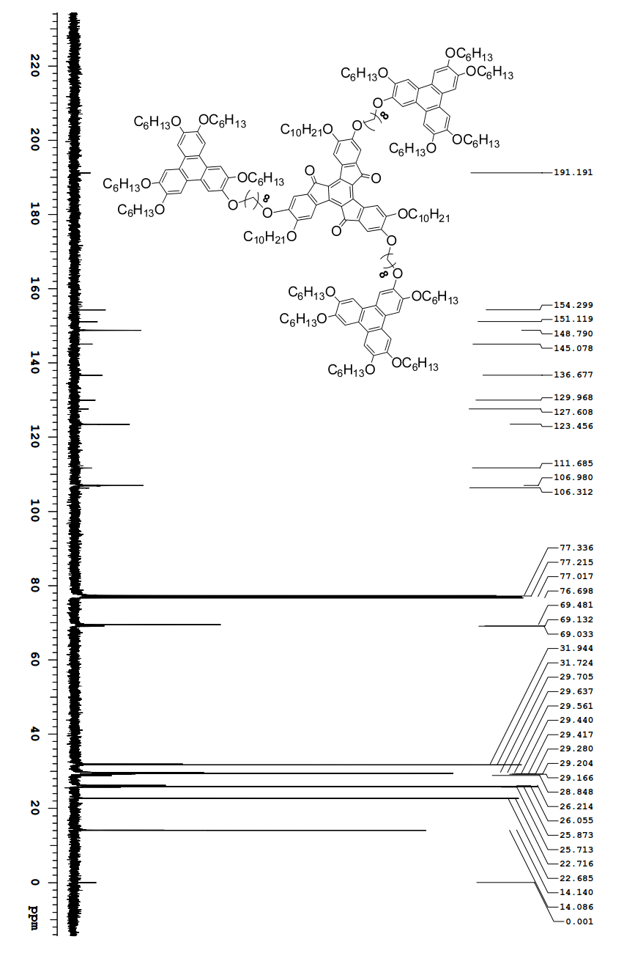

¹H NMR spectrum of compound TrO[O(CH₂)₁₀OTP]₃
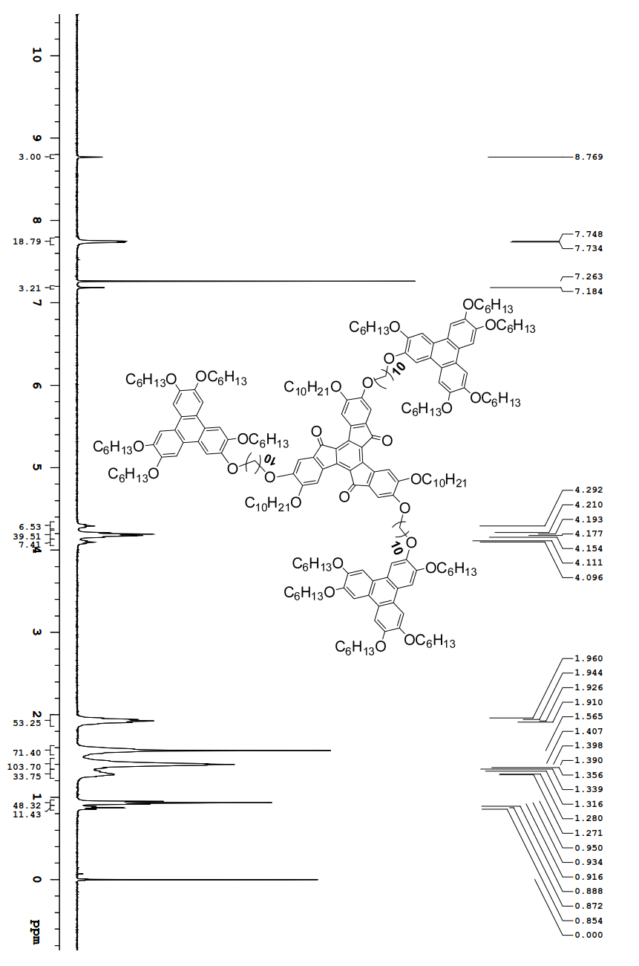

¹³C NMR spectrum of compound of TrO[O(CH₂)₁₀OTP]₃

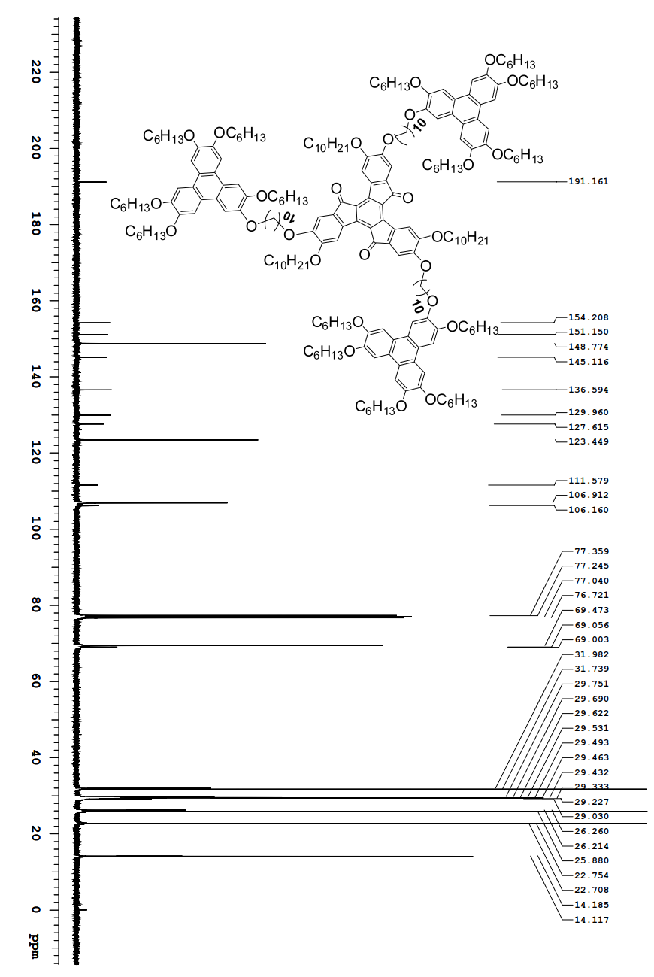

8. HRMS of three oligomers
TrO[O(CH₂)₆OTP]₃

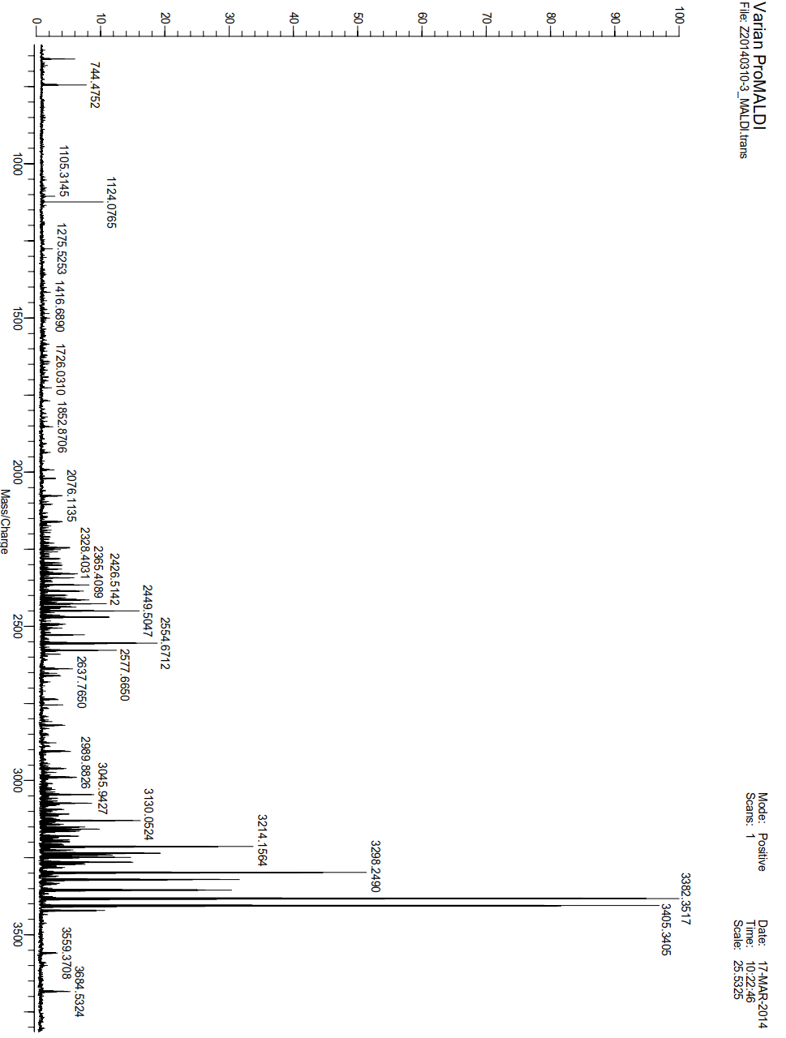

TrO[O(CH₂)₈OTP]₃

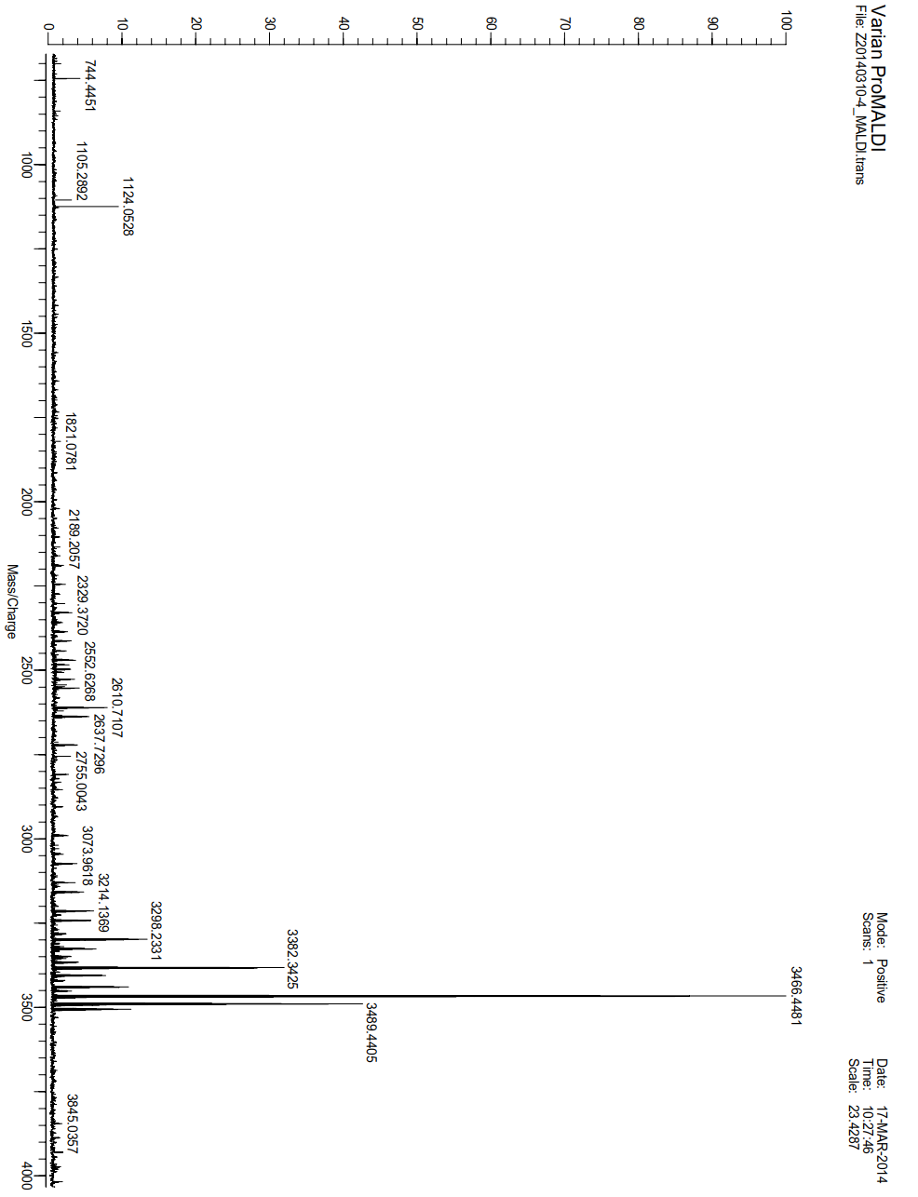

TrO[O(CH₂)₁₀OTP]₃

