Efficient Syntheses of π-Electron Deficient Macrocycles
Cheng Peng,¹ Chi Zhang, Jiwei Zhang^{2*} and Hao Li^{1*}

1. Department of Chemistry, Zhejiang University, Hangzhou 310027, China
2. School of Science，Jimei University
Email: zhangjw2014@sina.com;lihao2015@zju.edu.cn

Supporting Information

- General Methods
All reagents and solvents were purchased from commercial sources and used without further purification. Compound 1²⁺•2PF₆─,^{S1} 3,^{S2} 4,^{S3} 5,^{S4} 6²⁺•2PF₆⁻,^{S5} 7²⁺•2PF₆⁻,^{S6} 8,^{S7} 9,^{S8} 10^{S9} were prepared according to literature procedures. Nuclear magnetic resonance (NMR) spectra were recorded at ambient temperature using Bruker AVANCE III 400/500 spectrometers, with working frequencies of 400/500 and 100/125 MHz for ¹H and ¹³C, respectively. Chemical shifts are reported in ppm relative to the residual internal non-deuterated solvent signals (CD₃CN: δ = 1.94 ppm; CDCl₃: δ = 7.26 ppm). High-resolution mass spectra (HRMS) were recorded on an Fourier transform ion cyclotron resonance mass spectrometry (FT-ICR MS). UV/Vis/NIR absorption spectra were taken on a Cary Series UV-Vis-NIR spectrophotometer. X-ray crystallographic data were collected on a Bruker D8 Venture diffractometer. Isothermal titration calorimetry (ITC) experiments were performed on a MicroCal system, VP-ITC model.
- Synthetic Procedures
Scheme S1. Synthesis of 2²⁺•2PF₆─
2²⁺•2PF₆─: A mixture of 4,4'-bipyridine (260.0 mg, 1.67 mmol) and 2-azidoethyl 4-methylbenzenesulfonate (1.612g, 6.69mmol) in DMF (10 mL) was stirred at 100 °C for 4d. The reaction mixture was then cooled to room temperature and the solvent was removed under vacuum. The solid was purified by means of flash column chromatography (1M NH₄Cl in H₂O/methanol/nitromethane (12:7:1); silica gel, 200-300 mesh). The organic components of solvent was removed, followed by adding NH₄PF₆ into the aqueous solution, which led to precipitation of white solid.. The solid-state sample was collected by filtration, yielding pure 2²⁺•2PF₆─ (880mg, 90%). ¹H NMR (400 MHz, CD₃CN): δ = 8.91 (d, J = 6.0 Hz 4H), 8.41 (d, J = 6.0 Hz, 4H), 4.74 (t, J = 4.8 Hz, 4H), 4.00 (t, J = 4.8 Hz, 4H). ¹³C NMR (100 MHz, CD₃CN): δ = 150.1, 145.7, 126.8, 60.3, 49.8. HRMS-ESI for2²⁺•2PF₆─, Calcd for C₁₄H₁₆F₆N₈P: m/z = 441.1129 [M – PF6]⁺; Found: 441.1143 [M – PF6]⁺.
Scheme S2. Synthesis of M1⁴⁺•4PF₆─
M1⁴⁺•4PF₆─: A mixture of 1²⁺•2PF₆─ (55 mg, 0.1 mmol) , 2²⁺•2PF₆─ (58 mg, 0.1mmol), Cu(CN)₄PF₆ (2mg,0.05mmol) and TBTA in acetone (100 mL) was stirred at room temperature under an N₂ atmosphere for 8h. The solvent was then removed under vacuum. The resulting solid was purified by flash column chromatography (1M NH₄Cl in H₂O/methanol/nitromethane (12:7:1); silica gel, 200-300 mesh). After counteranion exchange, pure M1⁴⁺•4PF₆─(46mg, 42%) was obtained as a white solid. ¹H NMR (400 MHz, CD₃CN): δ = 8.81 (d, J = 6.0 Hz, 4H), 8.67 (d, J = 6.4 Hz, 4H), 8.26 (d, J = 6.0 Hz, 4H), 8.24 (d, J = 6.4 Hz, 4H), 7.84 (s, 2H), 5.13 (t, J = 7.2 Hz, 4H), 4.97 (t, J = 7.2 Hz, 4H), 4.94 (t, J = 6.4 Hz, 4H), 3.45 (t, J = 6.4 Hz, 4H). ¹³C NMR (100 MHz, CD₃CN): δ = 151.3, 151.0, 146.8, 146.3, 143.3, 128.1, 127.6, 125.5, 61.9, 61.8, 50.5, 27.0. HRMS-ESI for M1⁴⁺•4PF₆─, Calcd for C₃₂H₃₂F₁₂N₁₀P₂: m/z = 424.1128 [M – 2PF6]²⁺; Found: 424.1121 [M – 2PF6]²⁺.
Scheme S3. Synthesis of 6²⁺•2PF₆⁻ and 7²⁺•2PF₆⁻
6²⁺•2PF₆⁻: To a solution of 8 (3.13 g, 8 mmol) in 100mL MeCN, 4,4'-bipyridine (5.0 g, 32 mmol) was added. The mixture was heated and reflux for 72 h. After cooling to room temporature, 150 mL ethyl ether was added into reaction mixture to give a yellow precipitation, which was collected by filtration and washed with ethyl ether and CH₂Cl₂. The solid was dissolved in water, and then NH₄PF₆ was added, which yielded white precipitates. The resulting precipitates was collected and washed with water. The crude product was purified by silica gel chromatography (eluent: aqueous NH₄Cl solution/MeOH/MeNO₂ = 12/7/1, v/v). After counteranion exchange, 6²⁺•2PF₆ (3.96g, 65%) was obtained as a pure white solid. ¹H NMR(400MHz, CD₃CN) δ 8.84 (d, J = 4.8Hz, 4H), 8.74 (d , J = 6.0Hz, 4H), 8.29 (d, J = 6.0 Hz, 4H), 7.77 (d, J = 4.8 Hz, 4H), 4.67 (t, J = 4.8 Hz, 4H), 3.90 (t, J = 4.8Hz, 4H), 3.56 (s，4H).
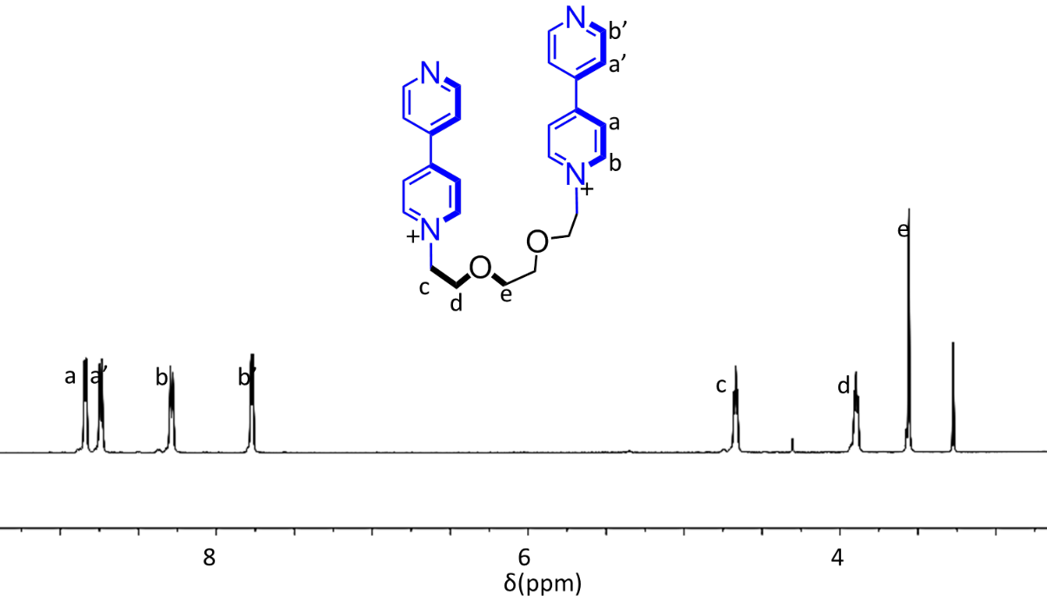
Figure S1. ¹H NMR spectrum (400 MHz, CD₃CN, 298 K) of 6²⁺•2PF₆⁻.
7²⁺•2PF₆ was obtained in 61% yield, using a similar procedure as 7²⁺•2PF₆, except that 9 was used in the reaction. ¹H NMR (400 MHz, CD₃CN) δ 8.85 (d, J = 6.8Hz, 4H), 8.60 (br, 4H), 8.25(d, J = 6.8Hz, 4H), 7.74 (d, J = 4.8Hz, 4H), 4.73 (t, J = 4.8Hz, 4H), 3.93 (t, J = 4.8Hz, 4H), 3.55 (t, J = 2.0Hz, 4H), 3.48 (t, J = 2.0Hz, 4H)
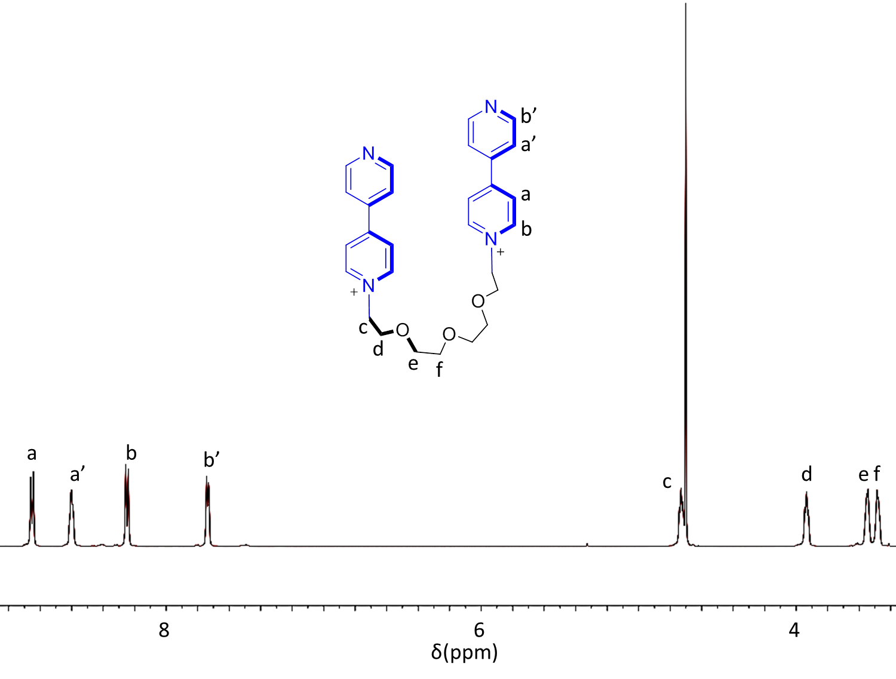
Figure S2. ¹H NMR spectrum (400 MHz, CD₃CN, 298 K) of 7²⁺•2PF₆⁻.
Scheme S4. Synthesis of M2⁴⁺•4PF₆⁻ and M3⁴⁺•4PF₆⁻
M₂⁴⁺•4PF₆⁻: Compound 6²⁺•2PF₆⁻ (402 mg, 0.56 mmol) and 1,4-bis(bromomethyl)benzene (170 mg, 0.65 mmol) were stirred in MeCN (150 ml) at room temperature for 7 days. Excess amount of tetrabutylammonium chloride was added to the reaction mixture, yielding yellow precipitates. These solids were collected and purified by column chromatography. After counteranion exchange, pure 6²⁺•2PF₆⁻ was obtained (36 mg, 8.4%). ¹H NMR (400 MHz, CD₃CN) δ 8.92(d, 4H, J = 6.5 Hz), 8.78 (d, 4H, J = 6.5 Hz), 8.25 (m, 8H), 7.62 (s, 4H), 5.80 (s, 4H), 4.71 (t, 4H, J = 4.5 Hz), 3.84 (t, 4H, J = 4.5 Hz). ¹³C NMR (100 MHz, CD₃CN) δ 149.8, 149.3, 145.6, 145.8, 135.7, 130.1, 127.1, 126.3, 117.0, 69.2, 36.7, 64.4, 61.6. MS (ESI-HRMS) calcd for C₃₄H₃₆N₄O₂⁴⁺•2PF₆⁻: m/z = 411.1055 [M + 2 PF₆] ²⁺, found m/z = 411.1048; calcd for C₃₄H₃₆N₄O₂⁴⁺•PF₆⁻: m/z = 225.7488 [M + PF₆] ³⁺, found m/z = 225.7454.

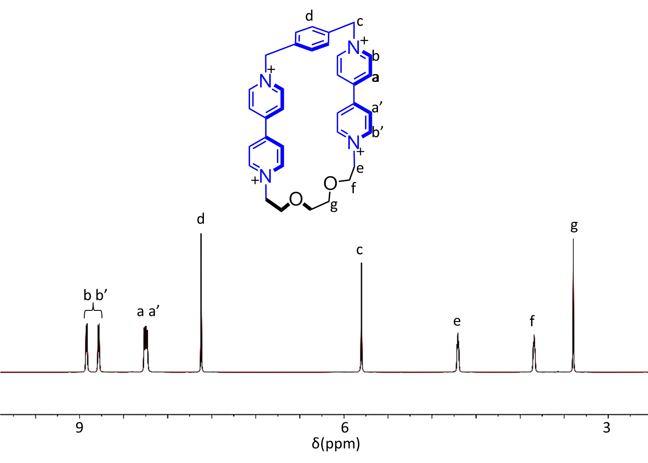
Figure S3. ¹H NMR spectrum (400 MHz, CD₃CN, 298 K) of M2⁴⁺•4PF₆⁻.

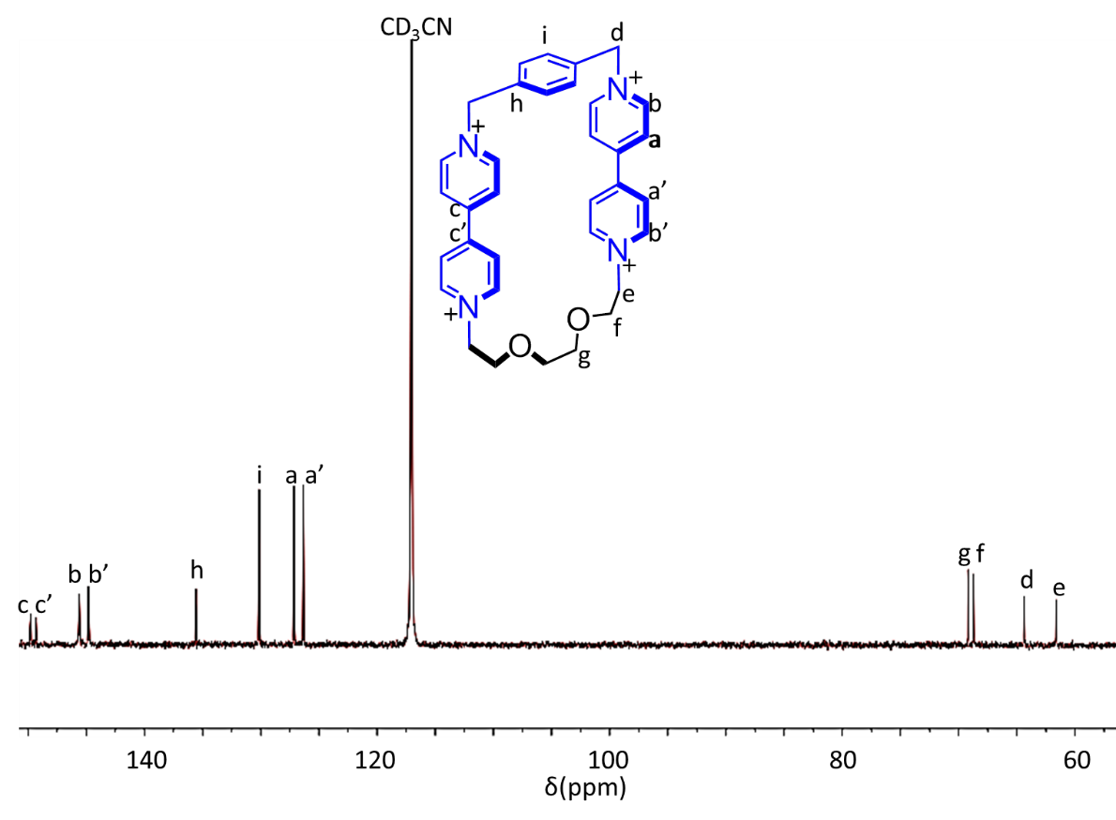
Figure S4. ¹³C NMR spectrum (100 MHz, CD₃CN, 298 K) of M2⁴⁺•4PF₆⁻.

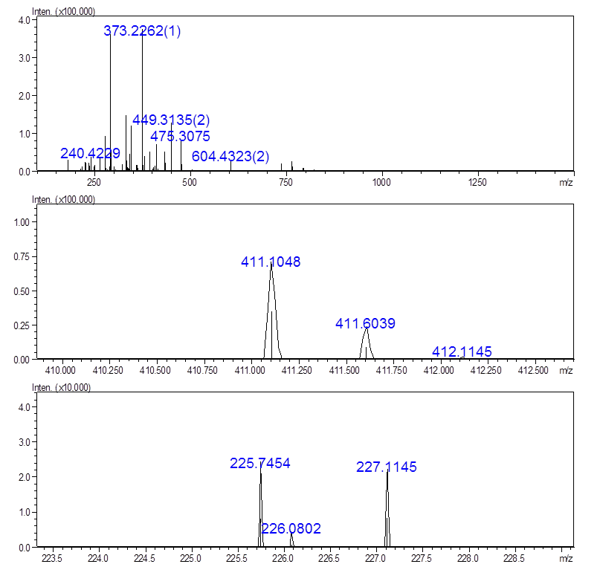
Figure S5. ESI-HRMS of M2⁴⁺•4PF₆⁻.
M3⁴⁺•4PF₆⁻ was prepared in 14 % yield in a similar procedure as that of M3⁴⁺•4PF₆⁻, expect that 7²⁺•2PF₆⁻ was used in the reaction. ¹H NMR (400 MHz, CD₃CN) 8.94 (s, 4H), 8.78 (d, J = 4.3Hz ,4H), 8.25 (d, J = 10.3Hz, 8H), 7.65 (s, 4H), 5.81 (s, 4H), 4.72 (t, 4H), 3.86 (s, 4H), 3.47 (s, 4H), 3.37 (s, 4H). ¹³C NMR(100MHz, CD₃CN) δ 169.7, 169.2, 145.5, 144.8, 135.1, 130.3, 127.1, 126.2, 117.1, 69.6, 69.2, 68.2, 64.2, 61.2. MS (ESI-HRMS) calcd for : m/z = 433.12 [M + 2 PF₆] ²⁺, found m/z = 433.1183; calcd for m/z = 240.42 [M + PF₆] ³⁺, found m/z = 240.4212; calcd for m/z = 144.08 [M] ⁴⁺, found m/z = 144.0759.
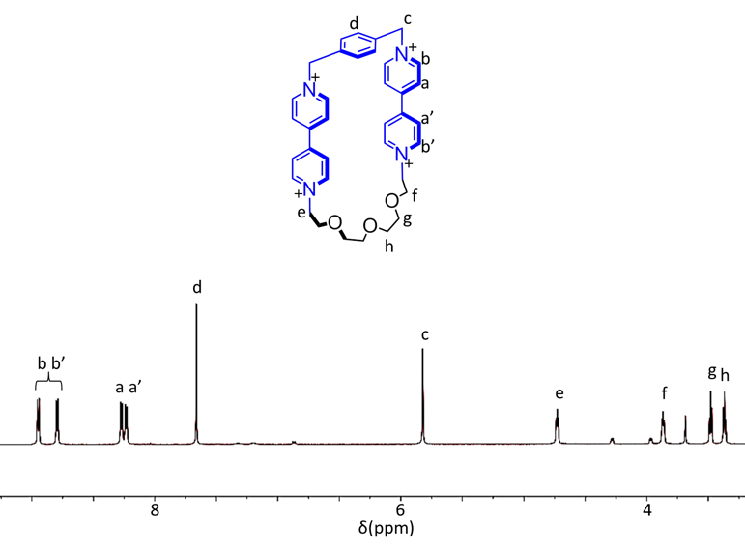
Figure S6. ¹H NMR spectrum (400 MHz, CD₃CN, 298 K) of M3⁴⁺•4PF₆⁻.
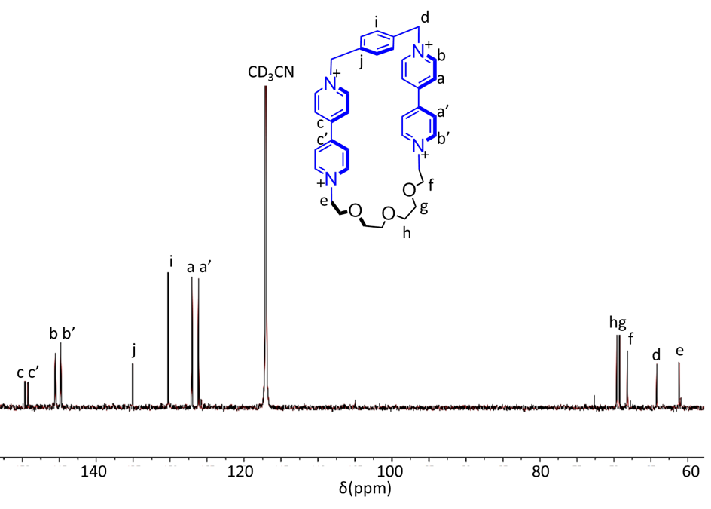
Figure S7. ¹³C NMR spectrum (100 MHz, CD₃CN, 298 K) of M3⁴⁺•4PF₆⁻.

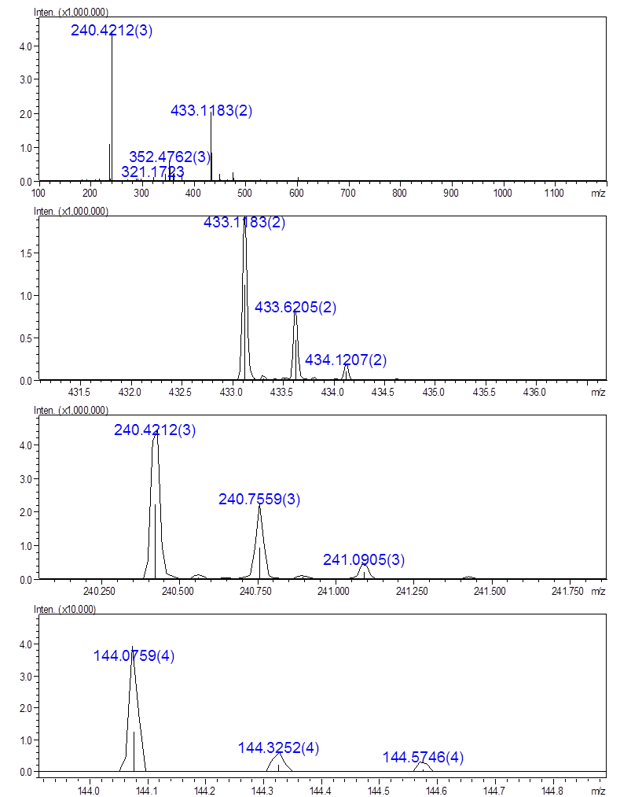
Figure S8. ESI-HRMS of M3⁴⁺•4PF₆⁻.

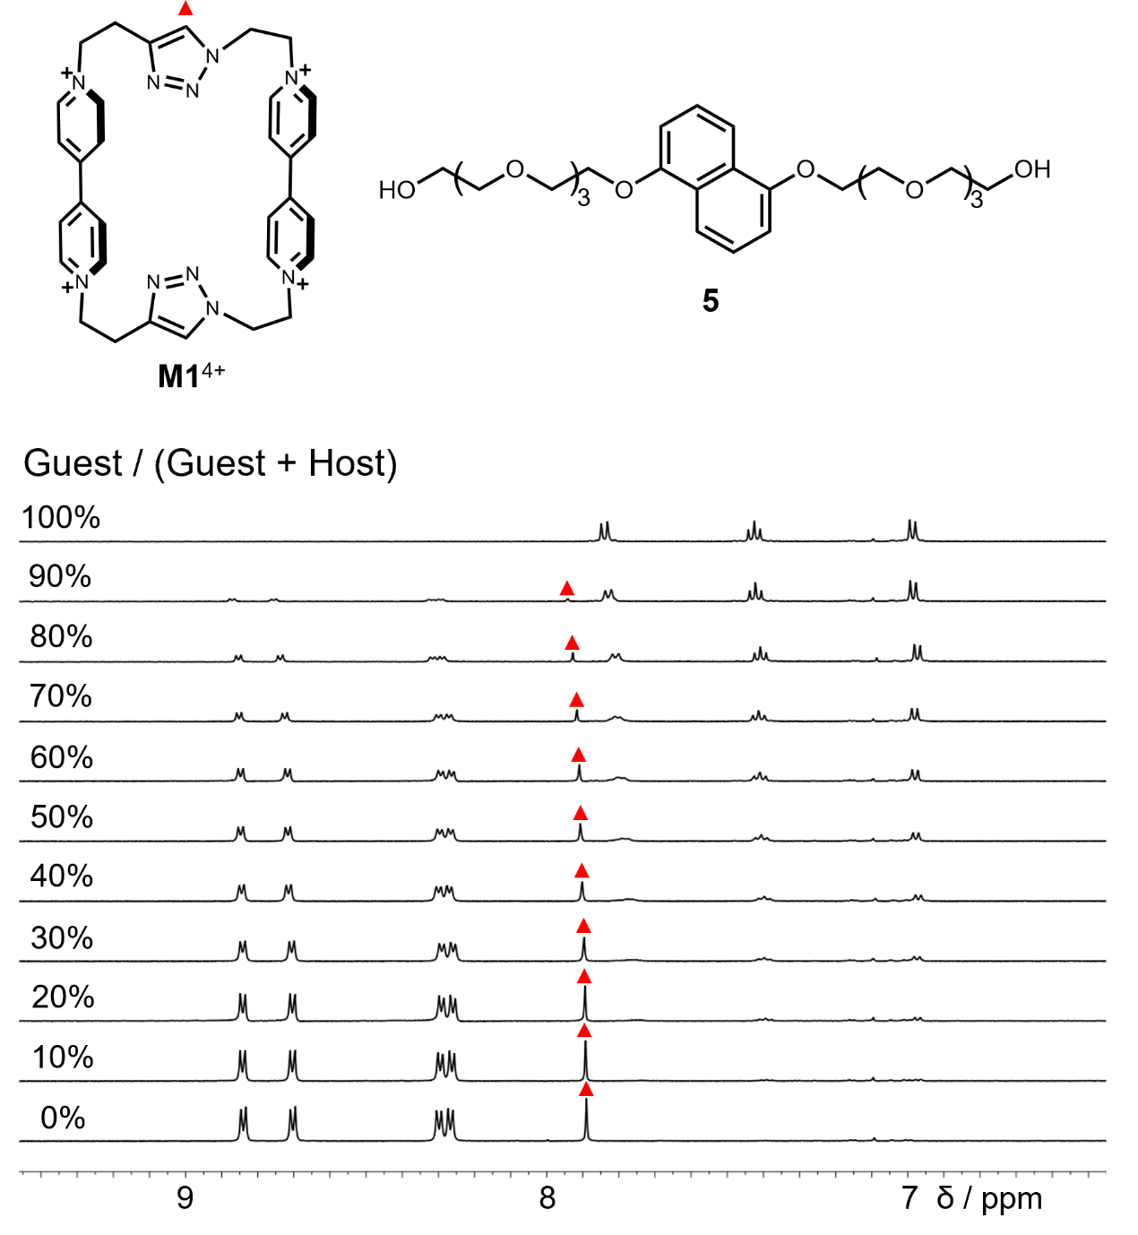
Figure S9. ¹H NMR spectra (400 MHz, CD₃CN, 298 K) of a mixture of M1⁴⁺•4PF₆⁻ and 5 with different ratios of [5]/([5]+[M1⁴⁺]). The chemical shifts of the resonances, which are labeled with red triangles, are used to make the job plot. [5]+[M1⁴⁺] is kept constant, which is 1 mM.
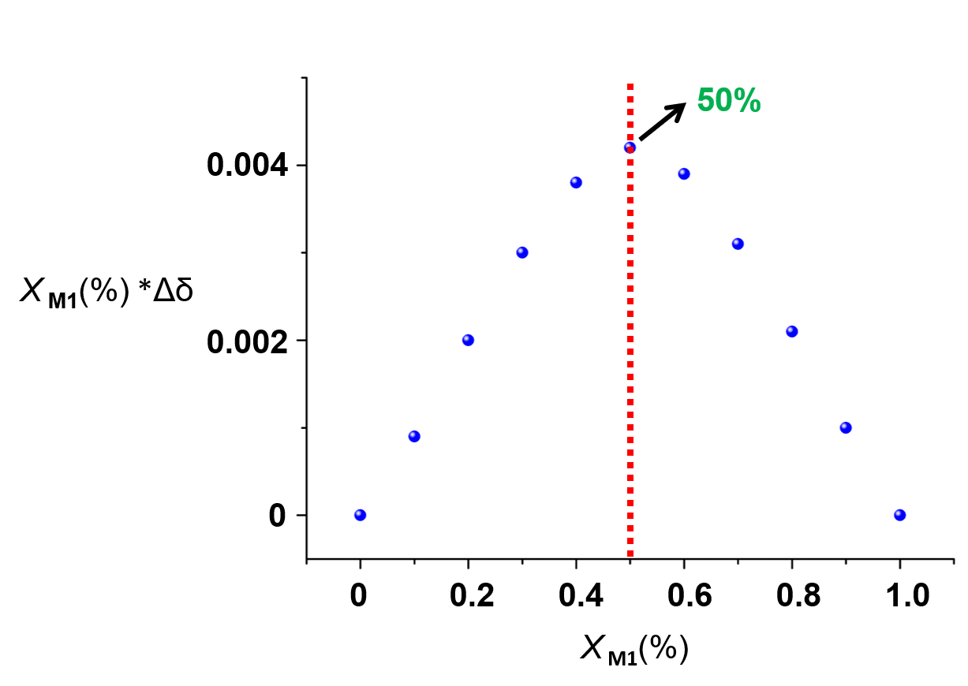

Figure S10. Job plot of 5 ⊂M1⁴⁺•4PF₆⁻, indicating a 1:1 binding model, which is obtained from the data in Figure S9.
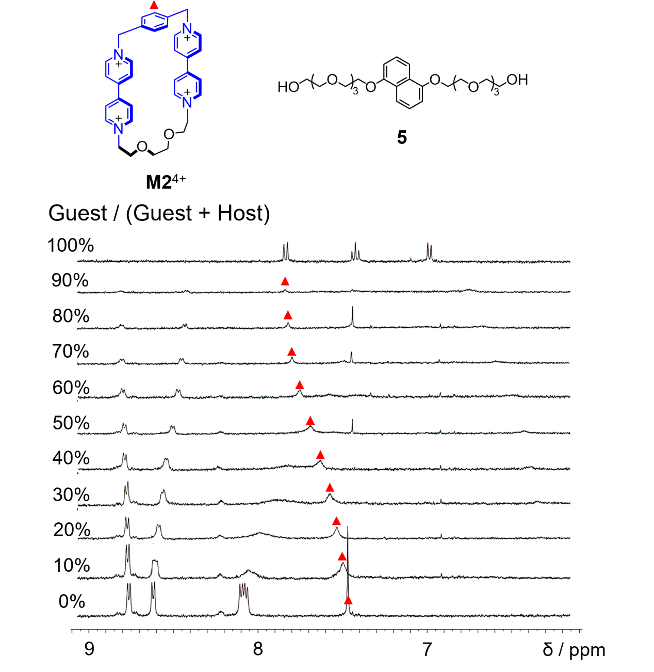
Figure S11. ¹H NMR spectra (400 MHz, CD₃CN, 298 K) of a mixture of M2⁴⁺•4PF₆⁻ and 5 with different ratios of [5]/([5]+[M2⁴⁺]). The chemical shifts of the resonances, which are labeled with red triangles, are used to make the job plot. [5]+[M2⁴⁺] is kept constant, which is 1 mM.

Figure S12. Job plot of 5 ⊂M2⁴⁺•4PF₆⁻, indicating a 1:1 binding model, which is obtained from the data in Figure S11.
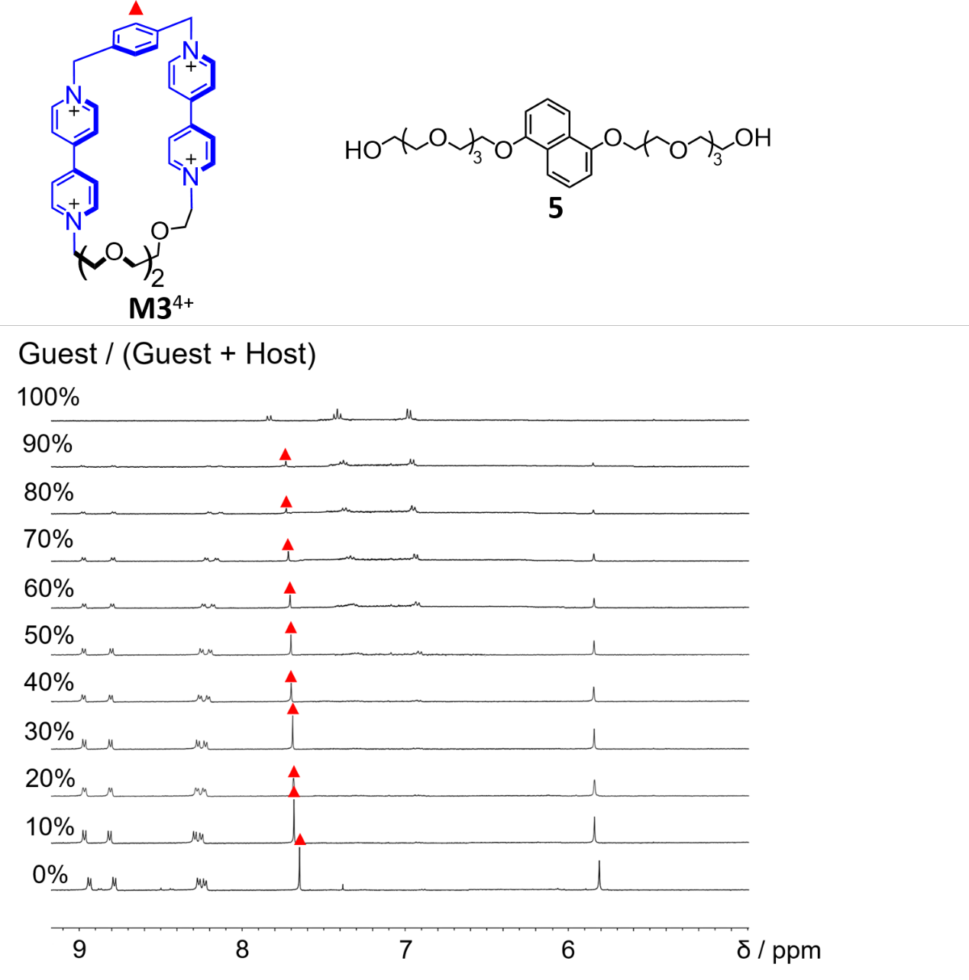
Figure S13. ¹H NMR spectra (400 MHz, CD₃CN, 298 K) of a mixture of M3⁴⁺•4PF₆⁻ and 5 with different ratios of [5]/([5]+[M3⁴⁺]). The chemical shifts of the resonances, which are labeled with red triangles, are used to make the job plot. [5]+[M3⁴⁺] is kept constant, which is 1 mM.

Figure S14. Job plot of 5 ⊂M3⁴⁺•4PF₆⁻, indicating a 1:1 binding model, which is obtained from the data in Figure S13.
Figure S15. ¹H NMR spectrum (500 MHz, CD₃CN, 298 K) of M2⁴⁺•4PF₆⁻ (1.9 mM) when titrated with 5 at 25 ºC. The shifts of the resonances labeled with red arrows are used to make the plot for calculating the binding constant of 5 ⊂M2⁴⁺.

Figure S16. The plot of the resonance shifts based on the corresponding ¹H NMR spectra in Figure S15. Binding constant is determined to be 7.14 ± 0.23 × 10³ M⁻¹.

Figure S17. ¹H NMR spectrum (500 MHz, CD₃CN, 298 K) of M3⁴⁺•4PF₆⁻ (1.7mM) when titrated with 5 at 25 ºC. The shifts of the resonances labeled with red arrows are used to make the plot for calculating the binding constant of 5 ⊂M3⁴⁺.

Figure S18. ¹H NMR spectra (500 MHz, CD₃CN, 298 K) of M3⁴⁺•4PF₆⁻ (1.7mM) upon addition of different amount of 5. Plot of the downfield shifts (Δδ) of the resonance of proton a (marked by red arrows in spectra). Binding constant is determined to be 5.90 ± 1.0 × 10² M⁻¹.

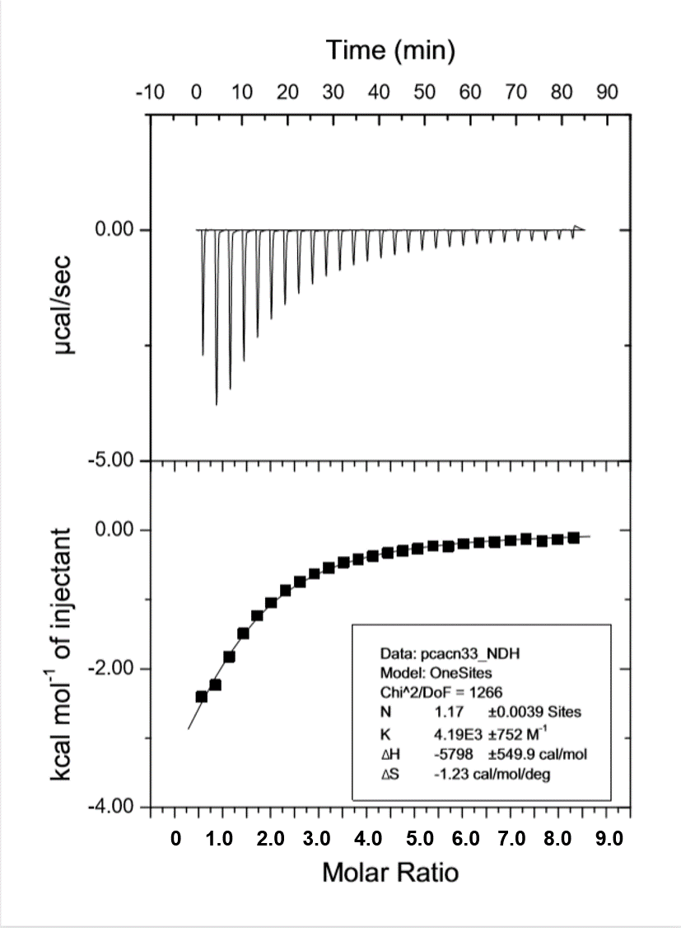

Figure S19. ITC (Isothermal Titration Calorimetry) experiments to calculate the binding constant of the complex 5 ⊂ M2⁴⁺•4PF₆. The K_{a} for the complex was determined to be 4.19 ± 0.75 × 10³ M⁻¹ in CH₃CN, which was consistent with that determined by NMR titration experiment.ΔH and ΔS were determined to be −5.78 ± 0.55 × 10³ cal·mol⁻¹ and −1.23 cal·mol⁻¹·K⁻¹, respectively.

References
- A. Coskun, S. Saha, I. Aprahamian, J. F. Stoddart, A Reverse Donor-Acceptor Bistable [2]Catenane. Org. Lett. 2008, 10, 3187-3190.
- D. Chouiki, S. Barluenga, N. Winssinger, Clickable peptide nucleic acids (cPNA) with tunable affinity. Chem. Commun. 2010, 46, 5476-5478.
- N. Sugai, H. Heguri, K. Ohta, Q. Meng, T. Yamamoto, Y. Tezuka, Effective Click Construction of Bridged- and Spiro-Multicyclic Polymer Topologies with Tailored Cyclic Prepolymers (kyklo-Telechelics). J. Am. Chem. Soc. 2010, 132, 14790-14802.
- C. J. Bruns, S. Basu, J. F. Stoddart, Improved synthesis of 1,5-dinaphtho[38]crown-10. Tetrahedron Lett. 2010, 51, 983-986.
- Z.-J. Zhang, Y.-M. Zhang, Y. Liu, Controlled Molecular Self-Assembly Behaviors betweenCucurbituril and Bispyridinium Derivatives. J. Org. Chem. 2011, 76, 4682-4685.
- H.-X. Zhao, D.-S. Guo, Y. Liu, Binding Behaviors of p‑Sulfonatocalix[4]arene with Gemini Guests. J. Phys. Chem. B. 2013, 117, 1978-1987.
- R. Crossley, Z. Goolamali, J. J. Gosper, P. G. Sammes, Synthesis and spectral properties of new fluorescent probes for potassium. J. Chem. Soc., Perkin Trans. 2, 1994, 513-520.
- M. Shao, P. Dongare, L. N. Dawe, D. W. Tompson, Y. Zhao. Biscrown-Annulated TTFAQ−Dianthracene Hybrid: Synthesis, Structure, and Metal Ion Sensing. Org. Lett. 2010, 12, 3050-3053.
- T. Wei, J. Chen, X. Wang, Y. Zhang, L. Wang, Phase Transfer Catalyzed Synthesis of Diaryl 1,4—Phenylene Dioxydiacetate. Synth. Commun. 1996, 26, 1447-1454.

