Exploration in the Sc-Al-Cu system: evidence for i-ScAl_{2.4}Cu_{3.2} quasicrystal and new data for five crystal phases.
Monique TILLARD

Supplemental material

Figure S1. Experimental XRD powder patterns (2 theta, Cu-Kα)
recorded for the quasicrystalline ScAl_{2.4}Cu_{3.2} phase (red) (Cu/Al ratio 1.33)
calculated (black) for the crystalline phases: from top to bottom hexagonal (Cu/Al ratio 0.40 and 1.20), tetragonal (1.25), orthorhombic (1.60) and cubic (2.0).

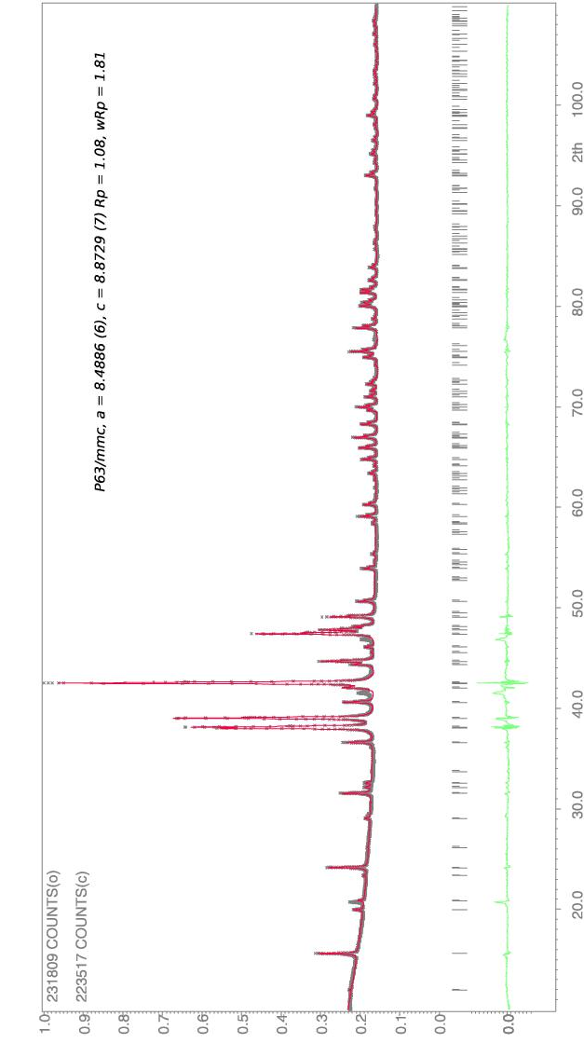

Figure S2. Profile refinement for the experimental XRD powder pattern (Cu-Kα) recorded for the hexagonal phase ScAl_{2.4}Cu_{2.9}

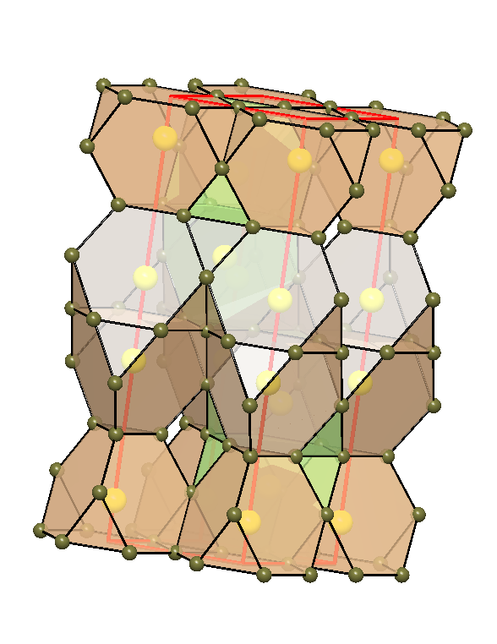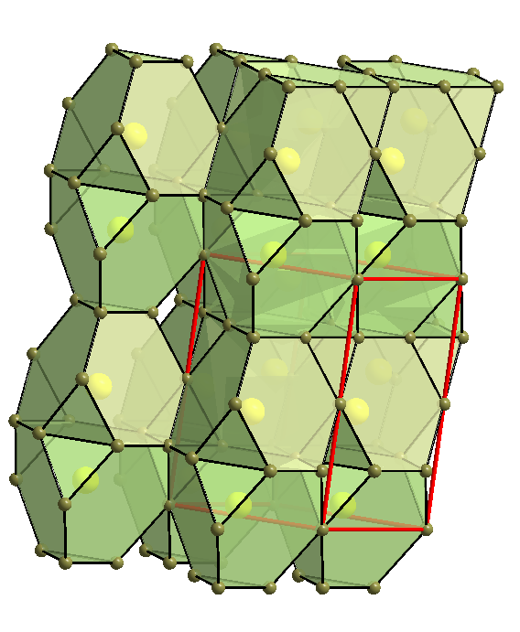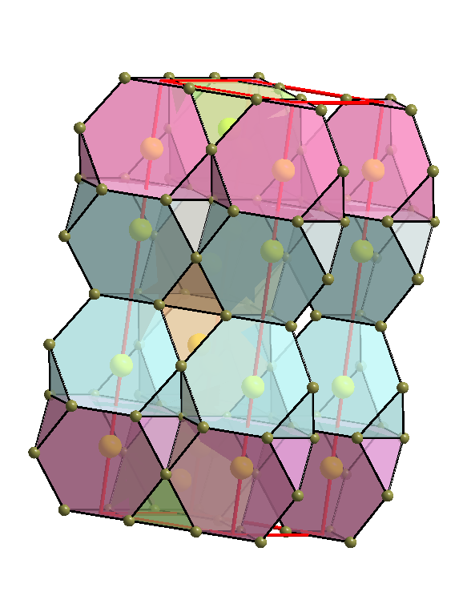
Figure S3. Structural representation of 12-vertex (Franck-Kasper) polyhedral packing approximately viewed along [-1 -1 0] direction.
From left to right: ScAl_{1.4}Cu_{0.6} (P6₃/mmm, 2 Sc independent sites), ScAlCu (P6₃/mmm, one Sc site) and ScAl_{1.1}Cu_{0.9} (Pm2, 4 Sc independent sites).

Tables S1–S7. Atom coordinates and equivalent isotropic displacement parameters (Å2×103). U_{eq} is defined as one third of the trace of the orthogonalized U_{ij} tensor.
Table S1. ScAl_{2.43}Cu_{2.91,} crystal S34, a = 8.4928(2), c = 8.8743(2), P6₃/mmc
_________________________________________________________________________
site Cu/Al content x y z U_{eq}
_________________________________________________________________________
Sc(1) 6h 0.1984(1) 0.3968(2) 0.25 9(1)
M(1) 12k 0.47/0.53(1) 0.1574(1) 0.3148(1) 0.5913(1) 14(1)
M(2) 6h 0.37/0.63(1) 0.5660(1) 0.1321(2) 0.25 9(1)
M(3) 6g 0.86/0.14(1) 0.5 0 0 9(1)
M(4) 4f 0.09/0.91(1) 0.3333 0.6667 0.0081(3) 9(1)
M(5) 2a 0.45/0.55(1) 0 0 0.25 30(1)
M(6) 2b 0.12/0.88(2) 0 0 0 35(2)
_________________________________________________________________________

Table S2. ScAl_{2.44}Cu_{2.88,} crystal S35, a = 8.4920(5), c = 8.8714(6), P6₃/mmc
_________________________________________________________________________
site Cu/Al content x y z U_{eq}
_________________________________________________________________________
Sc(1) 6h 0.1984(1) 0.3967(2) 0.25 8(1)
M(1) 12k 0.47/0.53(1) 0.1573(1) 0.3146(1) 0.5912(1) 14(1)
M(2) 6h 0.38/0.62(1) 0.5660(1) 0.1321(2) 0.25 9(1)
M(3) 6g 0.87/0.13(1) 0.5 0 0 10(1)
M(4) 4f 0.09/0.91(1) 0.3333 0.6667 0.0085(2) 9(1)
M(5) 2a 0.45/0.55(1) 0 0 0.25 32(1)
M(6) 2b 0.10/0.90(1) 0 0 0 32(2)
_________________________________________________________________________

Table S3. ScAl_{2.19}Cu_{3.42}, crystal S37, a = 21.8869(7), b = 8.3311(2), c = 8.3238(2), Cmmm
* M2 position is split into Cu2 and Al2. **Al content is the complement to unity
___________________________________________________________________________
site x y z U_{eq} Cu content**
this work [1]
___________________________________________________________________________
Sc1 8o 0.81290(7) 0 0.7051(2) 0.0289(3)
Sc2 4g 0.38542(9) 0 0 0.0291(4)
Sc3 4j 0 0.3044(2) 0.5 0.0283(4)
Al2* 8p 0.2521(3) 0.168(1) 0 0.062(3) 0.12(1) 0.48
Cu2* 4g 0.2575(2) 0 0 0.053(2) 0.245(9) 0.02
M1 4k 0 0 0.2631(2) 0.0297(5) 0.95(1) 0.95
M3 4i 0 0.2590(2) 0 0.0296(5) 0.82(1) 0.89
M4 8o 0.40573(5) 0 0.3480(1) 0.0272(3) 0.745(9) 0.88
M5 4h 0.0699(1) 0 0.5 0.0288(8) 0.13(1) 0.12
M6 4g 0.06009(7) 0 0 0.0300(5) 0.76(1) 0.78
M7 4f 0.25 0.25 0.5 0.0257(7) 0.25(1) 0.32
M8 16r 0.30741(4) 0.16054(9) 0.23744(9) 0.0303(3) 0.800(8) 0.72
M9 8p 0.65294(6) 0.3382(1) 0 0.0355(4) 0.900(11) 0.85
M10 8q 0.63246(4) 0.2548(1) 0.5 0.0264(3) 1 1
M11 4l 0 0.5 0.1857(3) 0.0264(6) 0.37(1) 0.22
M12 4h 0.30329(8) 0 0.5 0.0249(5) 0.56(1) 0.31
M13 16r 0.57975(6) 0.2767(2) 0.7749(2) 0.0288(4) 0.212(7) 0.07

[1] T. Ishimasa, A. Hirao, T. Honma and M. Mihalkovic, Philos. Mag. 91 (2011) p. 2594.

Table S4. ScAl_{5.34}Cu_{6.66}, crystal S36, a = 8.5605(3), c = 5.0061(3), I4/mmm
_________________________________________________________________________
site Cu/Al content x y z U_{eq}
_________________________________________________________________________
Sc 2a 0 0 0 14(1)
M(2) 8j 0.581/0.419(7) 0.2813(2) 0.5 0 21(1)
Cu(3) 8f 1.0/0.0 0.25 0.25 0.25 15(1)
M(4) 8i 0.085/0.915(6) 0.3461(2) 0 0 17(1)
_________________________________________________________________________

Table S5. ScAl_{1.03}Cu_{2.00}, crystal S42, a = 6.1958(6), Fmm
ScAl_{0.97}Cu_{2.00}, crystal S45, a = 6.1976(2), Fmm (* italic)
_______________________________________________________________________
site x y z U_{eq} (*)U_{eq}
_______________________________________________________________________
Cu 8c 0.25 0.25 0.25 13(1) 9(1)
Sc 4b 0.5 0 0 9(1) 5(1)
Al 4a 0 0 0 8(1) 5(1)
_______________________________________________________________________

Table S6. ScAl_{1.12}Cu_{0.88}, crystal S6, a = 5.2237(5), c = 16.8872(3), P2m
_____________________________________________________________________
site Cu/Al content x y z U_{eq}
________________________________________________________________________
Sc(1) 2g 0 0 0.8443(1) 8(1)
Sc(2) 2h 0.3333 0.6667 0.9063(1) 9(1)
Sc(3) 2g 0 0 0.3429(1) 8(1)
Sc(4) 2h 0.3333 -0.3333 0.4066(1) 8(1)
M(1) 6n 0.456/0.544(5) 0.4959(1) 0.5041(1) 0.7505(1) 9(1)
M(2) 3k 0.516/0.484(6) 0.3284(3) 0.1642(2) 0.5 9(1)
M(3) 3j 0.430/0.570(6) 0.8360(2) 0.1640(2) 0 8(1)
M(4) 2i 0.296/0.704(7) 0.6667 0.3333 0.8757(2) 8(1)
M(5) 2i 0.419/0.581(7) 0.6667 0.3333 0.6254(1) 10(1)
________________________________________________________________________

Table S7. ScAl_{1.13}Cu_{0.87}, crystal S7, a = 5.2215(1), c = 16.8861(4), P2m
________________________________________________________________________
site Cu/Al content x y z U_{eq}
________________________________________________________________________
Sc(1) 2g 0 0 0.8448(1) 9(1)
Sc(2) 2h 0.3333 0.6667 0.9059(1) 10(1)
Sc(3) 2g 0 0 0.3424(1) 9(1)
Sc(4) 2h 0.3333 -0.3333 0.4069(1) 7(1)
M(1) 6n 0.468/0.532(7) 0.4979(2) 0.5021(2) 0.7507(1) 9(1)
M(2) 3k 0.524/0.476(9) 0.3247(4) 0.1624(2) 0.5 9(1)
M(3) 3j 0.384/0.616(9) 0.8384(2) 0.1616(2) 0 10(1)
M(4) 2i 0.263/0.737(9) 0.6667 0.3333 0.8750(2) 10(1)
M(5) 2i 0.441/0.559(9) 0.6667 0.3333 0.6266(2) 9(1)
________________________________________________________________________

