Supplementary material

In Situ Aerosol Acidity Measurements Using a UV-Visible Micro-Spectrometer and its Application to the Ambient Air
Myoseon Jang*, Shiqi Sun, Ryan Winslow, Sanghee Han and Zechen Yu
Department of Environmental Engineering Science, University of Florida, Gainesville, Florida, United States;
*corresponding author: mjang@ufl.edu

This file includes:

Figures S1~S8

Section S1. Ambient aerosol sampling.

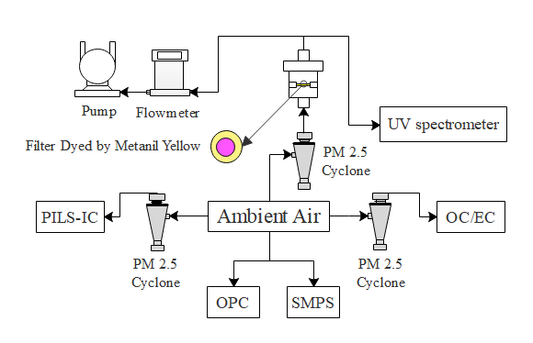
Figure S1. The experimental setup for the collection of ambient aerosols at the University of Florida, Gainesville, FL to measure aerosol acidity using the C-RUV method.
(a) (b)
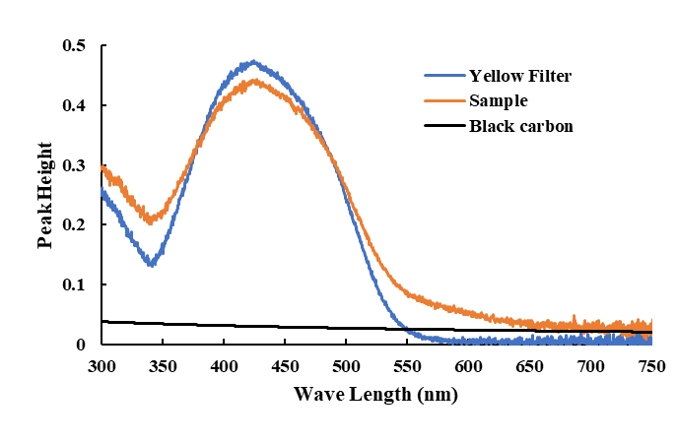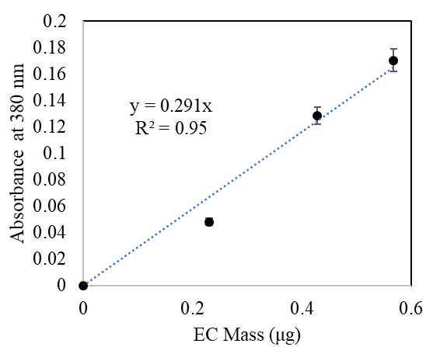

Figure S2. (a) Decoupling of the UV spectrum of the colorimetric filter sample into the black carbon spectrum and the aerosol spectrum associated with acidic aerosol. (b) The correlation between light absorption of EC at 380 nm vs. EC mass. The error associated with EC mass is 3% based on the company manual.

Section S2. Application of C-RUV calibration to the aerosol using inorganic thermodynamic models (E-AIM and ISORROPIA) for the Na(NH₄)_{x}H_{y}(SO₄)_{z} and Na_{z}H_{y}SO₄ (x+z=2) systems

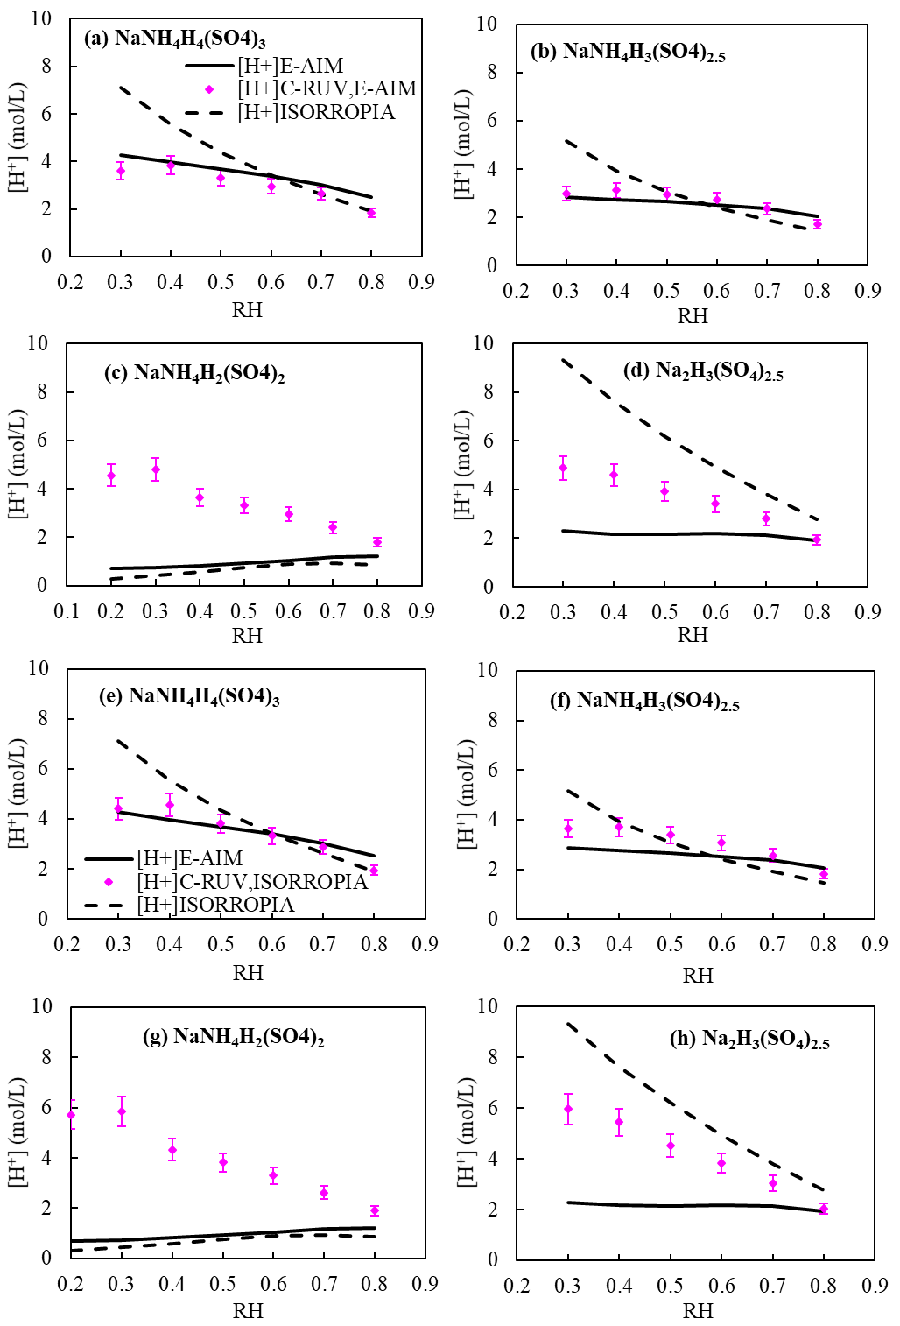
Figure S3. Comparison of [H⁺]_{C-RUV} with [H⁺]_{E-AIM} and [H⁺] _{ISORROPIA} to different compositions of Na⁺-NH₄⁺-SO₄²⁻-H₂O as a function of RH (a, b, c, and d use [H⁺]_{C-RUV,E-AIM}; e, f, g, and h use [H⁺]_{C-RUV,ISORROPIA}; Aerosol composition: Na(NH₄)_{x}H_{y}(SO₄)_{s}).

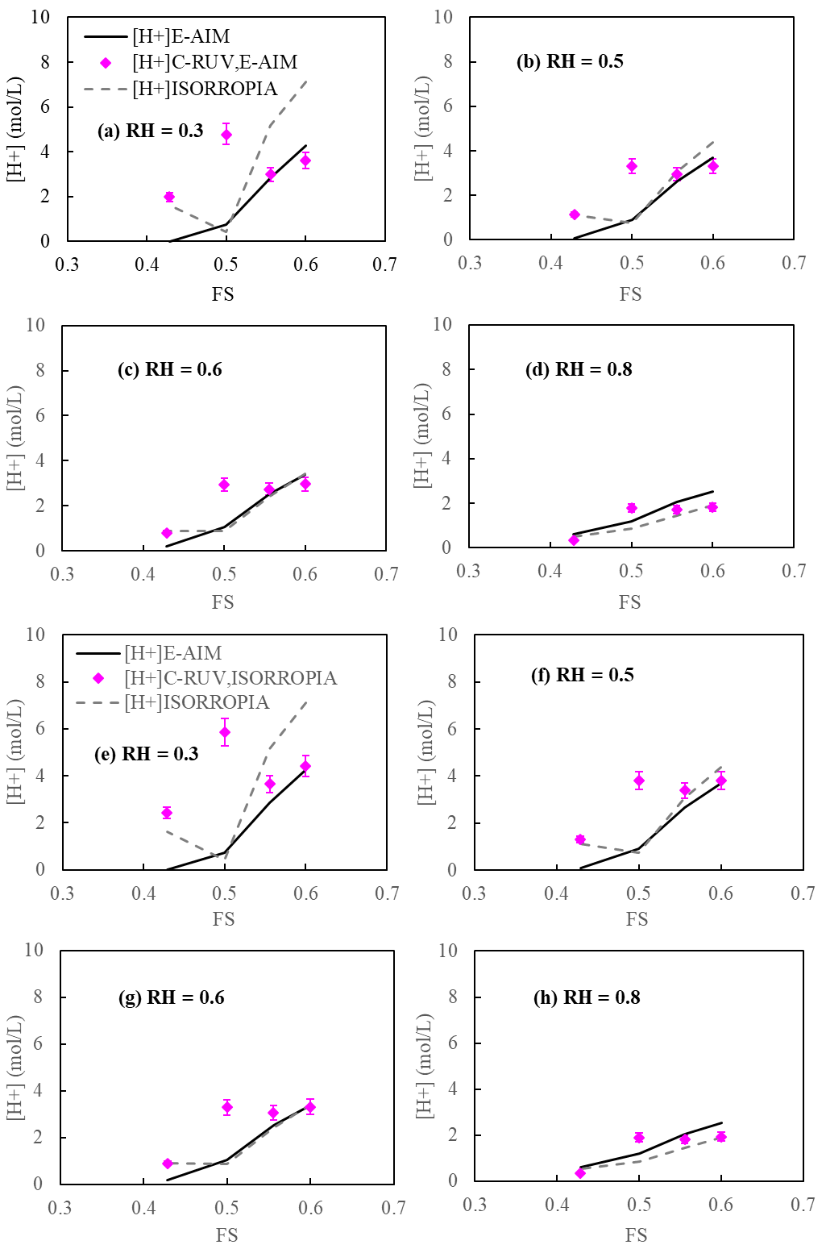

Figure S4. Comparison of [H⁺]_{C-RUV} with [H⁺]_{E-AIM} and [H⁺]_{ISORROPIA} under varying FS at a given RH (a-d use [H⁺]_{C-RUV,E-AIM}; e-h use [H⁺]_{C-RUV,ISORROPIA}; Aerosol composition: Na(NH₄)_{x}H_{y}(SO₄)_{s}) (1+x+y=2s).

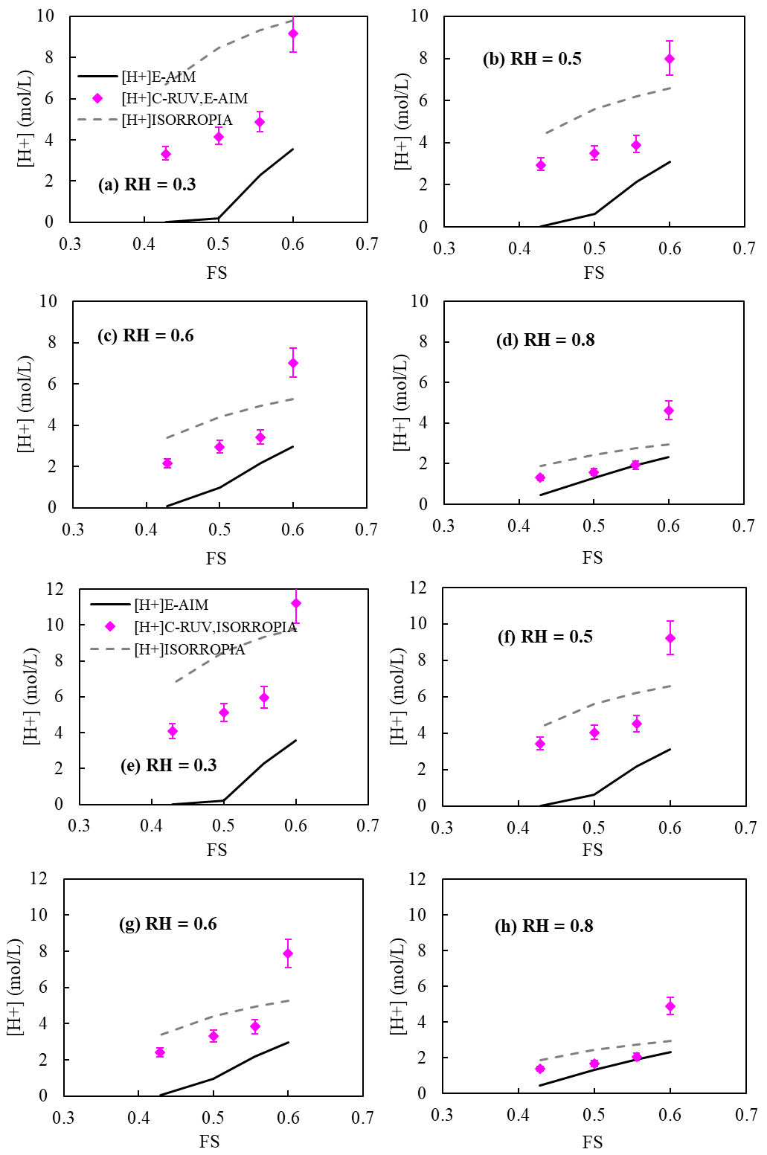
Figure S5. [H⁺]_{C-RUV} and their predicted proton concentrations with thermodynamic models [H⁺]_{E-AIM} and [H⁺]_{ISORROPIA} compared against FS at a given RH for the Na_{z}H_{y}SO₄ (y+z=2) system. a-d use [H⁺]_{C-RUV,EAIM}; e-h use [H⁺]_{C-RUV,ISORROPIA}.

Section S3. Ambient aerosol data collected at the sampling site located at the University of Florida, Gainesville, Florida
Decoupling of OC. Secondary organic carbon (OC_{sec}) concentration was calculated by multiplying the measured elementary carbon (EC) by the primary organic carbon (OCpri)/EC. The estimated error is ±15%. The OC_{sec} calculation technique has been described in a previous study (Cabada et al., 2004). The average ratio of primary OC to EC is 3.932, which was measured at the sampling site for this study between 2008 and 2019.

[H⁺]: For the particle samples classified as Class I and Class II, the proton concentration in particle samples was estimated using Eq. 10 based on the C-RUV measurement. In the wintertime, it is difficult to detect aerosol acidity using C-RUV due to low acidity levels. For the aerosol samples in Class III, which were collected in the wintertime, the proton concentration is estimated by applying PILS-IC data to Eq. 16. [H⁺] (mol/L) is estimated based on mol of H+ in inorganic salted aqueous phase, excluding diOS.

Diluted [H⁺]: For Class I and Class II, the proton concentration in particle samples was also estimated with the total inorganic aerosol volume sourced from the externally mixed aerosol which comprises the nitrated SSA and partially neutralized SSA with sulfate (Figure 6).

Ambient data: Class 1

Figure S6. Class 1-mixture of two types: aerosol with Na⁺-NO₃⁻ and aerosol with Na⁺- NH₄⁺-SO₄²⁻. The ambient aerosol was affected by sea salt aerosol (SSA).

- Time profile of the proton concentration ([H⁺]_{C-RUV,E-AIM}, Eq. 10 in main body) in the inorganic phase; the proton concentration estimated with the total aerosol mass (proton diluted); Organic Carbon (OC) (C-µg/m³); Secondary OC (Sec OC) which was decoupled from the total OC; sulfate ion concentrations (µmol/m³) in the aerosol sample; and dialkyl organosulfate (diOS) (µmol/m³).
- Time profiles of the diOS percent of the total sulfate
- Time profiles of inorganic ion concentrations (µmol/m³) measured with PILS-IC.
- Time profiles of gas concentrations (ppb) of NO_{x}, ozone (O₃), and SO₂.
- Time profiles of Temperature (T) and Relative Humidity (RH)

1-A. Ambient sample on 04/06/2018
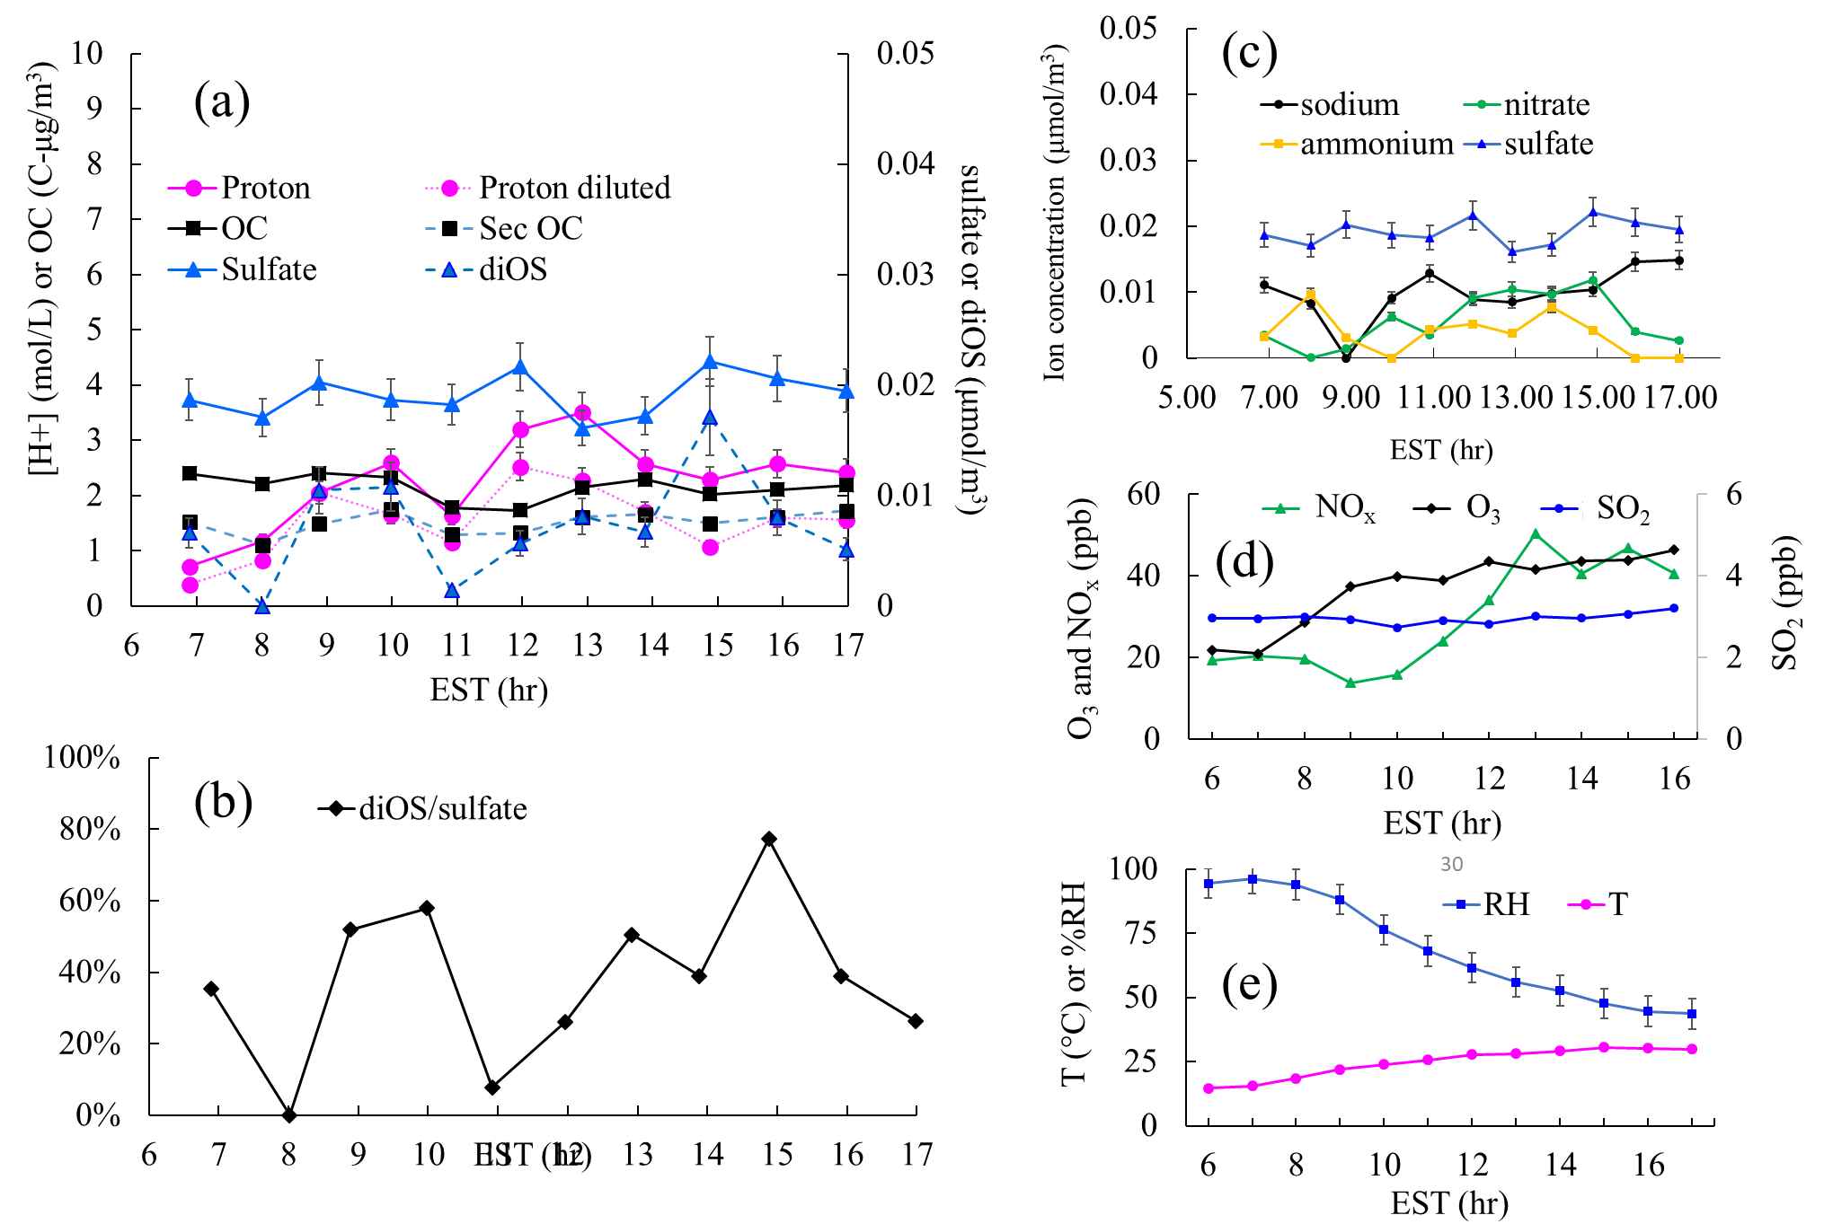

1-B. Ambient sample on 04/13/2018
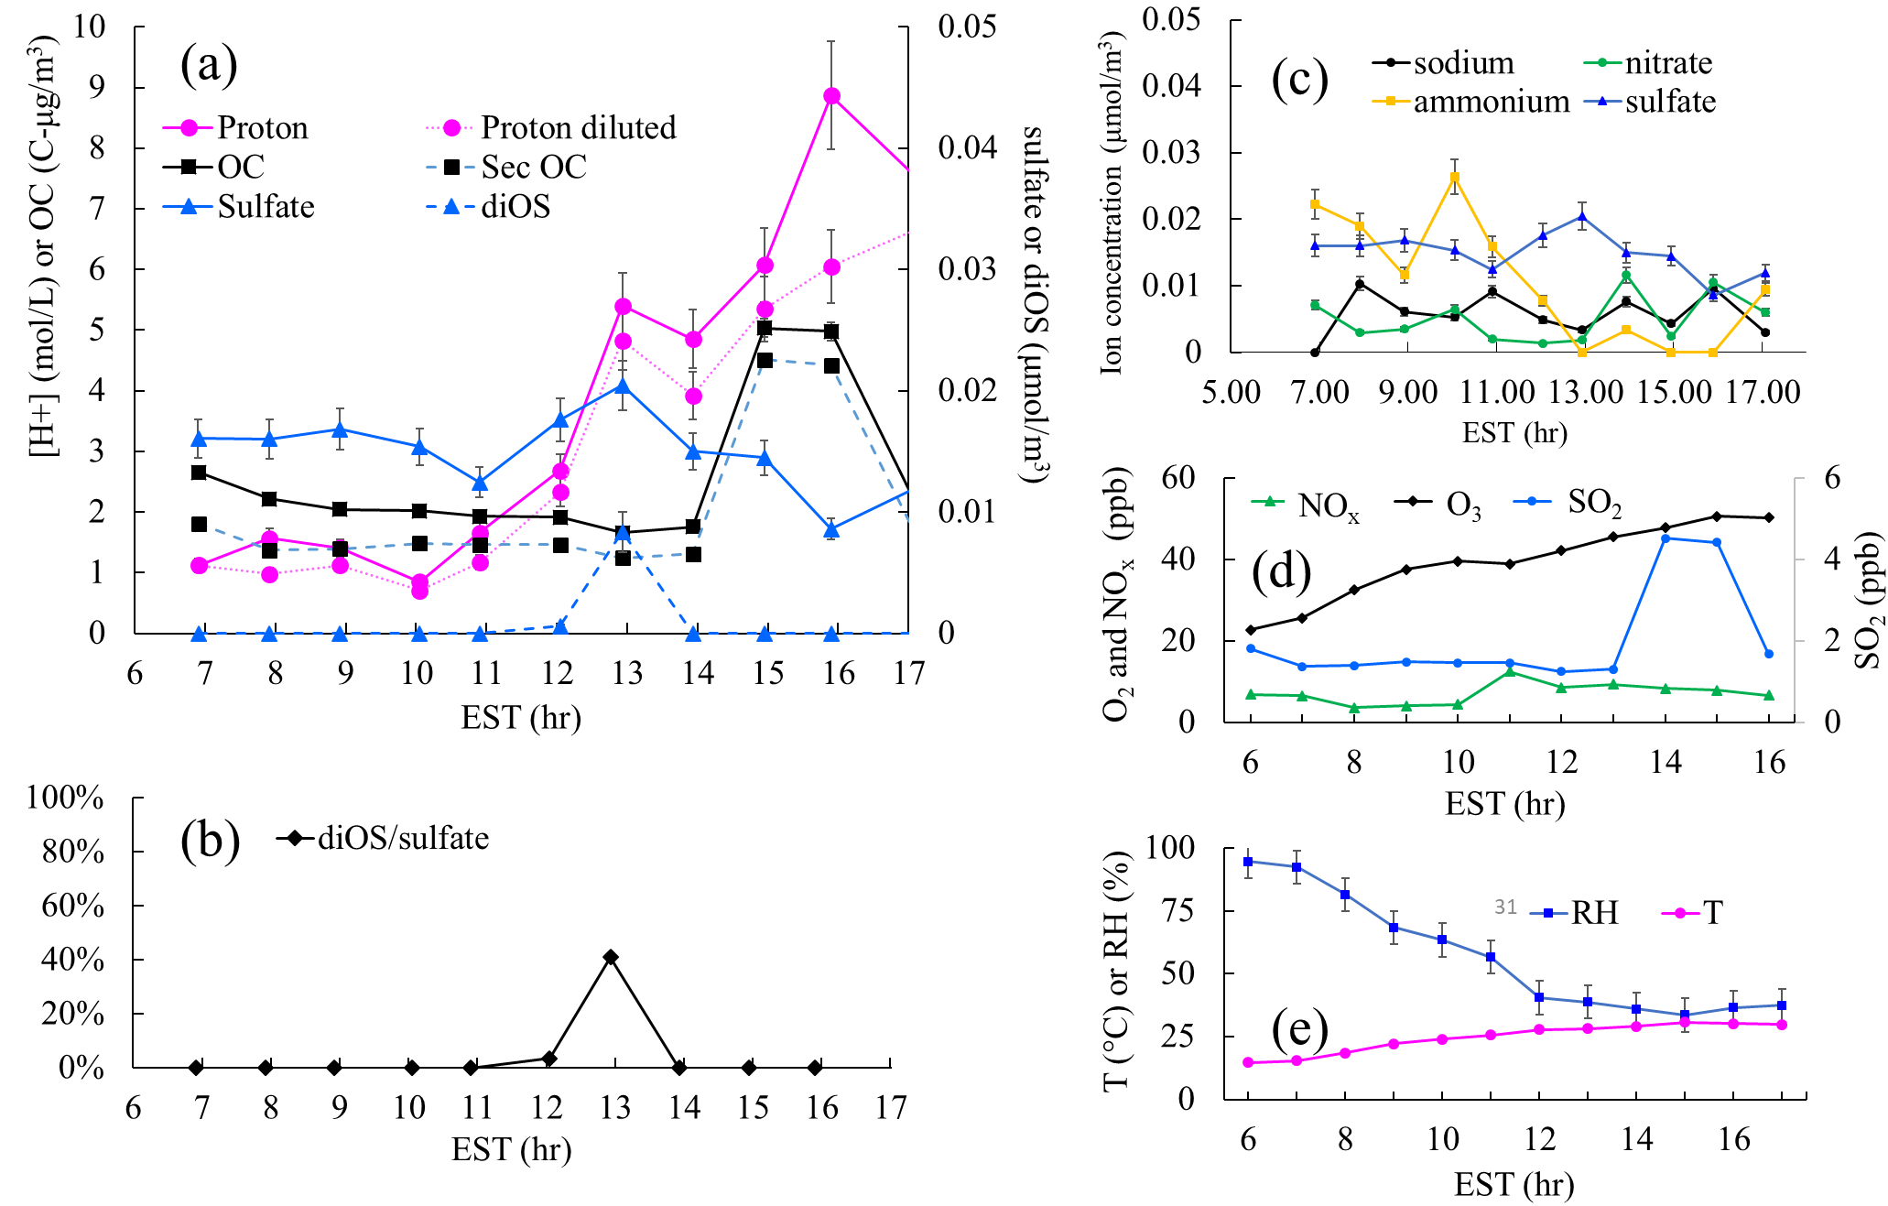
1-C. Ambient sample on 04/20/2018
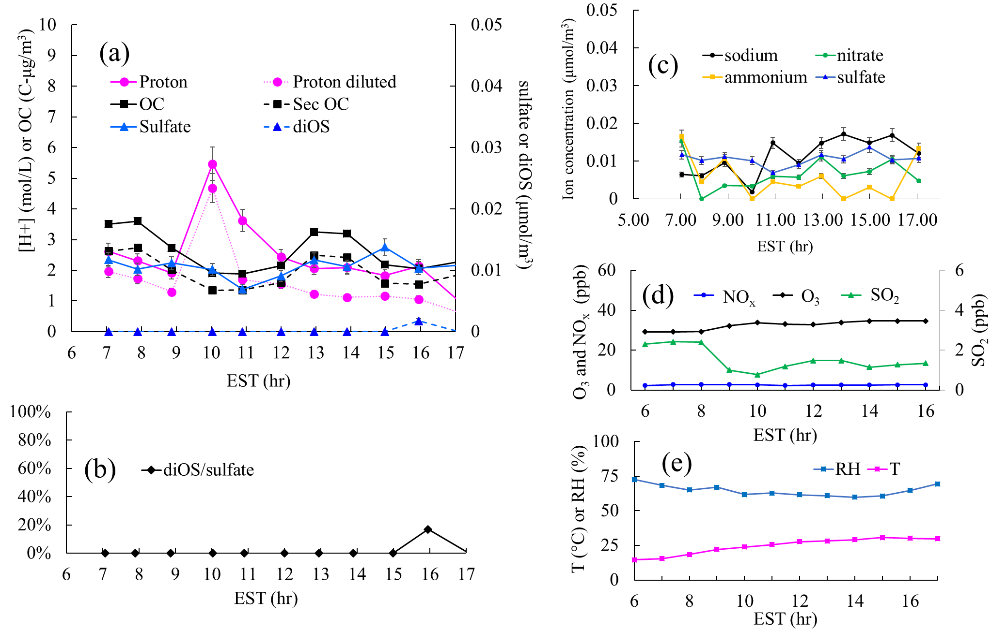

Ambient data: Class 2

Figure S7. Class 2 aerosol - the aerosol comprises Na⁺-NH₄⁺-SO₄²⁻. No nitrate appears but the aerosol is still affected by SSA.

- Time profile of the proton concentration ([H⁺]_{C-RUV,E-AIM}, Eq. 10 in main body) in the inorganic phase; the proton concentration estimated with the total aerosol mass (proton diluted); Organic Carbon (OC) (C-µg/m³); Secondary OC (Sec OC) which was decoupled from the total OC; sulfate ion concentrations (µmol/m³) in the aerosol sample; and dialkyl organosulfate (diOS) (µmol/m³).
- Time profiles of the diOS percent of the total sulfate
- Time profiles of inorganic ion concentrations (µmol/m³) measured with PILS-IC.
- Time profiles of gas concentrations (ppb) of NO_{x}, ozone (O₃), and SO₂.
- Time profiles of Temperature (T) and Relative Humidity (RH)

2-A. Ambient sample on 07/12/2018

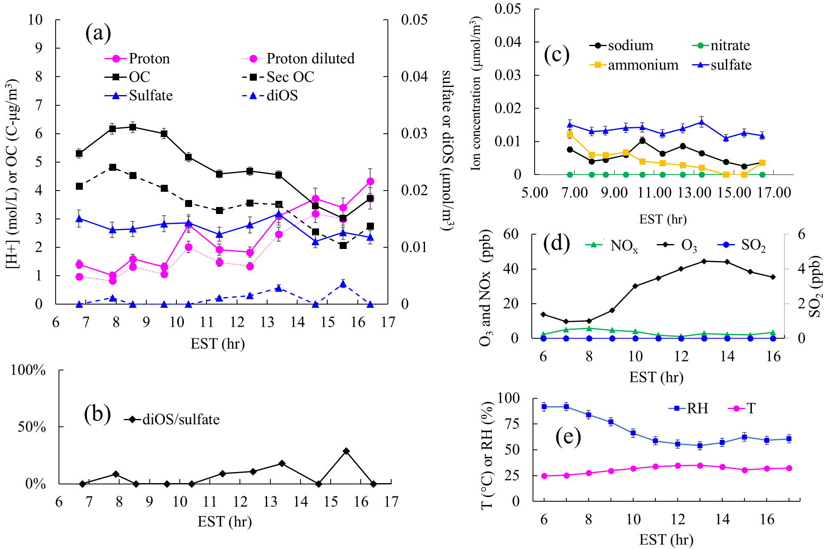

2-B. Ambient sample on 05/12/2018

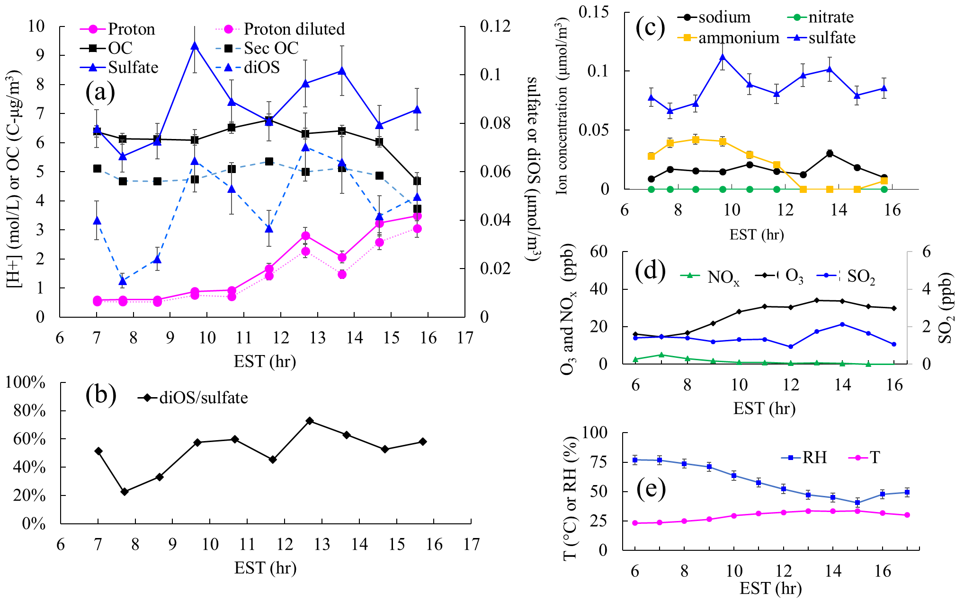

Ambient data: Class 3

Figure S8. Class III aerosol – the aerosol comprises NH₄⁺-SO₄²⁻- NO₃⁻. Nitrate appears in aerosol without being affected by SSA.

- Time profile of Organic Carbon (OC) (C-µg/m³); Secondary OC (Sec OC) which was decoupled from the total OC; and sulfate ion concentrations (µmol/m³) in the aerosol sample;
- Time profiles of the proton concentration ([H⁺]_{C-RUV,E-AIM}, Eq. 16 in main body) in the inorganic phase
- Time profiles of inorganic ion concentrations (µmol/m³) measured with PILS-IC.
- Time profiles of gas concentrations (ppb) of NO_{x}, ozone (O₃), and SO₂.
- Time profiles of Temperature (T) and Relative Humidity (RH)

3-A. Ambient sample on 11/28/2018

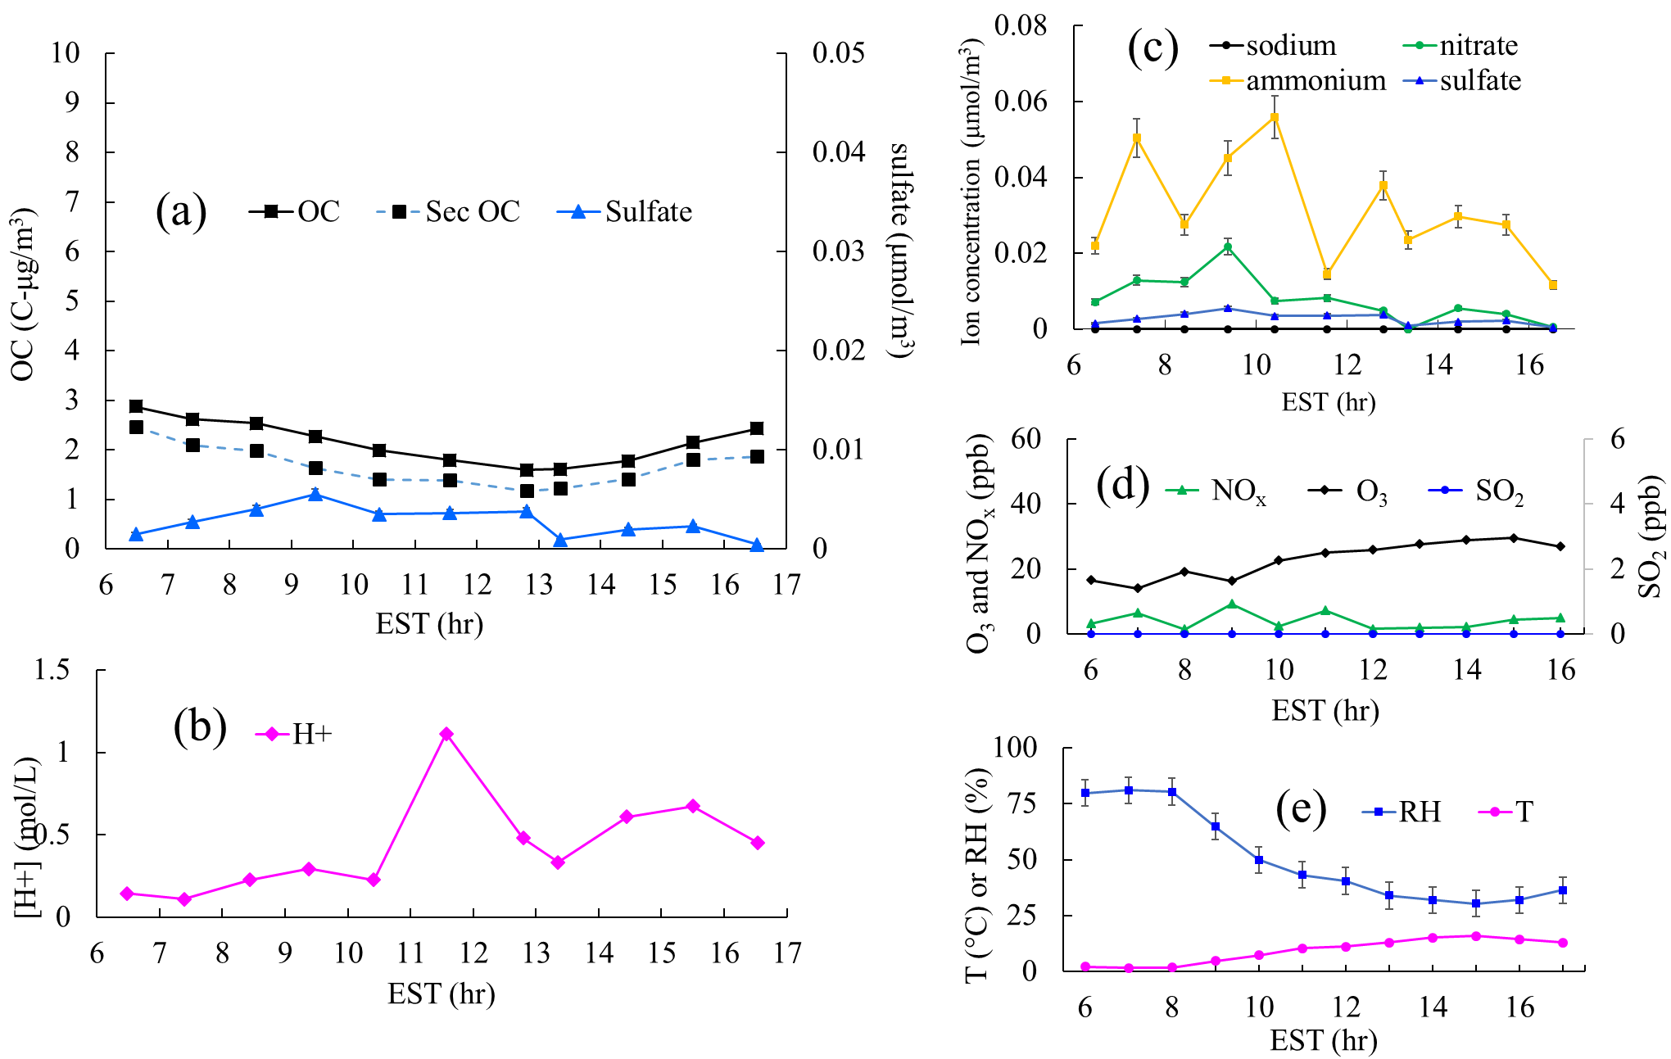

3-B. Ambient sample on 12/06/2018
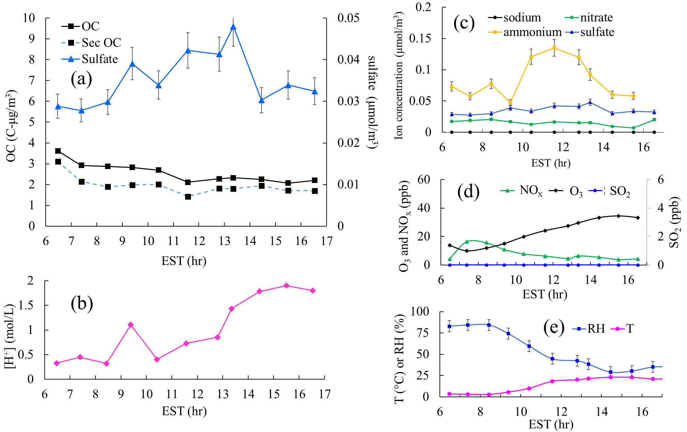

3-C. Ambient sample on 12/11/2018
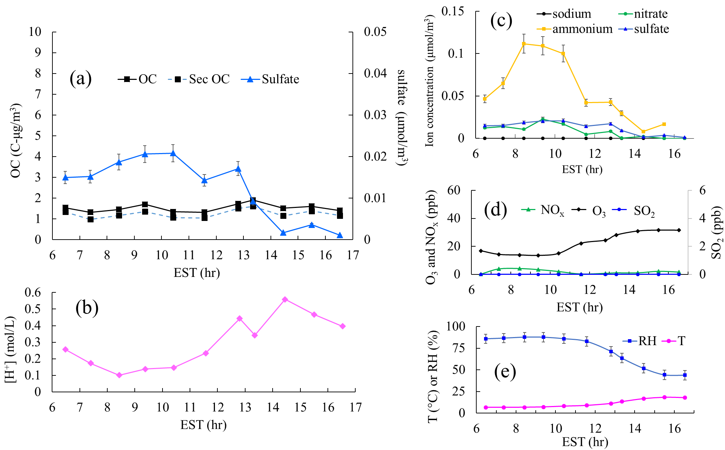

3-D. Ambient sample on 01/10/2019
