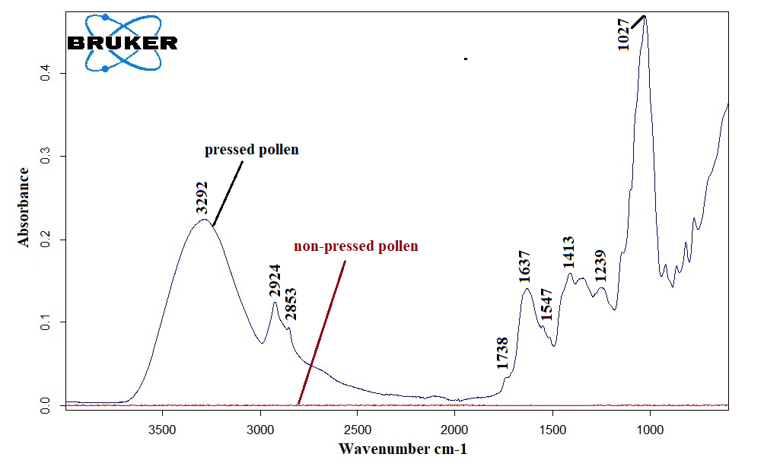

Figure S1 Comparison spectra of pressed pollen and non-pressed pollen on the diamond crystal of ATR accessory.

