Interpretation of Volatility Tandem Differential Mobility Analyzer (V-TDMA) Data for Accurate Vapor Pressure and Enthalpy Measurement: Operational Considerations, Multiple Charging, and Introduction to a New Analysis Program (TAO)

Christopher R. Oxford^{1,*}, Audrey J. Dang¹, Charles M. Rapp¹, and Brent J. Williams¹

¹ Department of Energy, Environmental, and Chemical Engineering, Washington University in St. Louis, St. Louis, Missouri 63130
* Corresponding Author

-- Supplemental Information --

- Graphical definitions
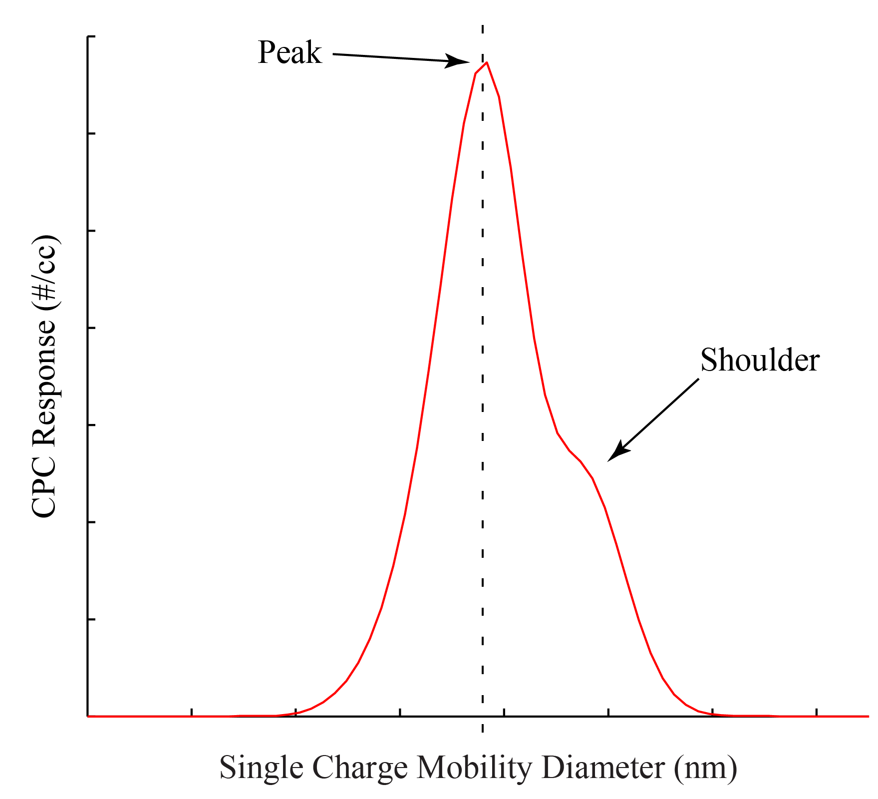
- Definitions of peak and shoulder
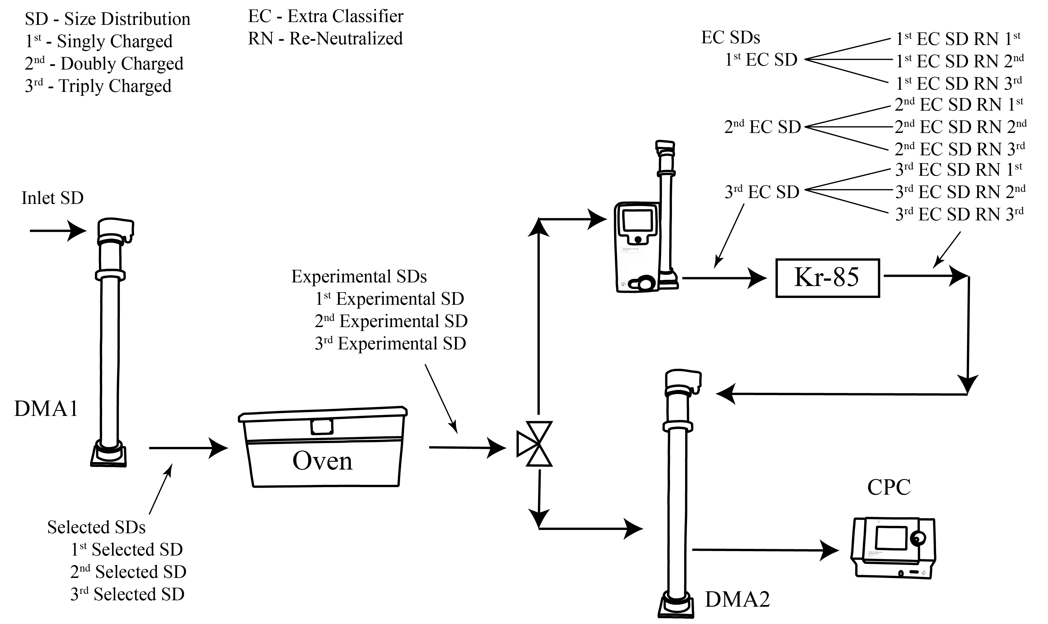
- Size distribution definitions and their locations

- Description of TAO
TAO requires input of the inlet size distribution, variables necessary to calculate the DMA1 transfer function, variables necessary to calculate the DMA2 transfer function, maximum number of charges to calculate, the recorded CPC response, and variables associated with the experiment. The user defines the resolution of the model. Throughout this paper, the bin size used is 0.25 nm. The user also defines the minimum population fraction of each individual charge (defined in DMA1 section below). We begin by defining the inlet size distribution, calculating the selected size distribution exiting DMA1, and integrating the CPC response. We will finish by defining the experimental evaporation model included in TAO.

  - Inlet size distribution
TAO requires a size distribution input in the form of a continuous log-normal size distribution. A mean, μ_{g}; standard deviation, σ_{g}; and total particle population, N_{p} are required inputs. Equation S1 displays the model used to generate the distribution (Friedlander 2000). Additional variables in Equation S1 are the input bin population, N; and the particle diameter, D_{p}. TAO separates the size distribution into equal bin widths specified by the user (as mentioned above). Once the input size distribution is fully defined, TAO converts the bin population to dN/dD by dividing the bin population by the bin diameter. TAO performs all further calculations in dN/dD space.
$$\frac{dN}{d\ln\left(D_{p}\right)}=\frac{N_{p}}{\sqrt{2π}\ln\left(σ_{g}\right)}\exp^{\left\{\frac{{-\left(\ln\left(D_{p}\right)-\ln\left(μ_{g}\right)\right)}^{2}}{2{\ln\left(σ_{g}\right)}^{2}}\right\}} (S1)$$

  - DMA1
To determine the selected size distribution exiting DMA1, TAO uses Equation S2 for each bin. In this equation, Ω_{nd} is the non-diffusing DMA transfer function, η is the charging fraction, N₁ is the DMA1 bin population, and the final term is from Equation S1. The subscript 1 denotes exiting DMA1. No DMA particle loss function or CPC counting fraction is used throughout. Equation S2 is evaluated for each size bin and for each charge. This method assumes that the DMA transfer function and the charging fraction are constant over each bin width for all bins and charges. The bipolar charging fraction used by TAO is defined by Wiedensohler. The first two charges are defined by the fitted algebraic expression (Wiedensohler 1988) while charges 3 through 10 are defined by the expression from Woessner and Gunn (1956). Coefficients for the algebraic expression are sourced from Baron (2001). For charges 3-10, the ratio of the electrical mobility of positive to negative ions is assumed to be 1.4/1.6 (Wiedensohler 1988).
$$\frac{dN_{1}}{dD_{p}}=Ω_{nd}*η*\frac{dN}{dD_{p}} (S2)$$

The non-diffusing transfer function (Stolzenburg and McMurry 2008) is shown as Equation S3 through S5. In Equation S3, ${\tilde{Z}}_{p}$ is the non-dimensional mobility. To calculate the non-dimensional mobility, expressions for the viscosity of air (Allen and Raabe 1985), Cunningham correction factor (Kim et al. 2005), and mean free path (Kim et al. 2005) are used along with the dimensions of a TSI-3081 long DMA. In Equation S4 and S5, Q_{s} is the classified aerosol flow rate, Q_{a} is the inlet aerosol flow, Q_{m} is the inlet sheath flow, and Q_{c} is the exit sheath flow. β and δ are non-dimensional DMA flows. The ideal shape of the non-diffusing transfer function is identified as a triangle. But for open flow sheath set-ups, the transfer function can easily assume a trapezoidal shape. TAO retains this capability using Equations S3 through S5.

$$Ω_{nd}=\frac{1}{2β\left(1-δ\right)}\left[\left|{\tilde{Z}}_{p}-\left(1+β\right)\right|+\left|{\tilde{Z}}_{p}-\left(1-β\right)\right|-\left|{\tilde{Z}}_{p}-\left(1+βδ\right)\right|-\left|{\tilde{Z}}_{p}-\left(1-βδ\right)\right|\right] (S3)$$
$$β=\frac{\left(Q_{s}+Q_{a}\right)}{\left(Q_{m}+Q_{c}\right)} (S4)$$
$$δ=\frac{\left(Q_{s}-Q_{a}\right)}{\left(Q_{s}+Q_{a}\right)} (S5)$$

The result of Equation S2 is an array, one for each charge, representing the selected size distributions. Since the bin width was determined by the user during calculation of the inlet size distribution, the bin width carries through because of Equation S2. To reduce calculation time, many charges are irrelevant for the solution. The maximum number of charges to carry is a required input and defines the total number of initial arrays. The user also enters the minimum population fraction for each charge. The DMA1 routine integrates each individual selected size distribution (1 for each charge) and sums the total to determine the total particle count. The subroutine tests to be sure all charges meet the minimum population fraction. If a charge does not meet the minimum requirement, the array is deleted. Therefore, if a user determines that the minimum population fraction is 0.01, for example, all charges that contribute less than 1 percent to the total particle population are deleted. This determines the number of charges carried through the remainder of the model.

  - DMA2 integration and CPC comparison
After calculating volatility, integration at DMA2 determines the modeled CPC response. This calculation is required for each entered DMA2 mobility. Since each experimental size distribution is treated as a sub-population, every experimental size distribution must undergo this integration individually. The total number of particles measured at that DMA2 mobility is a sum of all integrated populations (all charges). If particle losses are used, the routine assumes the final evaporated diameter to calculate the losses. This assumption will underestimate particle penetration.
Integration at each DMA2 mobility is performed using Equation S6. In Equation S6, Q_{a}, Q_{s}, D_{p}, and ${\tilde{Z}}_{p}$ are as previously defined. N_{exp} is the bin particle population after the experiment, N₂ is the particle population after DMA2, and ${\tilde{Z}}_{p,0,j}$ and ${\tilde{Z}}_{p,f,j}$ are the limits of the charge sub-population, j. The value of the derivative is calculated using Equations S7 and S8. In Equation S7, μ is the viscosity of air, ${\tilde{Z}}_{p}$ is the DMA2 non-dimensional mobility, Z_{p}* is the centroid mobility, j is the charge number, e is the charge of an electron, and C is the Cunningham correction factor. In Equation S8, λ_{air} is the mean free path in air; and A₁, A₂, and A₃ are the constants in the Cunningham correction factor equation (Kim et al. 2005). Due to the binning, the integral in Equation S6 is performed using MATLAB’s trapezoidal rule.
$$N_{2}=\sum_{j=1}^{nc}{\frac{Q_{a}}{Q_{s}}\int_{{\tilde{Z}}_{p,0,j}}^{{\tilde{Z}}_{p,f,j}}{Ω_{nd}\frac{dN_{exp,j}}{d\left(D_{p}\right)}\frac{d\left(D_{p}\right)}{d{\tilde{Z}}_{p}}d{\tilde{Z}}_{p}}} (S6)$$
$$\frac{d\left(D_{p}\right)}{d{\tilde{Z}}_{p}}=\frac{3πμZ_{p}^{*}}{je}\left[\frac{{\left(D_{p}\right)}^{2}}{D_{p}\frac{dC}{d\left(D_{p}\right)}-C}\right] (S7)$$
$$\frac{dC}{d\left(D_{p}\right)}=-\frac{2λ_{air}A_{1}}{{\left(D_{p}\right)}^{2}}-\frac{2λ_{air}A_{2}}{{\left(D_{p}\right)}^{2}}\exp^{\left(-\frac{A_{3}D_{p}}{2λ_{air}}\right)}-\frac{A_{3}A_{2}}{d_{p}}\exp^{\left(-\frac{A_{3}D_{p}}{2λ_{air}}\right)} (S8)$$

  - Volatility
The selected size distribution tables (one for each charge) are the input to the experimental routines. The main routine queries the user for estimates of vapor pressure, surface tension, and accommodation coefficient. These values are placed within each selected size distribution table (one table for each charge). Therefore, the contents of each table are the bin diameter, the mobility, the population in dN/dD_{p}, the vapor pressure, surface tension, and accommodation coefficient. The experimental subroutine must accept this data format for calculation and must return the experimental size distribution in the same format. The volatility calculation creates many temporary size distributions as we will see. The combination of the number of temporary size distributions and return data format requires a data reduction routine.
The experimental subroutine first converts the selected size distribution from dN/dD_{p} to absolute particle counts. TAO moves from the smallest diameter to the largest, and each bin diameter is used as limits in an integral by trapezoidal rule. This integrated absolute particle count is then assigned to a new bin diameter that is assumed as the midpoint between the two previous bin diameters. For example, we assume two subsequent bins of 150 nm and 152 nm. The 150 nm bin has a size distribution of 100 #/cc/nm, and the 152 nm bin has a size distribution of 110 #/cc/nm. The new bin would have a size of 151 nm with an absolute population of 210 #/cc. The smallest bin and the largest bin are assumed to have a particle count of zero. This method will result with one more bin than the original count of selected size distribution bins.
Then the volatility routine uses Equations S9, S10, and S11 to model the evaporation of the selected size distribution (Bilde et al. 2003). Particle diameter is D_{p} (0 and f subscripts are initial and final respectively), F is the transition regime correction factor, Kn_{i} is the Knudsen number of gas species i, α_{i} is the accommodation coefficient for gas species i, σ_{i} is the surface tension, M_{i} is the molecular weight of species i, R is the gas constant, T is the temperature of the oven, ρ_{i} is the density of the condensed phase, P* is the vapor pressure of species i, t’ is time, D_{i,air} is the diffusivity of species i in air, and λ_{i} is the mean free path of species i. The Knudsen number is calculated by dividing 2 times the mean free path of species i by the diameter of the particle. The mean free path of species i is calculated by Equation S11.
There is not a single characteristic residence time but a distribution of residence times in the oven (see Supplemental Information S3). Particles on the centerline of the tube will have a different residence time than those near the wall. Thus, fluid flow creates a distribution of residence times, and the distribution must be measured and entered as a discrete table. The format of the residence time distribution should be a vertical two column array of time and the cumulative distribution response (fcurve) associated with that time. For each selected size distribution bin, Equations S9 through S11 are used along with the residence time distribution to model the evaporation of the particles. The output from this step is a set of experimental size distributions: one size distribution (temporary table) for each residence time entry.

$$\int_{D_{p,0}}^{D_{p,f}}{\frac{D_{p}}{F\left({Kn}_{i},α_{i}\right)}\exp^{\left(\frac{4σ_{i}M_{i}}{RTρ_{i}D_{p}}\right)}dD_{p}}=-\frac{4D_{i,air}M_{i}P^{*}∆t^{'}}{ρ_{i}RT} (S9)$$
$$F\left({Kn}_{i},α_{i}\right)=\frac{1+{Kn}_{i}}{1+0.3773{Kn}_{i}+\frac{1.33{Kn}_{i}\left(1+{Kn}_{i}\right)}{α_{i}}} (S10)$$
$$λ_{i}=\frac{3D_{i,air}}{\sqrt{\frac{8RT}{πM_{i}}}} (S11)$$
The experimental routine then returns the absolute particle count back to the originally specified bin widths with particle populations specified in dN/dD_{p}. The program begins this process by creating a cumulative size distribution by progressively summing the particles in each bin for all temporary tables. Then dN/dD_{p} is calculated assuming linearity between bins. The routine creates the final experimental table containing bins spaced as specified by user settings at the beginning of the program. For each bin in the final experimental table, each temporary table is integrated using the experimental bins as limits and summed across all temporary tables. This places the total absolute particle numbers in each experimental bin. Then the routine creates the cumulative distribution and calculates the dN/dD_{p} for the experimental table. After all calculations, the routine conserves the total number of particles in the distribution to well within 1%.
This choice of accounting method has two benefits with several limitations. The first benefit is bins move as individuals and move relative to one another. This movement has two limits. First, the bins must change size. Second, each bin cannot pass over its neighbors. For example, the final diameter of the 152 nm bin cannot be smaller than the final diameter of the neighboring 150 nm bin. Thus, the experimental response can assume any shape as defined by the experimental model. The second benefit is the experimental routine can model the evaporation of each bin using the residence time distribution. This is a requirement of volatility due to the discrete residence time distribution.

- Residence time distribution calculation, measurement, and error
In the oven, a single residence time does not exist. If we assume that flow is laminar inside the tubing, a particle passing through the oven while traveling along the tubing centerline has a shorter residence time than a particle traveling along the wall. A distribution of residence times exists in the oven due to the velocity distribution inside the tubing. TAO uses a discrete table of residence times as a function of number fraction (e.g. 1/10th of the particles by number pass through the oven at 26.5 seconds). This supplemental section documents the methods used to recover the residence time distribution of our oven.
To determine the residence time distribution in the oven, 0.2 g Ammonium Sulfate (Sigma Aldrich A4915) in 18 MΩ deionized water was atomized and dried by a silica drier. After the first Differential Mobility Analyzer (DMA1), a bypass line directly connecting the entrance to the exit of the oven was selected by a manual three-way ball valve. The average residence time in the bypass line was significantly smaller than the residence time in the oven. By comparing the time required for the particles to pass through the V-TDMA, using the bypass line, to the time required for the particles to pass through the V-TDMA, using the oven; we can extract the oven residence time distribution.
To do this, we confirmed the first differential mobility analyzer (DMA1) was aligned with DMA2 at 100 nm, and the bypass line was selected by the three-way valve. Then the voltage at DMA1 was set to zero volts. At t=0, DMA1 voltage is returned to alignment with DMA2. At t=2 s (5 s for the 0.4 LPM case), DMA1 voltage is set to 9,500 V, which was well outside the detectible range of DMA2. Each step up in voltage is near instantaneous. The particle count (#/cc) was recorded as a function of time. The temporal resolution (Δt) of the response was 0.5 s throughout (e.g. a CPC measurement every 0.5 s). This procedure was repeated 20 times (25 times for 0.4 LPM) for the bypass line. We then averaged the 20 (or 25) measurements to obtain the average response. This average response is the sum of the time to traverse DMA1, the time from DMA1 to the oven, the time from the oven to DMA2, the time to traverse DMA2, and the time to be detected by the Condensation Particle Counter (CPC). This residence time distribution is denoted by C_{in}. Once C_{in} was measured, the three-way valve selected the oven and the procedure was repeated. The second response represents the first response plus the time in the oven. This response is denoted by C_{out}. Diameters of 50 nm and 200 nm were also investigated during the experiment. These diameters did not vary significantly from the 100 nm shown below.

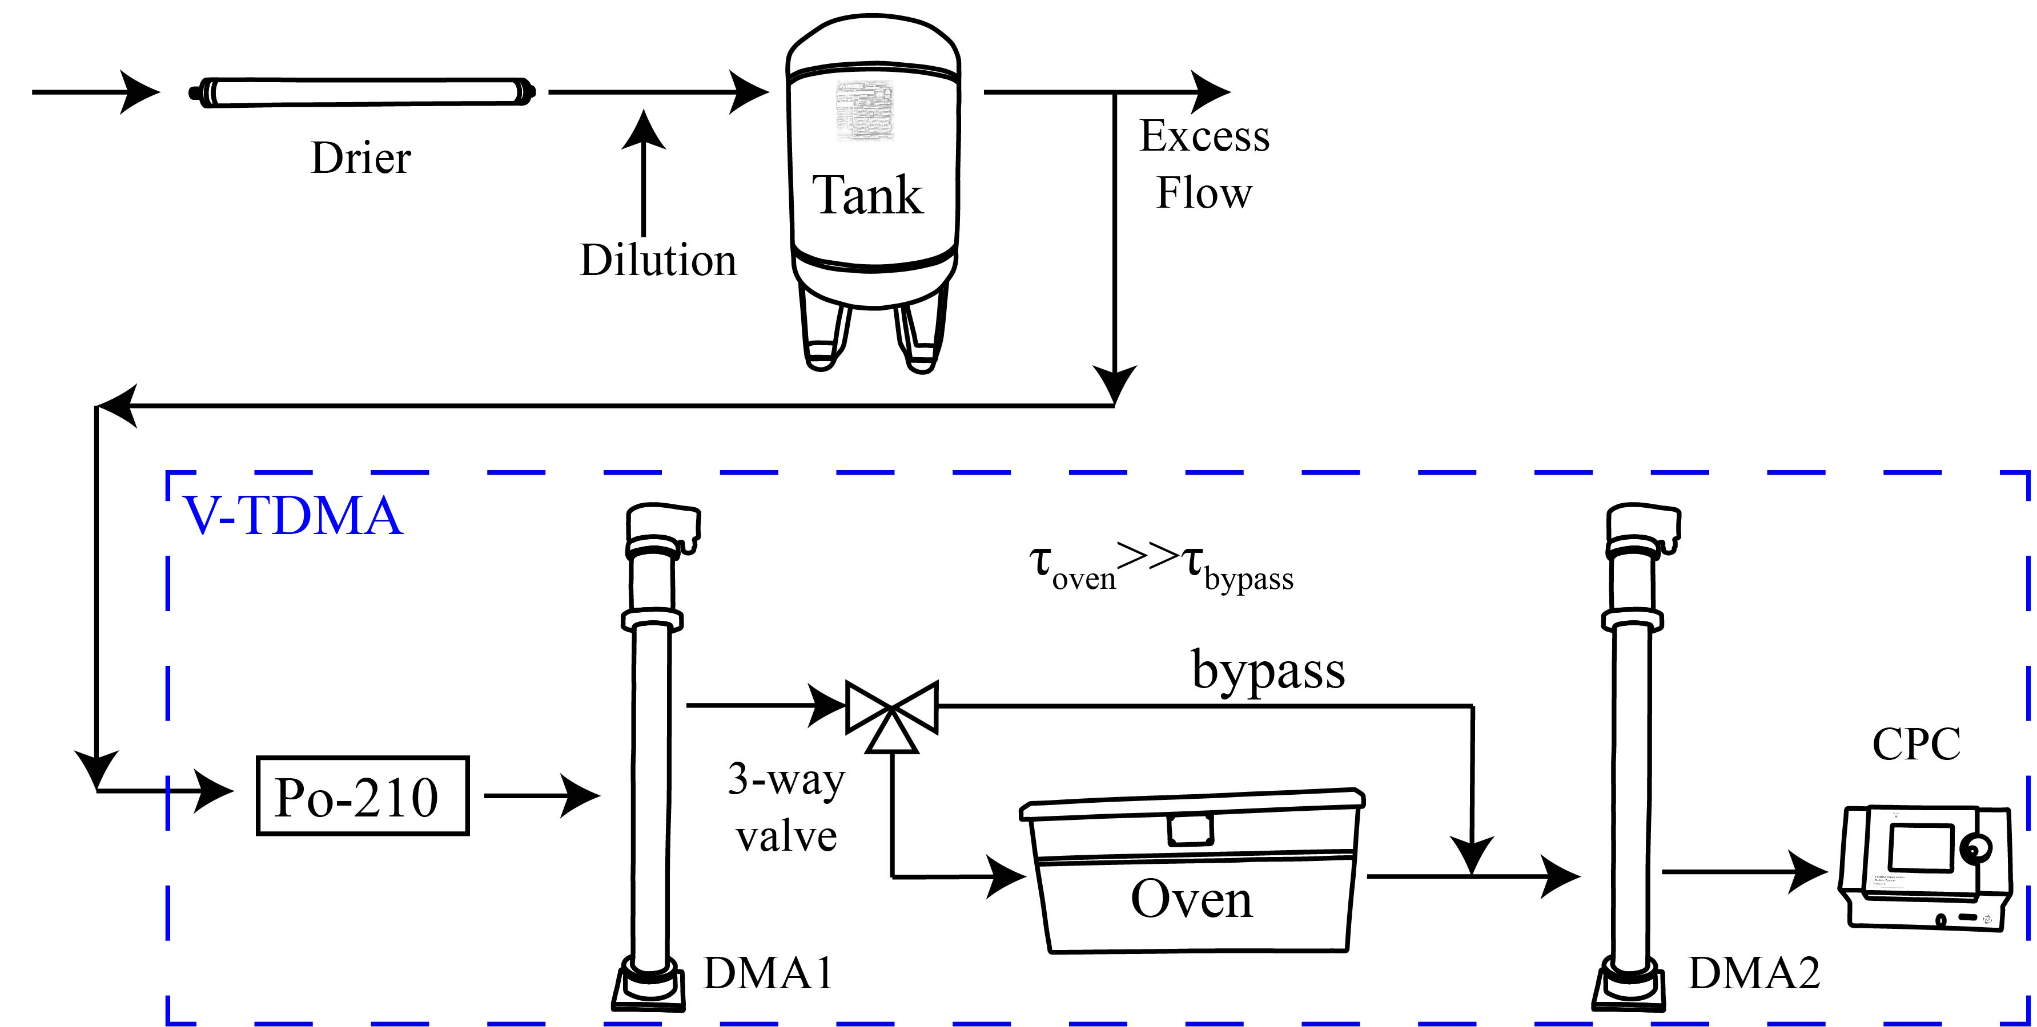
- Apparatus used to measure the oven residence time. The average residence time in the bypass line is significantly shorter than the average residence time in the oven.

The residence time distribution (RTD) in the oven can be determined by deconvolution (Levenspiel 1999) of the response. The entire TDMA system can be visualized as all the support tubing, DMA1, DMA2, and CPC preceding the oven (C_{in}). Then, Equation S1 represents the convolution of E, the fraction of number in oven at any time t´, with C_{in}, the concentration entering the oven at time t-t´. Two measured responses, one for all supporting equipment (C_{in}) and one for the supporting equipment and the oven (C_{out}), are required for deconvolution. E is the residence time distribution (ecurve) in the oven. In Equation S12, t is the time at exit of the oven, and t´ is the residence time in the oven (or time at the entrance of the oven).
$$C_{out}\left(t\right)=\sum{E\left(t^{'}\right)*C_{in}\left(t-t^{'}\right)△t} (S12)$$

Our deconvolution routine assumes an n number of summed beta distributions represent the ecurve. The computer iterates the values describing the beta distributions until the sum of the square of the errors in C_{out} is minimized. We used the minimum number of beta distributions required to explain the phenomena. For the two cases examined in this paper (one in this section and one further below), only a single beta distribution was necessary to explain the observations.
Figure S4 displays the results of the deconvolution at 1.5 LPM. The x-axis is the time, t, from the beginning of the DMA alignment. The y-axis is the E value. This value is the fraction of particles emitted at time t divided by the total number of particles. The blue curve is the time for the particles to navigate the TDMA system without the oven; the red curve is the time for the particles to navigate the entire TDMA system. The cyan curve is the time required for the particles to navigate the oven. This measurement was performed at a flow rate of 1.5 LPM and room temperature with 100 nm particles. Since E is divided by the total particle count, the area under each curve is equal to 1.

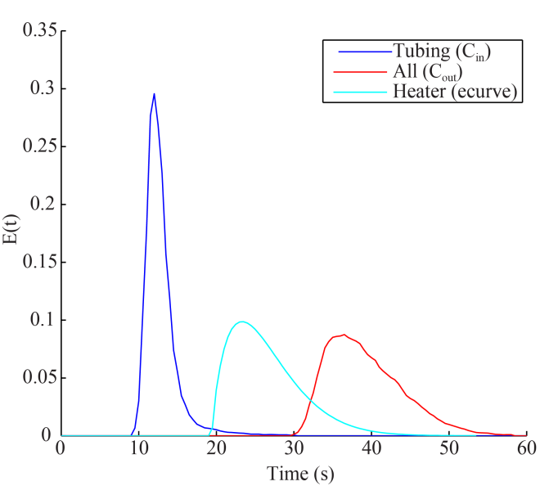
- The response from the oven residence time experiment. The blue curve represents C_{in}, the red curve represents C_{out}, and the cyan curve is the solved residence time distribution (ecurve).

The ecurve is converted to the fcurve: an integration of the ecurve. This area can be visualized as a progressive sum in time as shown in Figure S5. This fcurve is loaded into TAO. When the temperature in the oven is elevated, the gas inside the tubing expands, decreasing the residence time distribution. TAO uses the fcurve to estimate this phenomenon. We assume ideal gas law and scale the x-axis by the ratio of the room temperature divided by the oven temperature. In addition to assuming ideal gas law, this method assumes that the tubing dimensions remain constant for the different temperatures. Once a new fcurve is calculated, the new ecurve is calculated from the resulting temperature adjusted fcurve. An ecurve was also measured at 52 °C and found to correlate well with this estimation.

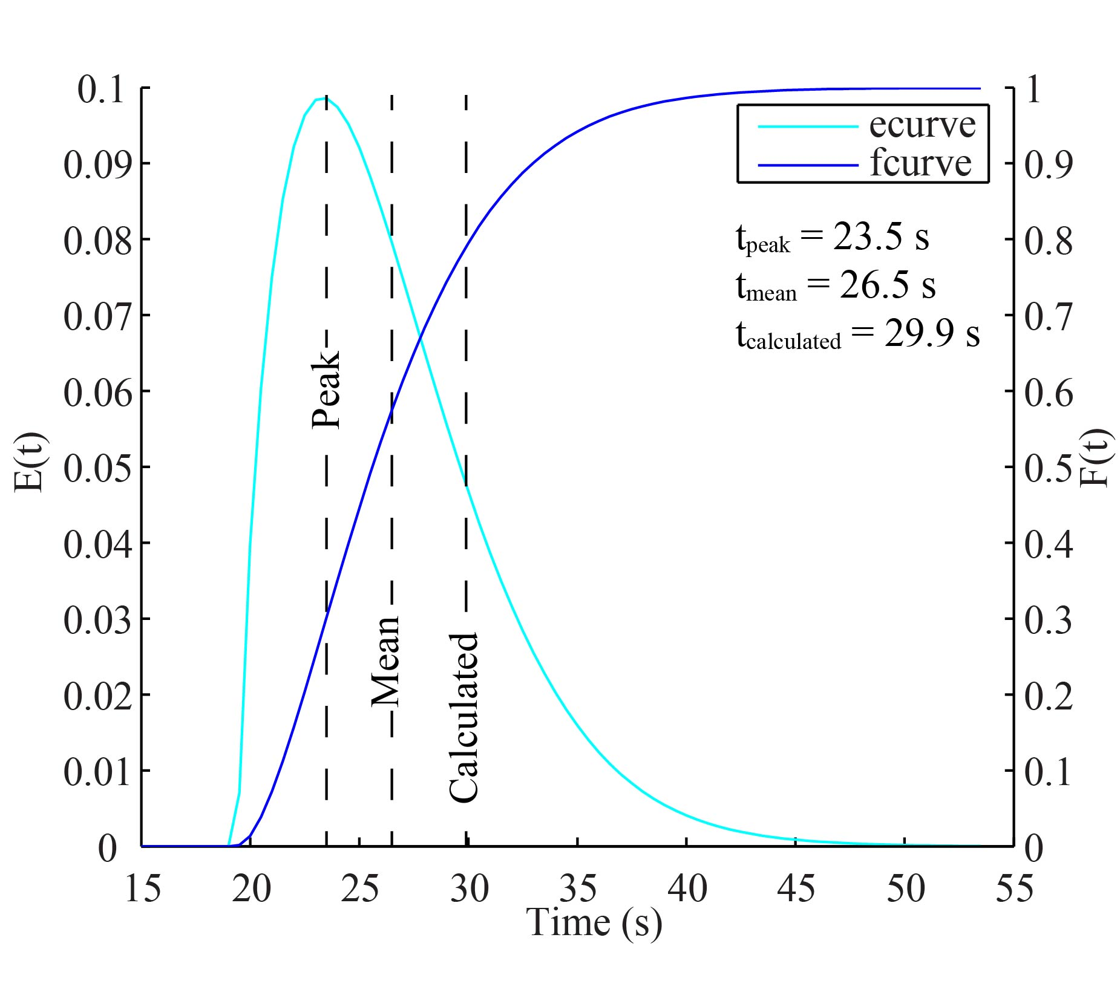
- The measured ecurve and the corresponding fcurve. The primary y-axis is the e value and the secondary y-axis is the f value. Three vertical lines denote the time at peak, the mean time, and the calculated time. The time at peak is the location of the peak of the ecurve. The mean time is the first moment of the ecurve. The calculated time is the calculated mean residence time based on the advertised inside diameter of the copper tubing.

Assuming an average residence time based on an advertised diameter can lead to large errors. The advertised tubing inside diameter was 0.79 cm. For a 1.5 LPM flow rate, the calculated mean residence time in the oven is 29.9 seconds for the 15.25 m length. The actual mean residence time (first moment of the ecurve) was 26.5 seconds. The difference in these times is 3.4 seconds, but neither measurement should be used to calculate vapor pressure. To calculate the vapor pressure of a pure component, the peak of the response should be used. The time corresponding with the peak of the DMA2 response correlates with the peak of the ecurve. This time is 23.5 seconds. If we had assumed the advertised diameter, an error of nearly 30 % would occur when calculating vapor pressure. This difference underscores the importance of not only deconvoluting the actual ecurve, but also determining the peak (not just the mean) of the residence time distribution. Even the peak time does not guarantee accurate results. See Supplemental Information S6.

- Derivation of Equation 3
Two versions of Equation 2 are used in the derivation of Equation 3. The first version is written for a singly charged particle and the second version for a doubly charged particle. Since all charges pass through the oven and DMAs under the same conditions, the constants cancel. This ratio results in Equation S13. In Equation S13, D_{p} is the particle diameter, and the subscript 1 is the singly charged particle and the subscript 2 is the doubly charged particle. The surface tension is σ_{i}, the molecular weight is M_{i}, R is the gas constant, T is the temperature, and ρ_{i} is the particle density. F is the ratio of the flux in the transitional regime divided by the flux in the continuous regime. Kn_{i} is the Knudsen number, and α_{i} is the mass accommodation coefficient. Use of Equation S13 will determine the rate of evaporation of the singly charged particle divided by the rate of evaporation of the doubly charged particle. This formula must be corrected so that the doubly charged particle is expressed in first charge diameter space.
$$\frac{dD_{p,1}}{dD_{p,2}}=\frac{\left(D_{p,2}\right)}{\left(D_{p,1}\right)}\frac{\exp^{\left(\frac{4σ_{i}M_{i}}{RTρ_{i}D_{p,1}}\right)}}{\exp^{\left(\frac{4σ_{i}M_{i}}{RTρ_{i}D_{p,2}}\right)}} \frac{F\left({Kn}_{i,1},α_{i,1}\right)}{F\left({Kn}_{i,2},α_{i,2}\right)} (S13)$$
Equation 1 is used to convert the doubly charged particle to first charge diameter space. This conversion is done by first equating the mobility of the doubly charged particle to a particle with the same mobility in single charge diameter space. This equality is shown as Equation S14. In Equation S14, Z is the mobility, and the subscript 2-1 is a singly charged particle with the same mobility as the doubly charged particle. The remaining variables are as previously defined. All constants exist on both sides of Equation S14 and can be removed. Once removed, the derivative of S14 can be performed implicitly. This results in Equation S15. All variables have been previously defined. The derivatives dC/dD_{p} can be calculated using Equation S8. Equation S15 is then multiplied into both sides of Equation S13. This results in Equation 3.
$$Z_{2}=\frac{2eC\left(D_{p,2}\right)}{3πμD_{p,2}}=\frac{eC\left(D_{p,2-1}\right)}{3πμD_{p,2-1}}=Z_{2-1} (S14)$$
$$\frac{dD_{p,2}}{dD_{p,2-1}}=\frac{D_{p,2}^{2}}{D_{p,2-1}^{2}}\frac{D_{p,2-1}\frac{dC_{2-1}}{dD_{p,2-1}}-C_{2-1}}{D_{p,2}\frac{dC_{2}}{dD_{p,2}}-C_{2}} (S15)$$
Equation 3 can be expressed in another form by reducing the Kelvin effect ratio (the β ratio). The surface tension, molecular weight, gas constant, particle density, and temperature are constants, and the Kelvin effect can be expressed as an exponential function of diameter raised to the power of the constants. The same constants occur in both the numerator and denominator, and therefore, the entire ratio can be raised to a single exponent containing all the component specific constants. This result is shown as equation S16. Although the β ratio is component specific, the component serves to augment the separation, not prevent the separation of the charges. The β ratio will always have a value greater than one. The derivative shown on the left side of Equation S16 will be named the evaporation rate ratio.
$$\frac{dD_{p,1}}{dD_{p,2-1}}={\left[\frac{\left(D_{p,2}\right)}{\left(D_{p,1}\right)}\right]}_{α}{{\left[\frac{\exp^{\left(\frac{1}{D_{p,1}}\right)}}{\exp^{\left(\frac{1}{D_{p,2}}\right)}}\right]}_{β}}^{\frac{4σ_{i}M_{i}}{RTρ_{i}}}{\left[\frac{F\left({Kn}_{i,1},α_{i,1}\right)}{F\left({Kn}_{i,2},α_{i,2}\right)}\right]}_{γ}{\left[\frac{dD_{p,2}}{dD_{p,2-1}}\right]}_{δ} (S16)$$

- Behavior of the ratios
Using the rate of evaporation of the aerosol in single charge diameter space to determine charge separation is complex. Several factors work together to determine charge separation. These include the ratios above, the width of the DMA1 and DMA2 transfer function, and the size of the aerosol particle at time of measurement and at initial sampling. To estimate the separation process, we assume the form in S16. In general, the numerator, on the left side of the S16 equality, can be viewed as a delta in diameter instead of a derivative. For example, if the first charge particle changed diameter by 50 nm, the ratio can be used to estimate the change in the second charge diameter in first charge diameter space. When reading the following passage keep this estimation method in mind.
The product of the α ratio and the γ ratio is constant and near one. The α ratio is significantly larger than one, and the γ ratio is significantly less than one as shown by Equation 4. The result of the product of the α and γ ratio in Equation 4 is 1.1, which is greater than one. Figure S6 panel (a) displays the evaporation of a 90 nm levoglucosan particle to a final diameter of 5 nm. The blue lines represent the α ratio and the green lines represent the γ ratio. The blue green lines display the product of the two ratios. During evaporation of a 90 nm particle of levoglucosan, this ratio changes very little. Reducing the mass accommodation has little impact on this conclusion. During evaporation, the ratio remains at the beginning value. If we view the α-γ ratio as a function of beginning diameter, the ratio is always greater than one. This product is shown in Figure S6 panel (b). The product approaches 1 as the initial diameter approaches zero and accommodation only causes the product to approach a value of one. From this analysis, we conclude that the product of these two ratios is stable during evaporation and always larger than one. For this reason, all further comparisons use the product of the α and γ ratios to simplify the comparisons.

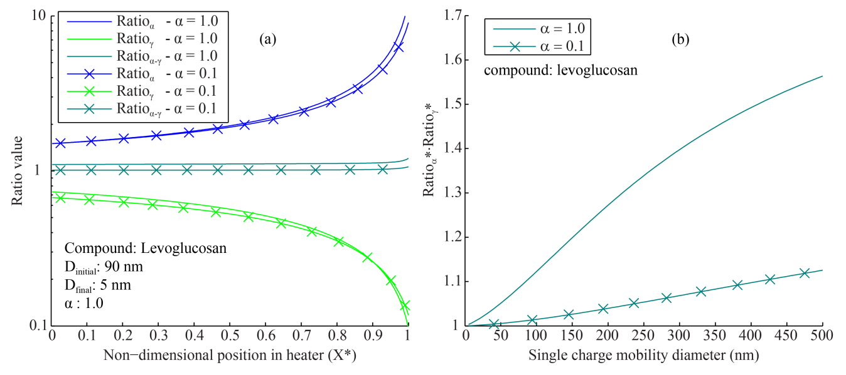
- Panel (a): The α ratio, the γ ratio, and the product of the α and γ ratios (blue-green) during evaporation of levoglucosan. Panel (b): The α-γ ratio as a function of diameter.

With an α-γ ratio greater than 1, the β and δ ratios determine the final value of the evaporation rate ratio. The β ratio is always greater than 1 and grows as the diameter decreases. The δ ratio is also greater than one throughout evaporation and decreases slightly. This pattern is shown in Figure S7 panel (a). We see in Figure S7 panel (a) that as the particle decreases in diameter, the Kelvin effect becomes the dominant ratio. As the single charge diameter decreases, the rate of the evaporation of the first charge relative to the others increases. This acceleration quickly separates the charges after evaporation. Figure S7 panel (b) displays the non-dimensional form of the ratios. Each ratio (α-γ, β, and δ) in panel (b) has been divided by its initial value. This panel displays which ratio controls the evaporation rate ratio (the left side of the S16 equality). At non-dimensional positions less than 0.4, the final evaporation ratio is controlled by a combination of the β ratio and the δ ratio. At distances greater than 0.4, the β ratio increases its dominance. By the end of the evaporation, the β ratio completely controls the evaporation rate ratio functionality.

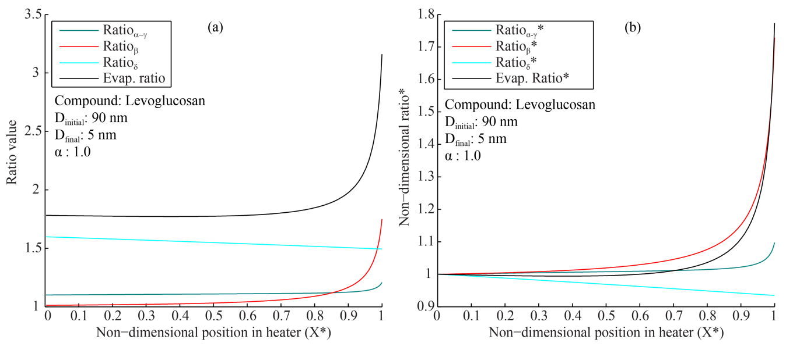
- Panel (a) The value of the α-γ ratio, the β ratio, the δ ratio, and the overall evaporation rate ratio. Panel (b) The relative value of the ratios during evaporation of levoglucosan. All ratios in panel (b) are shown in non-dimensional form, normalized to the initial condition. The α and γ ratios are expressed as a product of the two ratios. The evaporation rate ratio is the final value that determines charge separation.

In Figure S8, we see that the singly charged particles always separates first and the doubly charged particles will eventually separate from the triply charged particles. The value of the evaporation rate ratio expressed for the singly to doubly charged particles during 90 nm evaporation is greater than the evaporation ratio expressed for the doubly to triply charged particles. The product of the two ratios will equate to the evaporation ratio of the singly to triply charged particles. The evaporation ratio of the singly charged particles to either the doubly or triply charged particles is much greater than one. The evaporation ratio of the singly charged particles to the doubly charged particles is always larger than the ratio of the doubly to the triply charged particles. This ensures that the singly charged particles will always separate from the doubly charged particles before the doubly charged particles separates from the triply charged particles. If an initial diameter of 300 nm is chosen, the evaporation ratios increase further. The separation of the charges in the 300 nm case competes against the width of the DMA transfer functions. Selection of larger diameters widens the transfer function requiring a larger evaporation to take place before charge separation is revealed.

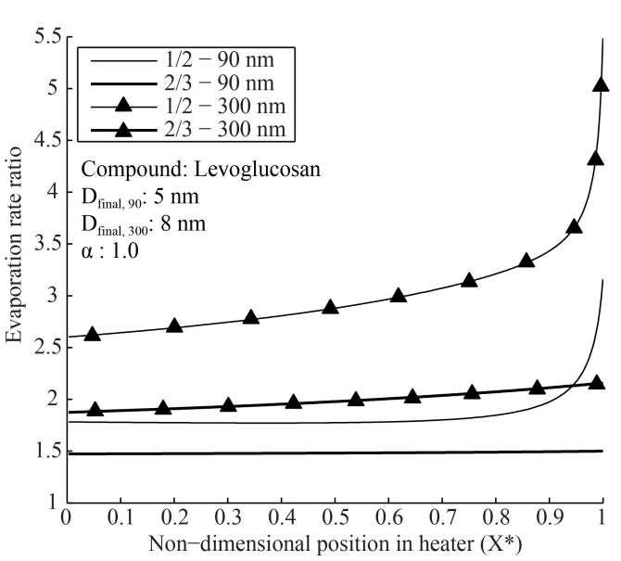
- Evaporation of levoglucosan with an initial diameter of 90 nm and 300 nm. The evaporation rate ratio of the first charge to the second charge is shown as a thin black line. The evaporation ratio of the second charge to the third charge is shown as a heavy line.

In Figure S9, we see that charge separation occurs regardless of accommodation coefficient. The figure displays evaporation rate ratio as a function of mass accommodation coefficient and charge ratio. The ½ represents the ratio of the singly charged evaporation rate to the doubly charged evaporation rate. The 2/3 represents the ratio of the doubly charged evaporation rate divided by the triply charged evaporation rate. The evaporation ratio of the singly charged particles to the doubly is greater than one in both cases and is greater than the ratio of the doubly charged particles to the triply charged particles. Decrease of the mass accommodation coefficient decreases the evaporation rate ratio but does not remove the separation. The evaporation rate ratios for a 0.1 mass accommodation coefficient are large and will still separate the charges.
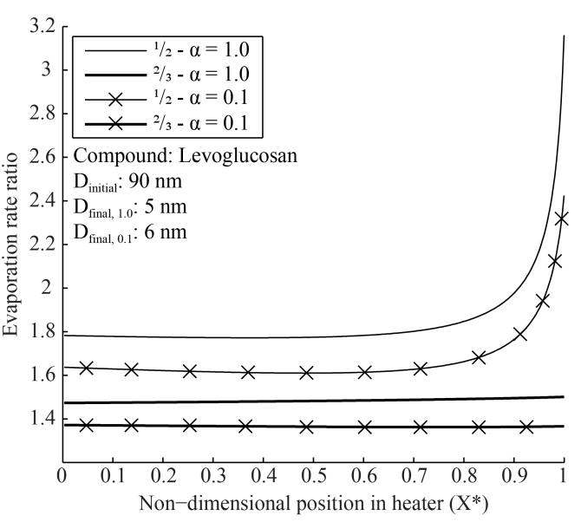
- Evaporation of a 90 nm particle of levoglucosan. The y-axis is the value of the evaporation ratio. The thin lines are the ratio of the first charge to the second charge. The thick lines are the ratio of the second charge to the third. Lines with x’s mark an accommodation coefficient of 0.1.

Different components impact the evaporation ratio, especially through the β ratio. We compare levoglucosan, malonic acid, and oleic acid to display the impact. The values for surface tension, particle density, molecular weight, collision diameter, and characteristic energy are shown in Table S1. The role of the components in the β ratio is apparent in Equation S16. The role of the components in the γ ratio is less apparent. The Knudsen number requires the mean free path in addition to the diameter. The mean free path is the distance between collisions between the evaporating gas molecules and can be calculated using the molecular weight and diffusivity of the condensing gas. We use Chapman-Engskog kinetic theory to calculate diffusivity (Bird, Stewart and Lightfoot 2002). We use these values to compare the impact of components on the overall evaporation ratio. This comparison is shown in Figure S10.

Table S1. Values used for comparison of the evaporation ratio.
Compound | Surface Tension/Energy | Density | Molecular Weight | Collision Diameter | Characteristic Energy
 | (J/m²) | (Kg/m³) | (g/mole) | (Å) | (K)
Malonic Acid^{A} | 0.2 | 1616 | 104.06 | 5.33 | 784.80
Levoglucosan | 0.022^{B} | 1640^{C} | 162.14 | 5.97E | 608.3E
Oleic Acid^{D} | 0.0325 | 895 | 282.46 | 8.41 | 601.37
A-(Bilde et al. 2003); B-(Topping et al. 2007); C-(Koehler et al. 2006); D-(Yaws 2008). E-(Oxford et al. 2019)

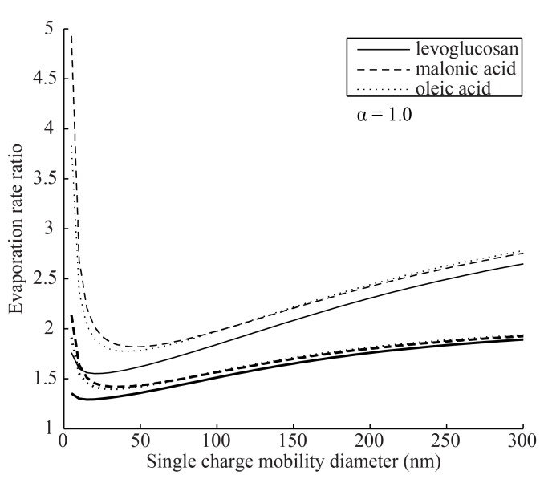
- The evaporation rate ratio for three different components. We see the value of the first to second charge over the range of 5 nm to 300 nm. The lightly weighted lines are the first charge to second charge evaporation rate ratio, and the darkly weighted lines are the second charge to third charge evaporation rate ratio.

Components impact the evaporation ratio, but do not inhibit separation. Figure S10 shows the value of the evaporation ratio for singly charged particles to doubly charge particles for the three components (thin line) as a function of beginning diameter. The doubly to triply charged evaporation ratio is the thick line. We see that malonic acid has a slightly higher evaporation ratio than oleic, and both malonic and oleic have a discernable increase in evaporation ratio over levoglucosan. The increase is due to a combination of both the Kelvin effect ratio and the γ ratio. At small diameters, the increase is dominated by the β ratio, and the contribution from the γ ratio is near one. At 200 nm, the contribution of the β ratio and the γ ratio to the increase in evaporation is nearly equivalent. The two functions change significantly as a function of diameter. The transition correction factor ratio changes by 20% (6 times the component contribution) over the range, and the Kelvin effect diameter ratio changes by 100 to 300%. The total increase in evaporation ratio due to individual components is small. The increase in the evaporation ratio of malonic acid over levoglucosan at 200 nm is 5%. From this analysis, we can conclude that components impact evaporation ratio at small diameters through the Kelvin effect ratio, but the impact of the γ ratio is minimal. The γ ratio is more a function of diameter than component.

- Inlet size distribution and DMA1 transfer function
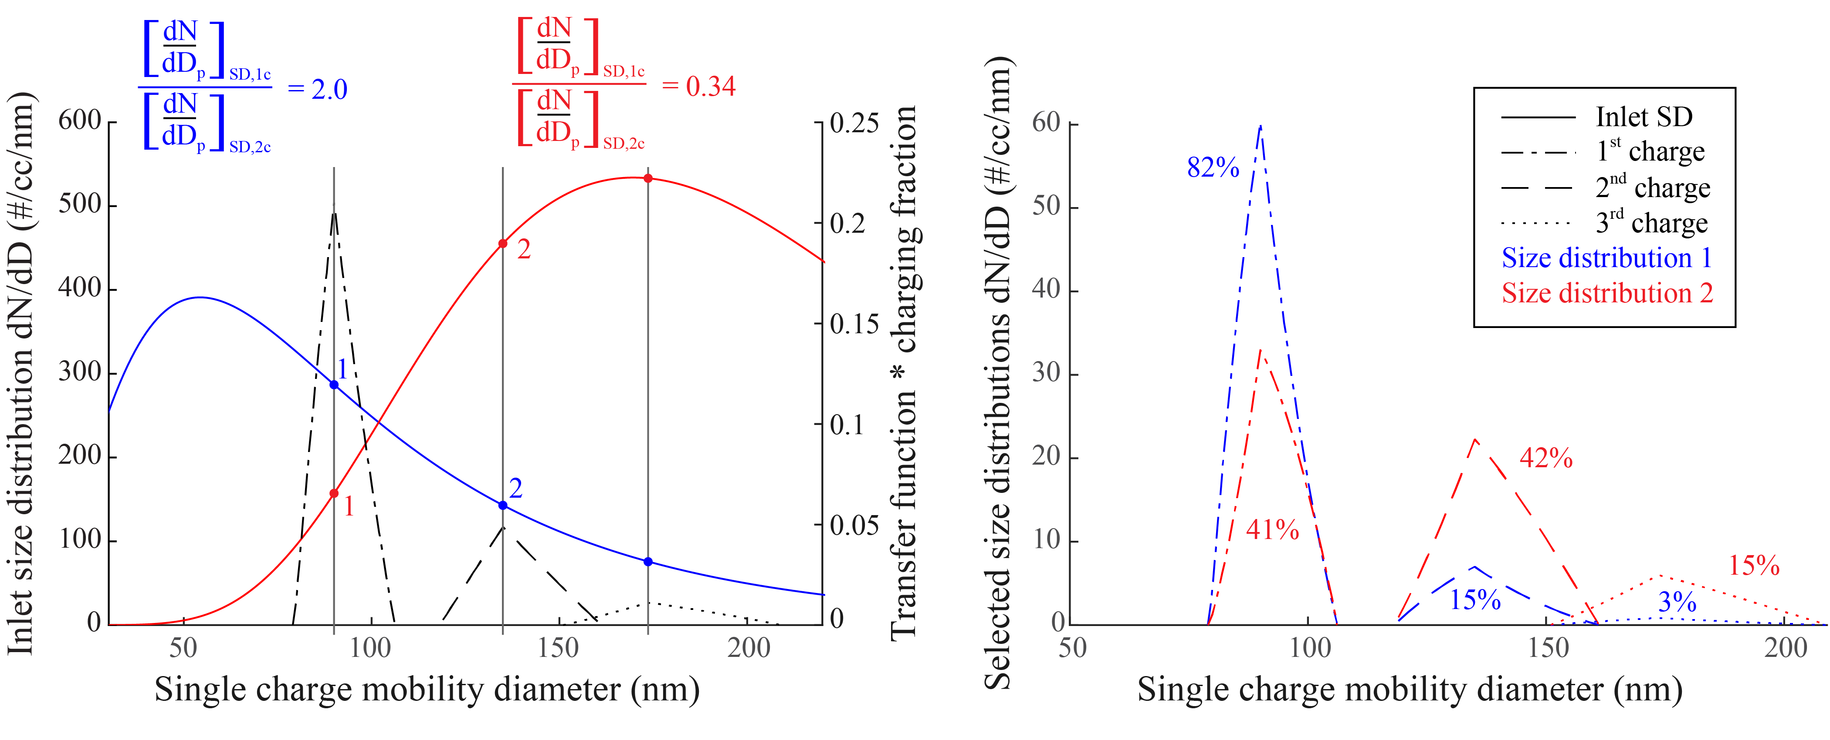
- Panel (a) displays the two inlet size distributions: size distribution 1 (blue) and size distribution 2 (red). The transfer functions corresponding with the singly, doubly, and triply charged particles are also plotted. Size distribution 1 has more particles in the area of the singly charged transfer function than the doubly charged transfer function. Size distribution 2 is the opposite. Panel (b) displays the product of the transfer function, the charging fraction, and the inlet size distribution. The percentages display the percent of the population within a transfer function.

- Role of the residence time distribution
The residence time distribution is the primary reason for the asymmetry in Figure 2 panel (a). The singly charged CPC response in Figure 2 panel (a) appears asymmetric with a tail on the left side of the response. This CPC response is due to the convolution of the input size distribution, the DMA1 transfer function, the DMA2 transfer function, and the residence time distribution. The response in Figure 2 panel (a) resembles the shape of Figure S5 reversed, and Figure 2 panel (a) does not contain any resemblance to the ideal TDMA transfer function. The final shape of the residence time distribution, and the DMA2 response, is a function of heater design.
The heater design and flow rate determine the residence time distribution. The shape of the distribution is influenced by fluid phenomena and diffusional spreading. For example, if a mixed tank is used as a heater, the residence time distribution would appear as a Continuous Stirred Tank Reactor (CSTR). The response would look like an exponential decay. If the heater is assumed as plug flow, the residence time distribution would consist of a single time. These two ideal examples represent extremes, but most designs exist between these two examples. The heater in Supplemental Information S3 is 15.25 m long tubing. The measured residence time distribution is neither a continuous stirred tank reactor nor a plug flow response. The design resides between the two ideal cases. Figure S12 compares the ecurve in Figure S4 with CSTRs in series model. We chose to use N=1.87 tanks to correlate the peak of the CSTR non-dimensionalized ecurve with the non-dimensionalized ecurve of Figure S4. The pattern of the two curves is dramatically different. The CSTR response is quite wide in comparison to the Figure S4 response.

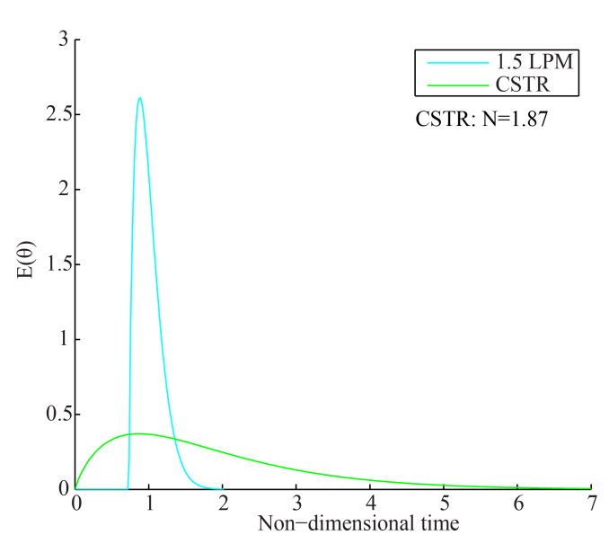
- The measured ecurve in Figure S2 compared to a CSTRs in series model. The number of tanks used is 1.87. Although difficult to tell, the location of the peak, in non-dimensional time, of the CSTR response is the same as the peak of the response from Figure S2.

The residence time distribution can prevent charge separation alone. To display this, we use the response from 1.87 CSTRs in series and compare this to the Figure S4 residence time distribution. We input this residence time distribution into TAO to estimate the response. The comparison is shown in Figure S13. The Figure 2 panel (a) response separates the charges well, but no indication of charge separation occurs in the CSTR case. The width of the convolution of the residence time distribution with the DMA transfer functions is much wider than the difference between the peaks of the singly charged particles and the remaining charges. Therefore, both peaks shown in Figure 2 panel (a) will exist under a single peak. The peak of the singly charged experimental size distribution is located at 63.5 nm while the total CPC response peak is located at 73.5 nm.

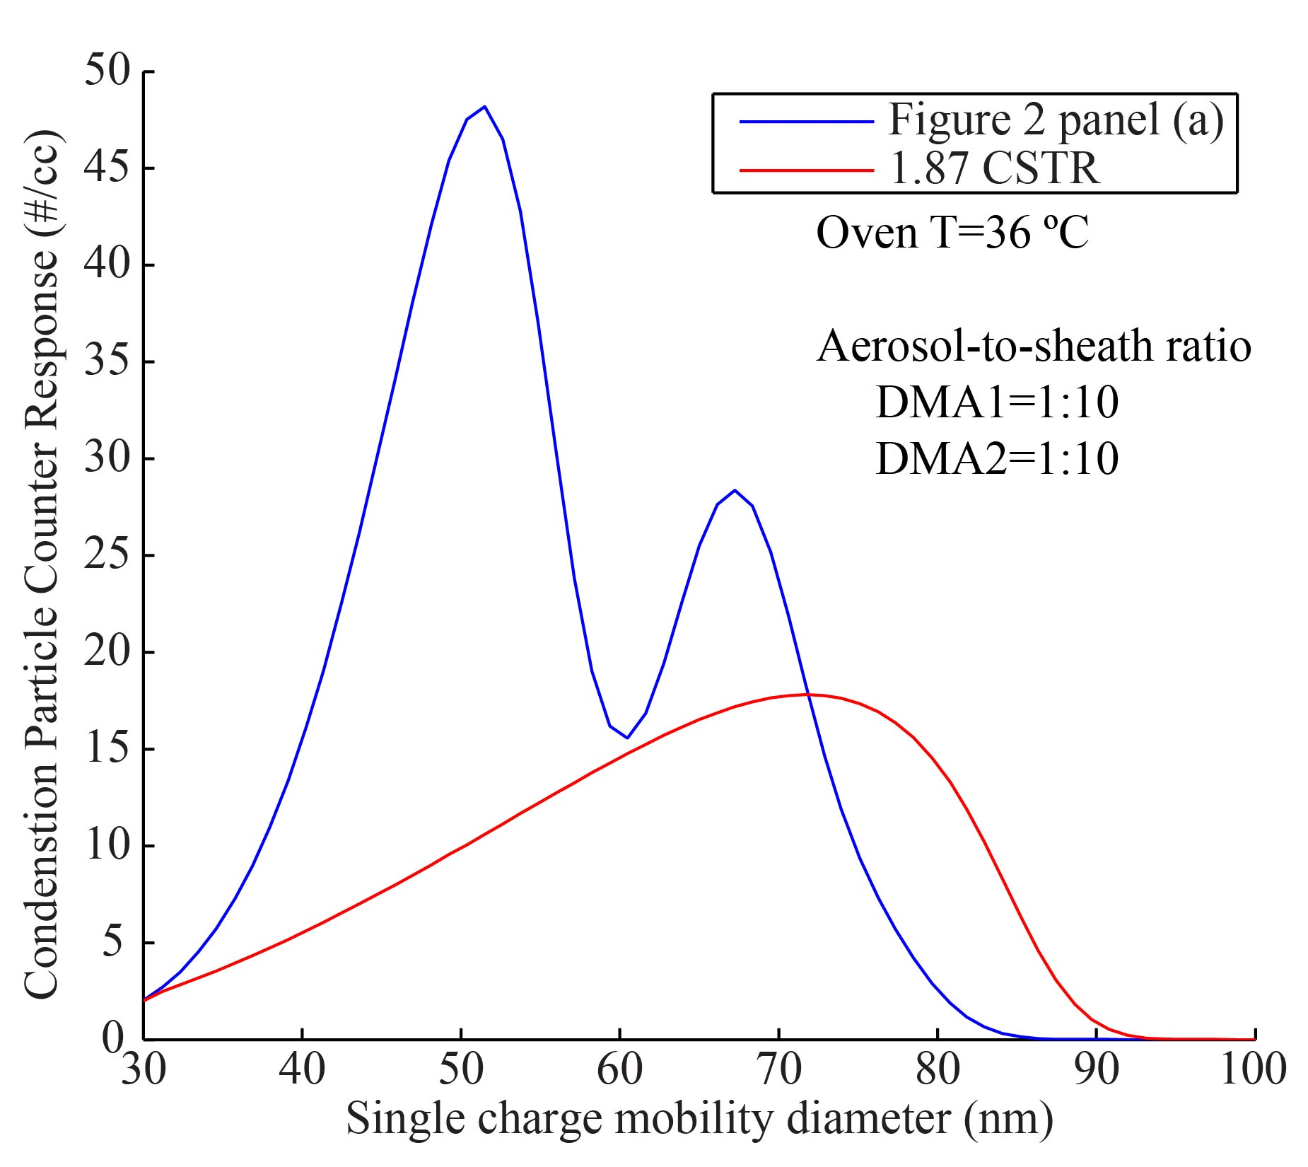
- The response from both Figure 2 panel (a) and the CSTR ecurve. In both responses, the aerosol-to-sheath ratio in both DMAs is 1:10, and the oven temperature is 36 °C.

Inaccuracy in vapor pressure measurement comes from both the lack of charge separation and the convolution of the RTD with the DMA1 transfer function. In Figure S13, the peak of the singly charged particles for the Figure 2 panel (a) case is approximately 50.7 nm. If we assume this peak correlates with the peak of the RTD in Supplemental Information S3, the vapor pressure is 0.7% high. This response is accurate. If we use the CSTR RTD from above, the peak of the singly charged size distribution is 63.5 nm with the same peak in residence time. The resulting convolution error is 47%. The CSTR CPC response peak in Figure S12 does not correlate with the peak of the singly charged experimental size distribution. If the CPC response peak of 72.3 nm from Figure S13 is used, the error increases to 123%. Inversions which do not include the convolution of the RTD with the DMA transfer functions could be significantly wrong, and the inability to locate the peak of the singly charged size distribution makes the situation much worse.
The flow rates in laminar flow heaters change the residence time distribution. Figure S14 shows two residence time distributions: the Supplemental Information S3 flow rate of 1.5 LPM and 0.4 LPM through the same heater. The x-axis is non-dimensional time which is defined as the time divided by the first moment of the ecurve. The y-axis is the concentration at any time divided by the total concentration. By reducing the flow rate to 0.4 LPM, the mean time of the residence time distribution increases by nearly a factor of 4. The extra time in the oven allows for diffusional spreading along the tubing axis. Some particles will exit earlier in non-dimensional time and some will exit later. This spreads the response recorded by DMA2. The spread will alter the convolution of the RTD with the DMA1 transfer function and may alter the apparent volatility. The ecurve for one flow rate does not equate to the ecurve for another flow rate. This concept can be expanded to tubing length as well. As a laminar flow reactor lengthens, diffusional spreading will occur, and the ecurve and convolution with DMA1 will change.

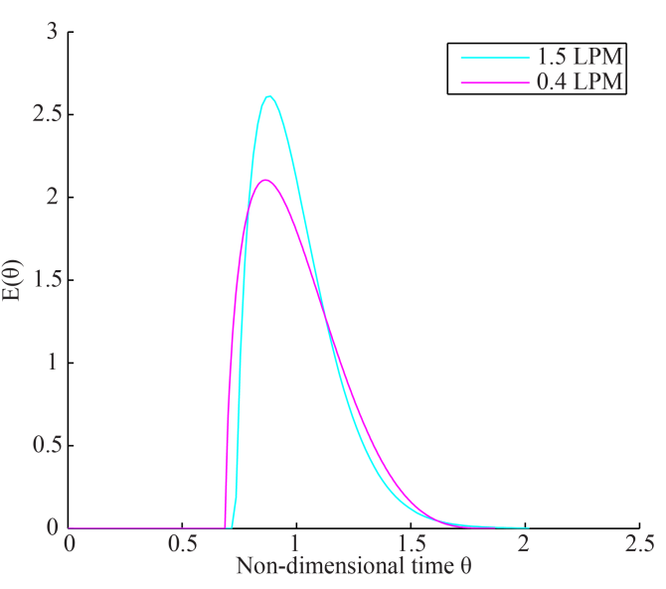
- The non-dimensionalized ecurves from the 15.25 m heater. The cyan curve is the response shown in Figure S2. The magenta response corresponds with the same tubing with a reduced flowrate.

- Evaporation at 200 nm
Even though the CPC response is a single peak and the location of the peak of the singly charged experimental size distribution is unknown, the accuracy in vapor pressure measurement may not sacrificed. The DMA1 diameter, 200 nm, is much larger in diameter than the diameter corresponding with the peak of the log-normal size distribution. This along with the charging function guarantees a selected population consisting of primarily singly charged particles. Like Figure 4, the peak of the singly charged size distribution does not deviate significantly from the peak of the CPC response. Figure S15 displays the accuracy of this case in panel a. In panel b, the vapor pressure measurements, derived from Figure 3 panel (b), follow the Clausius-Clapeyron model used to generate the CPC response.

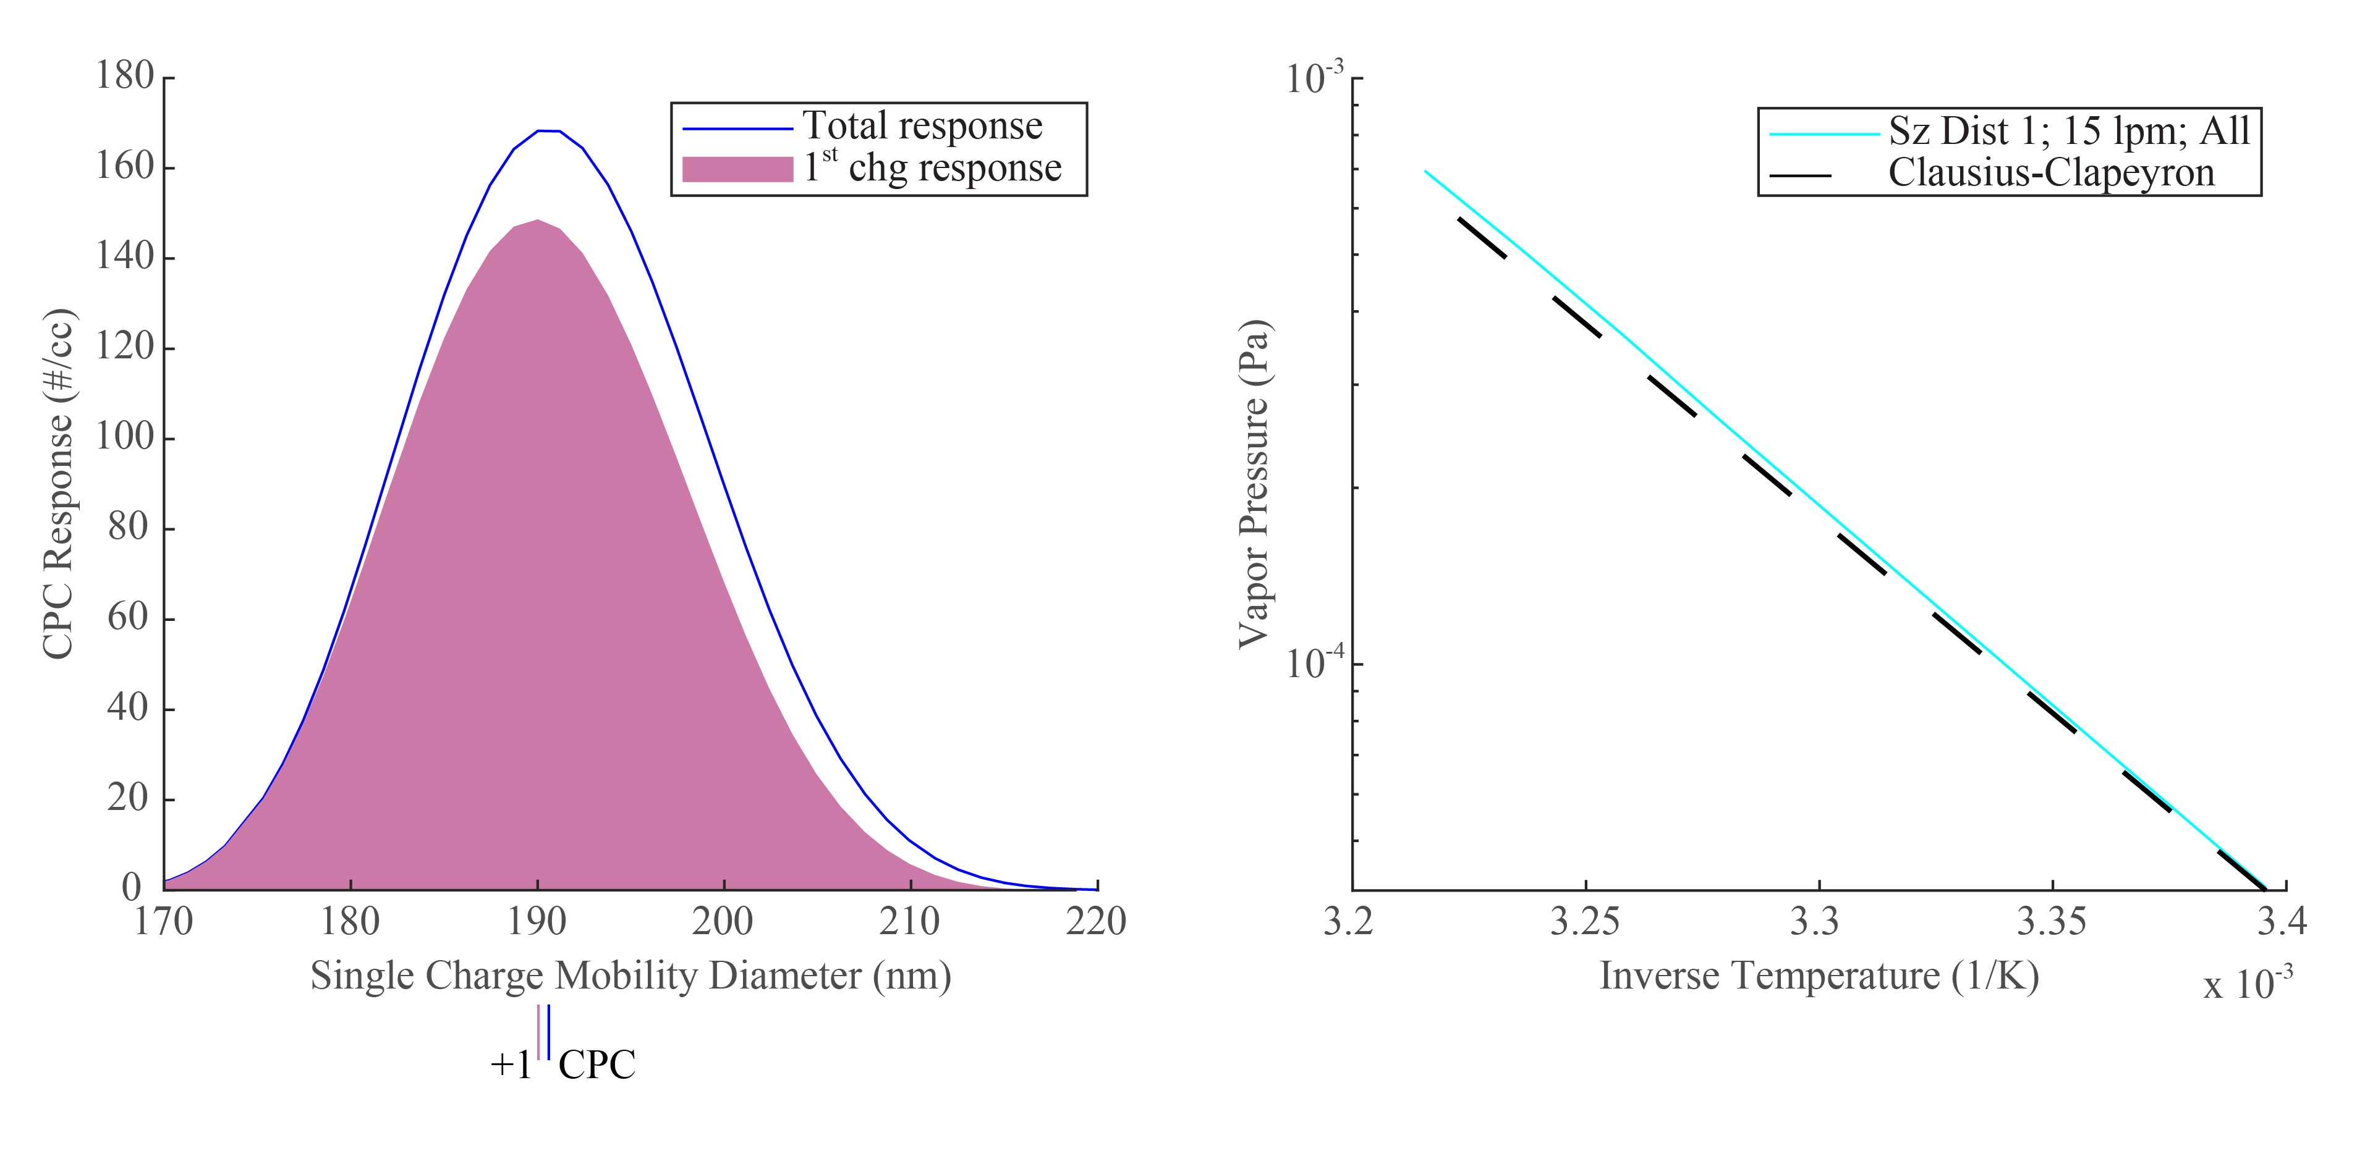
- Panel (a): The CPC response with an oven temperature of 28 °C. The first charge CPC response is shown with open circles, and the total CPC response is shown with asterisks. Panel (b): The vapor pressure calculations based on the peak of the total CPC response. The calculated vapor pressure response compared to the Clausius-Clapeyron relation used to generate the data.

Although this situation is accurate, the CPC response does not reveal whether the singly charged particles are tracked. The user has three methods available for determining the charging situation: use the additional equipment as in the experimental method, use the additional equipment as shown in Wright et al. (2016), or evaporate the aerosol until the singly charged size distribution is revealed. This 200 nm case, along with Figure 4 panel (a), displays primarily singly charged distributions. In these cases, when the charges separate, the peak of the remaining charges is smaller in population than the singly charged size distribution. Users choosing not to implement additional equipment must be careful to use tall, narrow residence time distributions along with narrow DMA transfer functions to determine the fraction of the population that is singly charged. Using wide DMA transfer functions or wide residence time distributions does not enable charge separation, and without additional equipment, the actual location of the peak of the singly charged size distribution will be unknown.

- List of symbols used in this document

A1 – 1st Cunningham correction factor constant
A2 – 2nd Cunningham correction factor constant
A3 – 3rd Cunningham correction factor constant
C – Cunningham correction factor
C₁ – Cunningham correction factor for a single charged particle
C₂ – Cunningham correction factor for a second charged particle
C₂₋₁ – Cunningham correction factor for a second charged particle in single charge diameter space
C_{in} – Concentration out of the system without the heater assuming that the entire system exists prior to the heater
C_{out} – Concentration out of the entire system
D_{i,air} – Diffusivity of component i in air
D_{p} – diameter of particle
D_{p,0} – Initial diameter of particle
D_{p,f} – Final diameter of particle
D_{p,1} – Diameter of a singly charged particle
D_{p,2} – Diameter of a doubly charged particle
D_{p,2-1} – Diameter of a doubly charged particle in single charged diameter space
E – ecurve. Fraction of the total mass emitted at time t
e – Charge of an electron. Bold face font means the value is a vector.
F – Transition regime correction factor.
f – Subscript used to denote the final state
i – Subscript used to denote the component under investigation
j – Subscript used to denote the charge of the particle
Kn_{i} – Knudsen number of component i
Kr-85 – Subscript used to denote the size distribution exiting the neutralizer
M_{i} – Molecular weight of component i
N – Number of particles in the inlet size distribution
N_{exp} – Number of particles in the size distribution exiting the heater
N_{p} – Total number of particles in the inlet size distribution
N₁ – Number of particles in the size distribution exiting DMA1
N₂ – Number of particles in the size distribution exiting DMA2
P* - Vapor pressure of component i
Q_{a} – Aerosol inlet flow to DMA
Q_{c} – Sheath inlet flow to DMA
Q_{m} – Sheath outlet flow from DMA
Q_{s} – Aerosol outlet flow from DMA
R – Gas constant
T – Temperature
TAO – Subscript used to denote the hypothesized size distribution calculated by TAO
t – time at exit of entire system
t’ – time in heater
Z₁ – Mobility of a single charged particle
Z₂ – Mobility of a doubly charged particle
Z₂₋₁ – Mobility of doubly charged particle in single charge diameter space
${\tilde{Z}}_{p}$ - Non-dimensional mobility
Z_{p}* - Mobility at the centroid of the DMA transfer function
α – Subscript used to denote the diameter ratio
α_{i} – Mass accommodation coefficient of component i
β – Non-dimensional flow used in DMA transfer function
β – Subscript used to denote the ratio of the Kelvin effects
γ – Subscript used to denote the ratio of the transition correction factors
δ – Non-dimensional flow used in DMA transfer function
δ – Subscript used to denote the conversion of the second charge to first charge diameter space
η – Fraction of particles receiving a charge
θ – Non-dimensional time
λ_{air} – Mean free path in air
μ – Viscosity of air
μ_{g} – Mean of the log-normal size distribution
ρ_{i} – Density of a particle of component i
σ_{i} – Surface tension of component i
σ_{g} – Standard Deviation of the log-normal size distribution
Ω_{nd} – DMA transfer function

- References

Allen, M. D. and O. G. Raabe. 1985. Slip Correction Measurements of Spherical Solid Aerosol Particles in an Improved Millikan Apparatus. Aerosol Sci. Tech. 4:269-286. DOI: 10.1080/02786828508959055.
Baron, P. A. 2001. Aerosol measurement principles, techniques, and applications. New York: Wiley.
Bilde, M., B. Svenningsson, J. Mønster, and T. Rosenørn. 2003. Even-odd alternation of evaporation rates and vapor pressures of C3-C9 dicarboxylic acid aerosols. Environ. Sci. Technol. 37:1371-1378. DOI: 10.1021/es0201810.
Bird, R. B., W. E. Stewart, and E. N. Lightfoot. 2002. Transport phenomena. New York: J. Wiley.
Friedlander, S. K. 2000. Smoke, dust, and haze : fundamentals of aerosol dynamics. New York: Oxford University Press.
Kim, J. H., G. W. Mulholland, S. R. Kukuck, and D. Y. H. Pui, D. Y. H. (2005). Slip Correction Measurements of Certified PSL Nanoparticles Using a Nanometer Differential Mobility Analyzer (Nano-DMA) for Knudsen Number From 0.5 to 83. J. Res. Natl. Inst. Stan. 110:31-54. DOI: 10.6028/jres.110.005.
Koehler, K. A., S. M. Kreidenweis, P. J. DeMott, A. J. Prenni, C. M. Carrico, B. Ervens, and G. Feingold. 2006. Water activity and activation diameters from hygroscopicity data - Part II: Application to organic species. Atmos. Chem. Phys. 6:795-809. DOI: 10.5194/acp-6-795-2006.
Levenspiel, O. 1999. Chemical reaction engineering. New York: Wiley.
Oxford, C. R., C. M. Rapp, Y. Wang, P. Kumar, P., D. Watson, J. L. Portelli,E. A. Sussman, S. Dhawan, J. Jiang, B. J. Williams. 2019. Development and qualification of a VH-TDMA for the study of pure aerosols. Aerosol Sci.Technol. 53:120-132. DOI: 10.1080/02786826.2018.1547358.

Stolzenburg, M. R., and P. H. McMurry. 2008. Equations Governing Single and Tandem DMA Configurations and a New Lognormal Approximation to the Transfer Function. Aerosol Sci. Tech. 42:421-432. DOI: 10.1080/02786820802157823.
Topping, D. O., G. B. McFiggans, G. Kiss, Z. Varga, M. C. Facchini, S. Decesari,and M. Mircea. 2007. Surface tensions of multi-component mixed inorganic/organic aqueous systems of atmospheric significance: measurements, model predictions and importance for cloud activation predictions. Atmos. Chem .Phys. 7:2371-2398. DOI: 10.5194/acp-7-2371-2007.
Wiedensohler, A. 1988. An Approximation of the Bipolar Charge-Distribution for Particles in the Sub-Micron Size Range. J. Aerosol Sci. 19:387-389. DOI: 10.1016/0021-8502(88)90278-9.
Woessner, R. H., and R. Gunn. 1956. Measurements related to the fundamental processes of aerosol electrification. Journal of Colloid Science 11:69-76. DOI: 10.1016/0095-8522(56)90021-6.
Wright, T. P., C. Song, S. Sears, M. D. Petters. 2016. Thermodynamic and kinetic behavior of glycerol aerosol. Aerosol Sci. Technol. 50:1385-1396. DOI: 10.1080/02786826.2016.1245405.
Yaws, C. L. 2008. Thermophysical properties of chemicals and hydrocarbons. Norwich, NY: William Andrew.

