Supporting information

Synthesis of biologically active copper oxide nanoparticles as promising novel antibacterial-antibiofilm agents
Fatih ERCI^{a,b, *}, Rabia CAKIR-KOC^{b}, Mustafa YONTEMª, Emrah TORLAK^{c}

ª Department of Biotechnology, Faculty of Science, Necmettin Erbakan University, Konya-TURKEY
^{b} Department of Bioengineering, Faculty of Chemical and Metallurgical Engineering, Yildiz Technical University, Istanbul-TURKEY
^{c} Department of Molecular Biology and Genetics, Faculty of Science, Necmettin Erbakan University, Konya-TURKEY

*Corresponding author:
Fatih Erci
Email: fxerci@gmail.com, ferci@erbakan.edu.tr
Phone: +90 5061499841

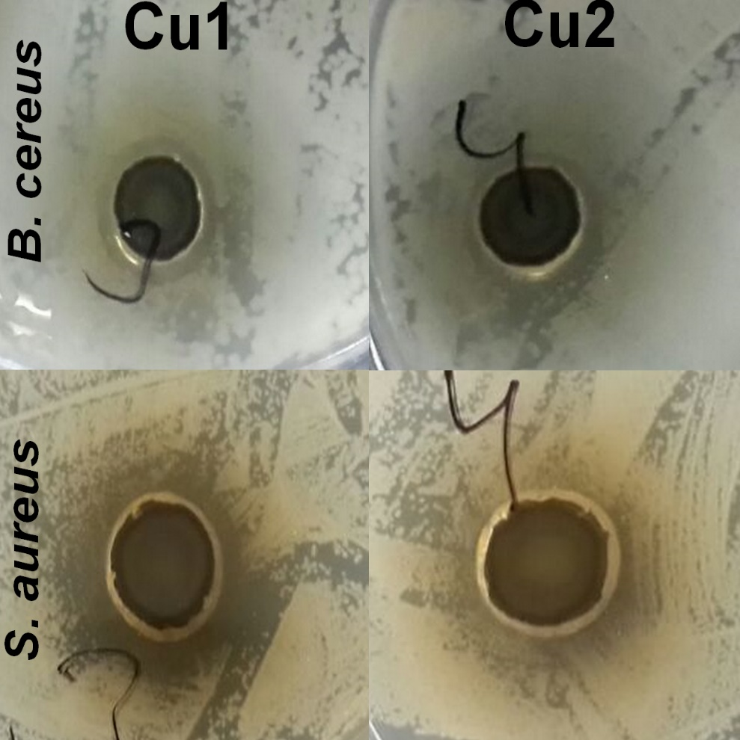

Figure S1. Antibacterial acitivity of biosynthesized copper oxide nanoparticles.
Cu1 denotes Ts1CuONPs
Cu2 denotes Ts2CuONPs

Figure S2. DPPH free radical scavenging activity of copper oxide nanoparticles

