**SUPPLEMENTARY MATERIAL**

**Appendix A**

**Composition of standard solutions**

|  |  |  |
| --- | --- | --- |
| **TITLE** | **CONCENTRATION** | **COMPOSITION** |
| Standard solution S0 | 0µg/ml | 10 ml acid + 0 ml stock solution B |
| Standard solution S2 | 2µg/ml | 9 ml acid + 1 ml stock solution B |
| Standard solution S4 | 4µg/ml | 8 ml acid + 2 ml stock solution B |
| Standard solution S6 | 6µg/ml | 7 ml acid + 3 ml stock solution B |
| Standard solution S8 | 8µg/ml | 6 ml acid + 4 ml stock solution B |
| Standard solution S10 | 10µg/ml | 5 ml acid + 5 ml stock solution B |

**Appendix B**

**Wavelength scans for the Vaseline® coated samples (6 replicates).**

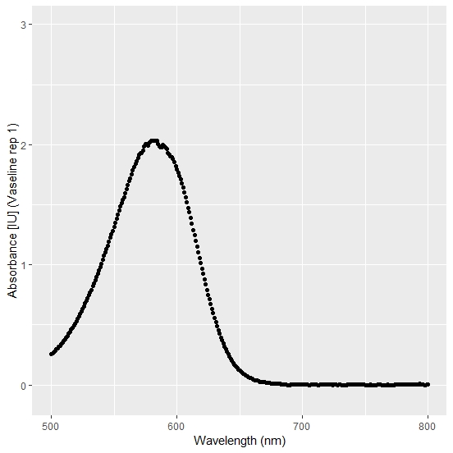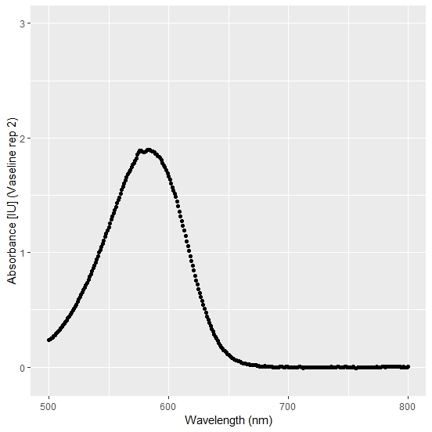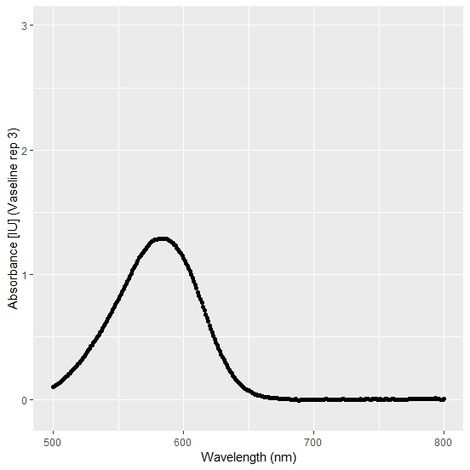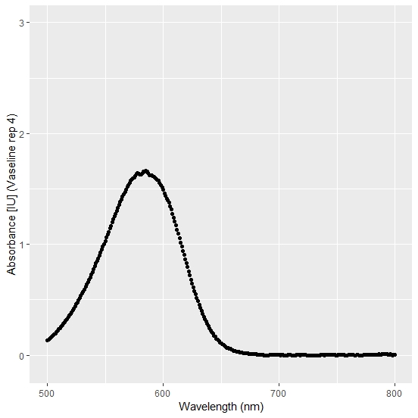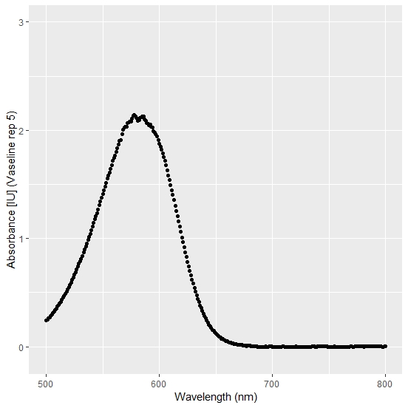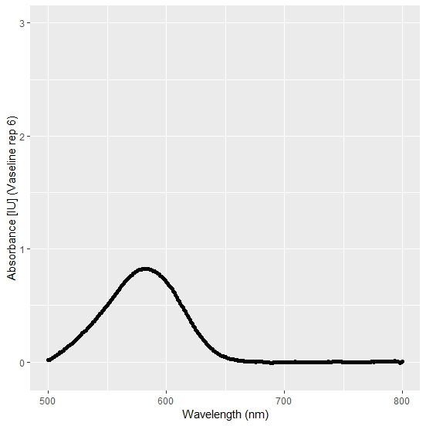

**Wavelength scans for the GC Fuji VARNISH™ coated samples (6 replicates).**

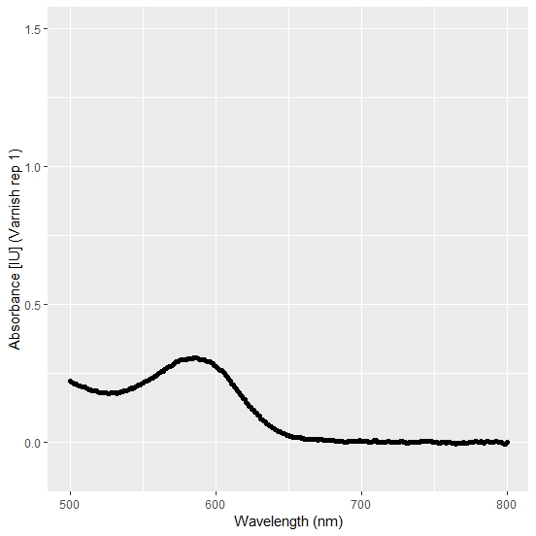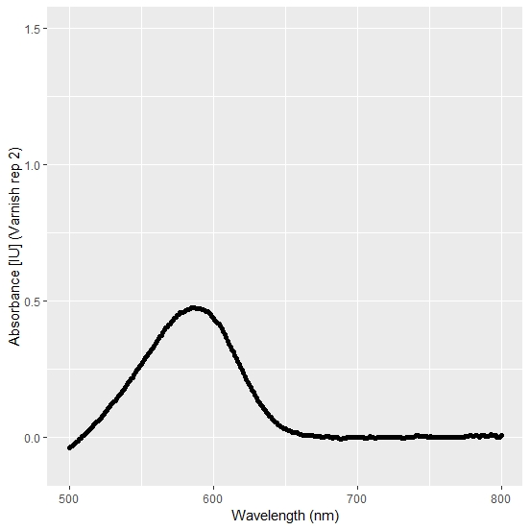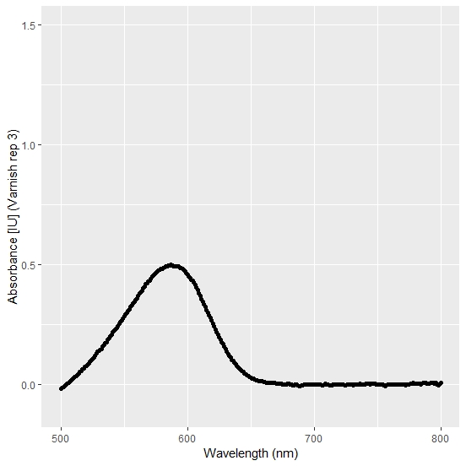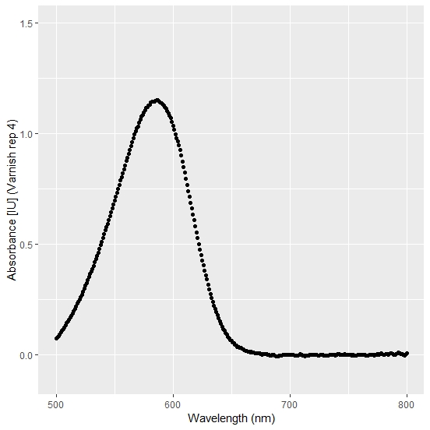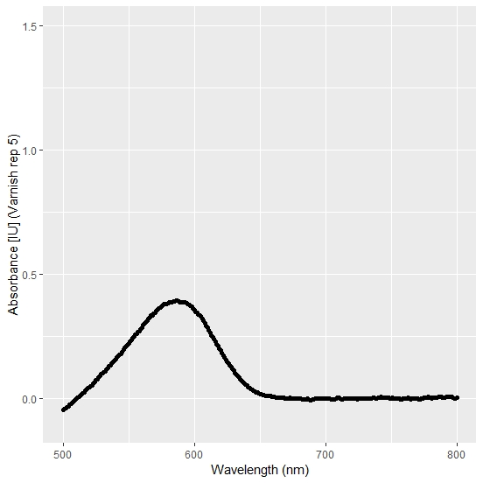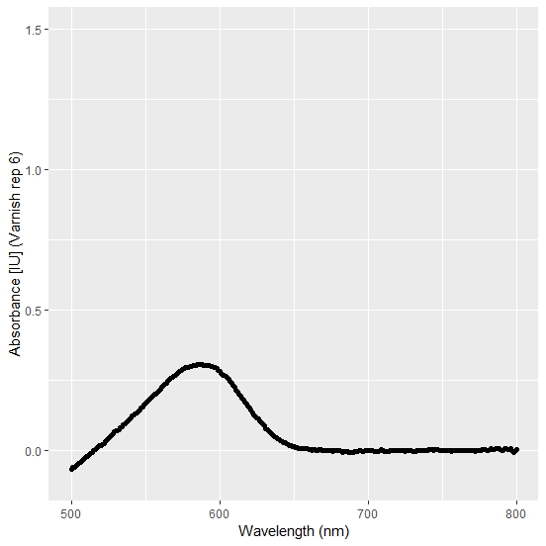

**Wavelength scans for the G-Coat Plus™ coated samples (6 replicates).**

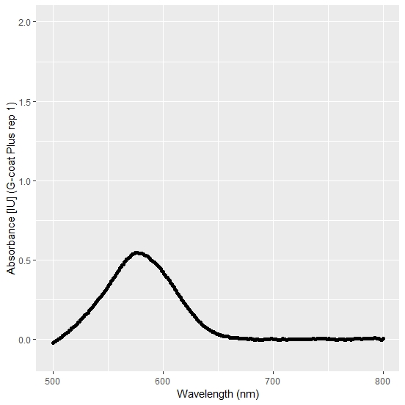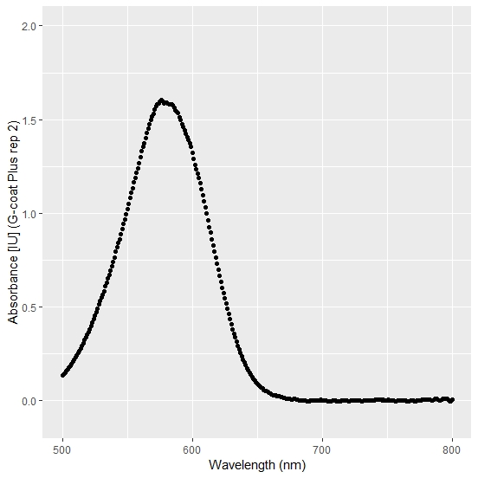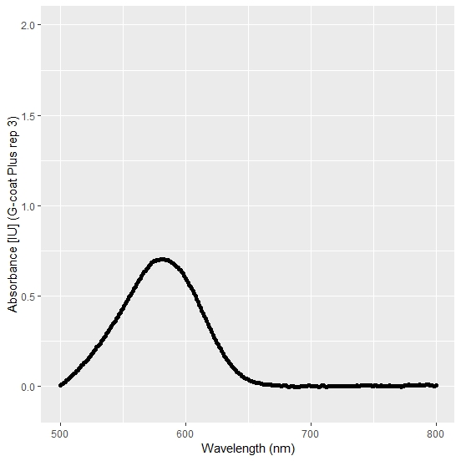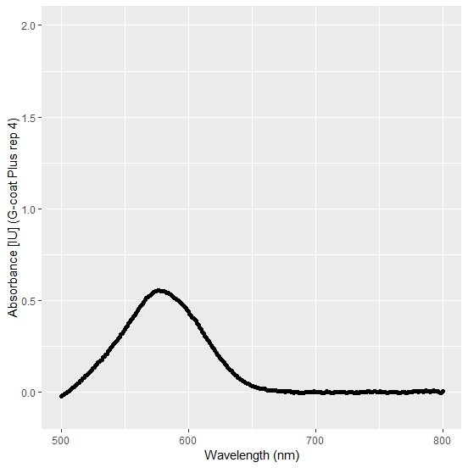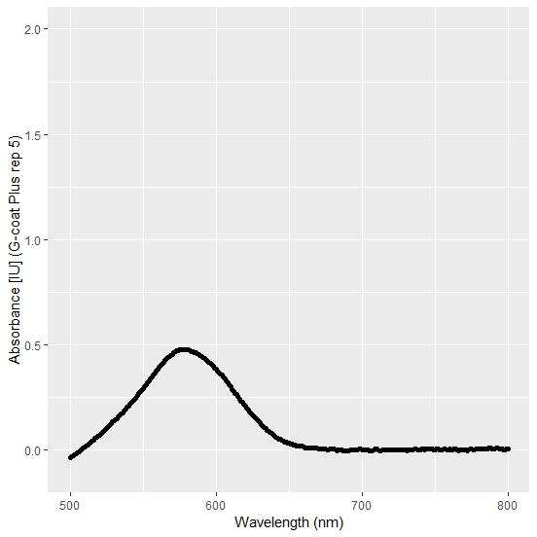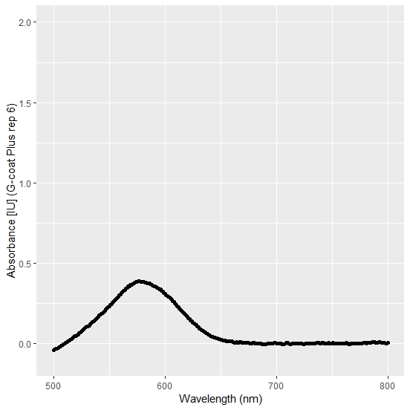

**Wavelength scans for the EQUIA® Coat coated samples (6 replicates).**