Supplementary Material

Variable structural bonding modes and antibacterial studies of thiosemicarbazone ligands of ruthenium, rhodium and iridium metal complexes

LATHEWDEIPOR SHADAP, VENKANNA BANOTHU, UMA ADEPALLY, SANJAY ADHIKARI and MOHAN RAO KOLLIPARA*

Contents
Figure S1. ¹H NMR spectrum of complex 1
Figure S2. ¹H NMR spectrum of complex 2
Figure S3. ¹H NMR spectrum of complex 4
Figure S4. ¹H NMR spectrum of complex 5
Figure S5. ¹H NMR spectrum of complex 6
Figure S6. ¹H NMR spectrum of complex 7
Figure S7. ¹H NMR spectrum of complex 8
Figure S8. ¹H NMR spectrum of complex 9
Figure S9. ¹³C NMR spectrum of complex 1
Figure S10. ¹³C NMR spectrum of complex 5
Figure S11. ¹³C NMR spectrum of complex 6
Figure S12. ¹³C NMR spectrum of complex 8
Figure S13. Mass spectrum of complex 1
Figure S14. Mass spectrum of complex 2
Figure S15. Mass spectrum of complex 3
Figure S16. Mass spectrum of complex 4
Figure S17. Mass spectrum of complex 5
Figure S18. Mass spectrum of complex 6
Figure S19. Mass spectrum of complex 7
Figure S20. Mass spectrum of complex 8
Figure S21. Mass spectrum of complex 9
Figure S22. UV-Visible spectrum of complexes 1-9
Figure S23. Ball and stick diagram of complex 1 presented just to show the mode of bonding. Hydrogen atoms (except NH protons) and counter ions have been omitted for clarity.
Figure S24. Ball and stick diagram of complex 8 presented just to show the mode of bonding. Hydrogen atoms (except NH protons) and counter ions have been omitted for clarity.
Figure S25. Antibacterial results of the compounds against gram-positive and gram-negative bacteria strains with ciprofloxacin as the reference.
Figure S26. The minimum inhibitory concentration (MIC) and minimum bactericidal concentration (MBC) of the tested compounds.
Figure S1. ¹H NMR spectrum of complex 1.
Figure S2. ¹H NMR spectrum of complex 2.
Figure S3. ¹H NMR spectrum of complex 4.
Figure S4. ¹H NMR spectrum of complex 5.
Figure S5. ¹H NMR spectrum of complex 6.
Figure S6. ¹H NMR spectrum of complex 7.

Figure S7. ¹H NMR spectrum of complex 8.
Figure S8. ¹H NMR spectrum of complex 9.
Figure S9. ¹³C NMR spectrum of complex 1.
Figure S10. ¹³C NMR spectrum of complex 5.
Figure S11. ¹³C NMR spectrum of complex 6.
Figure S12. ¹³C NMR spectrum of complex 8.
Figure S13. Mass spectrum of complex 1.
Figure S14. Mass spectrum of complex 2.
Figure S15. Mass spectrum of complex 3.
Figure S16. Mass spectrum of complex 4.
Figure S17. Mass spectrum of complex 5.
Figure S18. Mass spectrum of complex 6.
Figure S19. Mass spectrum of complex 7.
Figure S20. Mass spectrum of complex 8.
Figure S21. Mass spectrum of complex 9.

Figure S22. UV-Visible spectrum of complexes 1-9.

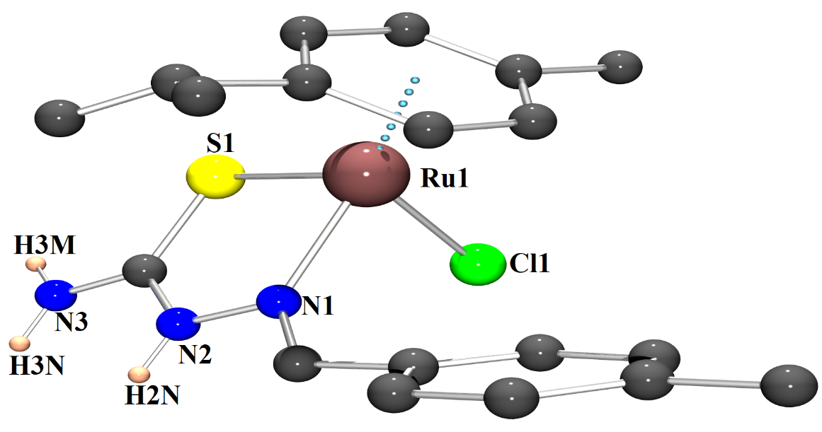
Figure S23. Ball and stick diagram of complex 1 presented just to show the mode of bonding. Hydrogen atoms (except NH protons) and counter ions have been omitted for clarity.
Figure S24. Ball and stick diagram of complex 8 presented just to show the mode of bonding. Hydrogen atoms and counter ions have been omitted for clarity.

Figure S25. Antibacterial results of the compounds against gram-positive and gram-negative bacteria strains with ciprofloxacin as the reference.

Figure S26. The minimum inhibitory concentration (MIC) and minimum bactericidal concentration (MBC) of the tested compounds.

