Supporting Information

Efficient removal of carcinogenic azo dyes by novel pyrazine-2-carboxylate substituted
calix[4, 8]arene derivatives

Ömer Güngör

University of Kocaeli, Advanced Vacational School of Hereke Omer Ismet Uzunyol, Department of Chemistry Technology, Kocaeli, Turkey
*Corresponding author e-mail: omer.gungor@kocaeli.edu.tr

Contents
Figure S1. Mass spectrum of the compound 3. | S2
Figure S2. Mass spectrum of the compound 6. | S2
Figure S3. H-NMR spectrum of the compound 3. | S3
Figure S3. H-NMR spectrum of the compound 6. | S3

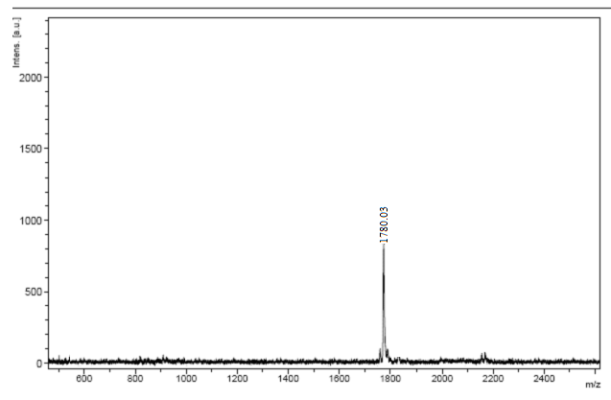
Figure S1. Mass spectrum of the compound 3.
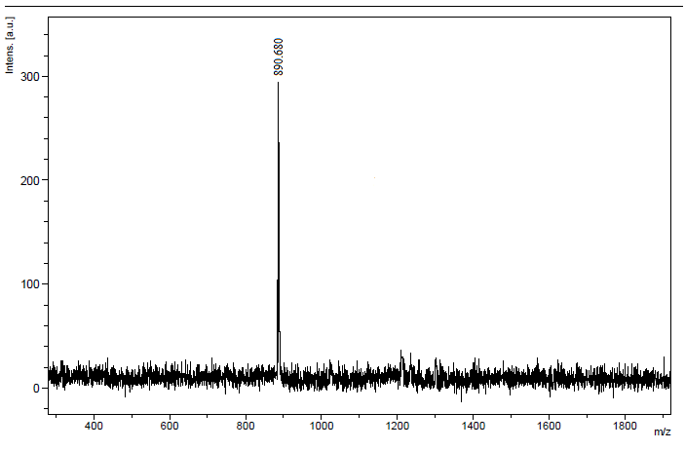
Figure S2. Mass spectrum of the compound 6.

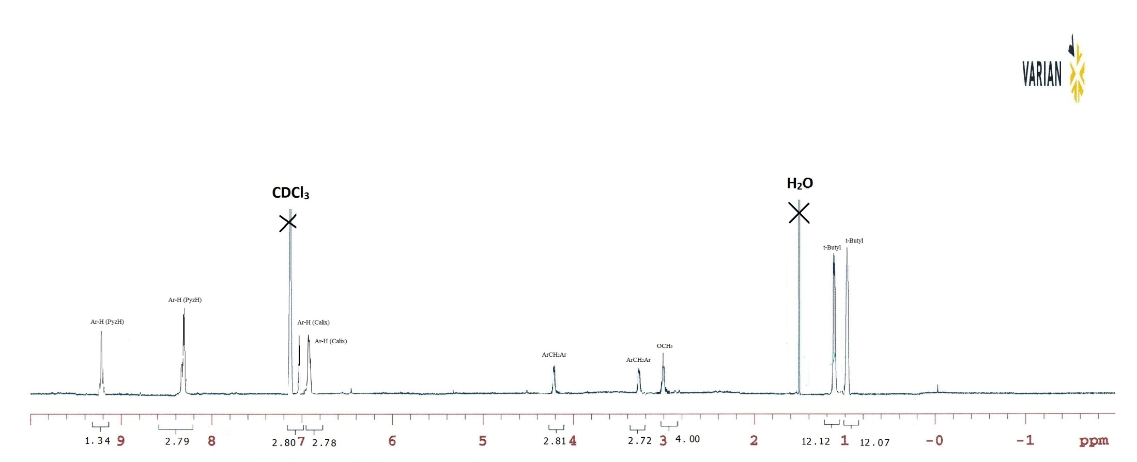
Figure S3. H-NMR spectrum of the compound 3.

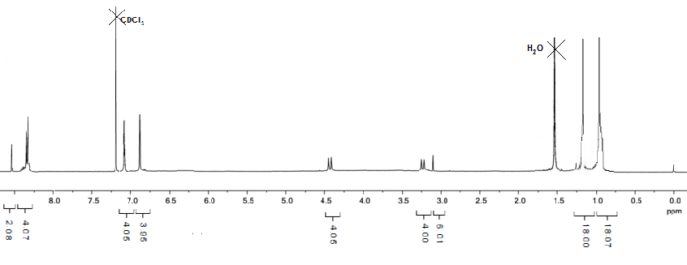
Figure S4. H-NMR spectrum of the compound 6.

