SUPPORTING INFORMATION

Fluorescent Macrocyclic Chemosensor for Zn(II) Detection at Alkaline pH Values
Gianluca Ambrosi,ª Mauro Micheloni,ª Daniele Paderni,ª Mauro Formica,ª Luca Giorgi,^{a*} Vieri Fusi^{a*}

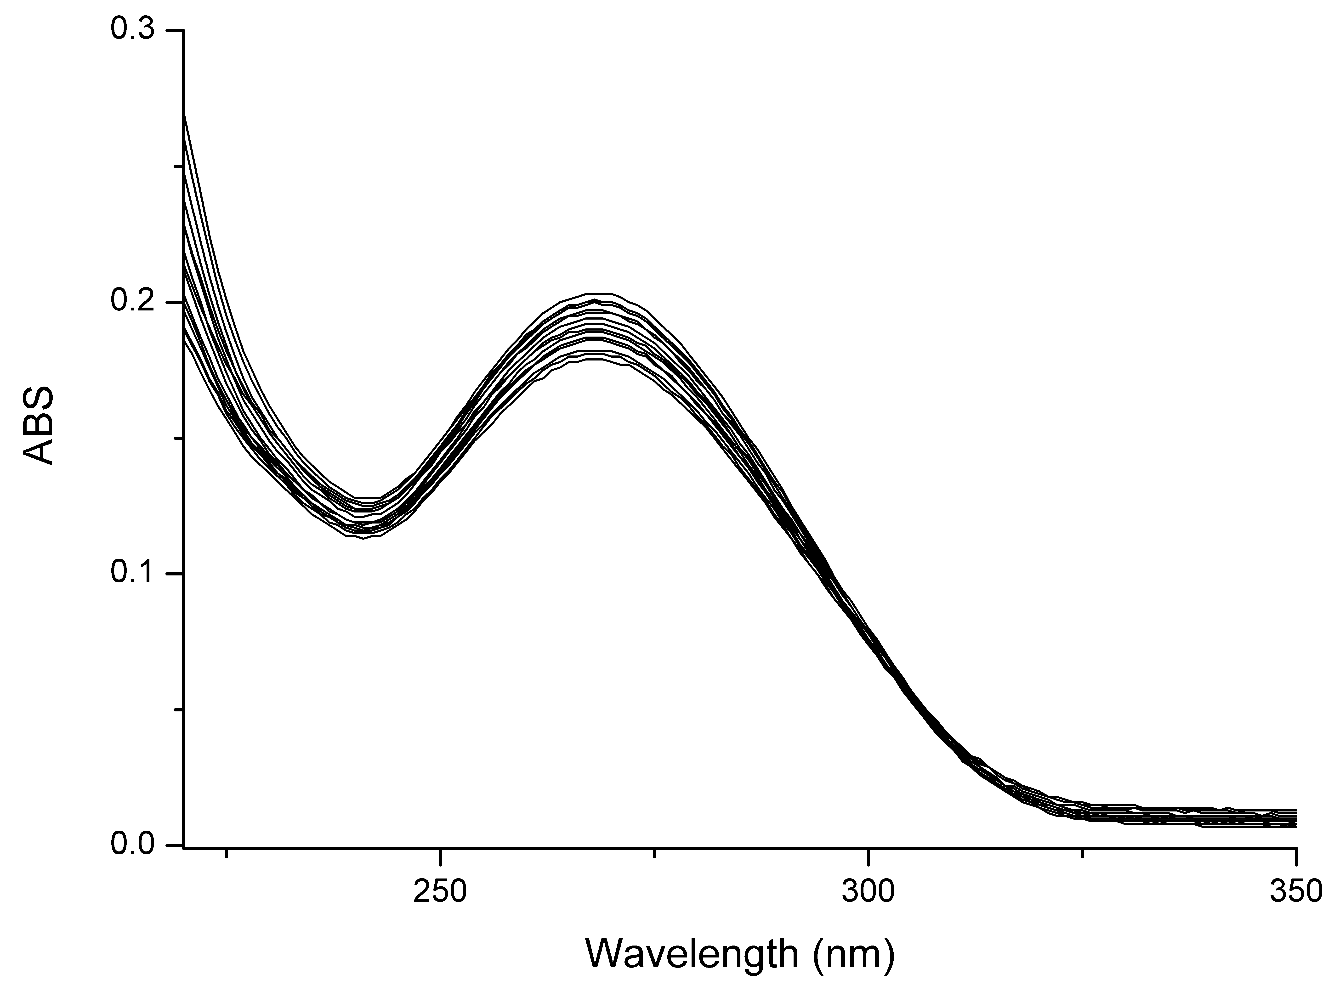

Figure S1. Absorption spectra of L registered in water/ethanol 99/1 v/v in the presence of HEPES buffer (10⁻³ mol dm⁻³) at pH = 7.0 by adding Zn(ClO₄)₂ up to 2 eq. ([L] = 1.5·10⁻⁵ mol dm⁻³)

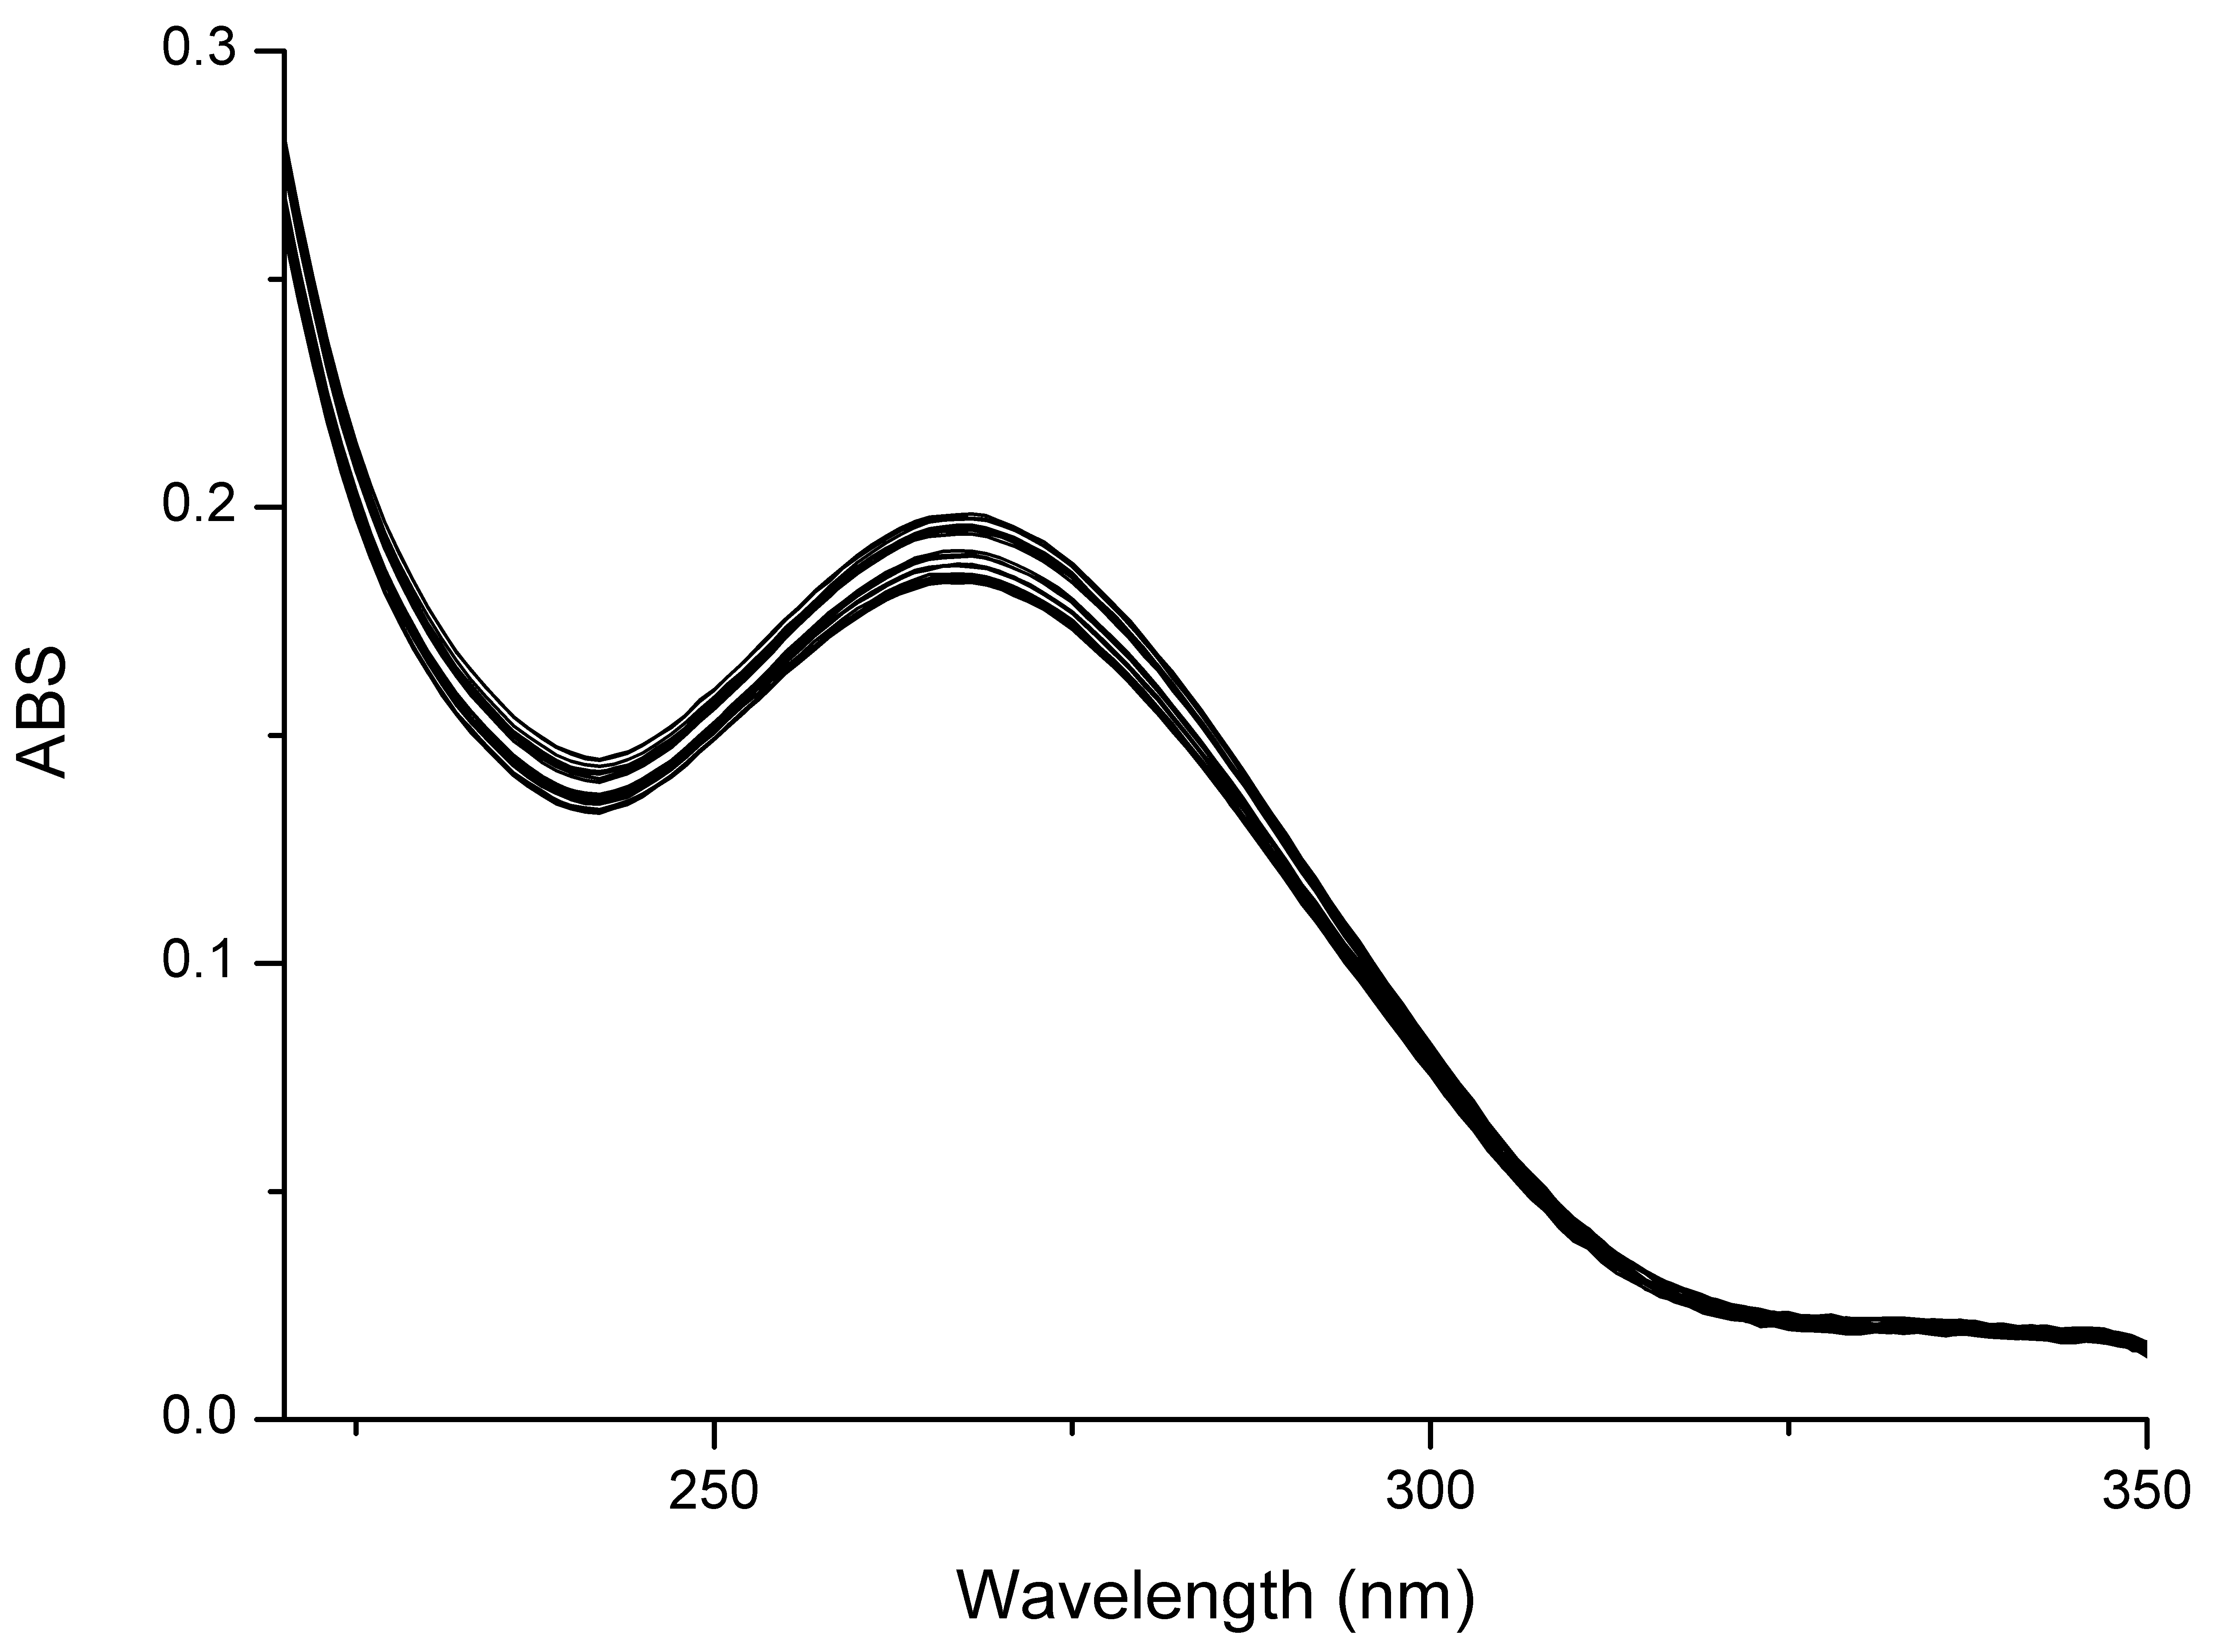

Figure S2. Absorption spectra of L registered in water/ethanol 99/1 v/v in the presence of HEPES buffer (10⁻³ mol dm⁻³) at pH = 7.0 by adding Cd(ClO₄)₂ up to 2 eq. ([L] = 1.5·10⁻⁵ mol dm⁻³)

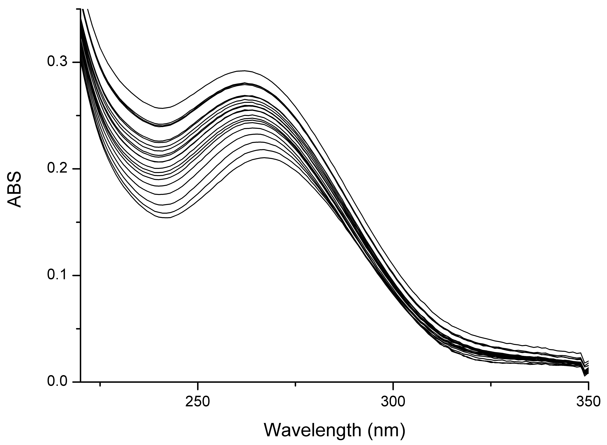

Figure S3. Absorption spectra of L registered in water/ethanol 99/1 v/v in the presence of HEPES buffer (10⁻³ mol dm⁻³) at pH = 7.0 by adding Cu(ClO₄)₂ up to 2 eq. ([L] = 1.5·10⁻⁵ mol dm⁻³)

