Supplementary material

Groundwater storage change from in situ and GRACE-based estimates in major river basins across India
Soumendra N. Bhanja^{1†}, Abhijit Mukherjee^{1,2}, Matthew Rodell³

Table S1. Datasets used in the study.
Parameter | Data source | Spatial resolution | Temporal resolution
Precipitation | India Meteorological Department (IMD) precipitation data (IMD4) | Gridded (0.25º × 0.25º) | Daily
Groundwater level | Central Groundwater Board (CGWB), India | Point | Quarterly
Terrestrial water storage (TWS) | GRACE, Spherical harmonics solution from NASA JPL | Gridded (1º × 1º) | Monthly
Terrestrial water storage (TWS) | GRACE, Mascon solution from NASA JPL | Gridded (1º × 1º) | Monthly
Soil moisture | GLDAS (CLM, Noah, VIC) from NASA | Gridded (1º × 1º) | Monthly
Surface runoff | GLDAS (CLM, Noah, VIC) from NASA | Gridded (1º × 1º) | Monthly

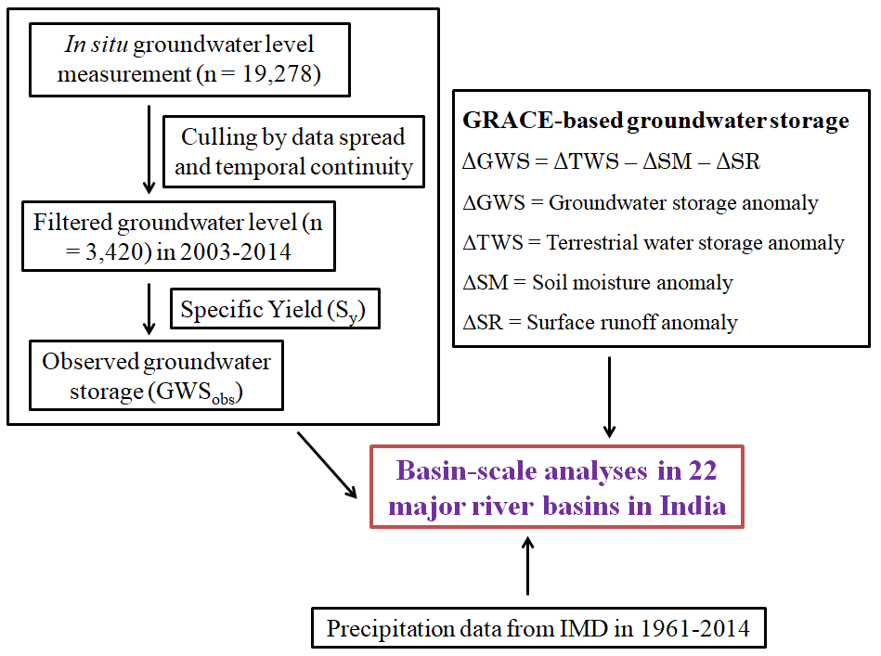
Figure S1. Flowchart showing the methodology adopted in the study.

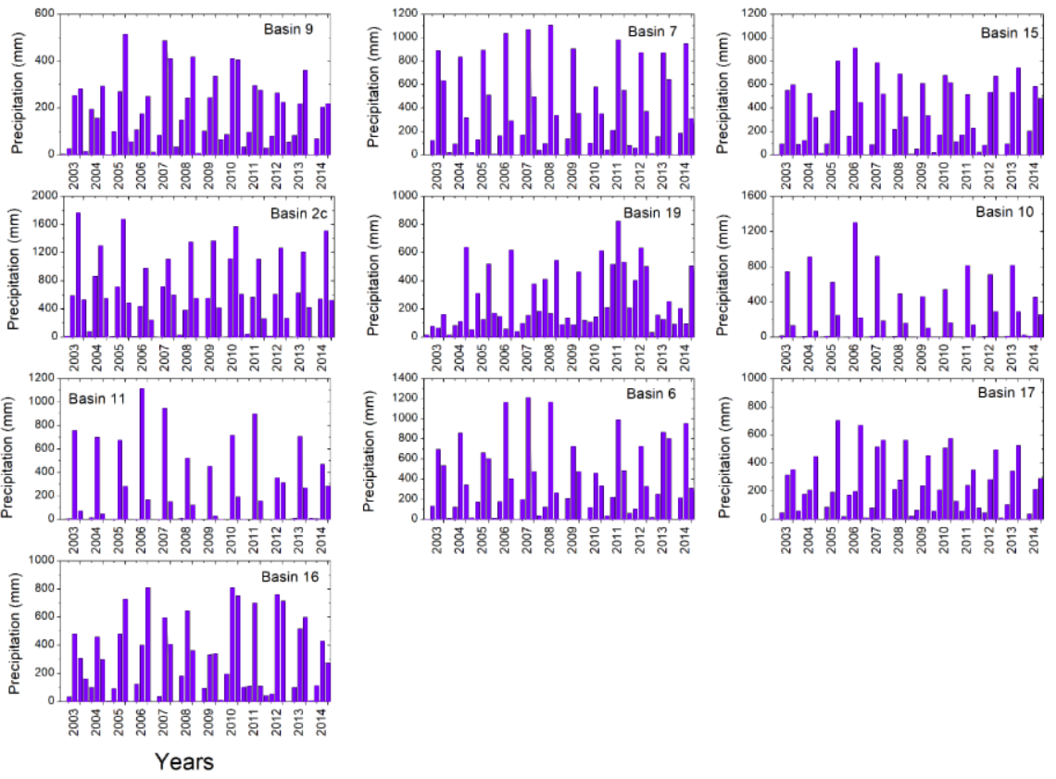
Figure S2. Basin-wise seasonal precipitation (mm). x-axis: seasons in 2003–2014 (four for each year). Basins are shown based on descending geographical area (N–S).

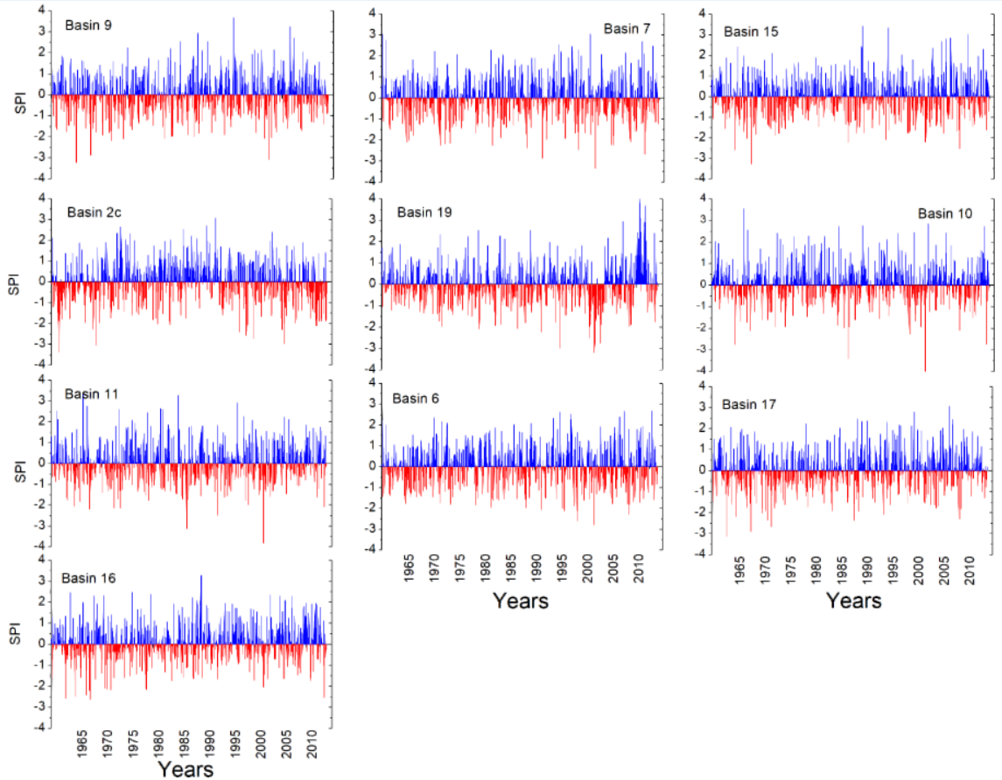
Figure S3. Basin-wise long-term (1961–2014) monthly SPI-1 values. Basins are shown based on descending geographical area.
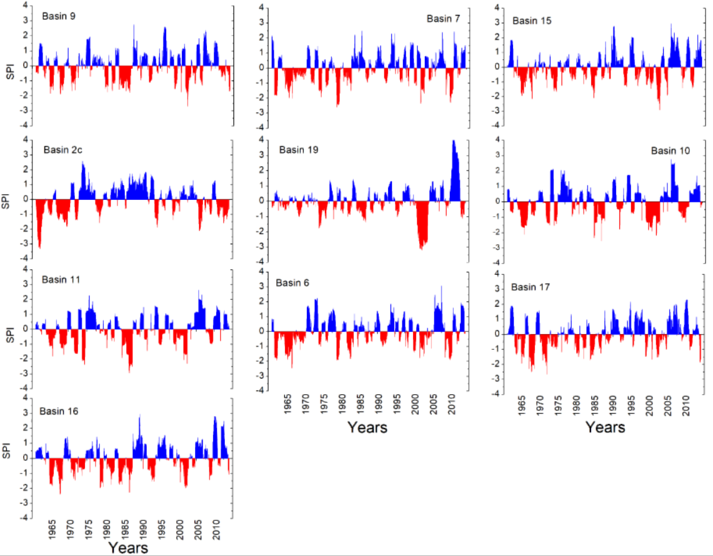Figure S4. Basin-wise long-term (1961–2014) monthly SPI-12 values. Basins are shown based on descending geographical area.
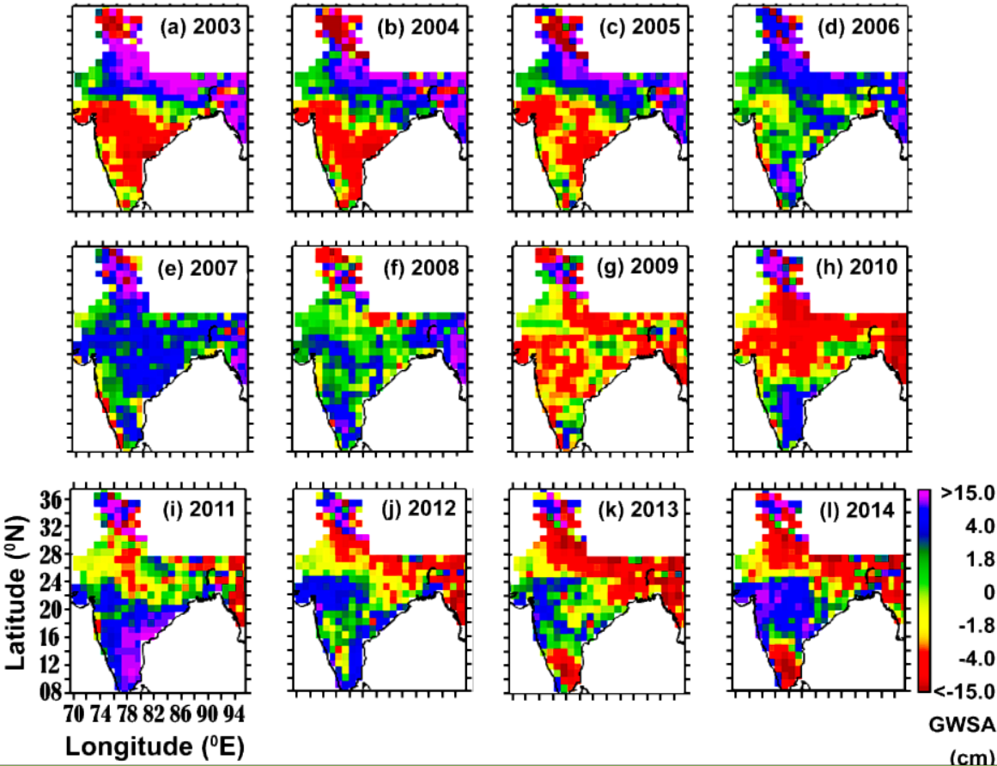
Figure S5. Annual satellite-based GWS anomalies (cm) using GRACE-SH data.
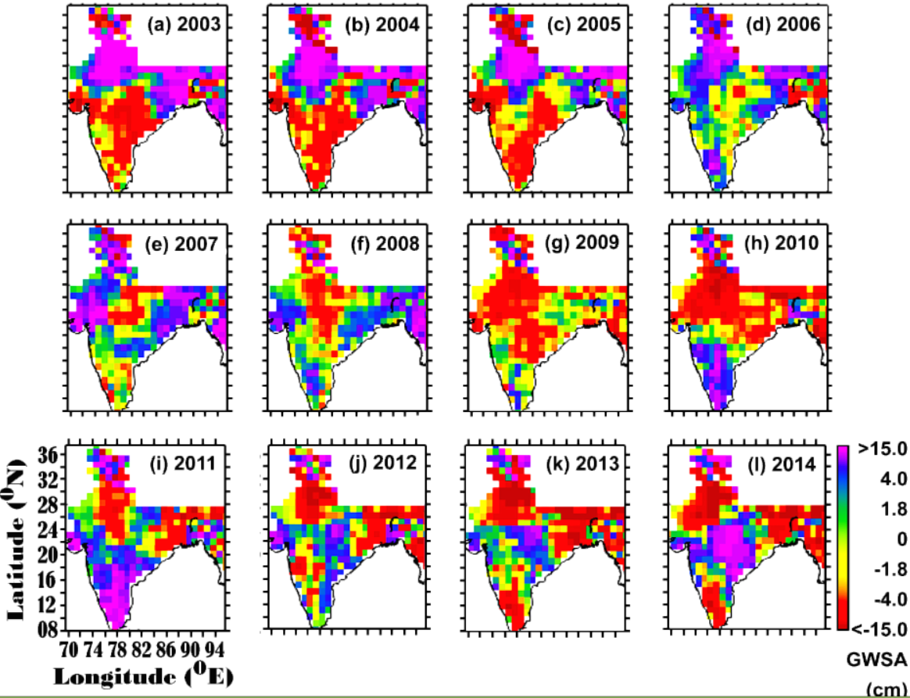
Figure S6. Annual satellite-based GWS anomalies (cm) using GRACE-MS data.

