Appendix 1. The expression of shipper surplus
 | $$CS=\int_{0}^{|z^{l}|}{\left[V-p_{1}-x\operatorname{Max}{\{0,D-I_{1}\}}-z t\right]}dz+\int_{0}^{z^{m}}{ }\left[V-p_{1}-x\operatorname{Max}{\{0, D-I_{1}\}}-zt\right]dz+\int_{z^{m}}^{1}{\left[V-p_{2}-x\operatorname{Max}{\{0, D-I_{2}\}-\left(1-z\right) t}\right]dz+\int_{1}^{z^{r}}{\left[V-p_{2}-x\operatorname{Max}{\{0, D-I_{2}\}-\left(z-1\right)t}\right]dz}}$$ | (A1)

Appendix 2. Numerical simulation on PA expected profit $E\left[Π_{i}\right]$ and expected regional welfare $E\left[SW\right]$.
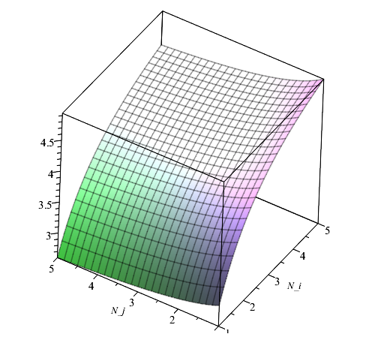
Figure A1. PA’s expected profit $E\left[Π_{i}(N_{i}, N_{j})\right]$ with changes in the number of TOCs in its own port (i.e., $N_{i}$) and the other port (i.e., $N_{j}$)
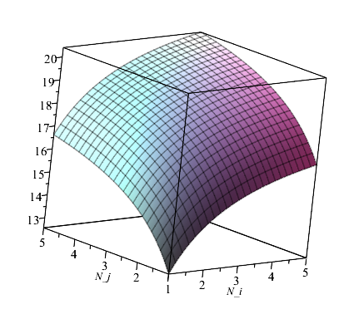
Figure A2. The expected regional welfare $E\left[SW(N_{i}, N_{j})\right]$ with changes in the number of TOCs at two ports (i.e., $N_{i}$ and $N_{j}$)
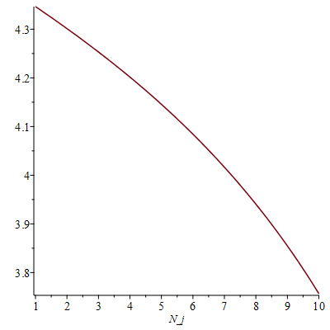
($V=1$, $D=1$, $t=0.05$, $Ω=0.01$,$Ψ=0.005$, $ω=0.2$, $N=5$, x=0.01)
Figure A3. PA expected profit $E\left[Π_{i}(N_{p})\right]$ with changes in the number of TOC JV pairs across two ports (i.e., $N_{p}$)
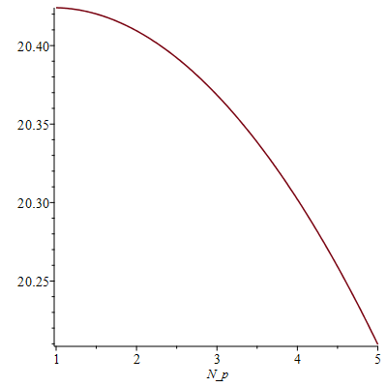
($V=1$, $D=1$, $t=0.05$, $Ω=0.01$,$Ψ=0.005$, $ω=0.2$, $N=5$, x=0.01)
Figure A4. The expected regional welfare $E\left[SW(N_{p})\right]$ with changes in the number of TOC JV pairs across two ports (i.e., $N_{p}$)

Appendix 3. TOC throughputs for JV and non-JV participants
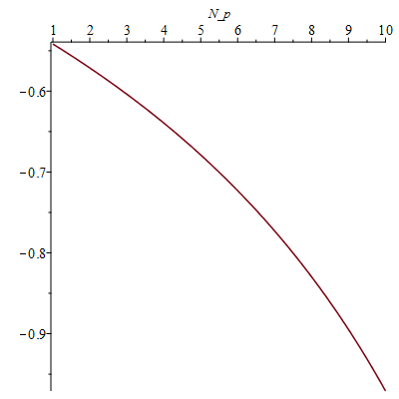
($V=1$, $D=1$, $t=0.05$, $Ω=0.01$,$Ψ=0.005$, $ω=0.2$, $N=5$, x=0.01)
Figure A5. Difference in throughput between JV and non-JV TOCs (i.e., ${q_{r,i}^{v}}^{*}-{q_{r,i}^{nv}}^{*}$) with the number of JV pairs cross two ports (i.e., $N_{p}$)

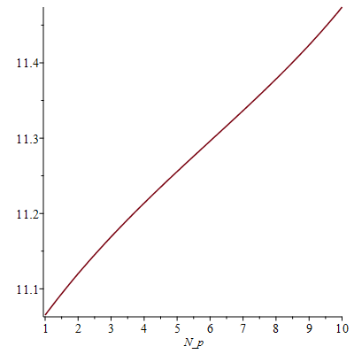
($V=1$, $D=1$, $t=0.05$, $Ω=0.01$,$Ψ=0.005$, $ω=0.2$, $N=10$, x=0.01)
Figure A6. Total port throughput between (i.e., $N_{p}{q_{r,i}^{v}}^{*}-(N-N_{p}){q_{r,i}^{nv}}^{*}$) with the number of JV pairs cross two ports (i.e., $N_{p}$)

