Supplemental Materials

NGSS Core Ideas for ESS3.B: Natural Hazards by Grade
Kindergarten
Some kinds of severe weather are more likely than others in a given region. Weather scientists forecast severe weather so that the communities can prepare for and respond to these events.

Grade 3
A variety of natural hazards result from natural processes. Humans cannot eliminate natural hazards but can take steps to reduce their impacts.

Grade 4
A variety of hazards result from natural processes (e.g., earthquakes, tsunamis, volcanic eruptions). Humans cannot eliminate the hazards but can take steps to reduce their impacts.

Middle School
Mapping the history of natural hazards in a region, combined with an understanding of related geologic forces can help forecast the locations and likelihoods of future events.

High School
Natural hazards and other geologic events have shaped the course of human history; [they] have significantly altered the sizes of human populations and have driven human migrations.

Operational Definitions for Levels of Science Knowledge
Naïve conception | Synthetic conception | Imprecise conception | Accepted  scientific understanding
scientifically incorrect ideas that appear to derive from perceptions of direct or vicarious phenomenological and sociocultural experiences; these ideas reflect perceptions that would be prior to, or without direct connection to, science instruction and learning | descriptions or explanations that combine aspects of incorrect conceptions with scientifically correct knowledge in a somewhat functional manner | descriptions or explanations that lack precision and clarity in representing scientifically accepted understandings | descriptions or explanations that are consistent with current scientifically accepted understandings

Operational Definitions for Levels of Preparedness Knowledge
Naïve conception | Synthetic conception | Imprecise conception | Accepted preparedness understanding
incorrect preparedness ideas that derive from perceptions of direct or vicarious phenomenological and sociocultural experiences; these ideas reflect perceptions that would be prior to, or without direct connection to, earthquake/tsunami preparedness instruction and learning | descriptions or explanations that combine incorrect conceptions with correct preparedness knowledge in a somewhat functional manner | descriptions or explanations that lack precision and clarity in representing accepted preparedness understandings | descriptions or explanations that are consistent with current accepted understandings of preparedness actions prior to, during, and after an earthquake or tsunami

Operational Definitions for Dimensions of Ontological Beliefs
Dimension
Thing | Direct process | Emergent process | Superintendent
- unconnected to process  - isolated entity, occurrence, or event  - random, unpredictable or predictable entity, occurrence, or event  - controllable or uncontrollable entity, occurrence, or event | - the observed occurrence/event or outcome/pattern is the result of a linear, sequential, or cause/effect interaction  - a single controlling agent directly or indirectly causes the occurrence/event or outcome/pattern  - a limited duration occurrence/event or outcome/pattern is not related to an ongoing process (i.e., what happened prior to, what will happen after) | - the interactions of multiple agents cause the occurrence/event or outcome/pattern  - the agents can act simultaneously and independently  - the outcome/pattern emerges from the collective interactions of the agents  - the process can continue beyond the observed occurrence/event | - a governing agent or teleological process

Operational Definitions for Dimensions of Epistemic Beliefs
Dimension
Certainty | Structure | Source | Rationale
the degree to which the student represents his or her science or preparedness knowledge as complete, certain, fixed, tentative, or subject to change | the degree to which the science or preparedness knowledge that the student represents is simplistic or complex conceptual understandings that relate facts together | the sources that the student represents for his or her knowledge of earthquake and tsunami | the student’s use of a rationale to support his or her claims of science or preparedness knowledge

Questions in the Earthquake Booklet for Students
- Describe what you think causes earthquakes to occur. If you are not sure of your response, that is OK. Just describe what you think might cause earthquakes to occur.
- Based on your response to Number 1, draw and label a diagram that shows what you think causes earthquakes to occur.
- Describe what you think are some of the effects of earthquakes. If you are not sure of your response, that is OK. Just describe what you think might be some of the effects of earthquakes.
- Based on your response to Number 3, draw and label a diagram to show what you think are some of the effects of earthquakes.
- Do you think an earthquake will ever occur in this area? Why do you think this?
- Describe some of the ways people can prepare for an earthquake. If you are not sure of your response, that is OK. Just describe some of the ways you think people might prepare for an earthquake.
- Suppose you experience an earthquake in the future. What do you think you would do during the earthquake? Why would you do this?
- Suppose you experience an earthquake in the future. How do you think you would feel during the earthquake? Why would you feel this way?
- Suppose a friend asked you the following question: “Do you think people can know when and where an earthquake will occur? What would you tell your friend?

Questions in the Tsunami Booklet for Students
- Describe what you think causes tsunamis to occur. If you are not sure of your response, that is OK. Just describe what you think might cause tsunamis to occur.
- Based on your response to Number 1, draw and label a diagram that shows what you think causes tsunamis to occur.
- Describe what you think are some of the effects of tsunamis. If you are not sure of your response, that is OK. Just describe what you think might be some of the effects of tsunamis.
- Based on your response to Number 3, draw and label a diagram to show what you think are some of the effects of tsunamis.
- Do you think a tsunami will occur along the coast of Oregon? Why do you think this?
- Describe some of the ways people can prepare for a tsunami. If you are not sure of your response, that is OK. Just describe some of the ways you think people might prepare for a tsunami.
- Suppose in the future you were somewhere at the coast. How would you know whether or not a tsunami was coming?
- Suppose in the future you were at the coast and you thought a tsunami was coming. What do you think you would do? Why would you do this?
- Suppose a friend asked you the following question: “Do you think people can prevent tsunamis from occurring? What would you tell your friend?

Planned Questions in the Interview Protocol
- Let’s first look at your Earthquake Booklet for Students. Can you describe for me what your diagram in Number 2 is showing about what causes earthquakes to occur?
- Can you describe for me what your diagram in Number 4 is showing about the effects of earthquakes?
- How sure are you about your descriptions of the causes and effects of earthquakes? For example, are you very sure, somewhat sure, just a little bit sure, or not sure at all?
- Can you tell me how each of the ways you described in Number 6 will help people prepare for an earthquake?
- For Number 7, you answered that you would ________________ if an earthquake occurred in the future. Suppose an earthquake occurred right now, what would be the best thing for you to do?
- Number 9 was about what you would tell your friend if they asked whether people can know when and where an earthquake will occur. You said you would tell your friend _______________________. What reasons would you give for your answer to your friend?
- Let’s now look at your Tsunami Booklet for Students. Can you describe for me what your diagram in Number 2 is showing about what causes tsunamis to occur?
- Can you describe for me what your diagram in Number 4 is showing about the effects of tsunamis?
- How sure are you about your descriptions of the causes and effects of tsunamis? For example, are you very sure, somewhat sure, just a little bit sure, or not sure at all?
- Can you tell me how each of the ways you described in Number 6 will help people prepare for a tsunami?
- Number 9 was about what you would tell your friend if they asked whether people can prevent tsunamis from occurring. You said you would tell your friend _______________________. What reasons would you give for your answer to your friend?
- We have been talking a lot about earthquakes and tsunamis. Where have you learned about earthquakes and tsunamis and where do your ideas come from?
- Do you think your knowledge about earthquakes and tsunamis will change in the future, and why do you think this way?
- Who do you think is most responsible for helping people be prepared for earthquakes and tsunamis?
- Suppose a friend asked you the following question: “If earthquakes and tsunamis can be so destructive to people and buildings, why do you think they happen at all?” What would you tell your friend?

Examples of Student Workbook Responses

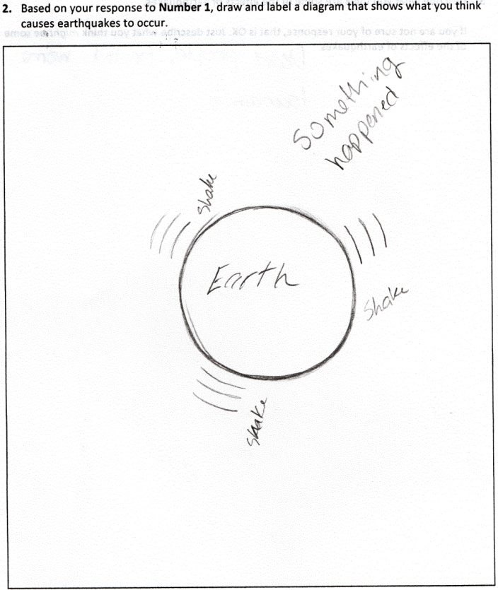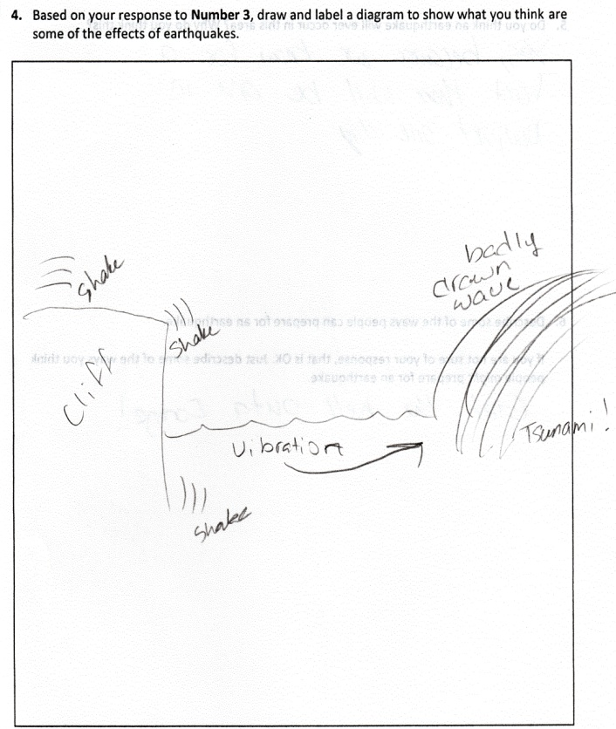

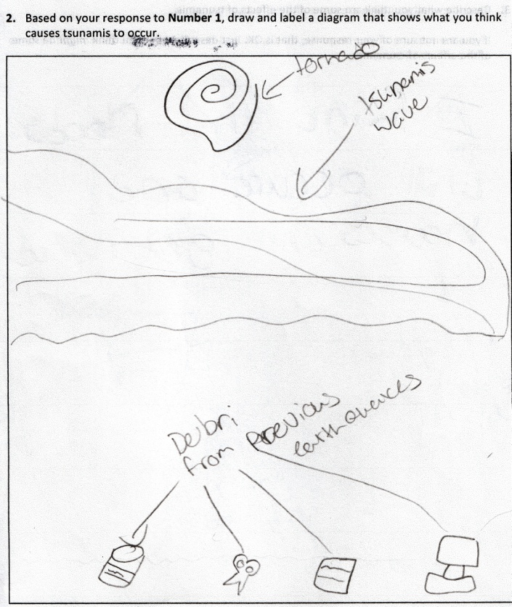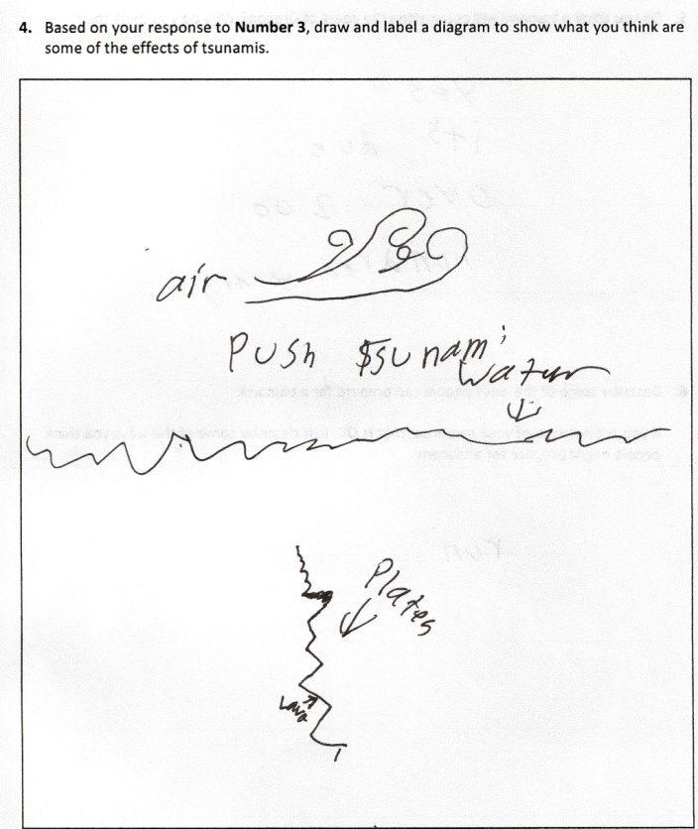

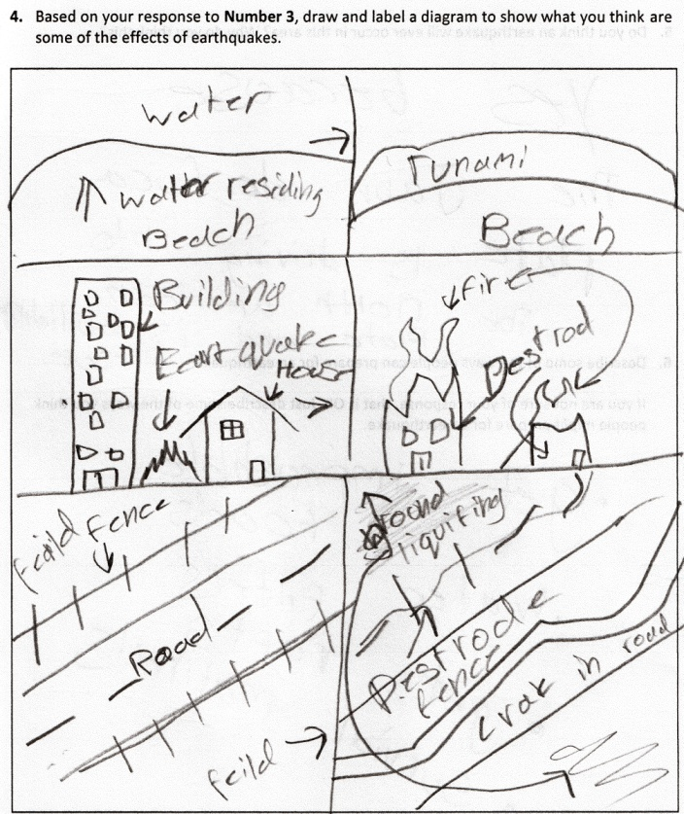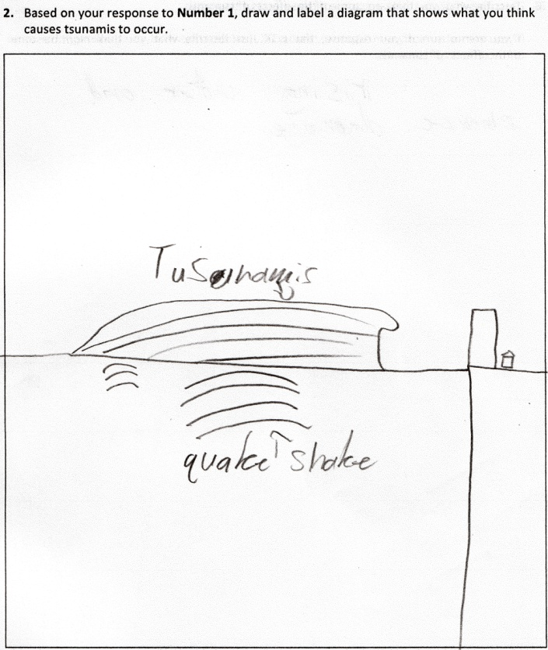

Examples of Student Representations of Sources of Knowledge

