Attacked from two fronts: interactive effects of anthropogenic and biotic disturbances generate complex movement patterns
Salvatore Valente, Anna Skarin, Paolo Ciucci, Alessia Uboni*

* Corresponding author. Department of Animal Nutrition and Management, Swedish University of Agricultural Sciences, 750 07 Uppsala, Sweden. E-mail: auboni@mtu.edu

Table S1. Thresholds of meteorological conditions at which oestrid (a) and mosquito (b) activity occurs, according to different studies.
(a) Oestrid activity
Source | Maximum  wind speed (m/s) | Minimum temperature (°C)
Hagemoen and Reimers (2002) | 12 | 6.9
Colman (2000) | - | 13
Mörschel (1996) | 11 | 10
Anderson et al. (1994) | 6-8 | 10
Helle et al. (1992) | - | 16-24
Helle and Tarvainen (1984) | - | 13-17
Helle and Aspi (1984) | - | 15
Kelsall (1975) | 8-9 | 13-15
White et al. (1975) | - | 13
MEAN | 9.6 | 13
(b) Mosquito activity
Source | Maximum  wind speed (m/s) | Temperature range  (°C)
Hagemoen and Reimers (2002) | 5-7.5 | t < 16
Anderson et al. (2001) | - | t > 7
Nixon and Russell (1990) | 6 | 7 < t < 18
Russell et al. (1993) | 6 | t > 7
White et al. (1975) | - | t > 7
MEAN | 6.12 | 7 < t < 17

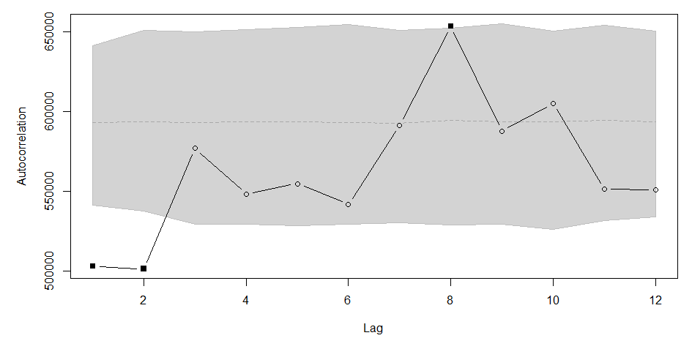
Figure S1. Correlogram showing temporal autocorrelation (y-axis) in the movement rates of a sample reindeer followed through a GPS collar in 2010 in the Udtja reindeer-herding district in northern Sweden. Filled squares indicate temporal autocorrelation with the reference value, i.e. lag = 0. The plot was created following Dray et al. (2010) and is the output of the acfdist.ltraj function available in the R package “adehabitatLT” (Calenge, 2006). We repeated the same assessment for all reindeer and years.

Figure S2. Circadian patterns in mean reindeer movement rates. The thick, horizontal line inside each boxplot represents the movement rate median for each hour of the day, averaged across individuals, while the white dots represent the mean. The panels refer to: A) all reindeer followed in 2010; B) all reindeer followed in 2011 starting on July 12 at midnight; C) all reindeer followed in 2011 starting on July 12 at 1 am; D) all reindeer followed in 2012 starting on July 12 at midnight; and E) all reindeer followed in 2012 starting on July 12 at 1 am.

Table S2. Occurrence of oestrid and mosquito harassment from July 12 to September 10, 2010-2012 in the Udtja reindeer herding community.
 | Presence | Absence | Exclusive presence | Total
OHI | 3298 | 15973 | 1006 | 19271
MHI | 4298 | 14973 | 5 | 19271
NOTE: Insect harassment was estimated using the Insect Harassment Indices (IHIs) described in the Methods section of the main manuscript. Data refer to the number of records (corresponding to the two-hour intervals of the GPS data) in which the IHIs were >0 (presence) or =0 (absence). “Exclusive presence” refers to the case in which an insect group was present (IHI > 0), while the other was absent (IHI=0). OHI = Oestrid Harassment Index. MHI = Mosquito Harassment Index.

Table S3. Model performance of two sets of regression models aimed to verify whether reindeer left the Vidsel Test Range, northern Sweden, while military exercises occurred in summers 2010-2012.
Predictor | Model | Random term | Correlation | df | AIC | Δ AIC | w_{i}
Vehicle | GLS.M1.cor1 |  | √ | 6 | 20474.69 | 0.00 | 0.73
 | GLMM.M1.cor1 | √ | √ | 7 | 20476.69 | 2.00 | 0.27
 | GLMM.M1 | √ |  | 6 | 23286.69 | 2812.00 | 0.00
 | GLMM.M3 | √ |  | 7 | 23288.69 | 2814.00 | 0.00
 | GLMM.M2 | √ |  | 6 | 24110.93 | 3636.24 | 0.00
 | GLS.M1 |  |  | 5 | 24242.77 | 3768.08 | 0.00
Aircraft | GLS.Ma.cor1 | √ | √ | 6 | 20459.97 | 0.00 | 0.73
 | GLMM.Ma.cor1 | √ |  | 7 | 20461.97 | 2.00 | 0.27
 | GLMM.Ma | √ |  | 6 | 23266.18 | 2806.21 | 0.00
 | GLMM.Mb |  |  | 6 | 24101.70 | 3641.73 | 0.00
 | GLS.Ma |  |  | 5 | 24231.58 | 3771.61 | 0.00
NOTES: The response variable in all models was the daily average Euclidean distance (in meters) between each reindeer and the three activity points (E, Q and T). The predictor variable was a categorical variable describing the occurrence of military exercises performed either with vehicles or with aircrafts, computed as the sum of the occurrence of military exercises at the three activity points. Models GLS.M1 and GLS.Ma were Generalized Least Squares (GLS) models. Models GLS.M1.cor1 and GLS.Ma.cor1 were also GLS models, but included an autoregressive correlation structure of the residuals AR1. Models GLMM.M1.cor1, GLMM.M1, GLMM.Ma.cor1, and GLMM.Ma were generalized linear mixed models (GLMM) with reindeer ID as a random intercept term. In addition, models GLMM.M1.cor1 and GLMM.Ma.cor1 contained an autoregressive correlation structure of the residuals AR1. Models GLMM.M2 and GLMM.Mb included year as a random intercept term. Model GLMM.M3 included reindeer ID/year as nested random terms. A similar model could not be run for military activities performed with aircraft because of overparameterization. df = degrees of freedom; AIC = Akaike Information Criterion; Δ AIC = difference in AIC compared to the best-fit model; w_{i} = Akaike weights.
Table S4. Model performance of four sets of regression models aimed to test the effects of military exercises performed at the Vidsel Test Range, northern Sweden, and insect harassment on reindeer movement rates in summer 2010-2012.
Focus variables ª | Model ^{b} | Random term | Variance structure | Correlation | df | AIC | Δ AIC | w_{i}
OHI + Vehi_ALL | GLS.var.year.cor |  | √ | √ | 28 | 274762.5 | 0.0 | 1.00
 | GLS.var.year |  | √ |  | 26 | 274961.2 | 198.7 | 0.00
 | GLS.var.month |  | √ |  | 26 | 274997.5 | 235.0 | 0.00
 | GLS |  |  |  | 24 | 275089.3 | 326.8 | 0.00
 | GLMM.id | √ |  |  | 25 | 275091.3 | 328.8 | 0.00
 | GLMM.year | √ |  |  | 25 | 275091.3 | 328.8 | 0.00
 | GLMM.id.year | √ |  |  | 26 | 275093.3 | 330.8 | 0.00
OHI + Air_ALL | GLS.var.year.cor |  | √ | √ | 28 | 274760.5 | 0.0 | 1.00
 | GLS.var.year |  | √ |  | 26 | 274960.6 | 200.1 | 0.00
 | GLS.var.month |  | √ |  | 26 | 274997.1 | 236.6 | 0.00
 | GLS |  |  |  | 24 | 275088.8 | 328.3 | 0.00
 | GLMM.id | √ |  |  | 25 | 275090.8 | 330.3 | 0.00
 | GLMM.year | √ |  |  | 25 | 275090.8 | 330.3 | 0.00
 | GLMM.id.year | √ |  |  | 26 | 275092.8 | 332.3 | 0.00
MHI + Vehi_ALL | GLS.var.year.cor |  | √ | √ | 28 | 274706.4 | 0.0 | 1.00
 | GLS.var.year |  | √ |  | 26 | 274892.2 | 185.8 | 0.00
 | GLS.var.month |  | √ |  | 26 | 274930.0 | 223.6 | 0.00
 | GLS |  |  |  | 24 | 275020.7 | 314.3 | 0.00
 | GLMM.id | √ |  |  | 25 | 275022.7 | 316.3 | 0.00
 | GLMM.year | √ |  |  | 25 | 275022.7 | 316.3 | 0.00
 | GLMM.id.year | √ |  |  | 26 | 275024.7 | 318.3 | 0.00
MHI + Air_ALL | GLS.var.year.cor |  | √ | √ | 28 | 274702.5 | 0.0 | 1.00
 | GLS.var.year |  | √ |  | 26 | 274888.0 | 185.5 | 0.00
 | GLS.var.month |  | √ |  | 26 | 274926.2 | 223.7 | 0.00
 | GLS |  |  |  | 24 | 275016.7 | 314.2 | 0.00
 | GLMM.id | √ |  |  | 25 | 275018.7 | 316.2 | 0.00
 | GLMM.year | √ |  |  | 25 | 275018.7 | 316.2 | 0.00
 | GLMM.id.year | √ |  |  | 26 | 275020.7 | 318.2 | 0.00
ª The focus variables were OHI = Oestrid Harassment Index, MHI = Mosquito Harassment Index, and the military exercises variables (either Vehi_ALL or Air_ALL). In addition to the focus variables, all models included the following variables: vegetation type, elevation, slope, ruggedness, temperature, NDVI, Area, and distance from roads. The models also included interaction terms 1) between the Insect Harassment Indices (either OHI or MHI) and i) the military exercises variables (either Vehi_ALL or Air_ALL), ii) vegetation type, iii) elevation, and iv) distance from roads; and 2) between Area and i) distance from roads and ii) the military exercises variables.
^{b} GLS = Generalized Least Squares model. GLMM = Generalized Linear Mixed-effect Model. The models GLS.var.year.cor were GLS models with year as fixed variance structure and an exponential spatial autocorrelation structure with range = 850, nugget = 0.4 and sill = 1.
NOTES: df = degrees of freedom. AIC = Akaike Information Criterion; Δ AIC = difference in AIC compared to the best-fit model; w_{i} = Akaike weights.

References

Anderson, J., Nilssen, A., and Folstad, I., 1994: Mating behavior and thermoregulation of the reindeer warble fly, Hypoderma tarandi L. (Diptera: Oestridae). Journal of Insect Behavior, 7(5): 679-706.
Anderson, J. R., Nilssen, A. C., and Hemmingsen, W., 2001: Use of host-mimicking trap catches to determine which parasitic flies attack reindeer, Rangifer tarandus, under different climatic conditions. The Canadian Field-Naturalist, 115(2): 274–286.
Calenge, C., 2006: The package “adehabitat” for the R software: a tool for the analysis of space and habitat use by animals. Ecological Modelling, 197(3): 516-519.
Colman, J., 2000: Behaviour patterns of wild reindeer in relation to sheep and parasitic flies. Dissertation, Faculty of Mathematics and Natural Sciences, University of Oslo, Oslo, Norway. Pages pp.
Dray, S., Royer-Carenzi, M., and Calenge, C., 2010: The exploratory analysis of autocorrelation in animal-movement studies. Ecological Research, 25(3): 673-681.
Hagemoen, R. I. M. and Reimers, E., 2002: Reindeer summer activity pattern in relation to weather and insect harassment. Journal of Animal Ecology, 71(5): 883-892.
Helle, T. and Aspi, J., 1984: Do sandy patches help reindeer against insects? Kevo Subarct. Res. Stat., 1957-62.
Helle, T. and Tarvainen, L., 1984: Effects of insect harassment on weight gain and survival in reindeer calves. Rangifer, 4(1): 24-27.
Helle, T., Aspi, J., Lempa, K., and Taskinen, E., 1992: Strategies to avoid biting flies by reindeer: field experiments with silhouette traps. Annales Zoologici Fennici, 29(2): 69-74.
Kelsall, J., Warble fly distribution among some Canadian caribou. In Luick, J. R., Lent, P. C., Klein, D. R., and White, R. G. (eds.), Proceedings of the First International Reindeer/Caribou Symposium 1972, conference proceedings, Fairbanks, Alaska, 1975, 509-517.
Mörschel, F. M., 1996: Effects of weather and parasitic insects on summer ecology of caribou of the Delta Herd. MSc Thesis, University of Alaska, Fairbanks, Alaska. Pages pp.
Nixon, W. and Russell, D., 1990: Group dynamics of the Porcupine Caribou Herd during insect season. Rangifer, 10(3): 175.
Russell, D. E., Martell, A. M., and Nixon, W. A., 1993: Range ecology of the Porcupine caribou herd in Canada. Rangifer, 13(5): 1-168.
White, R. G., Thomson, B., Skogland, T., Person, S., Russell, D., Holleman, D., and Luick, J., 1975: Ecology of caribou at Prudhoe Bay, Alaska. University of Alaska, Alaska, USA.

