Electronic Supplementary Information

Micellization, surface activities and thermodynamics study of dialkylpyridinium [C₁₆pymC_{n}][Br] (n = 1-4) in aqueous solutions

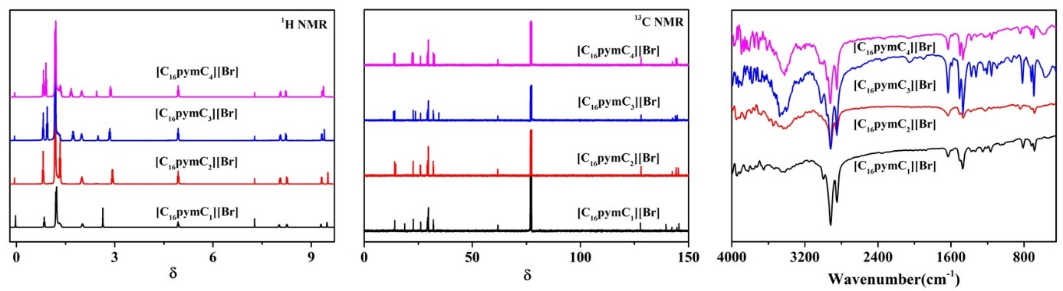
Figure S1. (¹H, ¹³C) NMR and FTIR spectrum of synthesized
[C₁₆pymC_{n}][Br]( n=1-4).

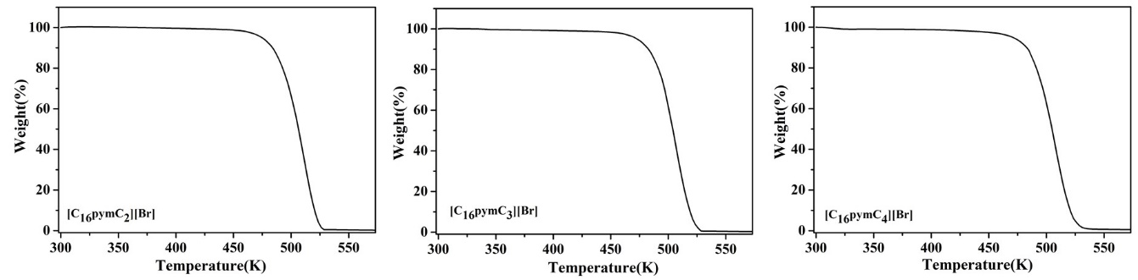
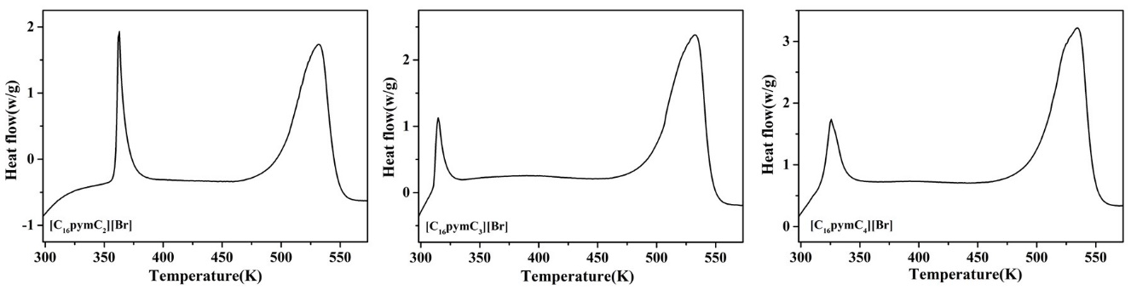
Figure S2. TG and DSC spectrum of synthesized [C₁₆pymC_{n}][Br](n=2-4).

Table S1. Coefficients of polynomials X_{CMC}=A+ BT + CT²; the temperature T*(CMC), at the minimum critical micelle concentration, CMC*
ILs | A | B | C | CMC* | T*
[C₁₆pymC₁][Br] | 6.57864 | -0.0443 | 8.071×10⁻⁵ | 0.521 | 283.20
[C₁₆pymC₂][Br] | 11.1991 | -0.0751 | 1.307×10⁻⁴ | 0.426 | 290.56
[C₁₆pymC₃][Br] | 8.15074 | -0.0547 | 9.524×10⁻⁵ | 0.293 | 287.09
[C₁₆pymC₄][Br] | 10.3093 | -0.0726 | 1.298×10⁻⁴ | 0.160 | 287.69
ª Units: T(K); B(K⁻¹); C(K⁻²); T*(K); CMC*(mmol·L⁻¹)

Table S2. Coefficients of polynomials log X_{CMC}=A+ BT + CT²; T₀ at ΔH_{m}^{θ}=0; standard heat capacity change upon micelle formation, ΔC_{p,m}^{θ}, for the investigated systems.
ILs | A | B | C | T₀ | ΔC_{p,m}^{θ}
[C₁₆pymC₁][Br] | 1.54843 | -0.0276 | 4.857×10⁻⁵ | 285.16 | -316.39
[C₁₆pymC₂][Br] | 4.09443 | -0.0644 | 1.126×10⁻⁴ | 287.02 | -671.84
[C₁₆pymC₃][Br] | 6.18604 | -0.0792 | 1.368×10⁻⁴ | 291.05 | -791.88
[C₁₆pymC₄][Br] | 6.24757 | -0.09491 | 1.626×10⁻⁴ | 288.19 | -954.49
ª Units: T(K); B(K⁻¹); C(K⁻²); T₀(K); ΔC_{p,m}^{θ} ( J·K⁻¹·mol⁻¹)

