Supporting information
A smart ATP-responsive chemotherapy drug-free delivery system using a DNA nanostructure for synergistic treatment of breast cancer in vitro and in vivo
Khalil Abnous^{a,b,¥}, Noor Mohammad Danesh^{c,¥}, Mohammad Ramezaniª, Mona Alibolandiª, Amirhossein Bahreyni^{a,d,e}, Parirokh Lavaee^{f}, Seyedeh Alia Moosavian^{g}, Seyed Mohammad Taghdisi^{h,i,}*

ªPharmaceutical Research Center, Pharmaceutical Technology Institute, Mashhad University of Medical Sciences, Mashhad, Iran.
^{b}Department of Medicinal Chemistry, School of Pharmacy, Mashhad University of Medical Sciences, Mashhad, Iran.
^{c}Research Institute of Sciences and New Technology, Mashhad, Iran.
^{d}Centre for Heart Lung Innovation, St. Paul's Hospital, Vancouver, BC, Canada.
^{e}Department of Pathology and Laboratory Medicine, University of British Columbia, Vancouver, BC, Canada.
^{f}Academic Center for Education, Culture and Research, Research Institute for Industrial Biotechnology, Industrial Biotechnology on Microorganisms, Mashhad, Iran.
^{g}Nanotechnology Research Center, Pharmaceutical Technology Institute, Mashhad University of Medical Sciences, Mashhad, Iran.
^{h}Targeted Drug Delivery Research Center, Pharmaceutical Technology Institute, Mashhad University of Medical Sciences, Mashhad, Iran.
^{i}Department of Pharmaceutical Biotechnology, School of Pharmacy, Mashhad University of Medical Sciences, Mashhad, Iran.
Short title: A smart ATP-responsive chemotherapy drug-free delivery system
¥ These authors contributed equally to the work.
* Corresponding author: Dr. Seyed Mohammad Taghdisi (taghdisihm@mums.ac.ir), Tel.: +98 513 1801203, Fax.: +98 513 882 3251

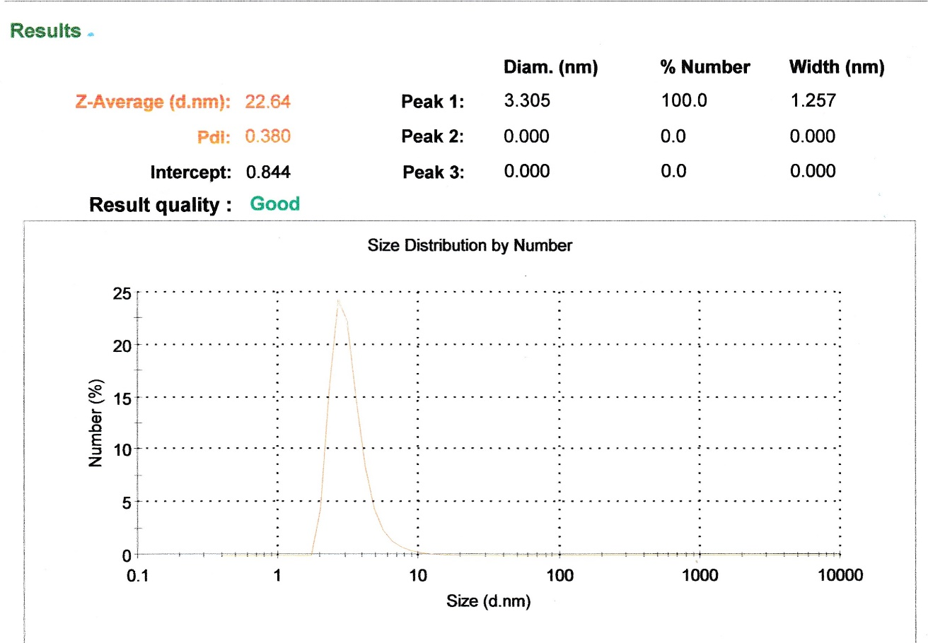
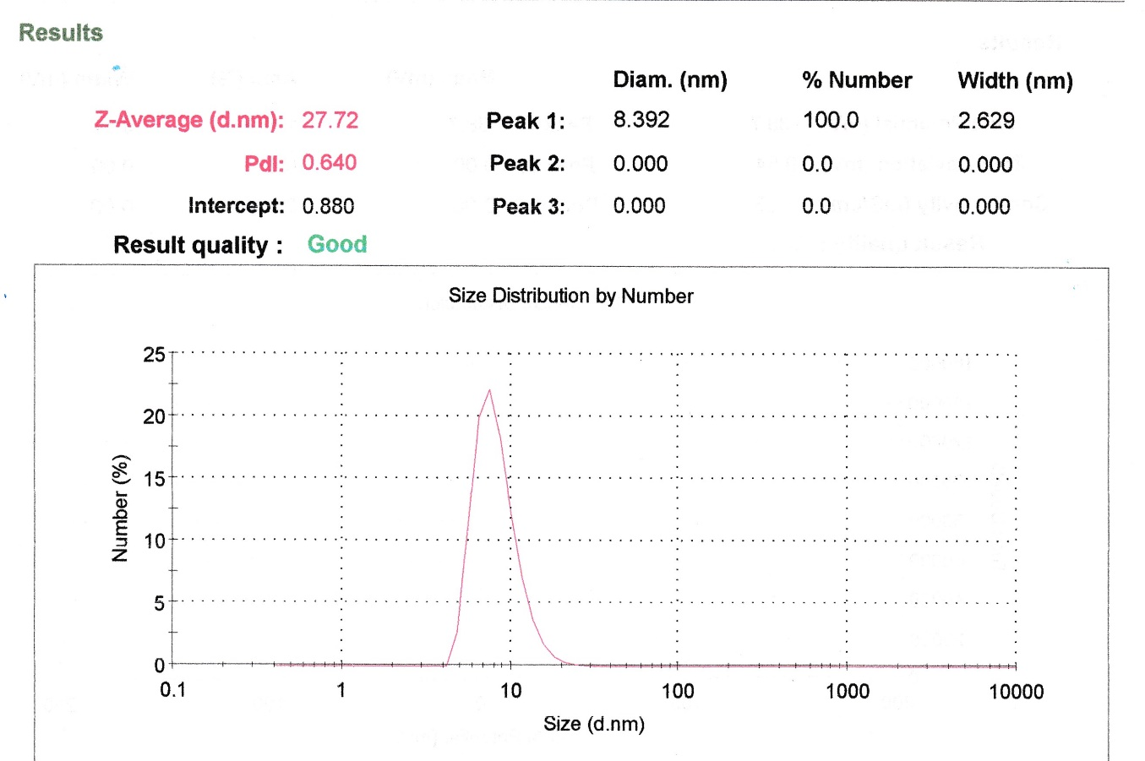

a)

b)

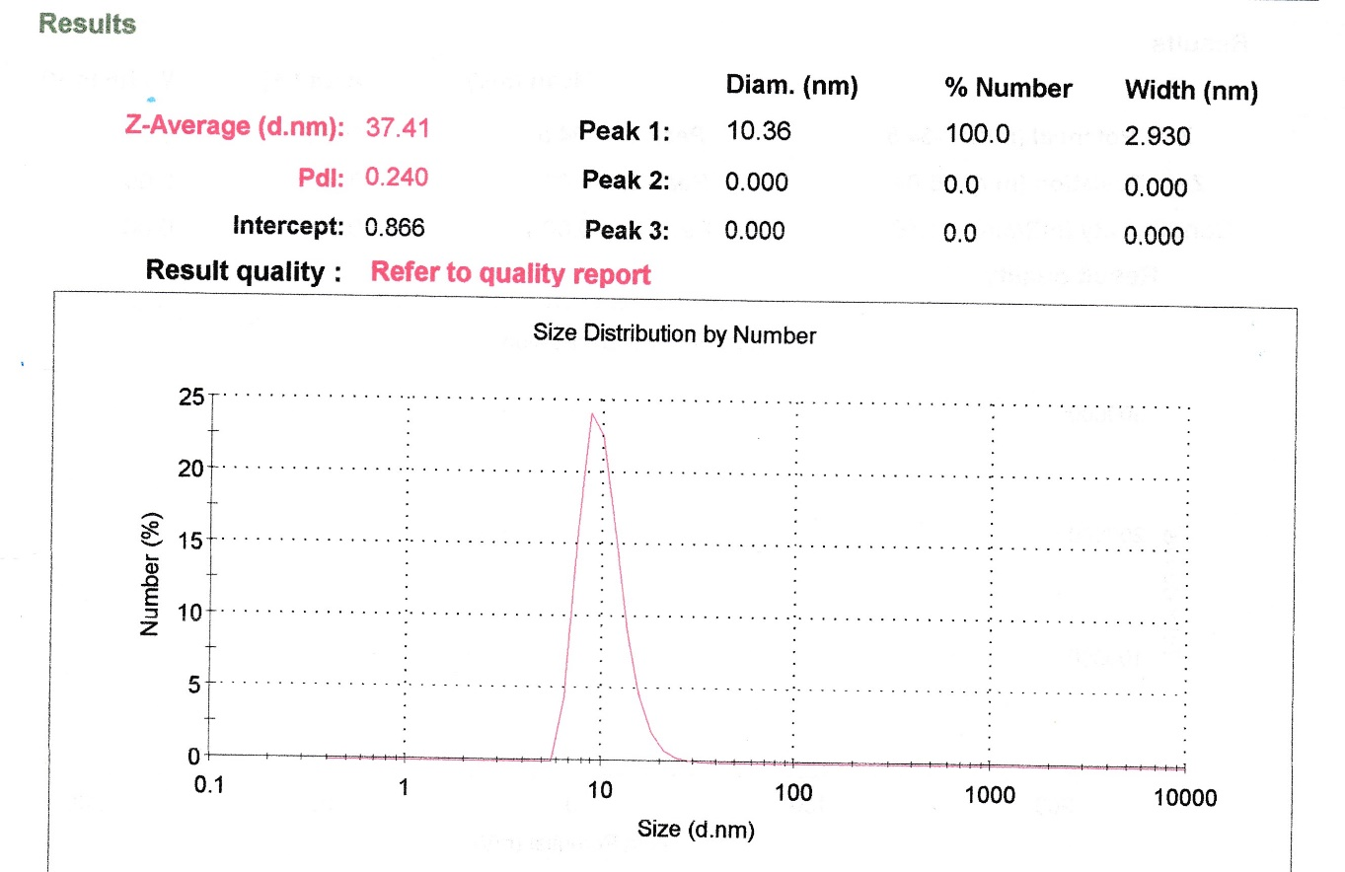

c)

Fig. S1. Evaluation of the assembly of the DNA nanostructure using DLS. (a) KLA-sequence 1, (b) PEG-sequence 2 (c) and DNA nanostructure.

