Supplementary Material

New stable phosphorus ylide (p-tolyl)₃P=CHCOC₆H₄(p-CN) and its metal complexes: Crystal and molecular structure, theoretical study and antibacterial investigation

LEILA VATANNAVAZ, SEYYED JAVAD SABOUNCHEI*, ASIEH SEDGHI, MEHDI BAYAT, KRISTOF VAN HECKE and ABDOLKARIM CHEHREGANI RAD

The ¹³C NMR spectrum synthesis of phosphonium salt (p-tolyl)₃PCH₂COC₆H₄ (p-CN) (1)

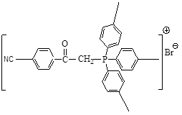
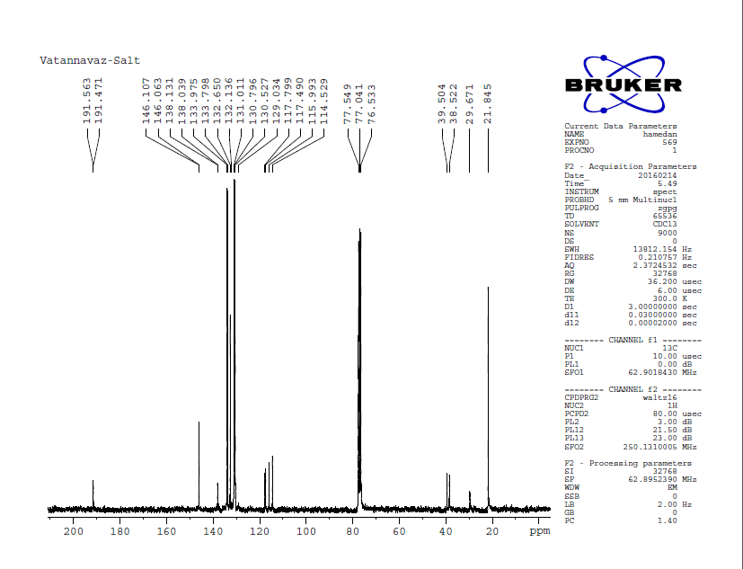

The ¹H NMR spectrum synthesis of phosphonium salt (p-tolyl)₃PCH₂COC₆H₄ (p-CN) (1)
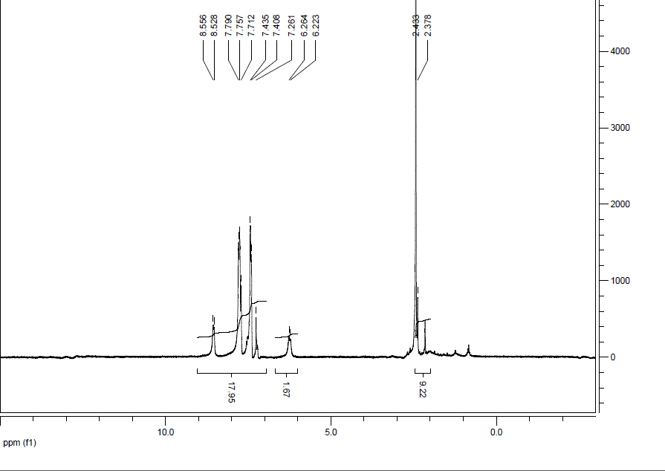
The ³¹P NMR spectrum synthesis of phosphorus ylide (p-tolyl)₃P=CHCOC₆H₄(p-CN) (Y) (2)
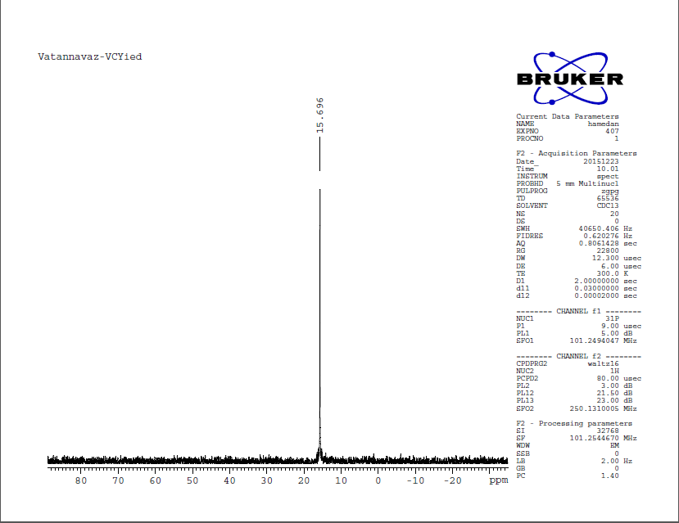

The ¹³C NMR spectrum synthesis of phosphorus ylide (p-tolyl)₃P=CHCOC₆H₄(p-CN) (Y) (2)
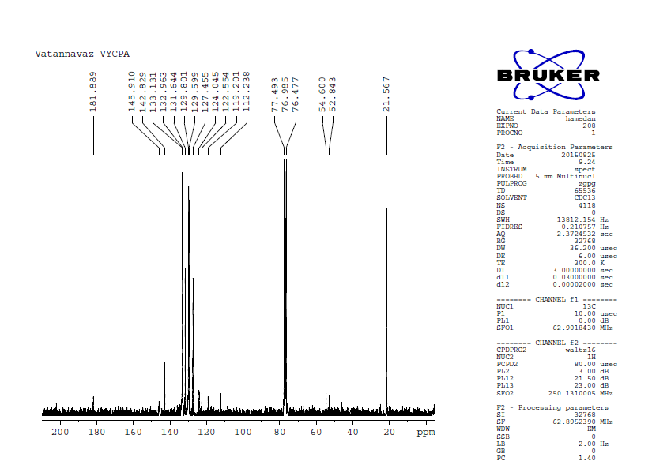

The ¹H NMR spectrum synthesis of phosphorus ylide (p-tolyl)₃P=CHCOC₆H₄(p-CN) (Y) (2)

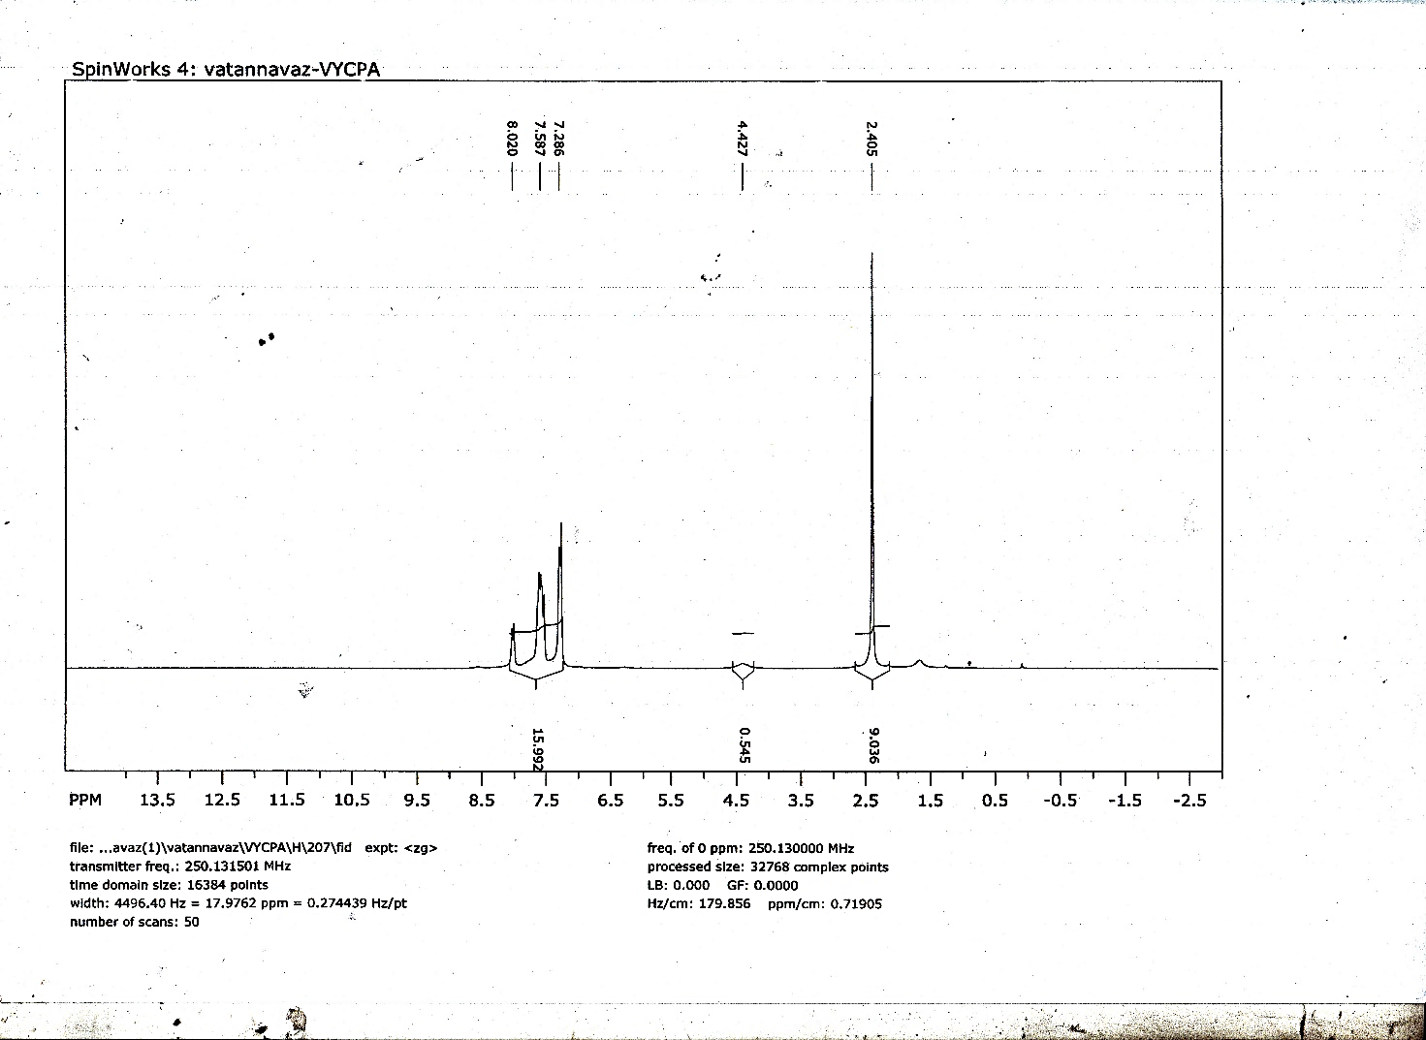

The ³¹P NMR spectrum synthesis of phosphorus [Y→HgCl₂]₂ (3)
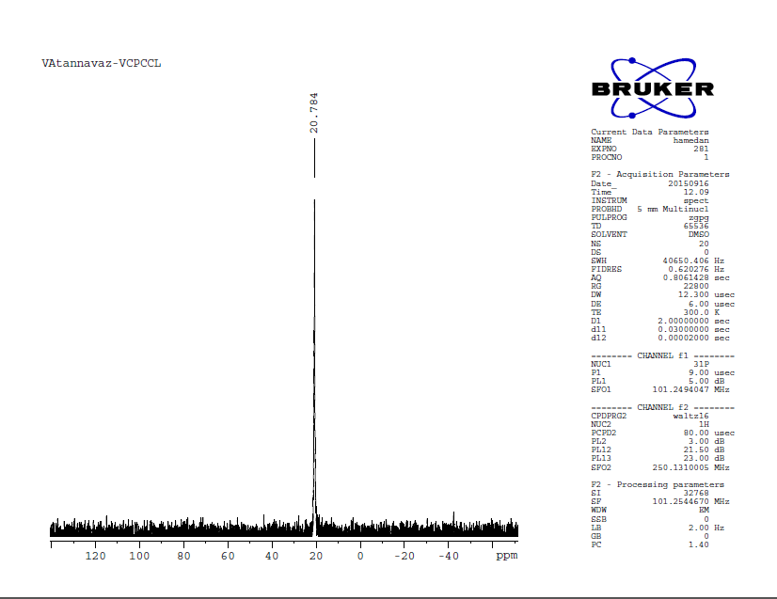

The ¹³C NMR spectrum synthesis of phosphorus [Y→HgCl₂]₂ (3)

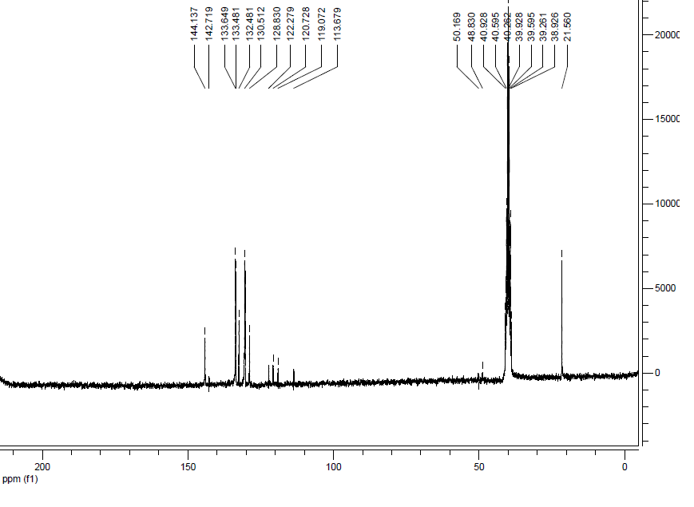

The ¹H NMR spectrum synthesis of phosphorus [Y→HgCl₂]₂ (3)

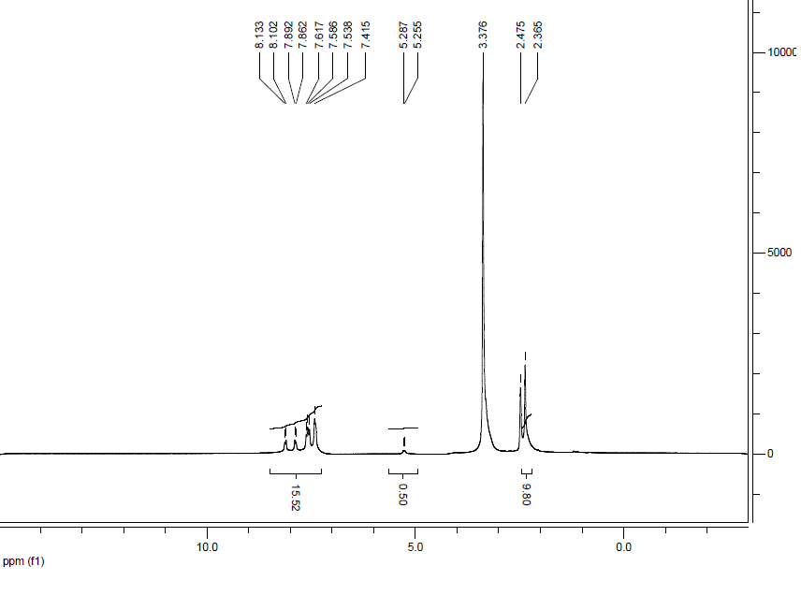

The IR spectrum synthesis of phosphorus [Y→HgBr₂]₂ (4)

The ³¹P NMR spectrum synthesis of phosphorus [Y→HgBr₂]₂ (4)
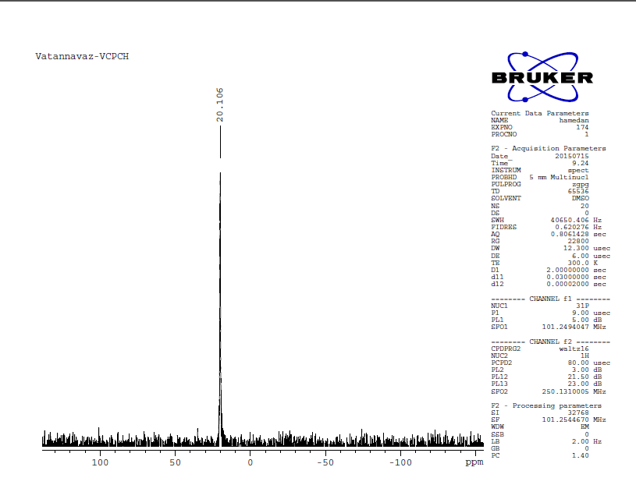

The ¹³C NMR spectrum synthesis of phosphorus [Y→HgBr₂]₂ (4)

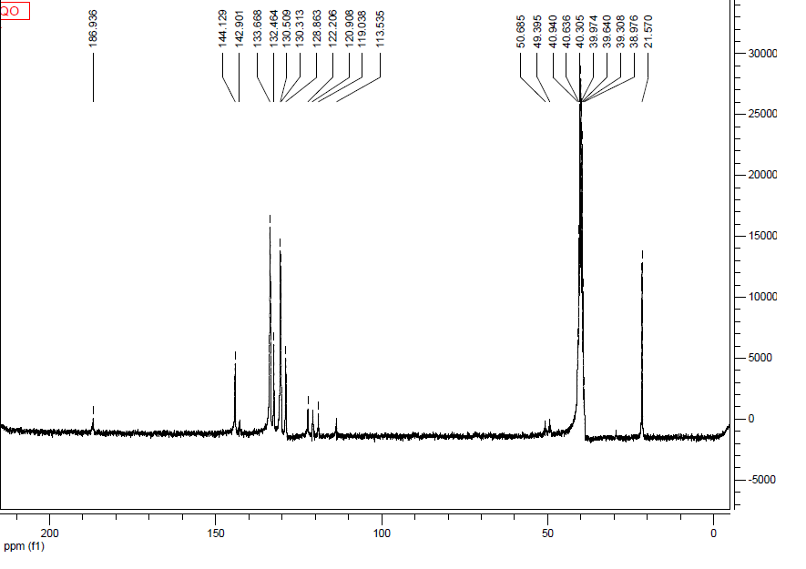

The ¹H NMR spectrum synthesis of phosphorus [Y→HgBr₂]₂ (4)

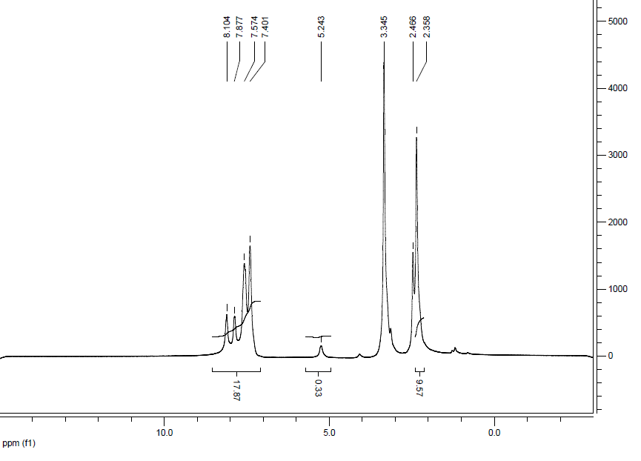

The IR spectrum synthesis of phosphorus [Y→HgI₂]₂ (5)

The ³¹P NMR spectrum synthesis of phosphorus [Y→HgI₂]₂ (5)
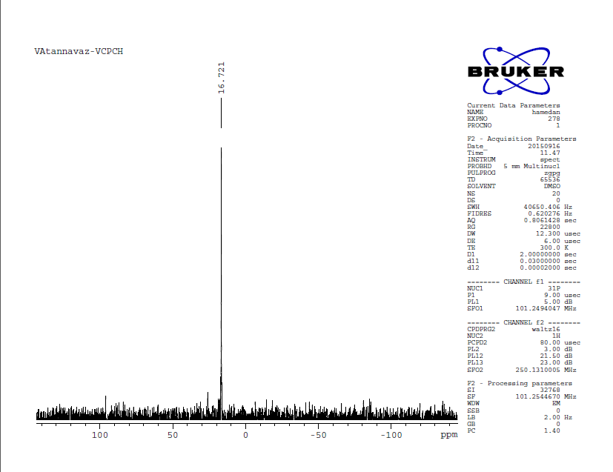

The ¹³C NMR spectrum synthesis of phosphorus [Y→HgI₂]₂ (5)

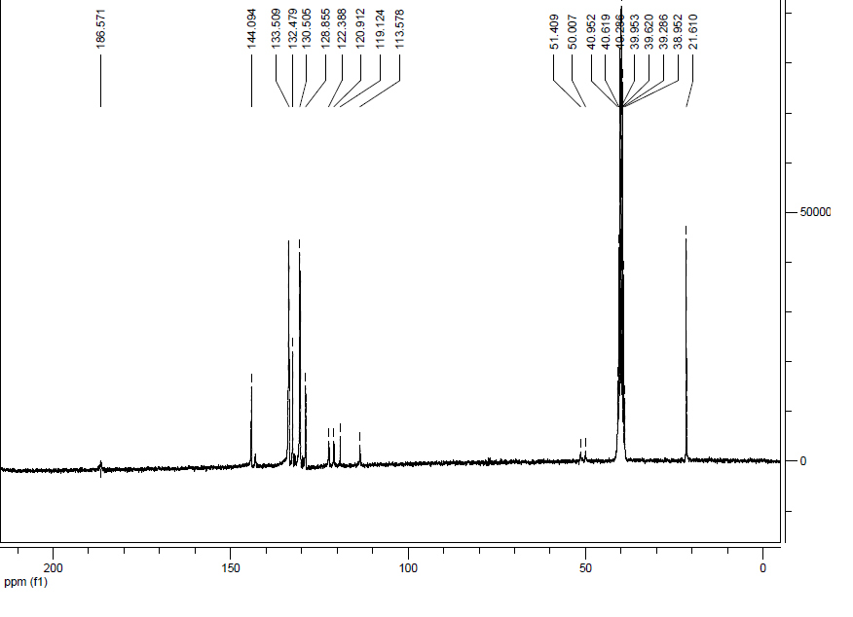

The ¹H NMR spectrum synthesis of phosphorus [Y→HgI₂]₂ (5)

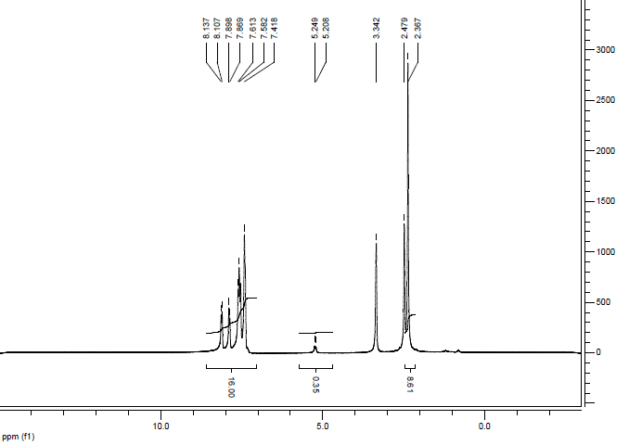

The IR spectrum synthesis of phosphorus [Y→Cd(NO₃)]₂ (6)

The ³¹P NMR spectrum synthesis of phosphorus [Y→Cd(NO₃)]₂ (6)

The ¹³C NMR spectrum synthesis of phosphorus [Y→Cd(NO₃)]₂ (6)

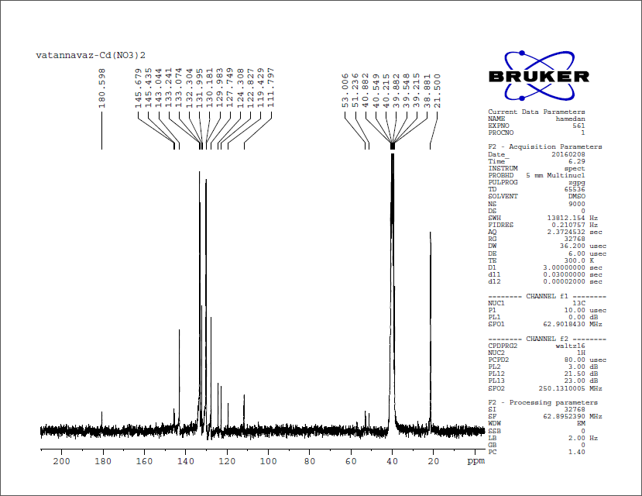

The ¹H NMR spectrum synthesis of phosphorus [Y→Cd(NO₃)]₂ (6)

