Supplementary information:
Predicting the deposition spot radius and the nanoparticle concentration distribution in an electrostatic precipitator
Calle Preger¹, Niels C. Overgaard², Maria. E. Messing¹ and Martin. H. Magnusson¹
¹NanoLund and Solid State Physics, Lund University, Box 118, 22100 Lund, Sweden
²Centre for Mathematical Sciences, Lund University, Box 118, 21100 Lund, Sweden
Corresponding author: Calle Preger, calle.preger@ftf.lth.se

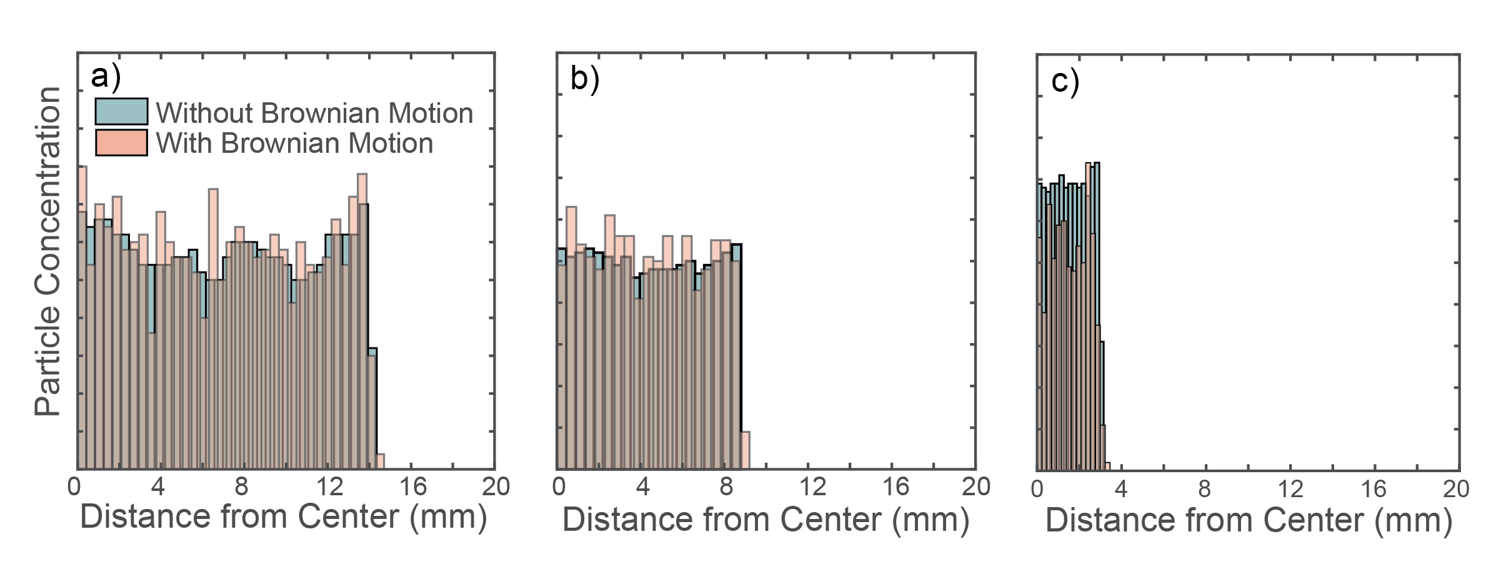
Figure S1. Particle concentration profile for simulations with and without Brownian forces for (a) 50 nm, (b) 30 nm and (c) 10 nm particles. The simulations consisted of 1000 particles without and 1000 particles with Brownian motion, in order to save computation time. The variation in the histograms is thus explained by $\frac{1}{\sqrt{N}}$ noise. The sizes of the deposition spot radii are nearly unaffected by the added Brownian force to the nanoparticles.

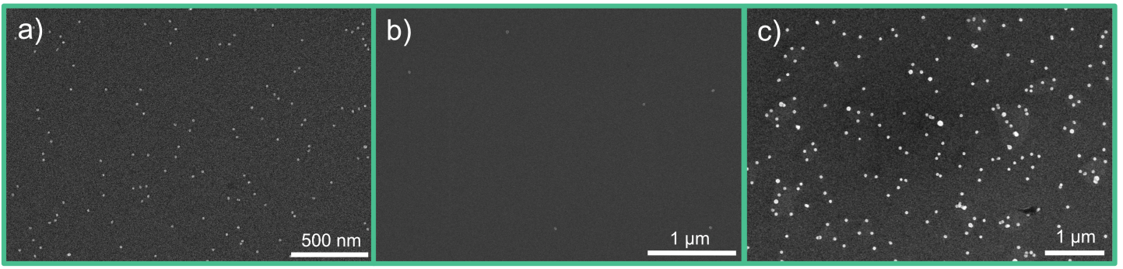
Figure S2. SEM images from three different deposition conditions. a) 15 nm Cu particles from data point number 12 in SI. 4, with measured surface concentration of 20.6 particles/$μm^{2}$. b) 30 nm Cu particles from data point number 5 in SI. 4, with measured surface concentration of 0.8 particles/$μm^{2}$. c) 45 nm Bi particles from data point number 28 in SI. 4, with measured surface concentration of 6.8 particles/$μm^{2}$.

Table S1. (a-d)Each of four set of simulations was fitted to a power relation with a 95 % confidence bound (power $a·x^{b}$). The $b$-values showed an almost perfect square root or inverse square root dependence. (e) Tabulated values for the linear fit ($p_{1}∙x+p_{2}$) comparing the simulated values and the experimental data to the semi-empirical equation.
a) | Gas flow rate ($Q$) | $$a$$ | $$b$$ | $$R^{2}$$
 | 25 nm, 15 mm, 6kV | 0.000988 | 0.4918 | 0.9999
 | 25 nm, 25 mm, 6kV | 0.000126 | 0.4933 | 1
 | 35 nm, 15 mm, 8kV | 0.000117 | 0.4952 | 1
 | 35 nm, 25 mm, 8kV | 0.000151 | 0.4884 | 0.9998

b) | Distance between inlet and plate (h) | $$a$$ | $$b$$ | $$R^{2}$$
 | 1.68 slm, 25 nm 6 kV | 2.163 | 0.4693 | 0.9973
 | 1.68 slm, 25 nm 8 kV | 1.858 | 0.4712 | 0.9996
 | 1.68 slm, 35 nm, 6 kV | 3.003 | 0.4649 | 0.9991
 | 1.68 slm, 35 nm, 8 kV | 2.598 | 0.4663 | 0.9991

c) | Applied electric potential (φ) | $$a$$ | $$b$$ | $$R^{2}$$
 | 1.68 slm, 25 nm, 15 mm | 603 | -0.5023 | 0.9999
 | 1.68 slm, 35 nm, 15 mm | 844 | -0.5038 | 0.9999
 | 1.68 slm, 25 nm, 25 mm | 754 | -0.4986 | 0.9999
 | 1.68 slm, 35 nm, 25 mm | 972 | -0.4907 | 0.9997

d) | Electrical mobility (Z) | $$a$$ | $$b$$ | $$R^{2}$$
 | 1.68 slm, 15 mm, 6 kV | 0.0043 | -0.5033 | 0.9999
 | 1.68 slm, 15 mm, 8 kV | 0.0040 | -0.4987 | 0.9999
 | 1.68 slm, 25 mm, 6 kV | 0.0060 | -0.4983 | 0.9999
 | 1.68 slm, 25 mm, 8 kV | 0.0049 | -0.5025 | 0.9999

e) |  | $$p_{1}$$ | $$p_{2}$$ | $$R^{2}$$
Simulated data vs semi-empirical equation |  | 0.546 | 0.008 | 0.9983
Experimental data vs semi-empirical equation |  | 0.549 | 0.558 | 0.9712

Table S2. Tabulated values for the experimental data points in Figure 4.
 | $C_{gas}$ ($particles/{cm}^{3})$ | Deposition time (min) | Measured number of particles on the substrate | Measured area (${μm}^{2}$) | Experimental radius (mm) | $$\sqrt{\frac{Qh}{φZ}}(mm)$$
1 | 20 000 | 10 | 321 | 311 | 10.2 | 18.4
2 | 20 000 | 10 | 459 | 249 | 7.6 | 13
3 | 22 000 | 10 | 669 | 229 | 6.3 | 10.6
4 | 22 000 | 10 | 1000 | 233 | 5.2 | 9.2
5 | 18 000 | 10 | 407 | 512 | 11.0 | 19.2
6 | 12 000 | 10 | 408 | 557 | 9.4 | 15.7
7 | 16 000 | 10 | 382 | 229 | 7.2 | 13.2
8 | 15 000 | 10 | 738 | 451 | 7.0 | 11.4
9 | 13 000 | 10 | 212 | 268 | 9.4 | 16.1
10 | 70 000 | 10 | 933 | 81 | 5.7 | 9.8
11 | 65 000 | 10 | 1441 | 78 | 4.3 | 7.7
12 | 65 000 | 10 | 1604 | 78 | 4.1 | 7.0
13 | 39 000 | 10 | 850 | 217 | 7.3 | 11.6
14 | 37 000 | 10 | 1234 | 229 | 6.1 | 10.8
15 | 37 000 | 10 | 1405 | 229 | 5.7 | 10.1
16 | 37 000 | 10 | 676 | 216 | 8.0 | 13.6
17 | 34 500 | 10 | 1009 | 228 | 6.5 | 10.7
18 | 36 000 | 10 | 661 | 229 | 8.2 | 14.5
19 | 34 000 | 10 | 515 | 229 | 9.0 | 16.0
20 | 35 000 | 10 | 426 | 228 | 10.0 | 17.5
21 | 380 000 | 10 | 3153 | 276 | 13.4 | 22.9
22 | 245 000 | 10 | 1088 | 179 | 14.7 | 18.1
23 | 380 000 | 5 | 1943 | 278 | 12.1 | 19.6
24 | 380 000 | 10 | 2430 | 276 | 15.2 | 27.2
25 | 380 000 | 10 | 1670 | 276 | 18.3 | 32.3
26 | 380 000 | 10 | 1386 | 274 | 20.1 | 38.2
27 | 380 000 | 15 | 2438 | 412 | 22.7 | 41.6
28 | 370 000 | 25 | 2795 | 414 | 27.1 | 48.7
29 | 380 000 | 15 | 2448 | 413 | 22.7 | 39.8
30 | 370 000 | 15 | 2367 | 414 | 22.8 | 34.5
31 | 380 000 | 10 | 2849 | 415 | 17.2 | 29.8
32 | 380 000 | 10 | 3877 | 412 | 14.7 | 23.2
33 | 390 000 | 10 | 3514 | 413 | 15.7 | 25.7

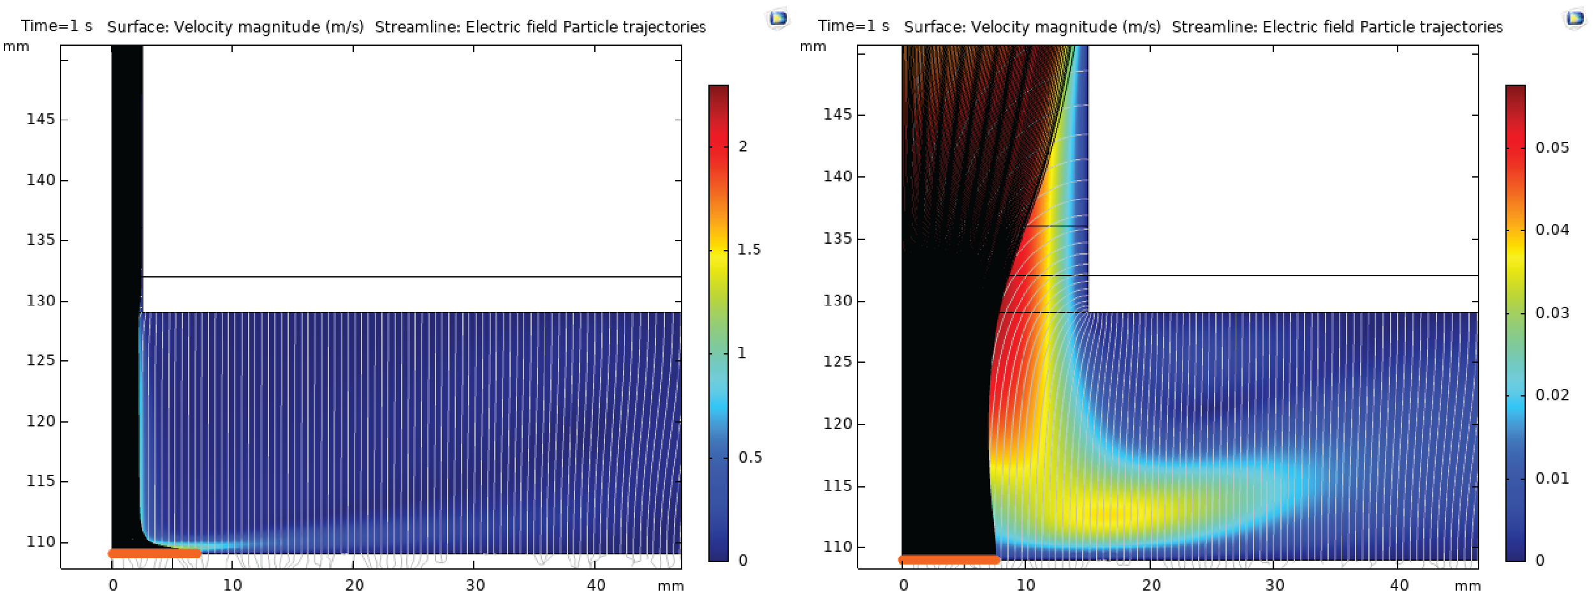

Figure S3. Particle trajectories (black lines) plotted together with the gas flow profile (color contour) and the electric field lines (grey lines) for a wide inlet and a narrow inlet. The deposition spot does not depend on the width of the inlet nor the gas velocity, as illustrated here. The deposition spot can both be thinner and wider than the width of the inlet nozzle.

