Supplementary Materials

Data Pre-processing
To prepare the data for automatic content analysis, we normalized all text from Weibo and newspapers by removing symbols, extra spaces, and special characters. For Weibo posts, we also corrected spelling mistakes and removed repetitive characters.

Figure 1. Five hundred most reposted posts from each gender-annotated group and the number of reposts they received.
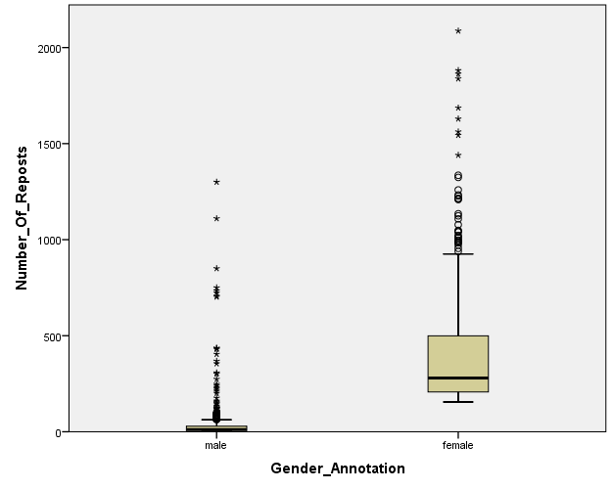
Note. The ten most reposted female-annotated posts have been omitted in this figure to achieve better layout results. The number of reposts they received ranged from 3,000 to 20,000.

Table 1. Five top-weighted documents under the topic on sexism in the newspaper-Weibo STM
No. | Weibo Text | Weight of top topic* | Weight of 2nd topic | Weight of 3rd topic
1 | Someone has already explained: When the majority of a group is of one gender, you always address the gender minority in that group with their gender, like the male nurse, female police officer, and Gongsun Ce. | 0.8326 | 0.1128 | 0.0127
2 | Besides, news reports usually explicitly say female drivers, as if male drivers never cause an accident. | 0.8326 | 0.1128 | 0.0127
3 | Emmm… I think using the phrase of female police officer is fine, right? Just as saying male nurse. | 0.8326 | 0.1128 | 0.0127
4 | It's so blunt in public Weibo posts, so you can imagine how they treat male drivers and female drivers differently in daily life. However, it is usually male drivers that cause terrible accidents. We should be worried about traffic in Shenzhen. | 0.8318 | 0.1083 | 0.0134
5 | Male drivers, again, male drivers… How many car accidents involving cell phone were caused by male drivers in this month? It's countless. Cherish your life and stay away from male drivers. | 0.8217 | 0.1188 | 0.0136
* The top topic refers to the sexism topic.

Table 2. Negative binomial regression model examining gender-annotation and reposting of the post (N=87,708)
Variable | B | SE | Wald χ² | Exp(B) | Exp (B) 95% Wald CI
 |  |  |  |  | Lower | Upper
Female-Annotation | .176*** | .0293 | 36.211 | 1.193 | 1.126 | 1.264
*p < .05. **p < .01. ***p < .001

Table 3. Five top-weighted documents under the topic on sexism in the gender-annotation STM
No. | Weibo Text | Weight of top topic* | Weight of 2nd topic | Weight of 3rd topic
1 | When female drivers were caught in car accidents, the news always emphasized their gender. When it happened to male drivers, the news usually did not mention their gender. (This pattern) makes it feel like only female drivers cause car accidents. | 0.4972 | 0.1613 | 0.0958
2 | The city's Department of Motor Vehicle noted that among all the severe car accidents in Changzhou, female drivers only accounted for 10% of them; in the past week, among drivers who reached the 12-point threshold to get license suspended, there were 2,730 male drivers but only 190 female drivers. | 0.4921 | 0.1832 | 0.0750
3 | It makes (people) feel like male drivers never cause car accidents. Why emphasized female drivers every day? What have female drivers done to you? | 0.4839 | 0.2137 | 0.0711
4 | The judge blamed both parties for this accident. If the female driver caused severe car accident -- if the female driver got herself killed in the accident -- would she have a chance to lay in the hospital and complain? What would the judge say in that case? The female driver should appreciate the male driver (for beating her).** | 0.4701 | 0.1894 | 0.0843
5 | The news editor is so annoying. (S)he always emphasized "female" when female drivers were caught in accidents. The accident yesterday in Guangxi was not caused by a female driver, right? It was the male driver's responsibility, but why didn’t you emphasize on "male"? | 0.4627 | 0.2366 | 0.0697
* The top topic refers to the sexism topic.
** This Weibo post refers to an event in which a female driver was severely beaten by a male driver after she cut in on him.

