Supplementary Information

Novel coordination compounds: Mn(II), Co(II), Ni(II), Cu(II) and Zn(II) cations with acesulfame/N,N-diethylnicotinamide ligands

TUĞRUL YILDIRIM, DURSUN ALI KÖSE*, GÜLÇIN ALP AVCI, ONUR ŞAHIN and FATIH AKKURT

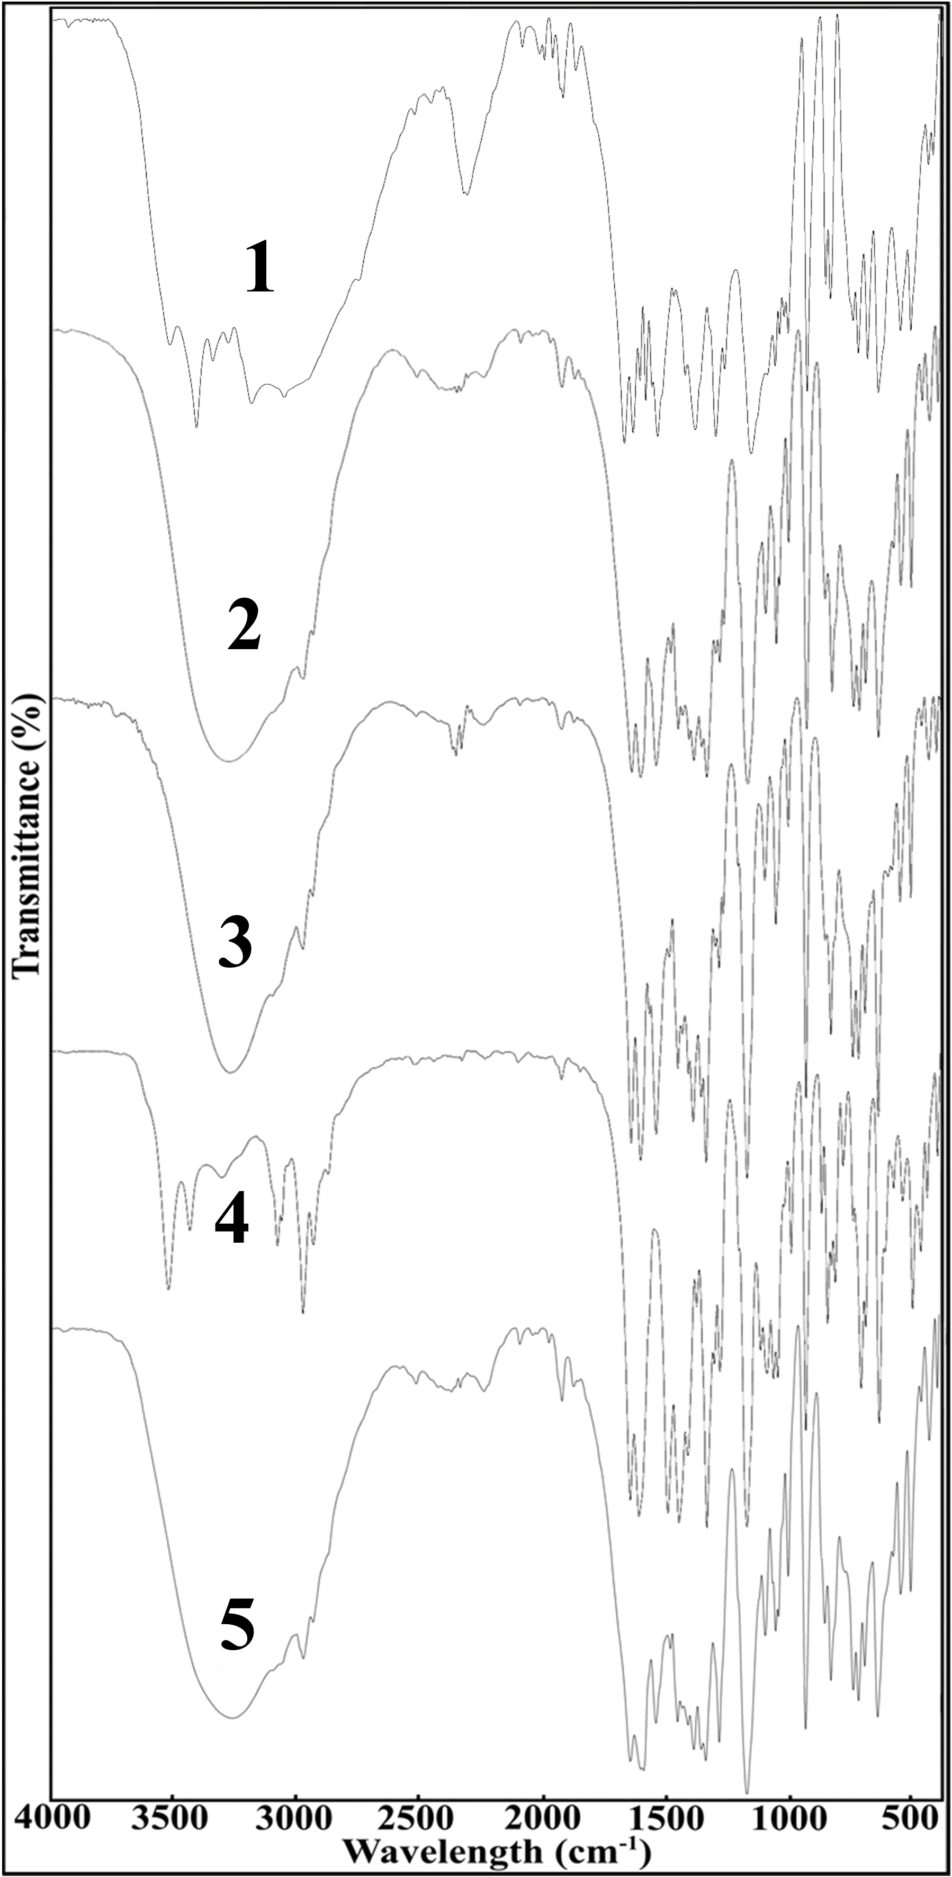
Figure S1. FT-IR spectra of compounds. (1) Mn^{II}, (2) Co^{II}, (3) Ni^{II}, (4) Cu^{II}, (5) Zn^{II}.

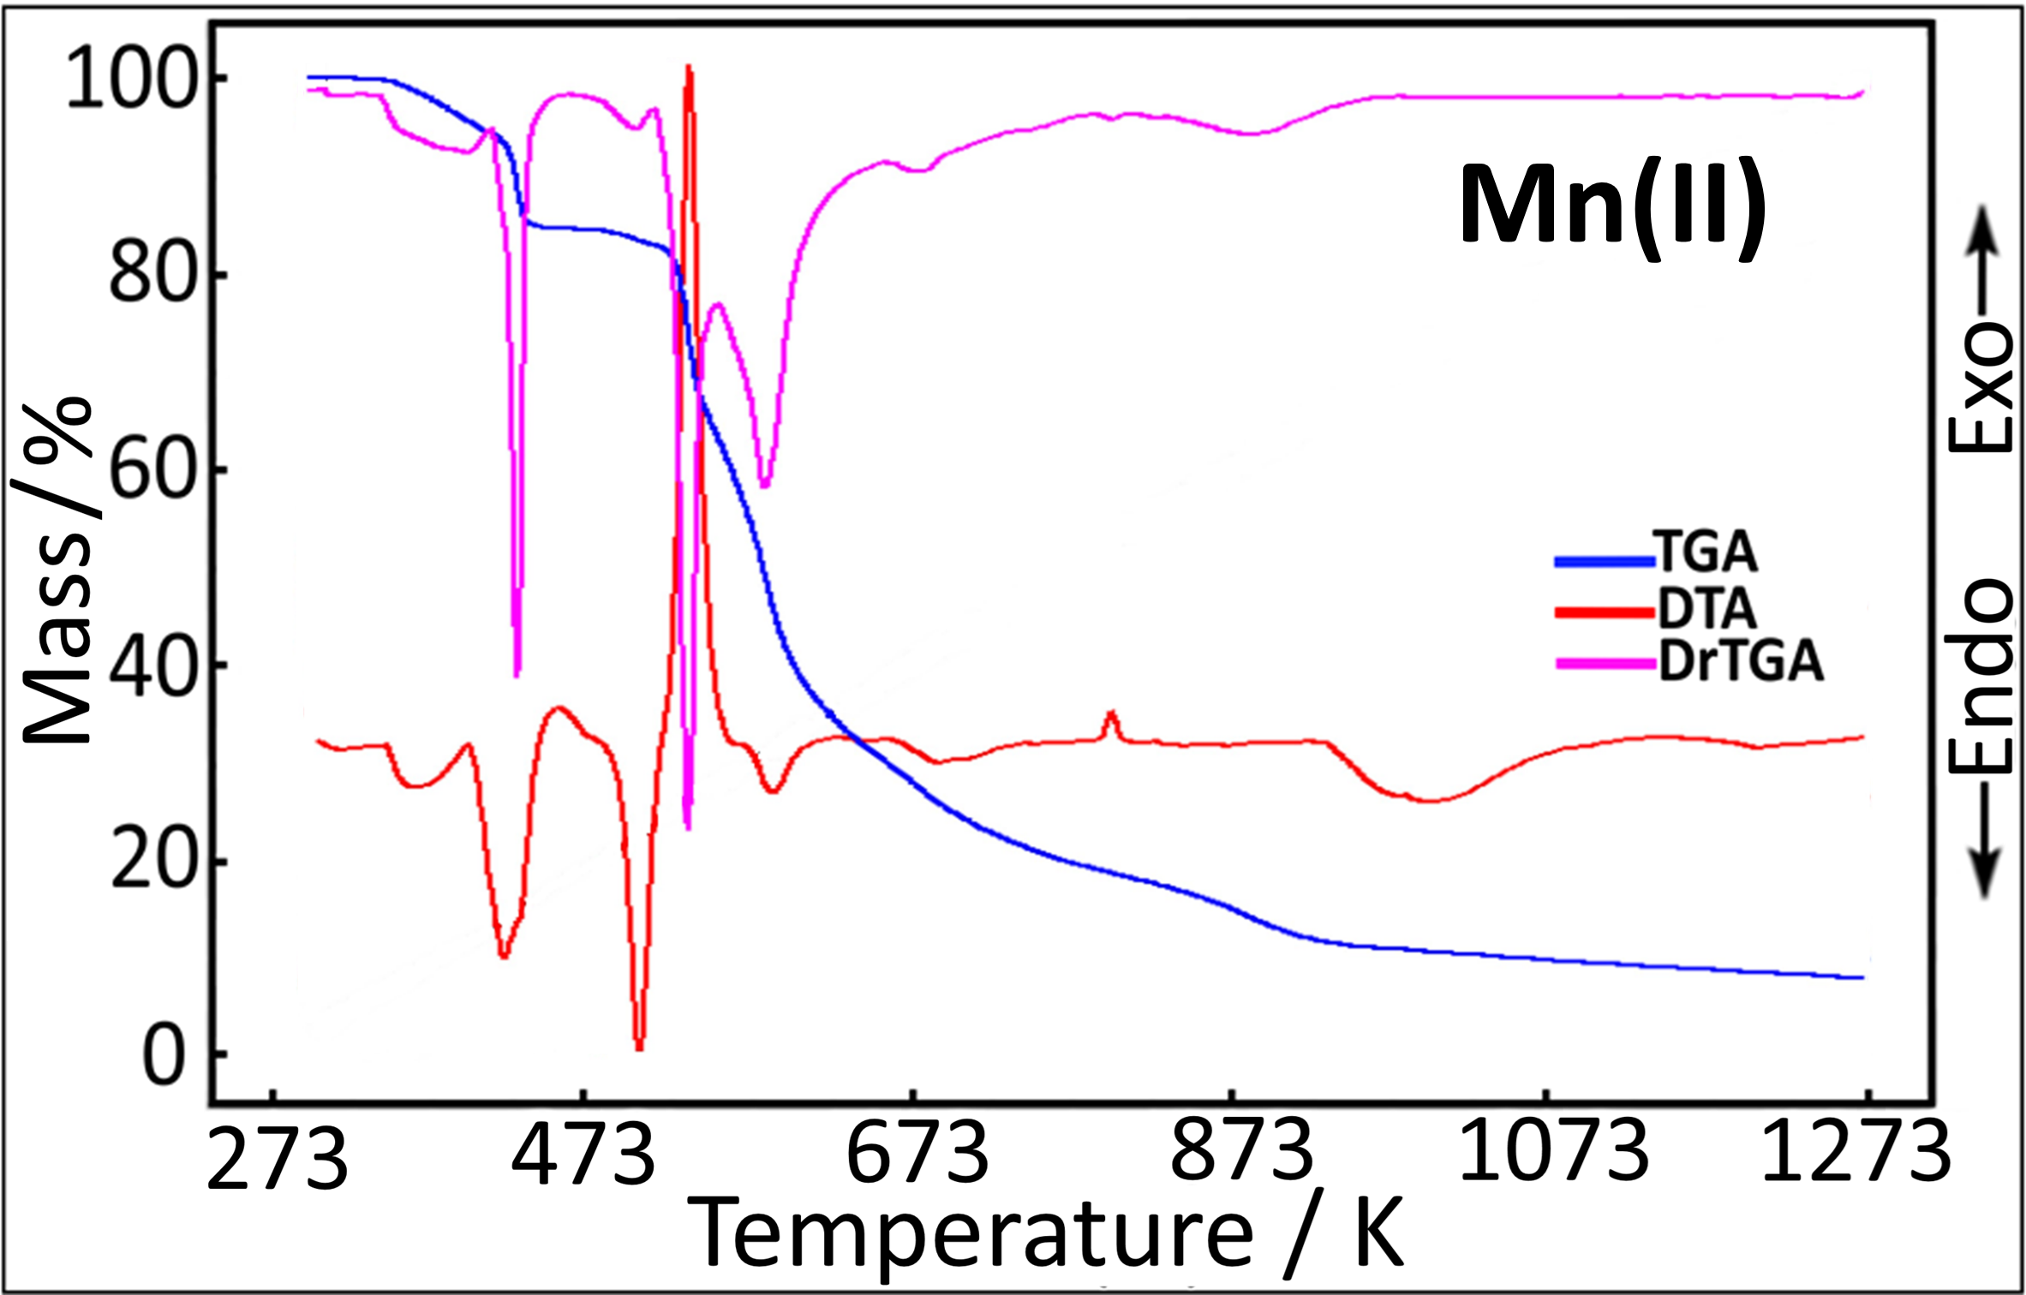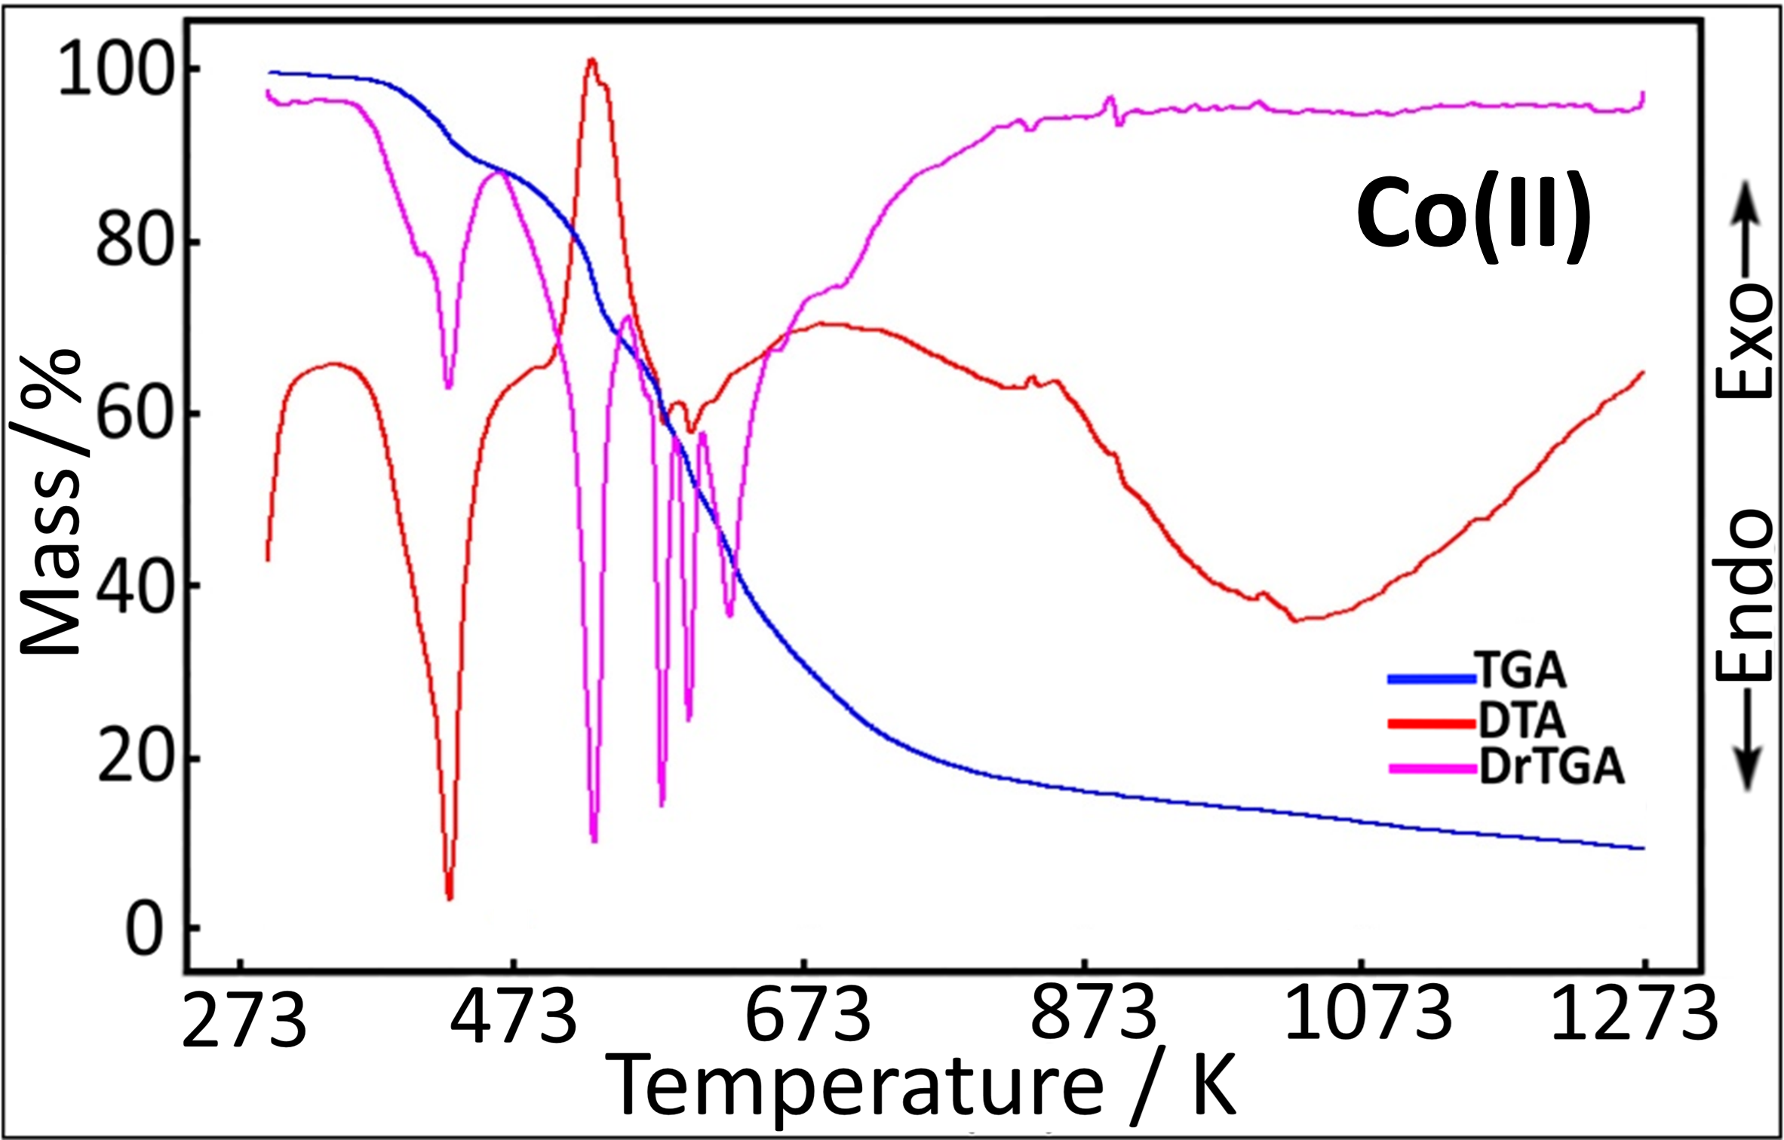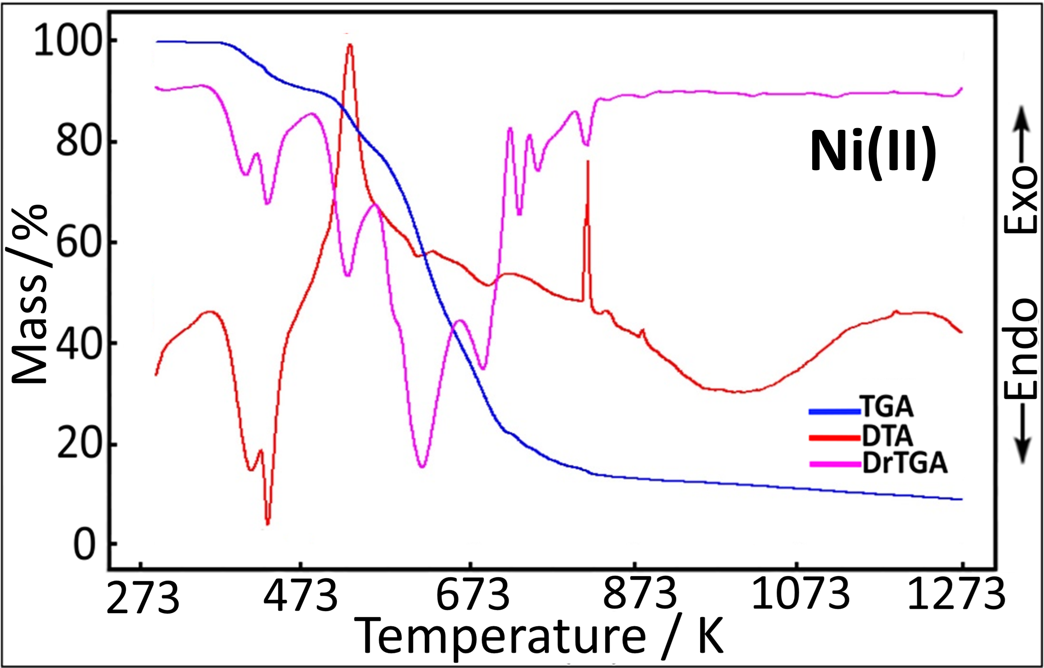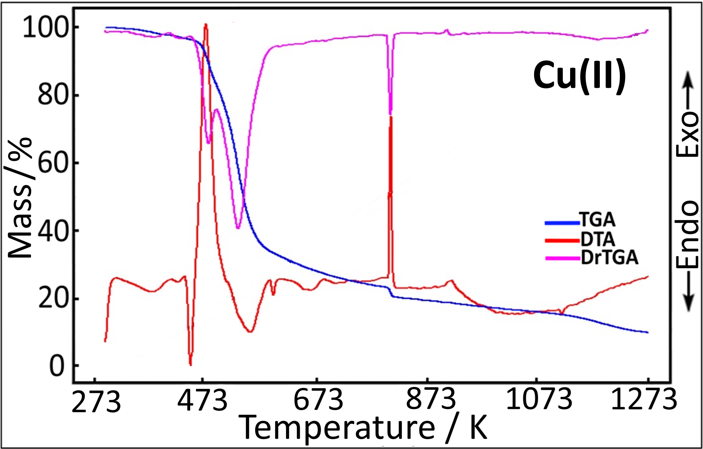
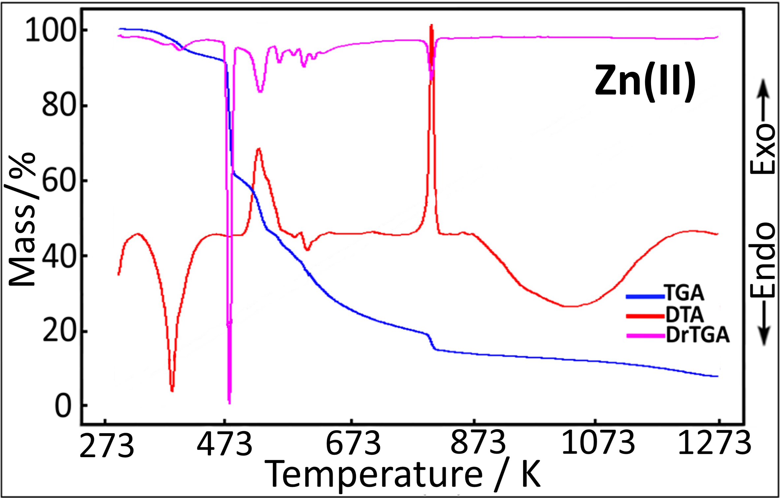
Figure S2. TGA/DTA/DrTGA curves of complexes.

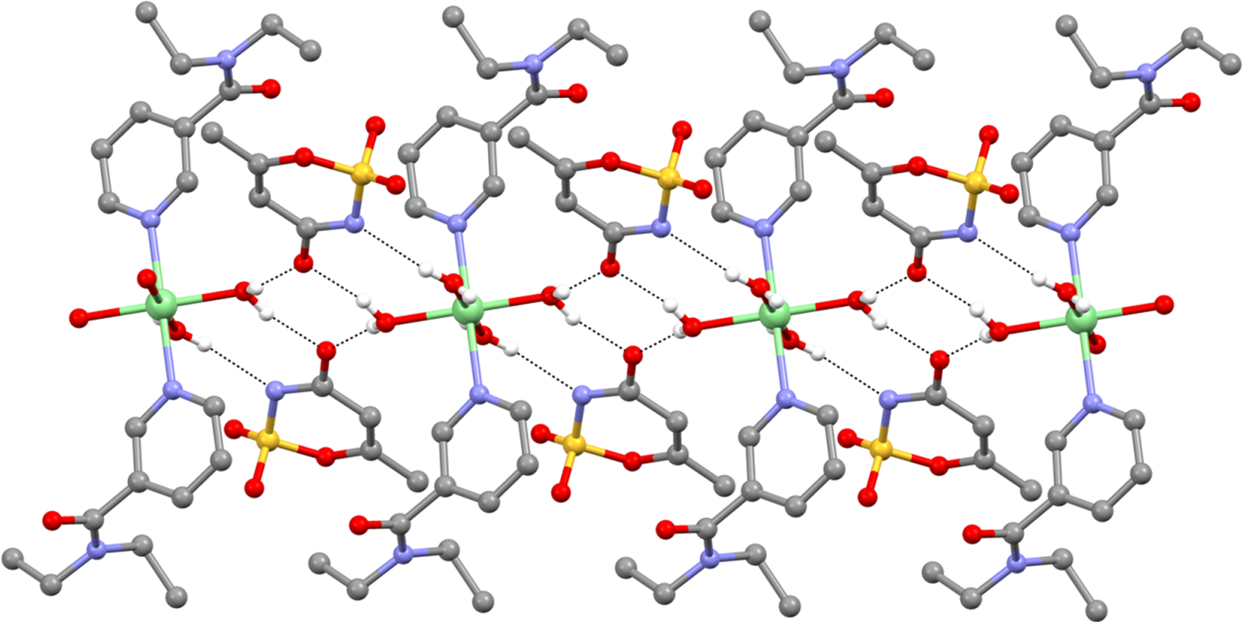
Figure S3. The formation of edge-fused R₂²(8) and R₄²(8) rings in 1, 2 and 5.

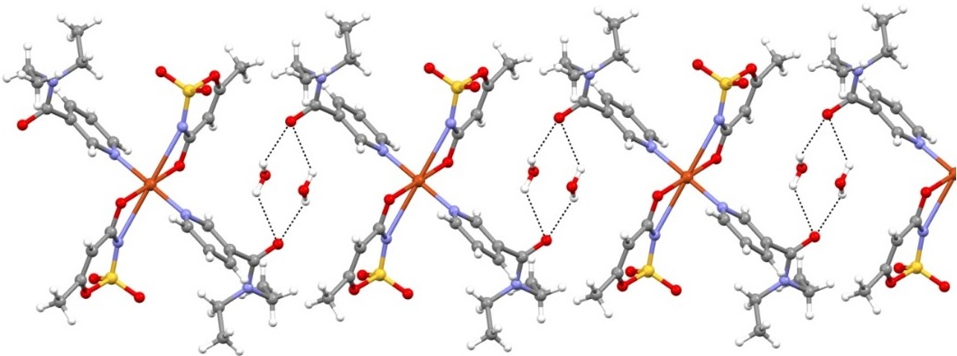
Figure S4. The formation of R₄²(8) rings in 4.

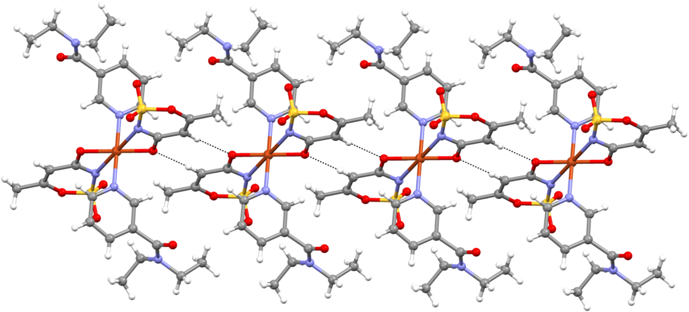
Figure S5. Display of the rings R₂²(8) formed along the direction in 4 [100].

