BST2 regulates interferon gamma-dependent decrease in invasion of HTR-8/SVneo cells via STAT1 and AKT signaling pathways and expression of E-cadherin

Sonam Verma¹, Amandeep Kaur Kang^{1#}, Rahul Pal², Satish Kumar Gupta¹*

Address for Correspondence
Dr. Satish Kumar Gupta, PhD
Emeritus Scientist
J. C. Bose National Fellow
Reproductive Cell Biology Laboratory
National Institute of Immunology
Aruna Asaf Ali Marg
New Delhi-110 067
India
Tel: +91 11 26741249
Fax: +91 11 26742125
Email: skgupta@nii.ac.in

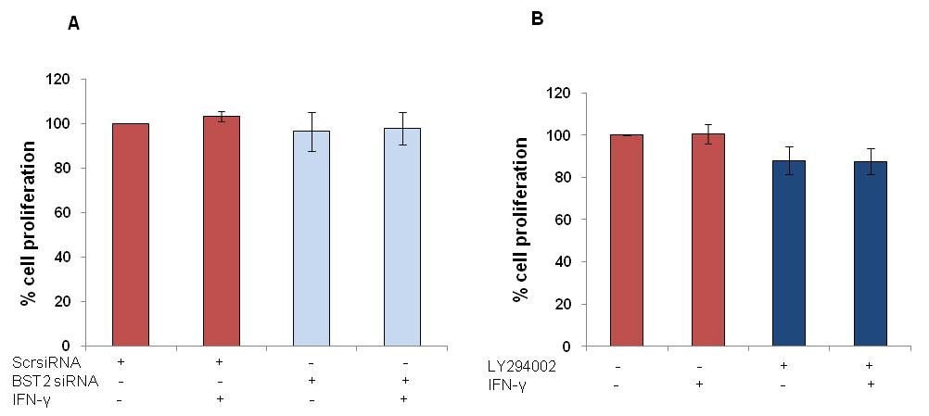
Suppl Fig. 1 - Effect of BST2 silencing by siRNA and inhibition of AKT by LY294002 pre-treatment on the proliferation of HTR-8/SVneo cells in the presence of IFN-γ. HTR-8/SVneo cells (0.1 X 10⁶/well) were seeded in 6-well cell culture plate and incubated overnight at 37°C in 5% CO₂ and 70% relative humidity. Next day, cells were transfected with either scrambled siRNA or BST2 siRNA for 48 h. Subsequently, cells were trypsinized, counted and 8000 cells/well were seeded in 96-well cell culture plates in the presence or absence of IFN-γ for 24 h at 37ºC in 5% CO₂ & 70% relative humidity and used to study their proliferation by BrdU incorporation. In another experiment, HTR-8/SVneo cells pre-treated with or without LY294002 and subsequently treated with IFN-γ for 24 h as described above, were also processed for BrdU incorporation. Panel A shows the percent cell proliferation transfected with either scrambled siRNA or BST2 siRNA and subsequently treated with and without IFN-γ. Panel B shows the percent cell proliferation in control and LY294002 pre-treated cells in the presence and absence of IFN-γ treatment. Percent cell proliferation was calculated from normalized absorbance (absorbance in experimental group - absorbance of blank wells) values of untreated group divided by treated group and multiplied by 100.

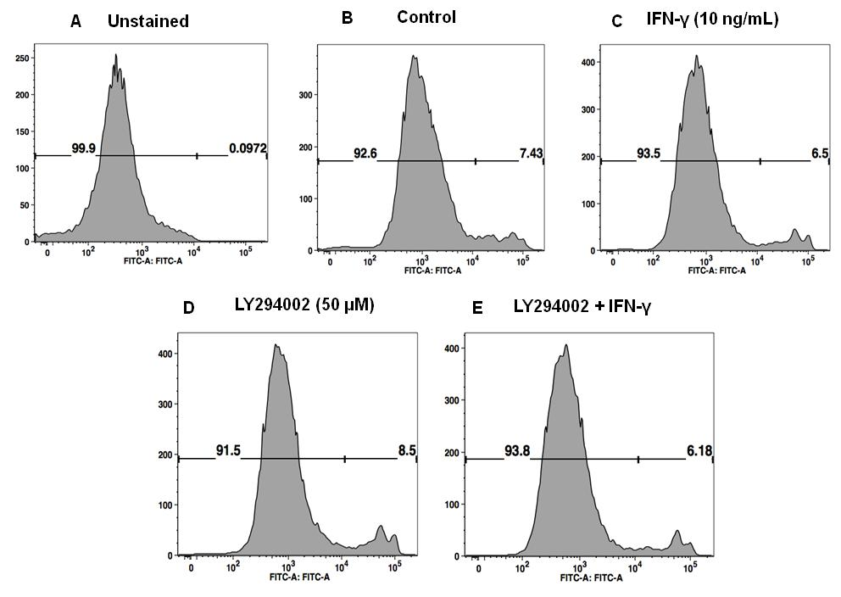
Suppl Fig. 2 - Effect of pre-treatment with LY294002 (PI3K inhibitor) on the cell viability of HTR-8/SVneo cells subsequently treated with IFN-γ. HTR-8/SVneo cells (0.1 x 10⁶/well) were cultured in 6-well cell culture plate overnight at 37°C in 5% CO₂ and 70% relative humidity. Next day, cells were pre-treated with and without LY294002 (50 μM) for 2 h followed by treatment with and without IFN-γ (10 ng/mL) for 24 h and cell viability assay (SYTOXTM green staining) was performed as described in Materials and Methods. The cells were trypsinized and re-suspended in saline (0.9 % Nacl) with working concentration of 5 μM SYTOXTM green. Panels A, B, C, D & E show the profiles of live and dead cells in unstained, untreated control, IFN-γ treated, LY294002 (PI3K inhibitor) pre-treated, and LY294002 (PI3K inhibitor) pre-treated followed by IFN-γ treatment in HTR-8/SVneo cells respectively. Percent total unstained (live cells) and stained cells (dead cells) were calculated by Flow Cytometry Facs Verse.

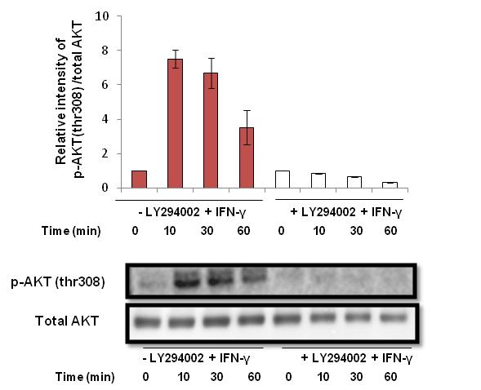
Suppl Fig. 3 - Confirmation of AKT inhibition by LY294002 in HTR-8/SVneo cells treated with IFN-γ. HTR-8/SVneo cells (0.1 x 10⁶/well) were cultured in 6-well cell culture plate overnight at 37°C in 5% CO₂ and 70% relative humidity. Next day, cells were pre-treated with and without LY294002 (50 μM) for 2 h followed by treatment with IFN-γ (10 ng/mL) for 0, 10, 30 and 60 min. After treatment, cell lysates were prepared and proteins resolved by 0.1% SDS-10% PAGE and processed for analysis of phosphorylated form of AKT (thr308) and total AKT by Western blotting as described in Materials and Methods. The densitometric plot shows relative intensity of p-AKT (thr308) with respect to total AKT in untreated and LY294002 pre-treated cells, which were subsequently treated with IFN-γ. Representative blots of p-AKT (thr308) and total AKT are appended. The data is expressed as fold change with respect to 0 min control of respective treatment set and values are shown as mean ± S.E.M. of at least three independent experiments.

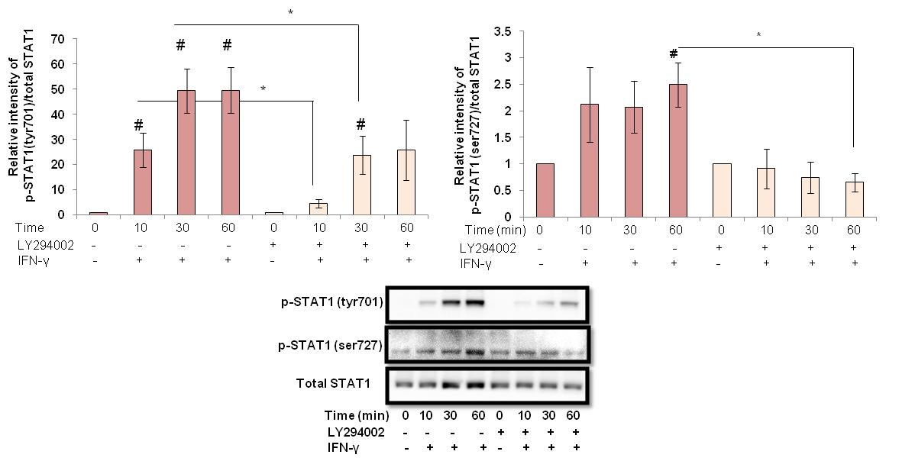
Suppl Fig. 4 - Effect of LY294002 pre-treatment on the activation of STAT1 in the presence of IFN-γ. HTR-8/SVneo cells (0.1 x 10⁶/well) were cultured in 6-well cell culture plate overnight at 37°C in 5% CO₂ and 70% relative humidity. Next day, cells were pre-treated with LY294002 (50 μM) for 2 h followed by treatment of IFN-γ (10 ng/mL) for 10, 30 and 60 min as described in Materials and Methods. Panels A and B show the densitometric profile of p-STAT1 (tyr701) and p-STAT1 (ser727) in cells pre-treated with and without LY294002 in the presence of IFN-γ normalized using total STAT1. Representative blots of p-STAT1 (tyr701), p-STAT1 (ser727) and total STAT1 are appended as Panel C. # Represents the significant p value (≤ 0.05) in IFN-γ treated cells for 10, 30, 60 min as compared to 0 min with and without pre-treatment of LY294002. *Represents the significant p value (≤ 0.05) in LY294002 pre-treated group vs LY294002 untreated group in the presence of IFN-γ.

