Supplementary Material

Ultrasound-assisted synthesis of layered zeolitic imidazolate framework: Crystal formation and characteristics

NADIA GHOLAMPOUR and MORTEZA ESLAMIAN*

Table S1. Metal/ligand ratios in the synthesis of Zn/Co, Zn and Co ZIF-L, synthesized via ultrasound technique.
ZIF-L | Zn ratio | Co ratio | 2-mIm ratio
Zn/Co | 1 | 1 | 16
Zn | 2 | 0 | 16
Co | 0 | 2 | 16

Table S2. Structural characteristics of Zn/Co ZIF-L, synthesized via ultrasound and room temperature (RT) techniques.
 | Sª_{BET} /m²g⁻¹ | S^{b}_{L} /m²g⁻¹ | Pore volume (cm⁻³g⁻¹)
Ultrasound-15 min | 8.5 | 13.8 | 0.002
Ultrasound-30 min | 21 | 35.3 | 0.001
Ultrasound-1 hour | 18.6 | 32.5 | 0.001
RT-3 hours | 12.7 | 24 | 0.001
ªBET surface area; ^{b}Langmuir surface area

Table S3. Comparison of some ZIFs and other MOFs according to capacity of CO₂ uptake. All performed at pressure of 800 mmHg and temperature of 298 K.
MOF | Sª_{BET} /m²g⁻¹ | CO₂ uptake capacity (mmolg⁻¹) | Ref.
Zn/Co ZIF-L | 8.5 | 0.87 | This work
Zn ZIF-L | 14.3 | 0.89 | This work
Co ZIF-L | 10 | 0.89 | This work
ZIF-L | 161 | 0.94 | [1]
ZIF-8 | 1807 | 0.78 | [2]
ZIF-8 | 1264 | 0.45 | [3]
ZIF-71 | 652 | 0.65 | [4]
ZIF-95 | 1050 | 0.8 | [5]
ZIF-97 | 564 | 1 | [4]
MOF-5 | 350 | 0.91 | [6]
ZIF-100 | 595 | 0.9 | [5]
ªBET surface area

Table S4. Various synthetic conditions and the yields of resultant products.
Sample | Zn ratio | Co ratio | 2-mIm ratio | Time of ultrasonication (min)
1 | 1 | 1 | 12 | 15
2 | 1 | 1 | 8 | 15
3 | 1 | 1 | 8 | 60

Table S5 Structural characteristics of Zn/Co ZIF-L, synthesized via ultrasound with various metal/ligand ratios.
Sample | Sª_{BET} /m²g⁻¹ | S^{b}_{L} /m²g⁻¹ | Pore volume (cm⁻³g⁻¹)
1 | 7.1 | 18.8 | 0.007
2 | 2.4 | 0.19 | 0.001
3 | 17.2 | 26 | 0.01
ªBET surface area; ^{b}Langmuir surface area

Table S6. Structural characteristics of Zn and Co ZIF-L, synthesized via ultrasound within 15 min.
Product | Sª_{BET} /m²g⁻¹ | S^{b}_{L} /m²g⁻¹ | Pore volume (cm⁻³g⁻¹)
Zn ZIF-L | 14.3 | 22.8 | 0.004
Co ZIF-L | 10 | 16.6 | 0.002
ªBET surface area; ^{b}Langmuir surface area

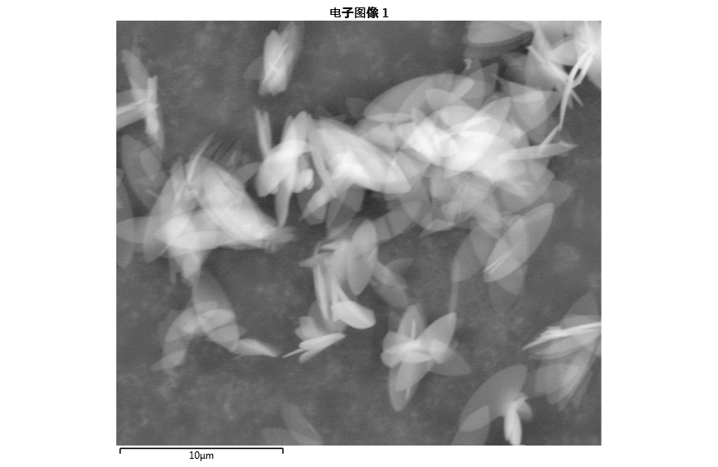
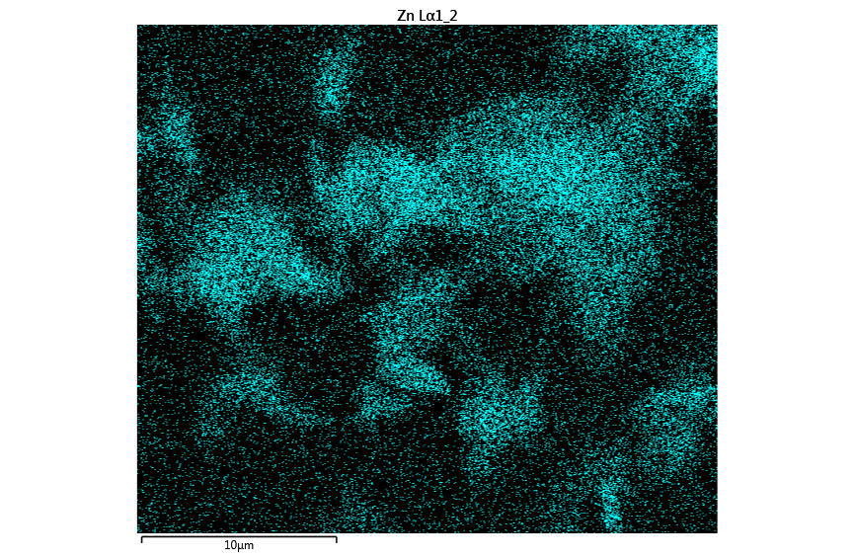
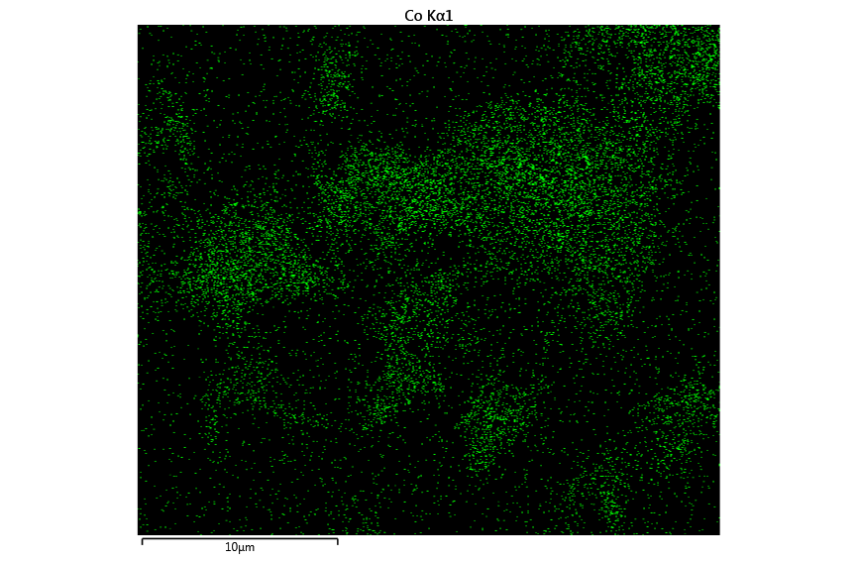
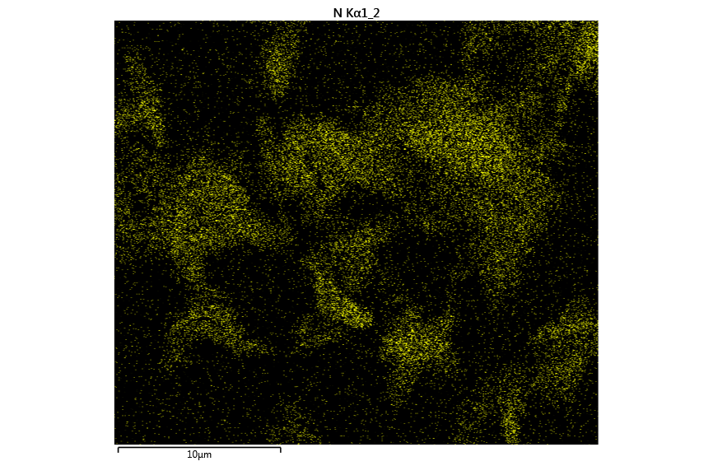
a)
b)
c)
d)

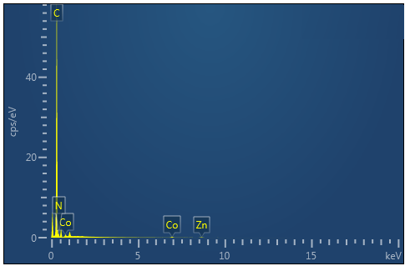
e)

Figure S1. SEM and EDS mapping of Zn/Co ZIF-L, synthesized via ultrasound technique within 15 min. a) SEM image, b) dispersion of Zn, c) dispersion of Co, d) dispersion of N, and e) EDS spectrum representing the presence of C, N, Co and Zn in the sample.
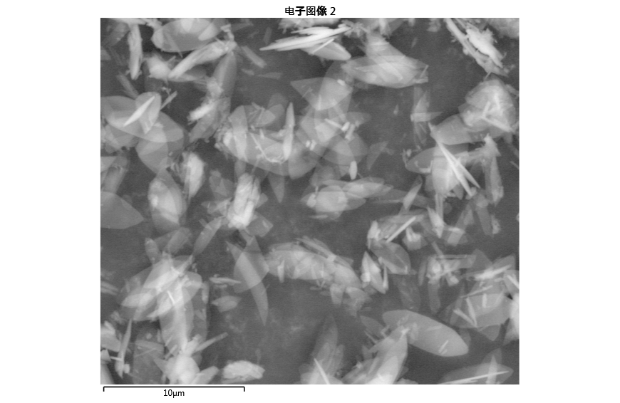
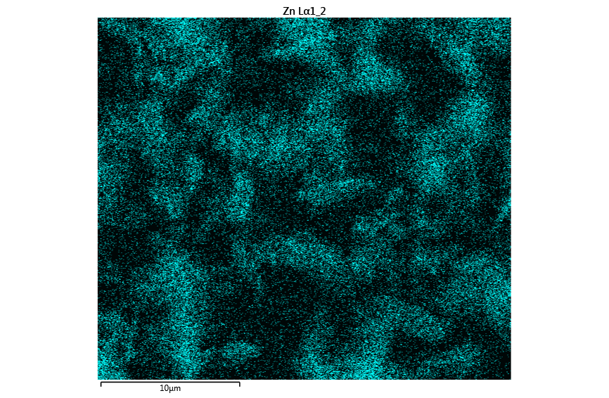
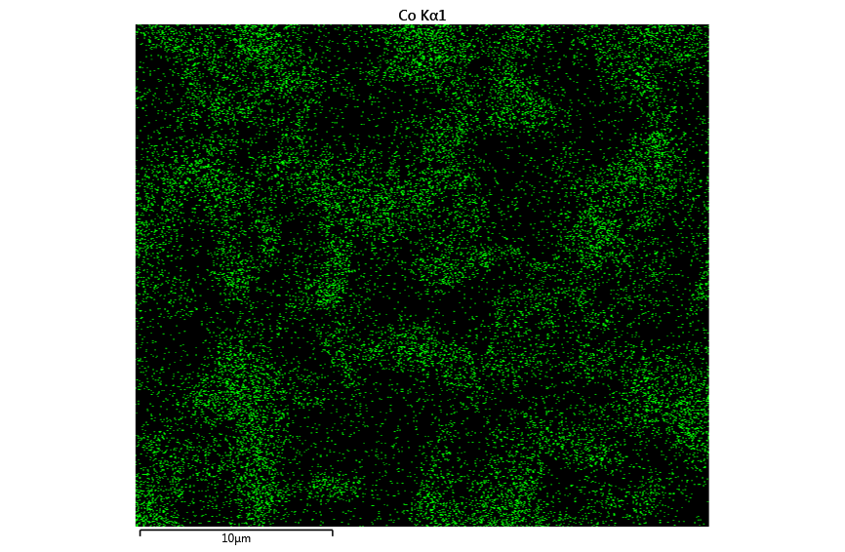
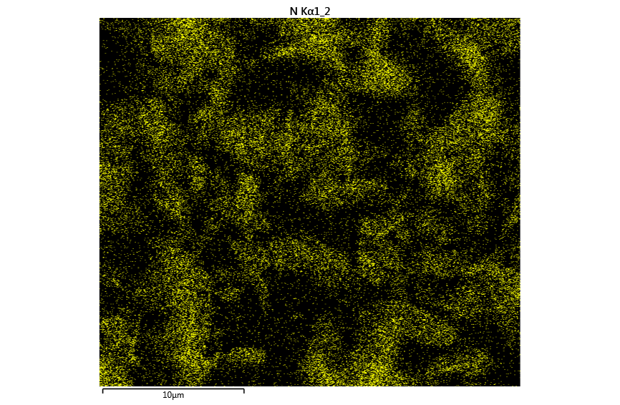
a)
b)
c)
d)

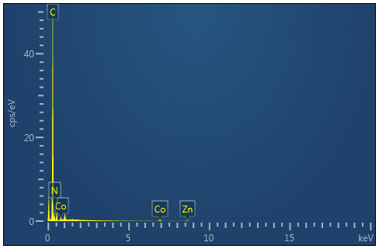
e)

Figure S2. SEM and EDS mapping of Zn/Co ZIF-L, synthesized via ultrasound technique within 30 min. a) SEM image, b) dispersion of Zn, c) dispersion of Co, d) dispersion of N, and e) EDS spectrum representing the presence of C, N, Co and Zn in the sample.

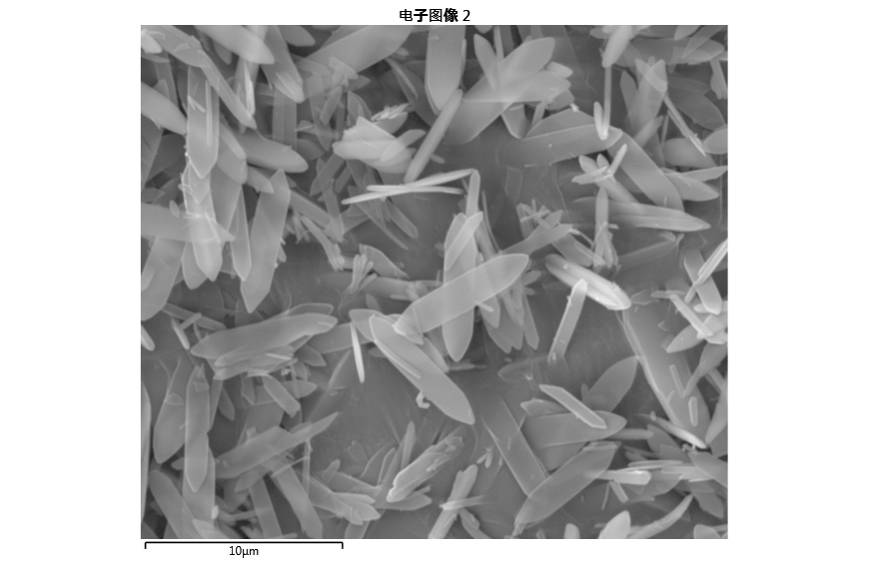
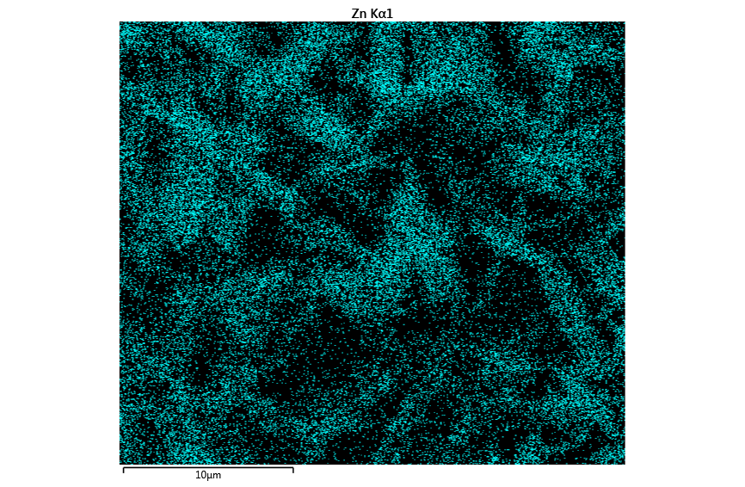
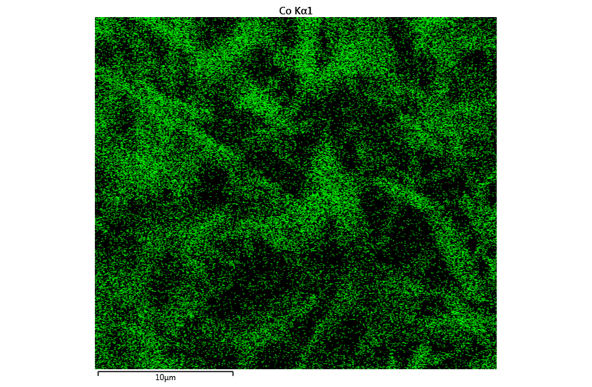
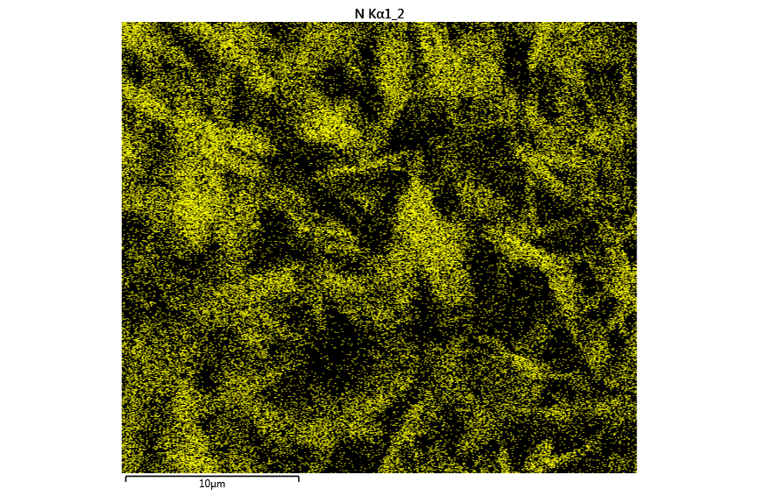
a)
b)
c)
d)

e)

Figure S3. SEM and EDS mapping of Zn/Co ZIF-L, synthesized via ultrasound technique within 1 hour. a) SEM image, b) dispersion of Zn, c) dispersion of Co, d) dispersion of N, and e) EDS spectrum representing the presence of C, N, Co and Zn in the sample.

Figure S4. Three cycles of CO₂ adsorption isotherm of Zn/Co ZIF-L, synthesized via ultrasound technique within 15 min at 298 K.

Figure S5. SEM images of Zn/Co ZIF-L, synthesized via ultrasound technique with various metal/ligand ratios and various synthesis time a) sample 1, b) sample 2, c) sample 3, the scale bar is 10 µm. d) PXRD patters of samples 1-3. e) N₂ adsorption isotherms of samples 1-3.

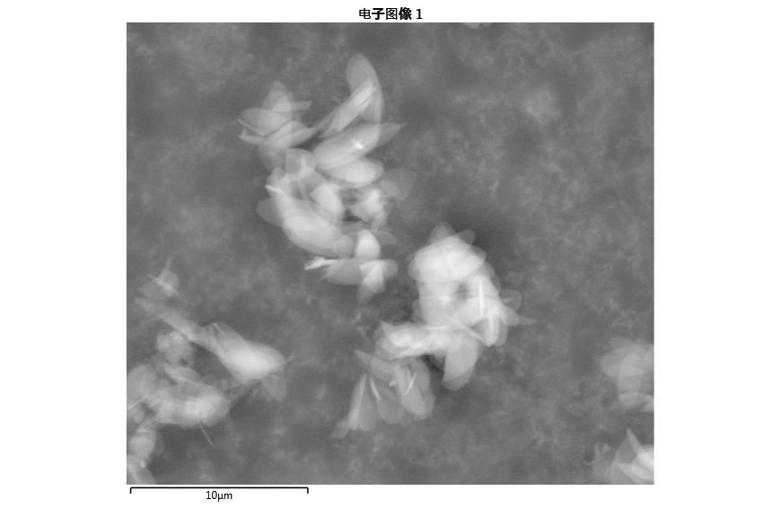
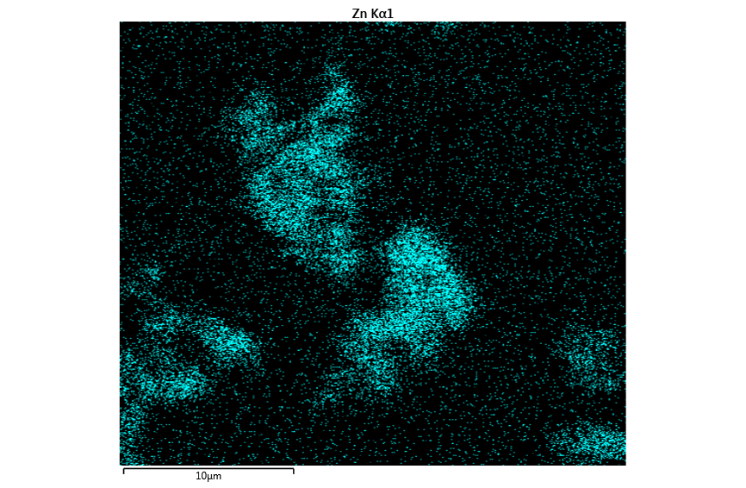
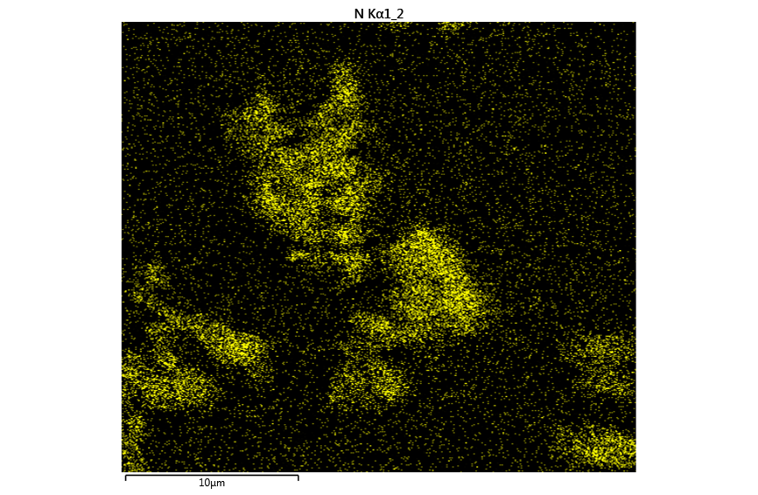
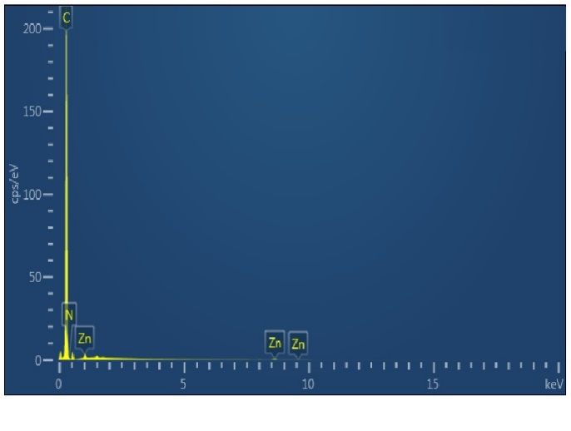
a)
b)
c)
d)

Figure S6. SEM and EDS mapping of Zn ZIF-L, synthesized via ultrasound technique within 15 min. a) SEM image, b) dispersion of Zn, c) dispersion of N, and e) EDS spectrum representing the presence of C, N, and Zn in the sample.

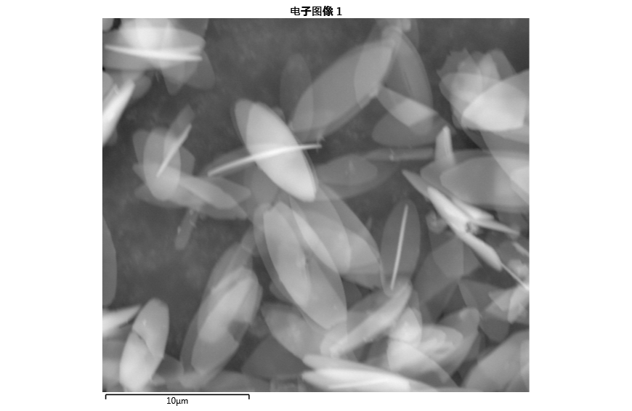
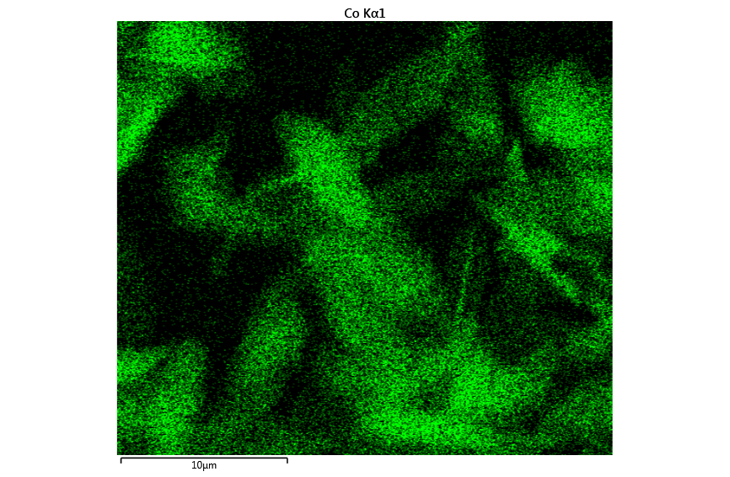
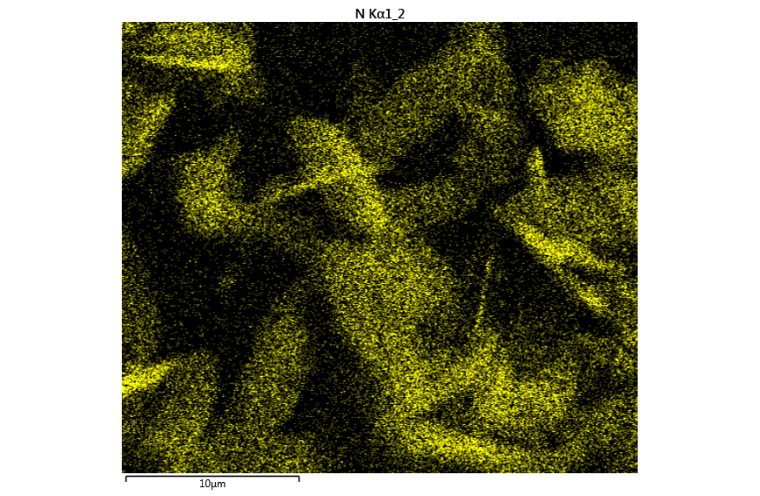
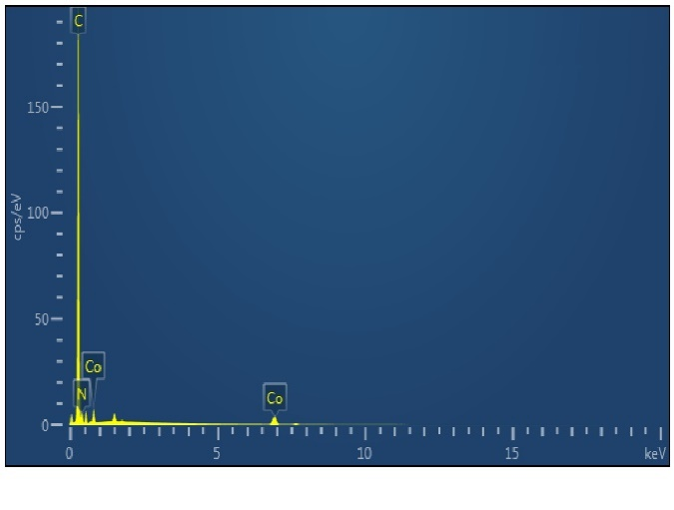
c)
b)
a)
d)

Figure S7. SEM and EDS mapping of Co ZIF-L, synthesized via ultrasound technique in 15 min. a) SEM image, b) dispersion of Co, c) dispersion of N, and d) EDS spectrum representing the presence of C, N, and Co in the sample.

a)
Figure S8 a) SEM image and b) XRD pattern of washed TiO₂ nanoparticles.

Figure S9. Degradation of MO in the presence of a) Zn/Co ZIF-L (without light), b) Zn/Co ZIF-L (under solar irradiation), c) TiO₂@Zn/Co ZIF-L under solar irradiation, and d) structure of methyl orange. Reaction condition: 50 mL aqueous solution of methyl orange (10 mgL⁻¹), 20 mg of catalyst (Zn/Co ZIF-L or TiO₂@Zn/Co ZIF-L), at room temperature.

Figure S10. a) SEM and b) XRD pattern of recovered TiO₂@Zn/Co ZIF-L.

References
[1] R. Chen, J. Yao, Q. Gu, S. Smeets, C. Baerlocher, H. Gu, D. Zhu, W. Morris, O.M. Yaghi, H. Wang. Chem. Commun., 49, 9500 (2013).
[2] H. Huang, W. Zhang, D. Liu, B. Liu, G. Chen, C. Zhong. Chem. Eng. Sci., 66, 6297 (2011).
[3] S.K. Nune, P.K. Thallapally, A. Dohnalkova, C. Wang, J. Liu, G.J. Exarhos. Chem. Commun., 46, 4878 (2010).
[4] W. Morris, B. Leung, H. Furukawa, O.K. Yaghi, N. He, H. Hayashi, Y. Houndonougbo, M. Asta, B.B. Laird, O.M. Yaghi. J. Am. Chem. Soc., 132, 11006 (2010).
[5] B. Wang, A.P. Côté, H. Furukawa, M. O’Keeffe, O.M. Yaghi. Nature, 453, 207 (2008).
[6] D. Saha, Z. Bao, F. Jia, S. Deng. Environ. Sci. Technol., 44, 1820 (2010).

