Supplementary Data
Synthesis, DFT, electrochemical, biological and DNA-interaction studies of a novel copper(II) complex of salicylic acid and N-tosyl substituted benzimidazole

NAGHMANA RASHID*, ALMAS KIRAN, IQBAL AHMAD*, ZAMAN ASHRAF, BOHARI MOHD. YAMIN and MUHAMMAD RAFIQ

CCDC 1001906

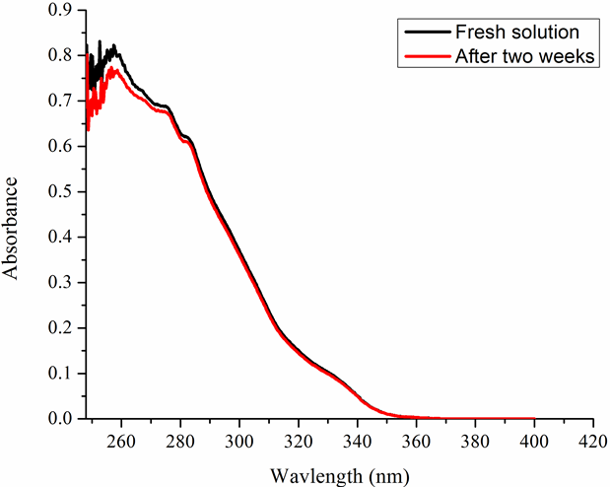

Figure S1. The UV-Visible spectra of 5×10⁴ M solutions of [Cu(L₁)(L₂)] for fresh and after two weeks.

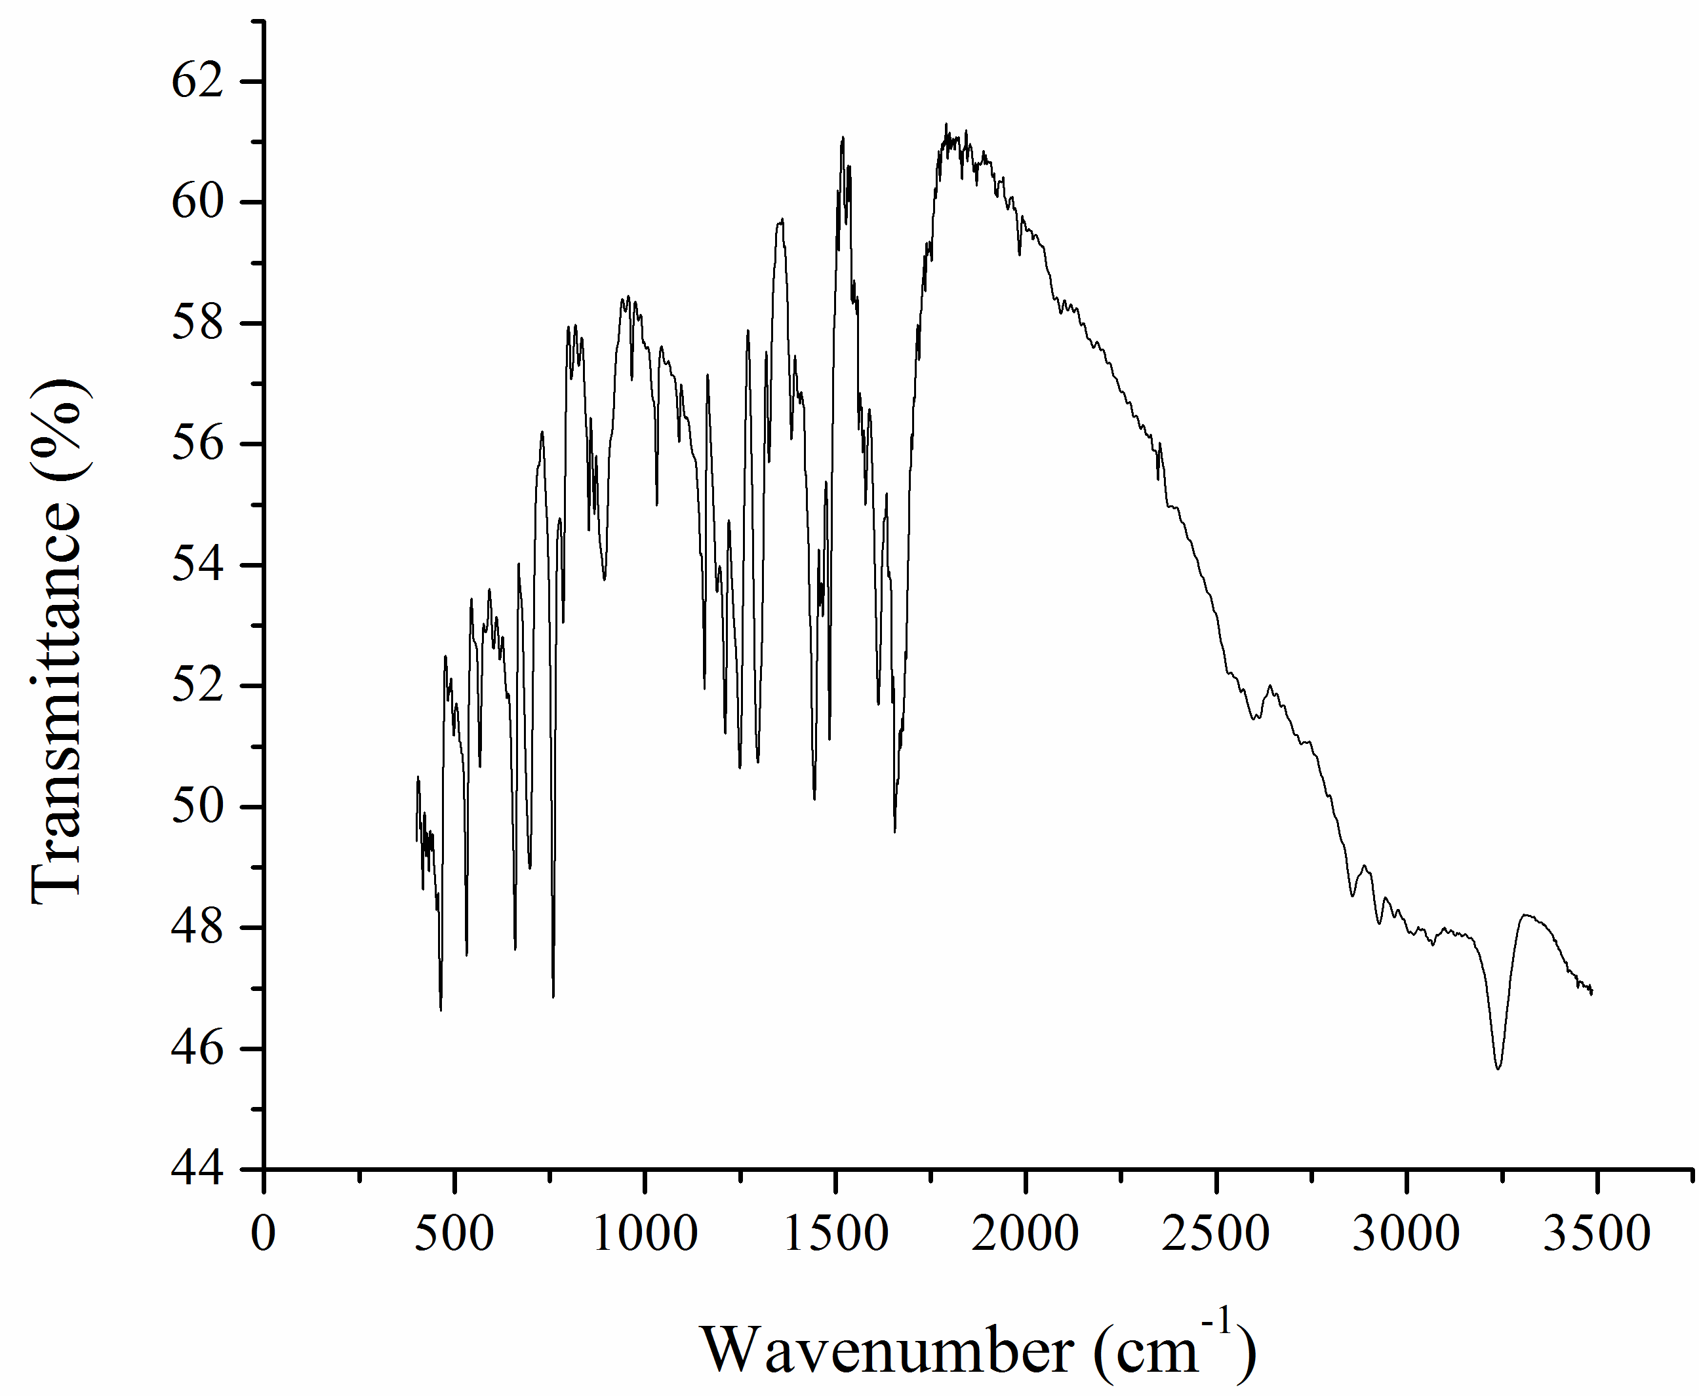
Figure S2. FTIR spectrum of L₁.

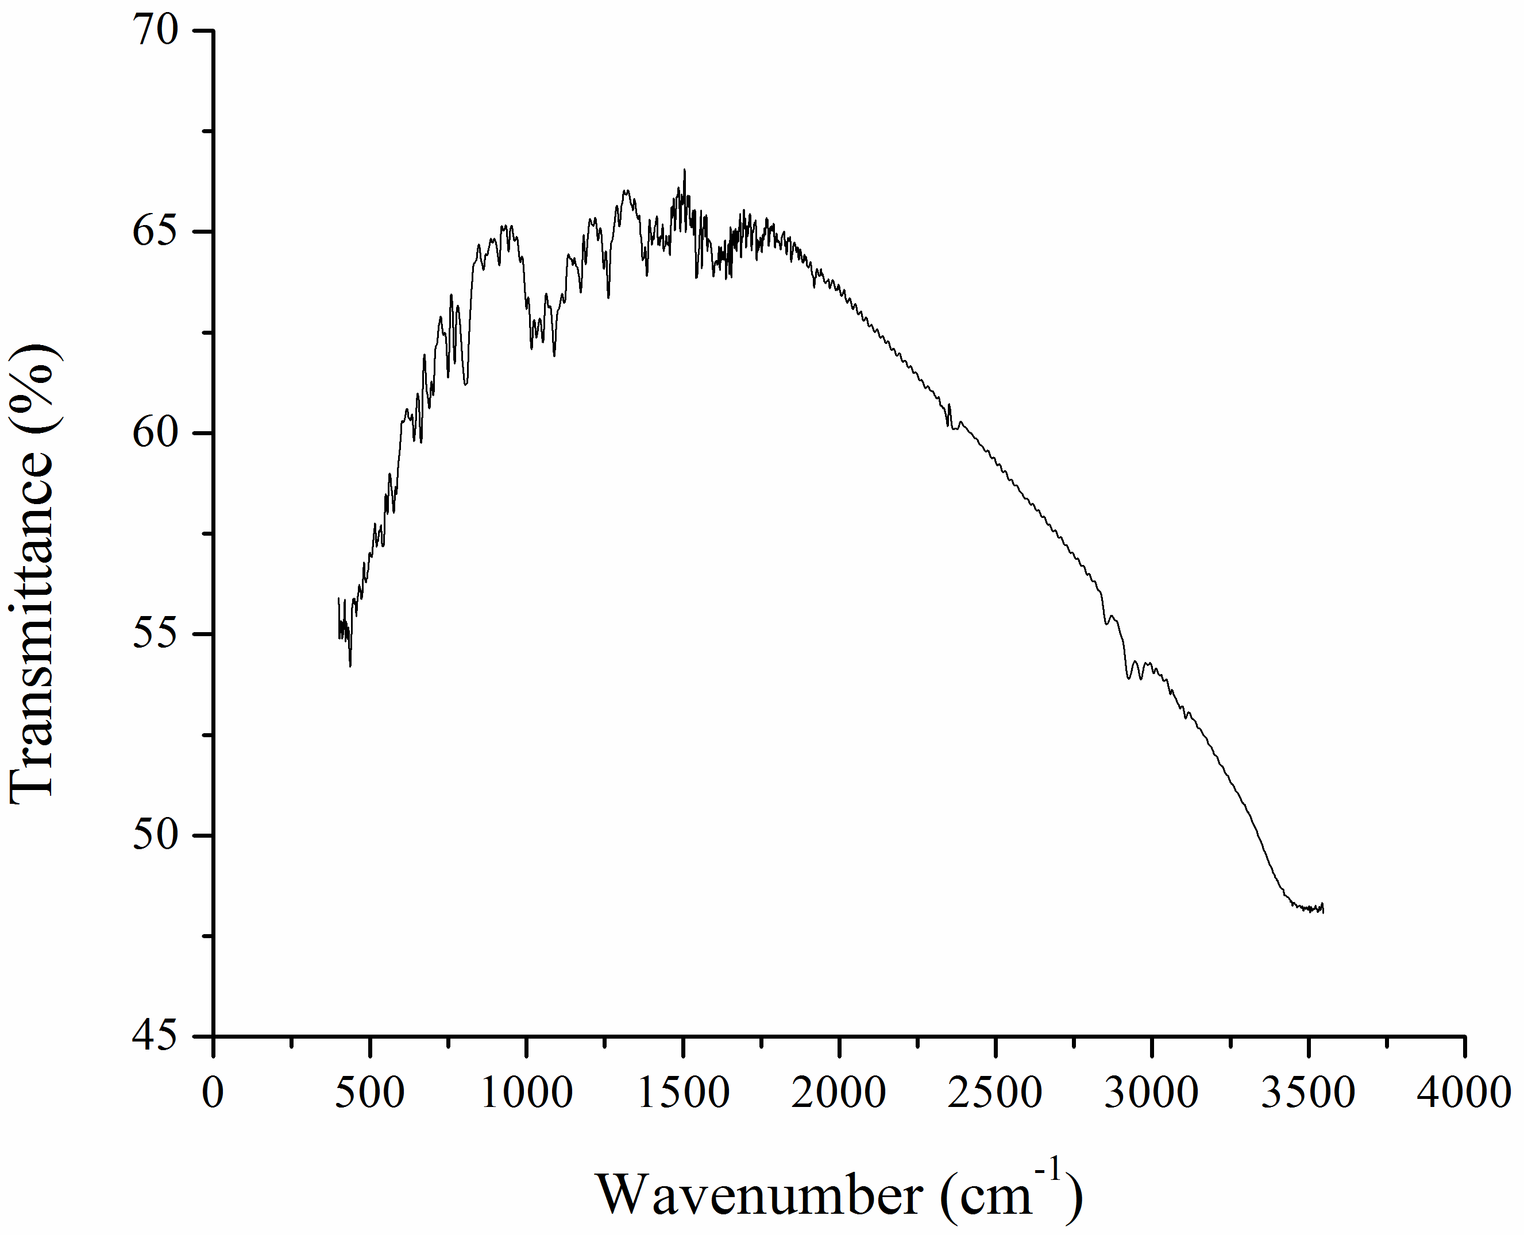
Figure S3. FTIR spectrum of L₂.

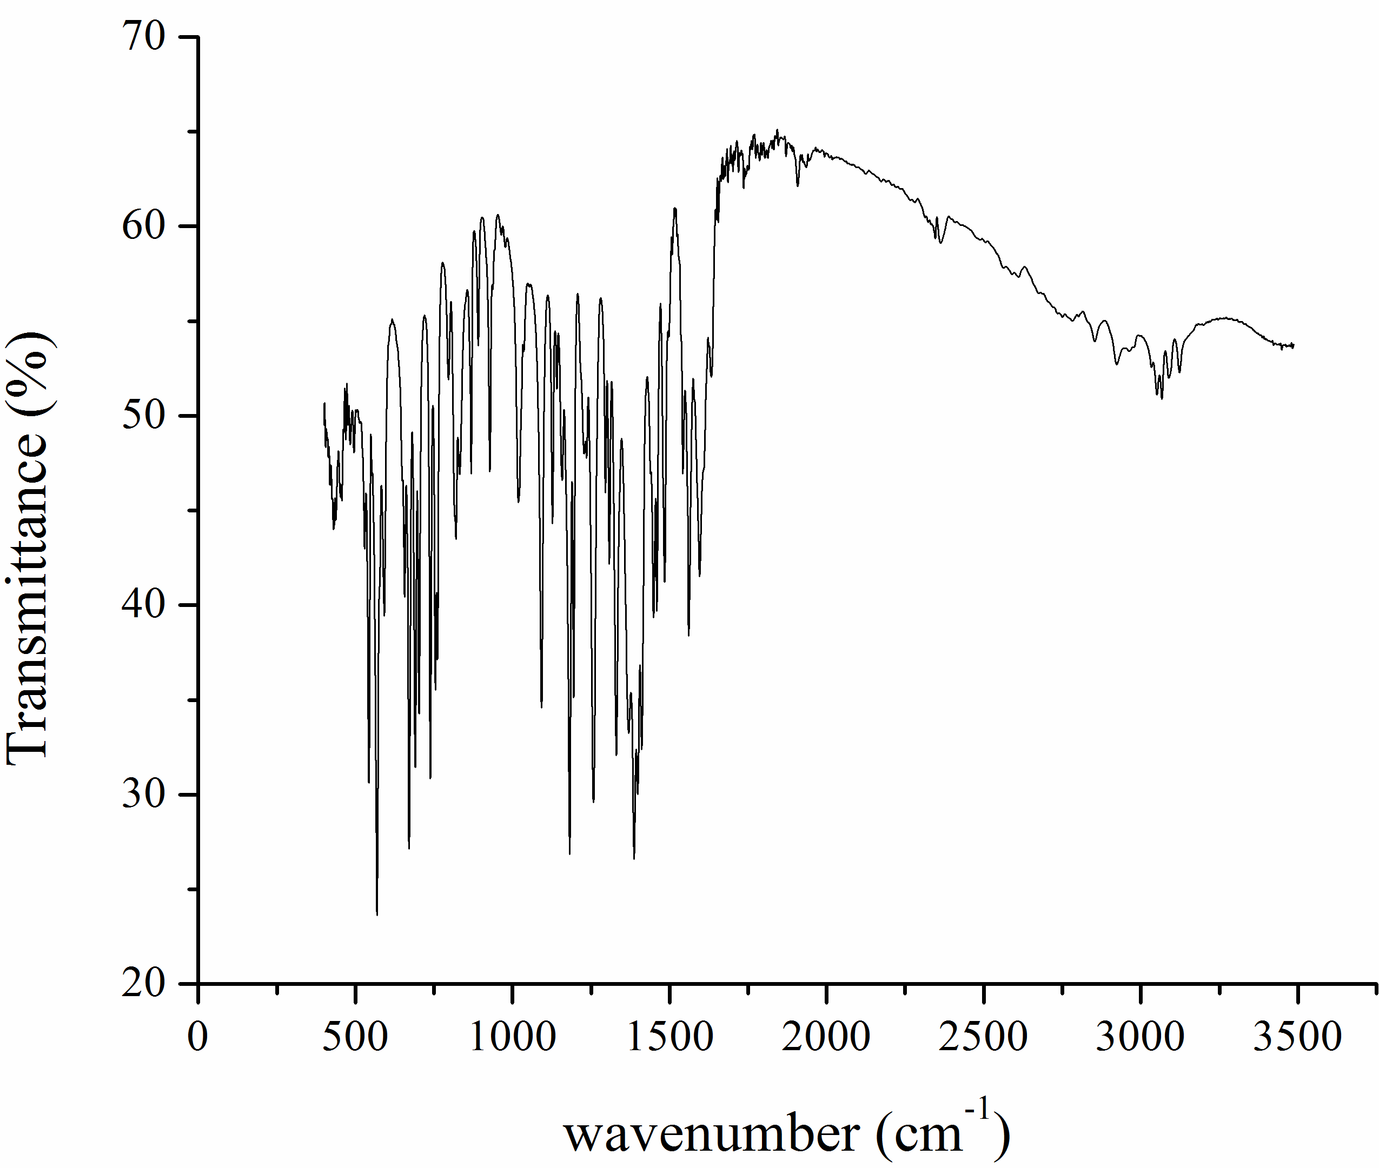
Figure S4. FTIR spectrum of [Cu(L₁)(L₂)].

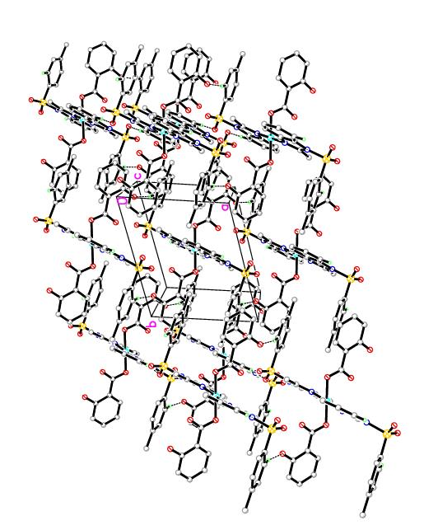
Figure S5. Molecular packing of [Cu(L₁)(L₂)] viewed down the c-axis. All hydrogens except hydrogen bonded are omitted for clarity.

Figure S6. Optimized structure of [Cu(L₁)(L₂)] determined from DFT method.

Figure S7. (A) HOMO and (B) LUMO energy levels of [Cu(L₁)(L₂)].

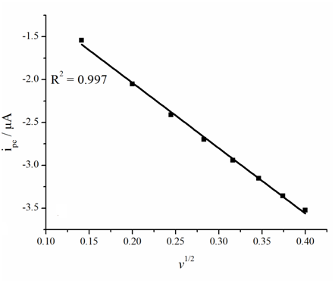
Figure S8. Plot of i_{pc} vs. V^{1/2} for determination of diffusion coefficient for 1 mM [Cu(L₁)(L₂)].

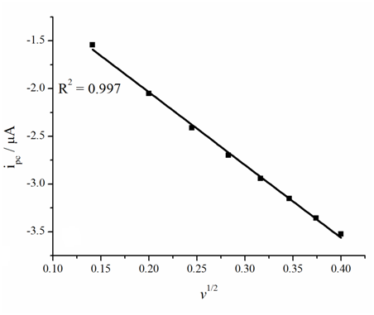
Figure S9. Plot of i_{pc} vs. V^{1/2} for determination of diffusion coefficient for 1 mM [Cu(L₁)(L₂)] in the presence of 2.2 μM DNA.
Figure S10. (A) Plot of (I_{o}-I)/I vs. [DNA] for 1 mM [Cu(L₁)(L₂)] for determination of size of binding site and (B) plot of 1/[DNA] vs. 1/(1-I/I_{o}) for 1 mM [Cu(L₁)(L₂)] for determination of binding constant.

Figure S11. Plot of [DNA]/ε_{a}-ε_{f} vs. [DNA] for determination of binding constant.

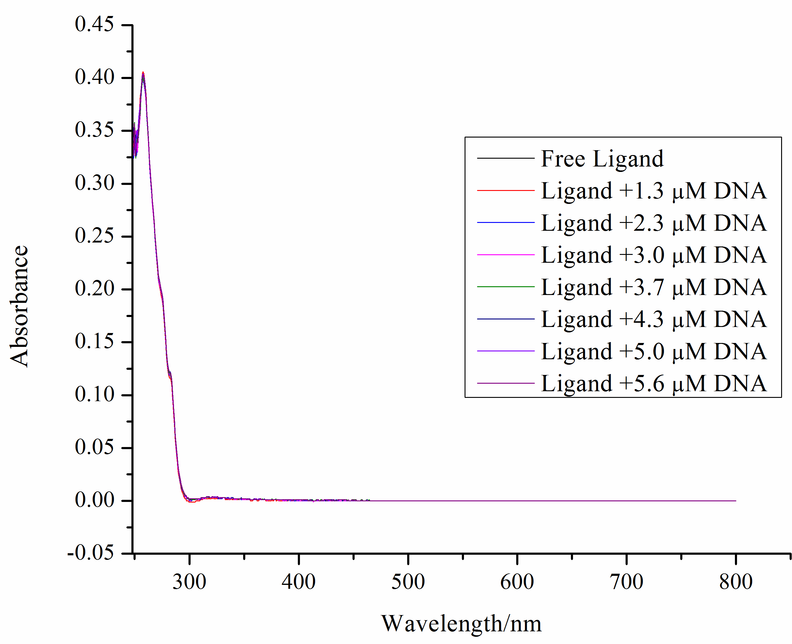
Figure S12. UV/Visible spectra of 5×10⁻⁴ M L₂ recorded in the absence and presence of 1.3, 2.3, 3.0, 3.7 4.3, 5.0 and 5.6 μM DNA in DMSO/water (9/1) solution at room temperature.

