**SUPPLEMENTARY MATERIAL**

**In vivo and ex vivo experiments to evaluate the biodistribution and cellular toxicity of ultrasmall iron oxide nanoparticles potentially used as oral iron supplements.**

J. García Fernández,a,c D. Turiel, J. Bettmer,a N. Jakubowski,b U. Panne,b,c , L. Rivasd, J. Llopisd, C. Sánchez Gonzálezd and M. Montes-Bayóna*

a Department of Physical and Analytical Chemistry, Faculty of Chemistry, University of Oviedo, Julián Clavería 8, 33006 Oviedo, Spain

b BAM Federal Institute for Materials Research and Testing, Richard-Willstaetter Str. 11, 12489 Berlin, Germany

c Humboldt-University Berlin, School of Analytical Sciences Adlershof, Unter den Linden 6, 10099 Berlin, Germany

d Biomedical Research Centre, iMUDS, Institute of Nutrition and Food Technology “José Mataix”, Department of Physiology, Faculty of Pharmacy, University of Granada, Campus Cartuja, 18071, Granada, Spain

*montesmaria@uniovi.es; Phone: +34-985103478

*Characterization of synthesized FeNPs*

High Resolution-Transmission Electron Microscopy (HR-TEM) images were taken in a JEOL JEM-2100F (Tokyo, Japan) with TEM operation voltage at 200 kV to image iron NPs suspensions deposited on copper grids, and analyzed to obtain particle diameter average and check nanoparticle shape and aggregation. Figure S1 shows discrete particles with no visible aggregates. The average of core size is 3.65 ± 0.39 nm and homogeneous size distribution as well as spherical shape are observed.

1. B) 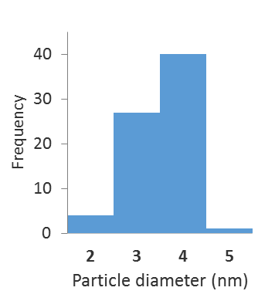

C)

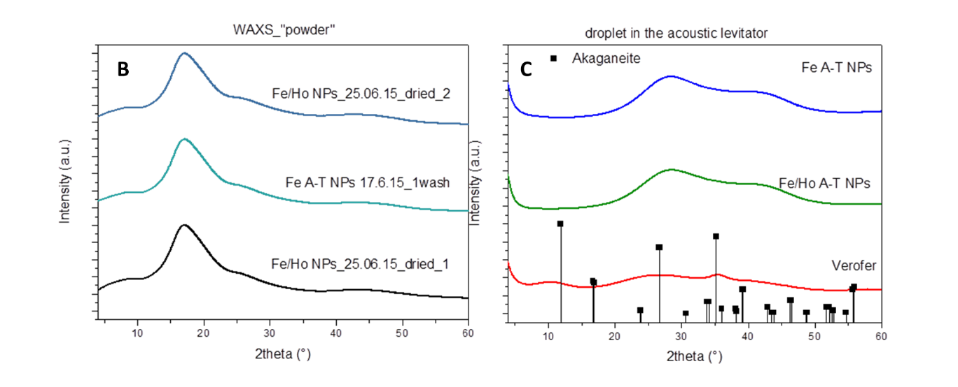Figure S1: A) TEM image of the synthesized iron NPs, B) Histogram of the analyzed particles (85) and C) EDX spectrum of the particles.

Figure S2: WAXS measurements of tartrate-modified NPs (blue line) and Holmium doped tartrate-modified NPs (green line) (in solution are represented with results for akaganeite structure that was expected with black squares).

Moreover, Dynamic Light Scattering (DLS) experiments were carried out in a Malvern Zetasizer Nano ZS (Malvern Instruments Ltd. Malvern, UK) with a detection angle of 173°. All measurements were taken at a temperature of 25ºC. Three replicates on each sample were taken to assess the repeatability of the measurements. The Nano S uses a 4 mW He–Ne laser operating at a wavelength of 633 nm. For the measurements, original samples were 100-fold diluted and ultrapure water was used. The dispersion in size as well as the NPs hydrodynamic diameter were assessed and the observed results are plotted in Figure S2A revealing that the hydrodynamic diameter is around 11.77 nm with a polydispersity index of 0.276. This means an acceptable monodispersing and homogeneity in this suspension and it can also be concluded that the modified tartrate coating corresponds to about 7-8 nm.

In addition, the results reveal that in the presence of “biological media” such as cell growing media, the particles tend to slightly aggregate to form, partially, entities with a size below 100 nm and in the range of 50-60 nm.

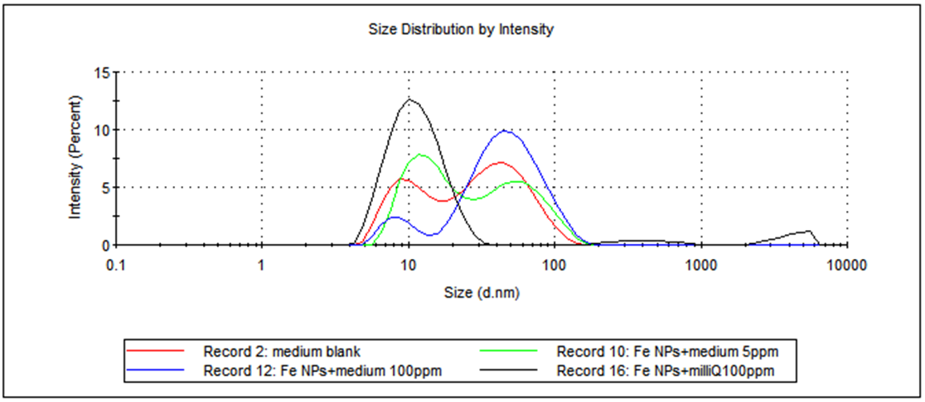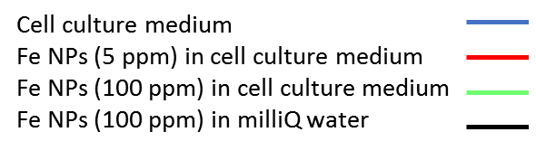

Figure S3: DLS results of different nanoparticle suspensions.

Optical absorption spectra were recorded using a Genesys 10S UV-vis spectrophotometer (Thermo Scientific, USA). A UV/Vis spectrum was obtained to evaluate the energy band gap of the semiconductor Fe-based nanomaterial.

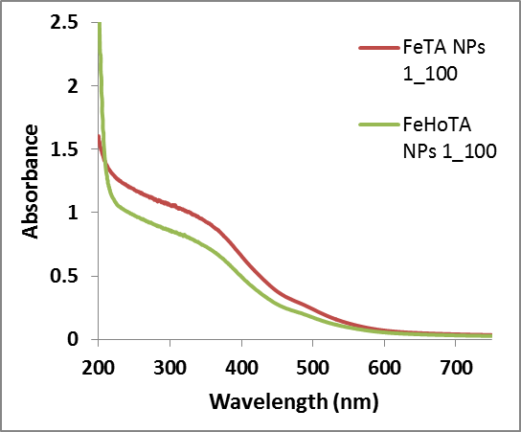

Figure S4: UV/Vis spectra of the synthesized iron nanoparticles.

The optical absorbance measurement was carried out at room conditions and Figure S4 shows the absorption profile obtained for synthesized FeNPs at two different dilutions. It appears as a continuous highly intensity band decreasing gradually at longer wavelengths. However, a high intensity band can be seen around 350 nm corroborating the presence of the oxo-metal charge transfer transition, expected in this kind of nanostructure in the range of 250-390 nm.

Histological integrity of the small intestine

The images show that the treatment with FeNP has not produced histological damage in the duodenum, jejunum or ileum, showing normal patterns in the mitochondria, intercellular junctions, microvilli and rest of cellular structures

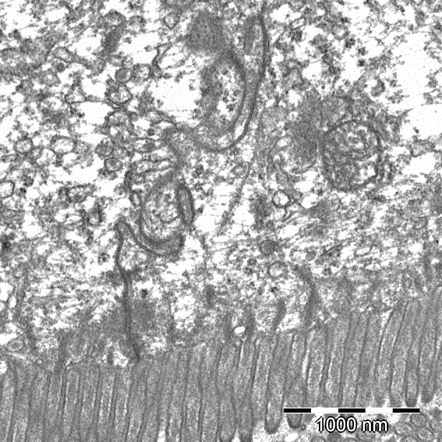 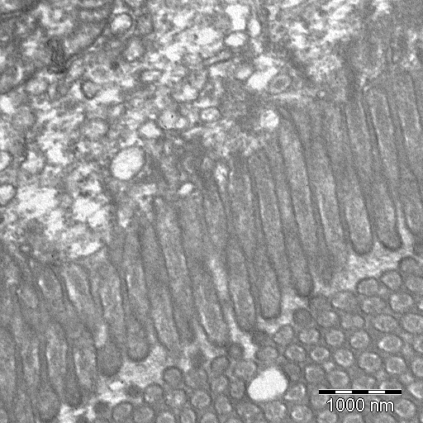

Figure S5: Normal histology of duodenum

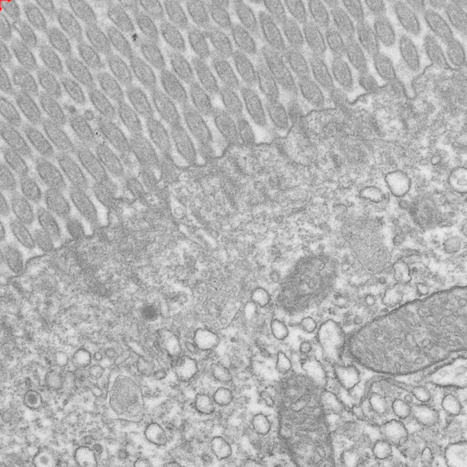 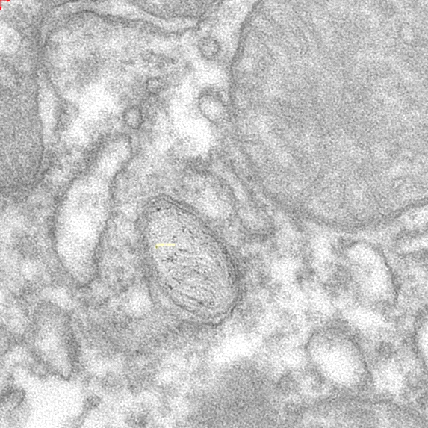

Figure S6: Normal histology of jejunum

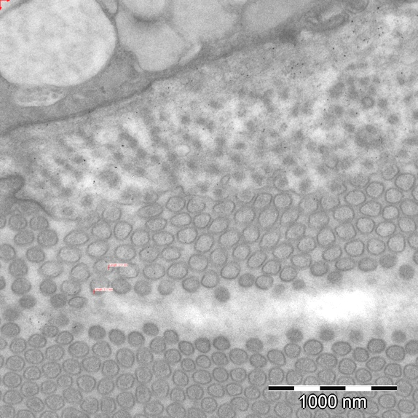 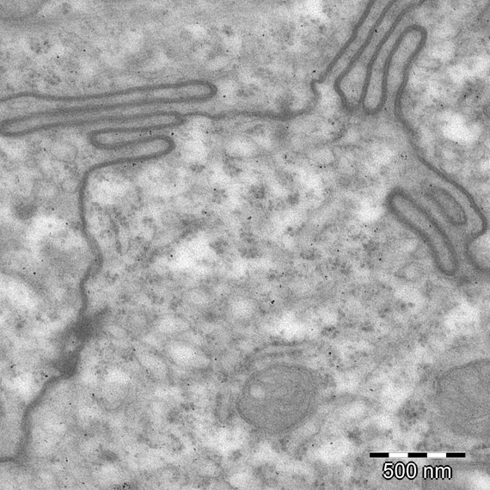

Figure S7: Normal histology of ileum

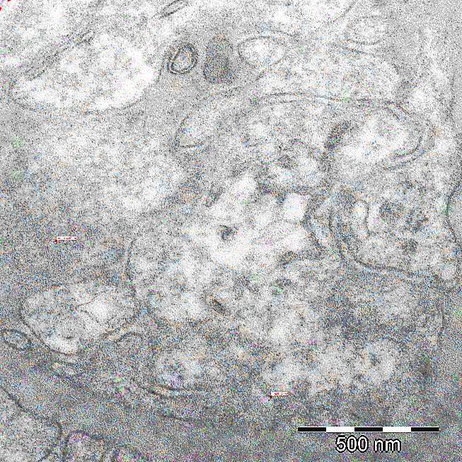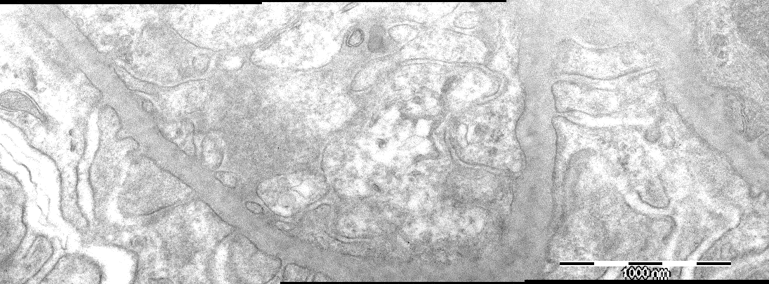

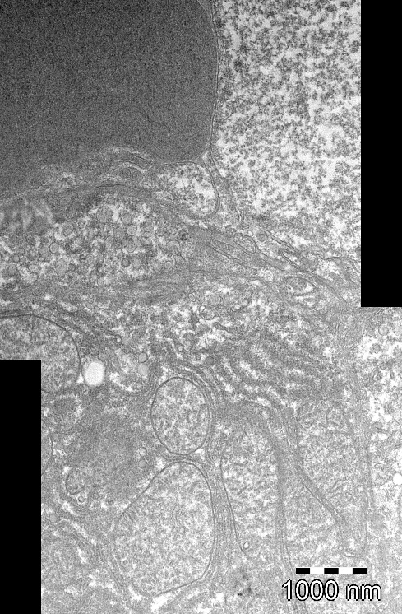Figure S8: Histology of the kidney (glomerulus)

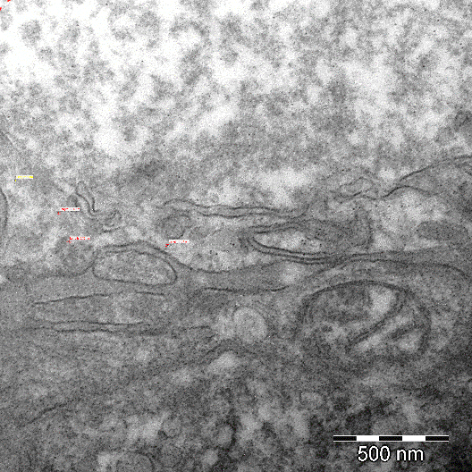

Figure S9: Histology of the liver (disse space)

**Table 1.** ICP-MS operating conditions

|  |  |  |
| --- | --- | --- |
| Instrument | Agilent 7700 | iCAP-TQ-ICP-MS |
| RF Power | 1500 W | 1550 W |
| Carrier gas flow rate | 1.15 L·min-1 | 0.8 L·min-1 |
| Coolant plasma gas flow rate | 15 L·min-1 | 14 L·min-1 |
| Reaction/collision gas flow | H2 | He |
|  | 3.5 mL·min-1 | 7.8 mL·min-1 |
| Octapole bias | -18 V | -11.83 V |
| QP bias | -16 V | - |
| Nebulizer | Meinhard Type | Concentric |
| Spray chamber | Double pass, Peltier cooled (2oC) | Cyclonic |
| m/z monitored | 54, 56, 57 | 56, 57 |
| Dwell time | 0.1 s | 0.1 s |
| Sensitivity (59Co) | 170.000 (cps/ppb) | 300.000 (cps/ppb) |