Electronic supplementary material (ESM)

Table 1. KMO and Barlett’s Test
KMO and Bartlett's Test
Kaiser-Meyer-Olkin Measure of Sampling Adequacy. |  | .981
Bartlett's Test of Sphericity | Approx. Chi-Square | 444186.614
 | Df | 2628
 | Sig. | .000

Table 2. Total variance explained

Total Variance Explained
Component | Initial Eigenvalues |  |  | Extraction Sums of Squared Loadings |  |  | Rotation Sums of Squared Loadingsª
 | Total | % of Variance | Cumulative % | Total | % of Variance | Cumulative % | Total
1 | 61.970 | 84.890 | 84.890 | 61.970 | 84.890 | 84.890 | 57.810
2 | 4.188 | 5.737 | 90.627 | 4.188 | 5.737 | 90.627 | 45.511
3 | 1.851 | 2.536 | 93.163 | 1.851 | 2.536 | 93.163 | 44.049
4 | .668 | .915 | 94.078
5 | .547 | .749 | 94.827
6 | .355 | .486 | 95.313
7 | .336 | .461 | 95.774
8 | .302 | .413 | 96.187
9 | .228 | .313 | 96.500
10 | .201 | .276 | 96.775
11 | .178 | .243 | 97.019
12 | .169 | .231 | 97.250
13 | .155 | .213 | 97.463
14 | .148 | .203 | 97.665
15 | .128 | .175 | 97.840
16 | .123 | .169 | 98.009
17 | .120 | .164 | 98.173
18 | .108 | .147 | 98.321
19 | .096 | .132 | 98.452
20 | .088 | .120 | 98.573
21 | .079 | .108 | 98.680
22 | .077 | .105 | 98.786
23 | .072 | .098 | 98.884
24 | .065 | .089 | 98.973
25 | .061 | .083 | 99.056
26 | .058 | .080 | 99.136
27 | .054 | .074 | 99.210
28 | .052 | .071 | 99.281
29 | .046 | .063 | 99.344
30 | .043 | .058 | 99.403
31 | .036 | .050 | 99.452
32 | .035 | .048 | 99.500
33 | .032 | .044 | 99.544
34 | .028 | .038 | 99.582
35 | .027 | .037 | 99.619
36 | .024 | .033 | 99.652
37 | .021 | .029 | 99.681
38 | .021 | .028 | 99.709
39 | .018 | .025 | 99.734
40 | .016 | .022 | 99.756
41 | .015 | .020 | 99.777
42 | .014 | .020 | 99.796
43 | .014 | .019 | 99.815
44 | .012 | .017 | 99.832
45 | .011 | .015 | 99.847
46 | .009 | .013 | 99.860
47 | .009 | .012 | 99.872
48 | .009 | .012 | 99.884
49 | .008 | .011 | 99.894
50 | .007 | .010 | 99.905
51 | .007 | .010 | 99.914
52 | .007 | .009 | 99.924
53 | .006 | .008 | 99.931
54 | .005 | .007 | 99.939
55 | .005 | .007 | 99.946
56 | .004 | .006 | 99.952
57 | .004 | .006 | 99.957
58 | .004 | .005 | 99.962
59 | .003 | .005 | 99.967
60 | .003 | .004 | 99.971
61 | .003 | .004 | 99.975
62 | .002 | .003 | 99.979
63 | .002 | .003 | 99.982
64 | .002 | .003 | 99.985
65 | .002 | .003 | 99.987
66 | .002 | .002 | 99.990
67 | .002 | .002 | 99.992
68 | .001 | .002 | 99.994
69 | .001 | .002 | 99.995
70 | .001 | .001 | 99.997
71 | .001 | .001 | 99.998
72 | .001 | .001 | 99.999
73 | .001 | .001 | 100.000
Extraction Method: Principal Component Analysis.
- When components are correlated, sums of squared loadings cannot be added to obtain a total variance.

Table 3. Similarity limit
Descriptive Statistics
 | Mean | Std. Deviation | N
N1as1 | .2594 | .30434 | 1666
N1as2 | .2602 | .30591 | 1666
N1as3 | .2672 | .29991 | 1666
N10as1 | .2595 | .21607 | 1666
N10as2 | .2764 | .31709 | 1666
N10as3 | .3094 | .32118 | 1666
N13as1 | .2574 | .29171 | 1666
N13as2 | .4774 | .33031 | 1666
N13as3 | .2924 | .30609 | 1666
N13bs1 | .2992 | .27506 | 1666
N13bs2 | .2785 | .28733 | 1666
N13bs3 | .3036 | .26289 | 1666
N14as1 | .2676 | .21767 | 1666
N14as2 | .2154 | .20229 | 1666
N14as3 | .3287 | .23422 | 1666
N18as1 | .2760 | .35935 | 1666
N18as2 | .3439 | .34211 | 1666
N18as3 | .2928 | .31014 | 1666
N19as1 | .2519 | .26420 | 1666
N19as2 | .2383 | .29731 | 1666
N19as3 | .2789 | .30667 | 1666

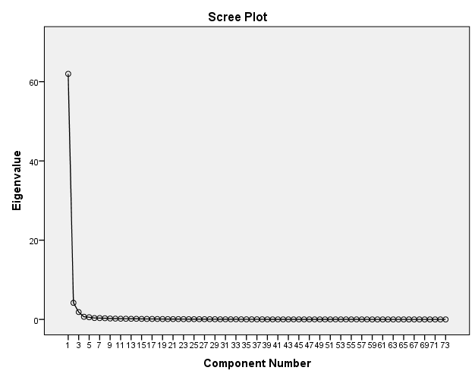

Fig.1 Scree plot

