EVALUATION AND CHARACTERIZATION OF ALGAL BIOMASS APPLIED TO THE DEVELOPMENT OF FINGERMARKS ON GLASS SURFACES
Table 1S. Chemical components (% of area) of the biomass of the studied marine organisms.
Compounds | Chlorella sp. | D. anceps | L. dendroidea | L. searlesiana | Spirulina sp.
Lactic acid | 1.08 ± 0.04^{ab} | 0.36 ± 0.03^{ab} | nd^{b} | 0.28 ± 0.05^{ab} | 1.15 ± 0.03ª
Acetic acid | 0.37 ± 0.08ª | 0.49 ± 0.08ª | 2.80 ± 0.22^{b} | 0.39 ± 0.04ª | 0.24 ± 0.05ª
Hydroxybutyric acid | 0.62 ± 0.02ª | ndª | ndª | ndª | 0.54 ± 0.05ª
Hydroxyvaleric acid | 0.51 ± 0.03ª | ndª | ndª | ndª | ndª
Succinic acid | 1.64 ± 0.25ª | 0.19 ± 0.00^{b} | nd^{b} | nd^{b} | nd^{b}
Benzenepropanoic acid | 1.85 ± 0.04ª | nd^{b} | nd^{b} | nd^{b} | 0.24 ± 0.03^{b}
Hydroxyhydrocinnamic acid | 0.41 ± 0.04ª | ndª | ndª | ndª | ndª
Tetradecanoic acid | 0.58 ± 0.10ª | ndª | 2.34 ± 0.09^{b} | ndª | ndª
Docosahexaenoic acid | 0.50 ± 0.04ª | ndª | ndª | ndª | 0.44 ± 0.05ª
Palmitoleic acid | 8.12 ± 0.19ª | nd^{c} | nd^{c} | nd^{c} | 2.32 ± 0.29^{b}
Hexadecanoic acid | 9.76 ± 0.34ª | 0.46 ± 0.08^{c} | 14.56 ± 0.05^{b} | 0.46 ± 0.10^{c} | 9.40 ± 0.60ª
Linoleic acid | 25.31 ± 0.34ª | nd^{b} | nd^{b} | 0.24 ± 0.08ª | nd^{b}
Linolenic acid | ndª | ndª | ndª | ndª | 5.75 ± 0.56^{b}
Oleic acid | ndª | ndª | 1.42 ± 0.20ª | ndª | ndª
Octadecanoic acid | 0.47 ± 0.03ª | ndª | 0.70 ± 0.18ª | 0.17 ± 0.04ª | ndª
Glycerol monopalmitolate | 0.19± 0.05ª | ndª | ndª | 0.18 ± 0.02ª | 0.59 ± 0.46ª
Glycerol monostearate | ndª | ndª | ndª | ndª | 0.22 ± 0.27ª
Carboxylic acids | 50.94 ± 0.83ª | 1.52 ± 0.20^{c} | 21.82 ± 0.34^{b} | 1.73 ± 0.11^{c} | 20.93 ± 0.77^{b}
Alanine | 1.57 ± 0.14ª | 1.57 ± 0.23ª | nd^{b} | nd^{b} | 0.36 ± 0.15^{b}
L-norvaline | 0.68 ± 0.05ª | ndª | ndª | ndª | ndª
Aminocaproic acid | 0.40 ± 0.04ª | 0.06 ± 0.01ª | ndª | ndª | ndª
Amines | 2.66 ± 0.16ª | 1.63 ± 0.22ª | nd^{b} | nd^{b} | 0.36 ± 0.15^{b}
Heptadecane | 0.40 ± 0.03ª | ndª | ndª | ndª | 1.15 ± 0.11^{b}
Hydrocarbons | 0.40 ± 0.03ª | ndª | ndª | ndª | 1.15 ± 0.11^{b}
Glycerol | 10.19 ± 0.14ª | nd^{d} | 1.52 ± 0.41^{c} | 1.69 ± 0.02^{c} | 5.82 ± 0.07^{b}
3,7,11,15-Tetramethyl-2-hexadecen-1-ol | 1.86 ± 0.14ª | nd^{b} | nd^{b} | nd^{b} | 0.23 ± 0.02^{b}
Phytol | 2.89 ± 0.16ª | nd^{b} | nd^{b} | nd^{b} | 0.94 ± 0.10^{b}
Glycerolgalactopyranoside | 1.76 ± 0.37ª | nd^{b} | nd^{b} | nd^{b} | nd^{b}
Deoxyglucose | 2.23 ± 0.26ª | ndª | ndª | ndª | ndª
Glycerophosphoric acid | 2.56 ± 0.50ª | nd^{b} | nd^{b} | nd^{b} | 0.24 ± 0.08^{b}
3,7,11,15-Tetramethyl-2-hexadecen-1-ol | 4.36 ± 0.30ª | 0.54 ± 0.14^{bc} | nd^{c} | 0.27 ± 0.03^{c} | 1.60 ± 0.19^{b}
3,7,11-Trimethyl-1-dodecanol | 0.43 ± 0.09ª | ndª | ndª | ndª | 0.19 ± 0.05ª
D-turanose | 2.08± 0.37ª | nd^{b} | nd^{b} | nd^{b} | nd^{b}
Erythro-pentofuranose | ndª | ndª | ndª | ndª | 0.27 ± 0.12ª
Deoxy-galactose | ndª | ndª | ndª | ndª | 21.64 ± 2.59^{b}
Glycerol-galactopyranose | ndª | ndª | ndª | ndª | 14.13 ± 2.81^{b}
Unknown carbohydrate | ndª | 79.19 ± 3.15^{b} | ndª | 81.77 ± 2.48^{b} | ndª
Elatol | ndª | ndª | 53.35 ± 1.47^{b} | ndª | ndª
Alcohols | 28.39 ± 1.47ª | 79.73 ± 3.01^{d} | 55.06 ± 1.06^{c} | 83.74 ± 2.42e | 45.08 ± 0.26^{b}
Cholesterol | 0.92 ± 0.00ª | ndª | 5.22 ± 0.22^{b} | ndª | 0.38 ±0.03ª
Ergosterol | 1.45 ± 0.11ª | nd^{b} | nd^{b} | nd^{b} | nd^{b}
Fucosterol | ndª | 2.57 ± 0.56^{b} | ndª | 2.77 ± 0.07^{b} | ndª
Steroids | 2.38 ± 0.11ª | 2.57 ± 0.56ª | 5.22 ± 0.22^{c} | 2.77 ± 0.07ª | 0.38 ± 0.03^{b}
Unidentified | 14.71 ± 1.12 | 14.55 ± 2.03 | 17.88 ± 1.62 | 11.75 ± 2.46 | 32.08 ± 0.55
Results expressed as mean ± standard deviation of triplicates (n=3)
Different superscript letters indicate significant differences (p<0.05)

Table 2S. Results of the IR Spectroscopy analysis of the samples.
Bonding (cm⁻¹) | Chlorella sp. | D. anceps | L. dendroidea | L. searlesiana | Spirulina sp.
-O-H | 3280 | 3240 | 3303 | 3253 | 3280
=C-H | - | 3022 | 3022 | 3022 | -
-C-H | 2918 | 2968 | 2973 | 2973 | 2954  2923
-C=O  (ester) | 1737 | 1737 | 1737 | 1737 | -
-O-H  (bending) | - | - | 1418 | - | -
-C=O  (amide) | 1643 | - | - | - | 1650
-N-H  (amide) | 1536 | - | - | - | 1540
-C-H  (bending) | 1454 | 1366 | 1368 | 1366 | 1450
-C-N | 1230 | 1228 | 1228 | 1228 | 1233
-C-O | 1217  1027 | 1215  1208  1079  1020 | 1217  1206  1138  1124  1095  1025 | 1217  106 | 1020
-C-Cl | - |  | 875 |  | -
-C-Br | - |  | 656 |  | -

Table 3S. Particle size distribution of the studied marine biomasses.
Samples | 10% (μm) | 50% (μm) | 90% (μm)
Chlorella sp. | 23.56 | 84.73 | 192.80
D. anceps | 14.58 | 86.49 | 243.98
L. dendroidea | 15.67 | 84.86 | 195.18
L. searleasiana | 21.69 | 140.00 | 350.92
Spirulina sp. | 8.66 | 42.18 | 148.00
Commercial developer | 2.73 | 28.43 | 42.87

Table 4S. Superficial elementary composition of the studied marine biomasses.
Elements (%) | Samples
 | Chlorella sp. | D. anceps | L. dendroidea | L. searlesiana |  | Spirulina sp.
Si | - | - | 0.6 |  | - |  | -
P | 14.54 | 0.51 | - |  | 0.29 |  | 11.57
S | 7.37 | 2.08 | 4.45 |  | 1.5 |  | 10.91
Cl | - | 46.54 | 45.84 |  | 37.94 |  | -
K | 23.3 | 41.3 | 9.63 |  | 51.83 |  | 45.59
Ca | 40.62 | 8.3 | 36.19 |  | 5.98 |  | 22.44
Ti | 0.56 | - | 0.13 |  | - |  | -
Mn | 0.3 | - | - |  | - |  | 0.2
Fe | 12.85 | 0.24 | 0.81 |  | 0.06 |  | 7.08
Cu | 0.16 | 0.05 | 0.04 |  | 0.03 |  | 0.19
Zn | 0.12 | 0.07 | - |  | - |  | -
As | - | 0.03 | - |  | 0.04 |  | -
Br | - | 0.33 | 2.05 |  | 1.42 |  | -
Rb | - | - | - |  | 0.06 |  | -
Sr | 0.19 | 0.47 | 0.18 |  | 0.3 |  | 0.13
Zr | - | - | 0.04 |  | - |  | -
Ag | - | 0.04 | - |  | 0.06 |  | -
I | - | - | 0.05 |  | 0.48 |  | -
Ba | - | - | - |  | - |  | 1.89
Pa | - | 0.03 | - |  | - |  | -

Figure 1S. FT-IR spectrum of all the algae biomasses.
Figure 2S. GC-MS chromatogram of the extract from the biomass of Chlorella sp.
Figure 3S. GC-MS chromatogram of the extract from the biomass of Spirulina sp.
Figure 4S. GC-MS chromatogram of the extract from the biomass of L. dendroidea.
Figure 5S. GC-MS chromatogram of the extract from the biomass of D. anceps.
Figure 6S. GC-MS chromatogram of the extract from the biomass of L. searlesiana.

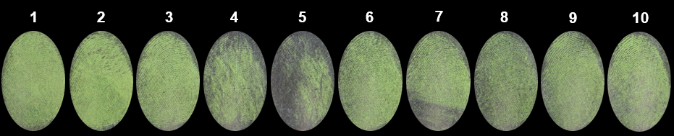
Figure 7S. Depletion study using Spirulina sp. biomass under 24 hours for natural latent fingerprint
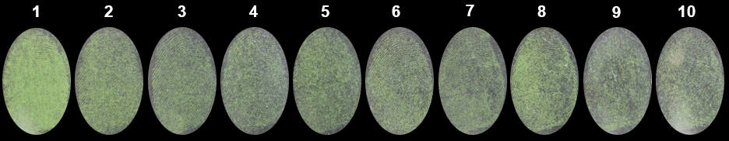
Figure 8S. Depletion study using Spirulina sp. biomass under 72 hours for natural latent fingerprint
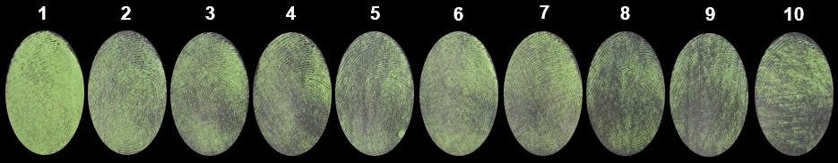
Figure 9S. Depletion study using Spirulina sp. biomass under 24 hours for sebaceous latent fingerprint.
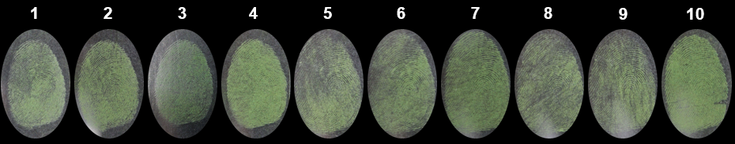
Figure 10S. Depletion study using Spirulina sp. biomass under 72 hours for sebaceous latent fingerprint

