**A two step optimization approach for maximizing biosorption of hexavalent chromium ions (Cr(VI)) using alginate immobilized *Sargassum sp* in a packed bed column**

Ashish A Prabhua, Dharanidaran Jayachandrana, Sushma Chityalaa, Narendra Naik Deshavathb and Veeranki Venkata Dasua,b*

*aBiochemical Engineering Laboratory, Department of Biosciences and Bioengineering,*

*bCentre for the Environment, Indian Institute of Technology Guwahati, Guwahati 781039, Assam, India*

Supporting Information

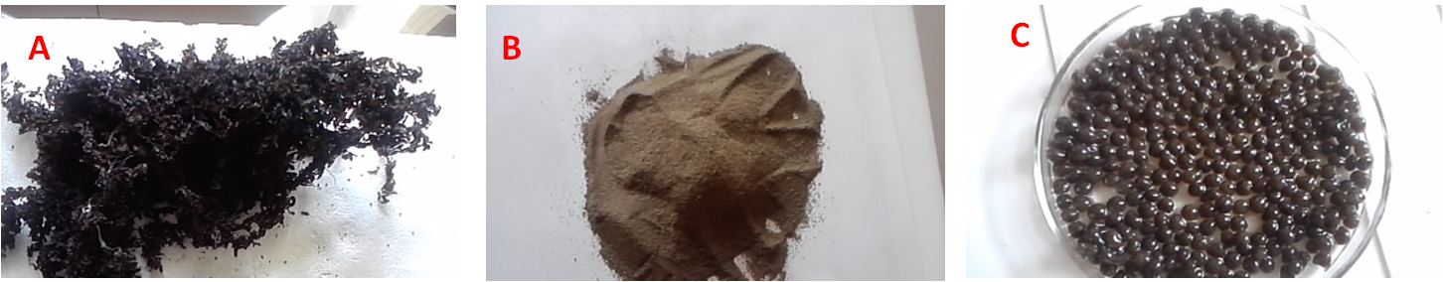

**Fig S1**: Biosorbent preparation: (A) Washed and Dried *Sargassum sp* (B) Powdered *Sargassum sp* (C) Alginate immobilized *Sargassum sp*.

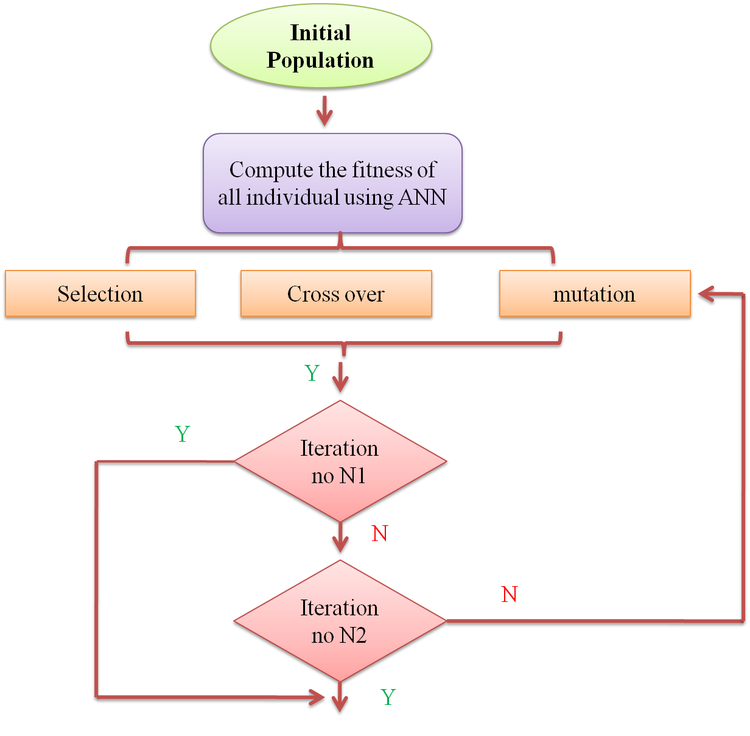

**Fig S2:** Schematic representation of ANN-GA procedure adopted for Cr(VI) biosorption in packed bed column

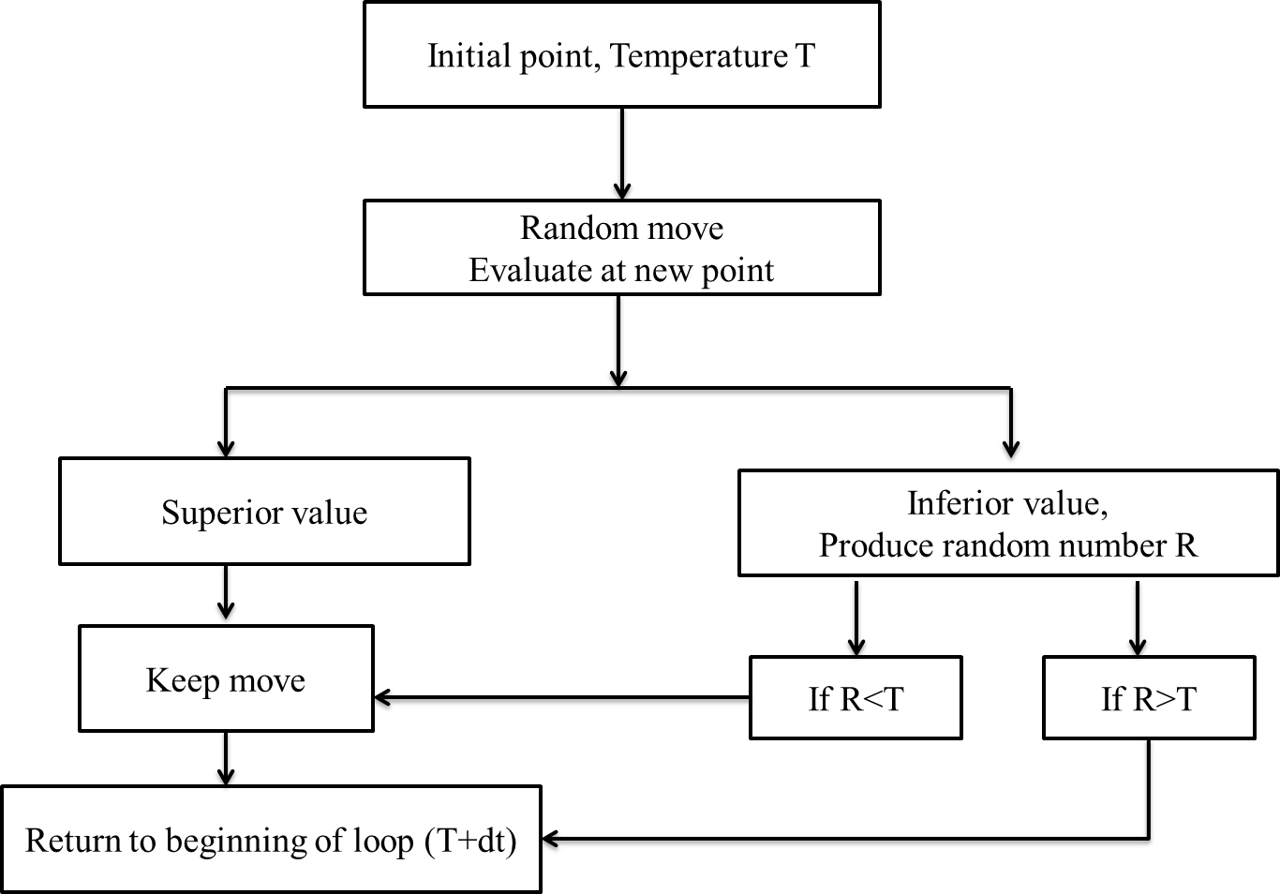

**Fig S3**: work flow algorithm of simulated annealing method adopted for Cr(VI) biosorption in packed bed column



**Fig S4**: Graphical representation of data points used for training, validation and Test in ANN



**Fig S5**: Error and learning curve of the neural network