SUPPLEMENTARY MATERIALS

Atmospheric pollution assessment near potential source of natural aerosols in the South Gobi Desert region, China
Mikalai Filonchyk*, Volha Hurynovich
Faculty of Geomatics, Lanzhou Jiaotong University, Lanzhou 730070, China.
Gansu Provincial Engineering Laboratory for National Geographic State Monitoring, Lanzhou 730070, China
*Corresponding author. e-mail: Mikalai Filonchyk: filonchyk.mikalai@gmail.com

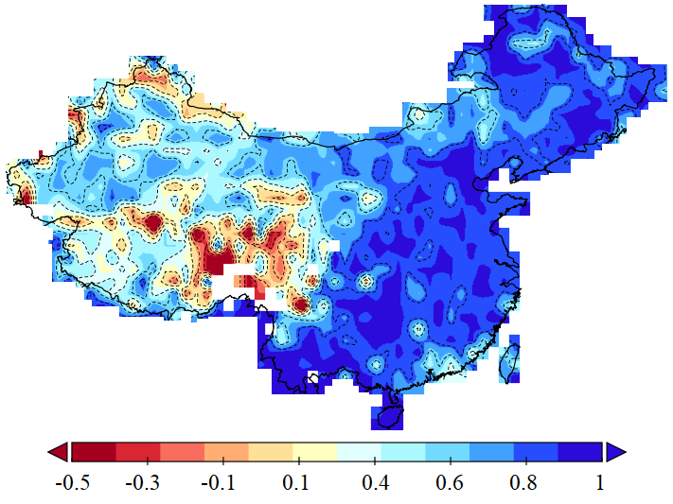
Figure S1. Spatial correlations between MODIS and MISR AOD.

Figure S2. Vertical profiles of aerosol extinction from four seasons.

Table S1. The number of days in a year that exceed established class 1 standards for PM_{2.5} (35 µg/m³) and PM₁₀ (50µg/m³).
PM_{2.5} | Wuhai | Alashan | Wuzhong | Zhongwei | Wuwei | Jinchang | Zhangye
2016 | 215 | 105 | 224 | 210 | 160 | 122 | 160
2017 | 233 | 133 | 187 | 146 | 208 | 102 | 116
2018 | 192 | 133 | 158 | 163 | 178 | 79 | 148
PM₁₀
2016 | 318 | 229 | 300 | 295 | 279 | 294 | 286
2017 | 319 | 225 | 329 | 302 | 318 | 266 | 227
2018 | 327 | 239 | 299 | 292 | 303 | 265 | 240

Table S2. Correlation between mass concentration of PM_{2.5} and PM₁₀. (p<0.05)
 | Wuhai |  | Alashan |  | Wuzhong |  | Zhongwei |  | Wuwei |  | Jinchang |  | Zhangye |  | Average
 | PM_{2.5}/PM₁₀ | R | PM_{2.5}/PM₁₀ | R | PM_{2.5}/PM₁₀ | R | PM_{2.5}/PM₁₀ | R | PM_{2.5}/PM₁₀ | R | PM_{2.5}/PM₁₀ | R | PM_{2.5}/PM₁₀ | R | PM_{2.5}/PM₁₀ | R
January | 0.50 | 0.805 | 0.59 | 0.638 | 0.53 | 0.596 | 0.53 | 0.613 | 0.49 | 0.967 | 0.41 | 0.772 | 0.50 | 0.745 | 0.49 | 0.778
February | 0.50 | 0.511 | 0.57 | 0.82 | 0.47 | 0.452 | 0.50 | 0.754 | 0.45 | 0.757 | 0.35 | 0.758 | 0.47 | 0.816 | 0.47 | 0.668
March | 0.41 | 0.78 | 0.52 | 0.879 | 0.43 | 0.626 | 0.46 | 0.695 | 0.39 | 0.924 | 0.30 | 0.889 | 0.35 | 0.942 | 0.41 | 0.86
April | 0.33 | 0.9 | 0.45 | 0.927 | 0.38 | 0.849 | 0.39 | 0.873 | 0.39 | 0.868 | 0.28 | 0.838 | 0.36 | 0.864 | 0.37 | 0.908
May | 0.35 | 0.939 | 0.45 | 0.965 | 0.41 | 0.947 | 0.38 | 0.939 | 0.36 | 0.937 | 0.27 | 0.961 | 0.36 | 0.967 | 0.37 | 0.971
June | 0.39 | 0.795 | 0.51 | 0.869 | 0.44 | 0.789 | 0.40 | 0.80 | 0.37 | 0.914 | 0.28 | 0.927 | 0.39 | 0.981 | 0.40 | 0.911
July | 0.48 | 0.808 | 0.55 | 0.788 | 0.47 | 0.969 | 0.40 | 0.936 | 0.39 | 0.944 | 0.31 | 0.897 | 0.45 | 0.966 | 0.44 | 0.934
August | 0.49 | 0.765 | 0.56 | 0.688 | 0.48 | 0.608 | 0.46 | 0.759 | 0.43 | 0.834 | 0.32 | 0.727 | 0.50 | 0.917 | 0.46 | 0.702
September | 0.42 | 0.778 | 0.57 | 0.759 | 0.44 | 0.567 | 0.45 | 0.658 | 0.42 | 0.877 | 0.27 | 0.701 | 0.42 | 0.778 | 0.43 | 0.70
October | 0.45 | 0.669 | 0.53 | 0.689 | 0.48 | 0.815 | 0.46 | 0.77 | 0.45 | 0.771 | 0.32 | 0.84 | 0.45 | 0.913 | 0.45 | 0.806
November | 0.40 | 0.759 | 0.46 | 0.865 | 0.42 | 0.684 | 0.41 | 0.783 | 0.45 | 0.908 | 0.33 | 0.857 | 0.44 | 0.861 | 0.41 | 0.861
December | 0.41 | 0.778 | 0.58 | 0.827 | 0.47 | 0.617 | 0.49 | 0.747 | 0.52 | 0.913 | 0.35 | 0.891 | 0.53 | 0.846 | 0.48 | 0.803
Average | 0.43 | 0.766 | 0.53 | 0.875 | 0.45 | 0.738 | 0.44 | 0.785 | 0.42 | 0.892 | 0.32 | 0.863 | 0.44 | 0.865 | 0.43 | 0.842

Table S3. Mass concentration of PM₁₀/PM_{2.5} (µg/m³) and PM_{2.5}/PM₁₀ ratio in the period of dust storms occurred on 3-5 May 2017 and 2-3 December 2018.
 | Wuhai |  | Alashan |  | Wuzhong |  | Zhongwei |  | Wuwei |  | Jinchang |  | Zhangye
 | PM_{2.5}/PM₁₀ | Ratio | PM_{2.5}/PM₁₀ | Ratio | PM_{2.5}/PM₁₀ | Ratio | PM_{2.5}/PM₁₀ | Ratio | PM_{2.5}/PM₁₀ | Ratio | PM_{2.5}/PM₁₀ | Ratio | PM_{2.5}/PM₁₀ | Ratio
03.05.2017 | 159/711 | 0.22 | 98/369 | 0.27 | 109/349 | 0.31 | 192/765 | 0.25 | 92/305 | 0.30 | 245/1001 | 0.24 | 53/296 | 0.18
04.05.2017 | 253/1070 | 0.24 | 244/1054 | 0.23 | 326/818 | 0.40 | 187/548 | 0.34 | 137/339 | 0.40 | 114/522 | 0.22 | 51/227 | 0.22
05.05.2017 | 131/567 | 0.23 | 132/518 | 0.25 | 164/441 | 0.37 | 226/724 | 0.31 | 133/529 | 0.25 | 53/195 | 0.27 | 51/208 | 0.25
02.12.2018 | 96/623 | 0.15 | 136/777 | 0.18 | 159/1078 | 0.15 | 198/1130 | 0.18 | 271/1496 | 0.18 | 49/280 | 0.18 | 144/746 | 0.19
03.12.2018 | 40/224 | 0.18 | 60/216 | 0.28 | 92/439 | 0.21 | 121/488 | 0.25 | 108/406 | 0.27 | 27/128 | 0.21 | 49/170 | 0.29

