Supplementary Material

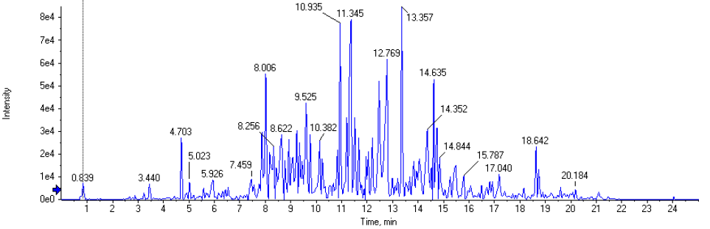

Fig S1. TIC chromatogram of the ethyl acetate fraction of C. mangga

p-Hydroxycinnamic acid [M-H]⁻ 163.089 at RT 0.839 min

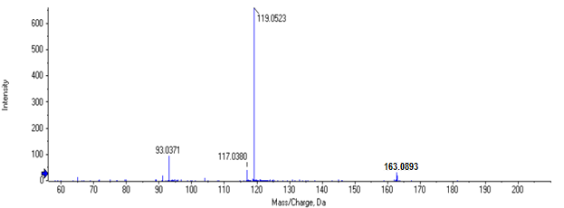

Copallic acid [M-H]⁻ 303.1913 at RT 2.81 min
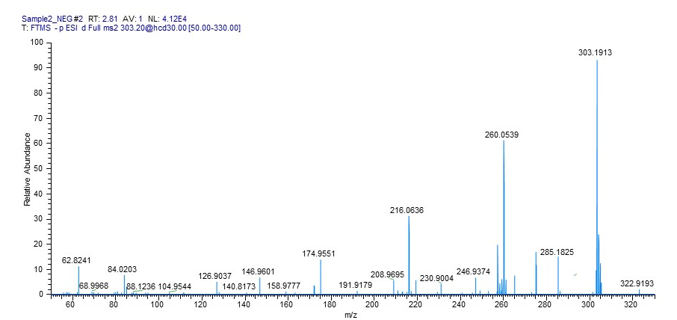

Demethoxycurcumin [M-H]⁻ 337.1090 at RT 5.52 min

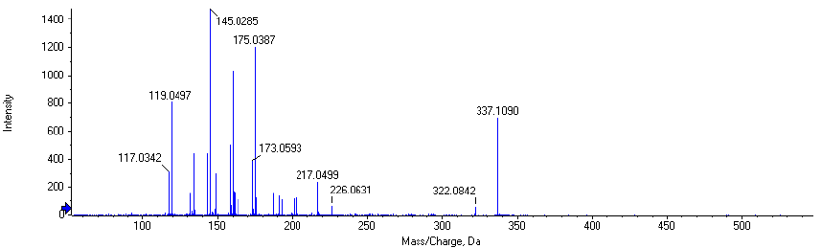

Curcumin [M-H]⁻ 367.2129 at RT 5.92 min

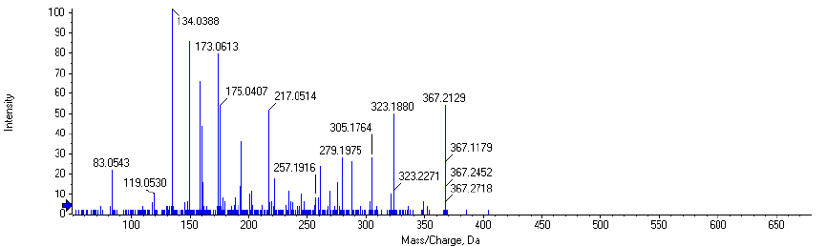

Calcaratarin A [M-H]⁻ 347.1495 at RT 7.45 min

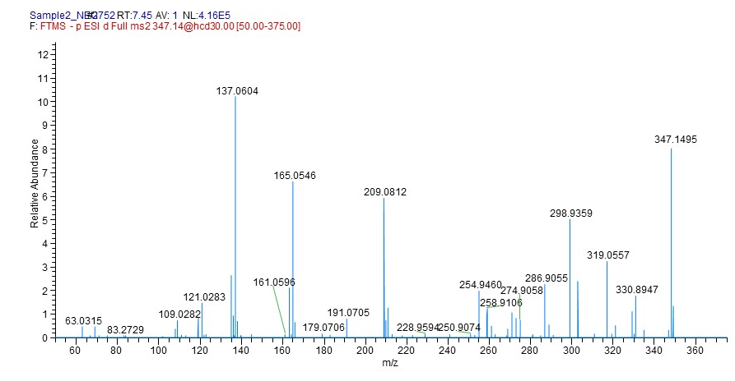

Epigallocatechin 305.2139 at RT 8.33 min

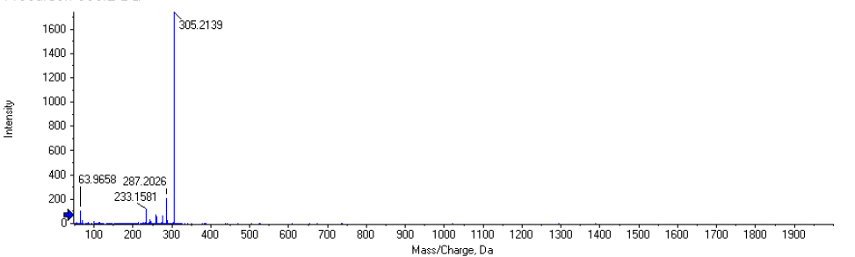

Zerumin A [M-H]⁻ 317.2159 at RT 8.94 min

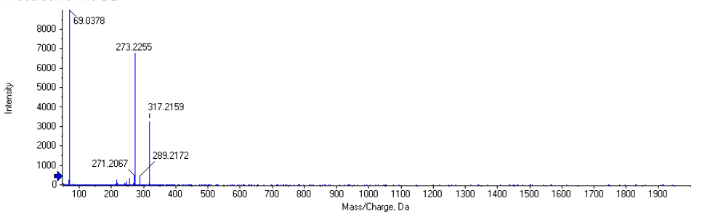

Zerumin B [M-H]⁻ 333.2083 at RT 9.95 min

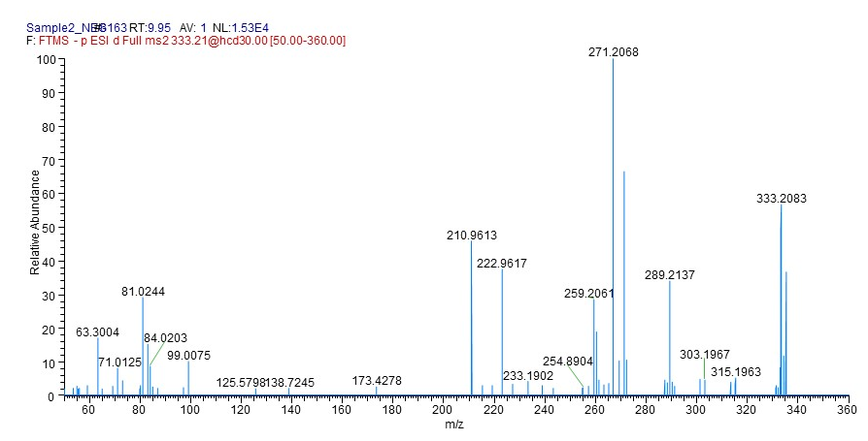

1,7-Bis(4-hydroxyphenyl)-1,4,6-heptatrien-3-one [M-H]⁻ 291.1213 at RT 10.93 min
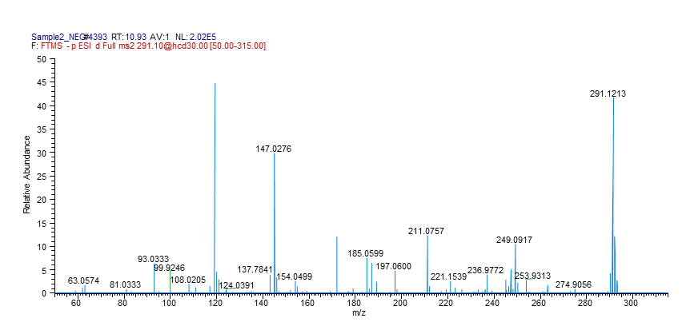

Curcumanggoside [M-H]⁻ 511.3420 at RT 11.81 min 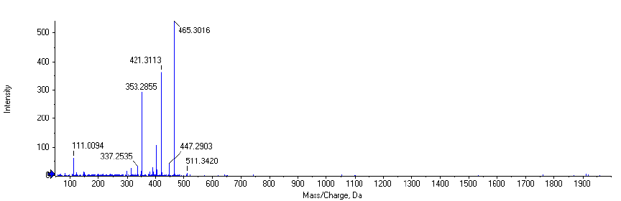

Labda-8(17),12-diene-15,16-dial [M-H]⁻ 301.2035 at RT 18.64 min
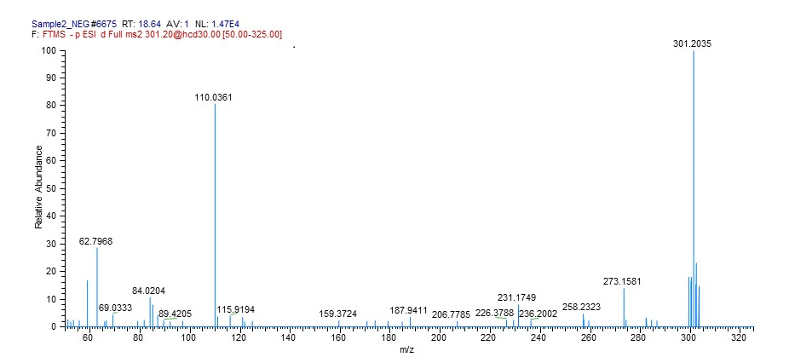

Fig S2. Mass spectra of compounds identified from the ethyl acetate fraction of C. mangga

