Supplementary Material
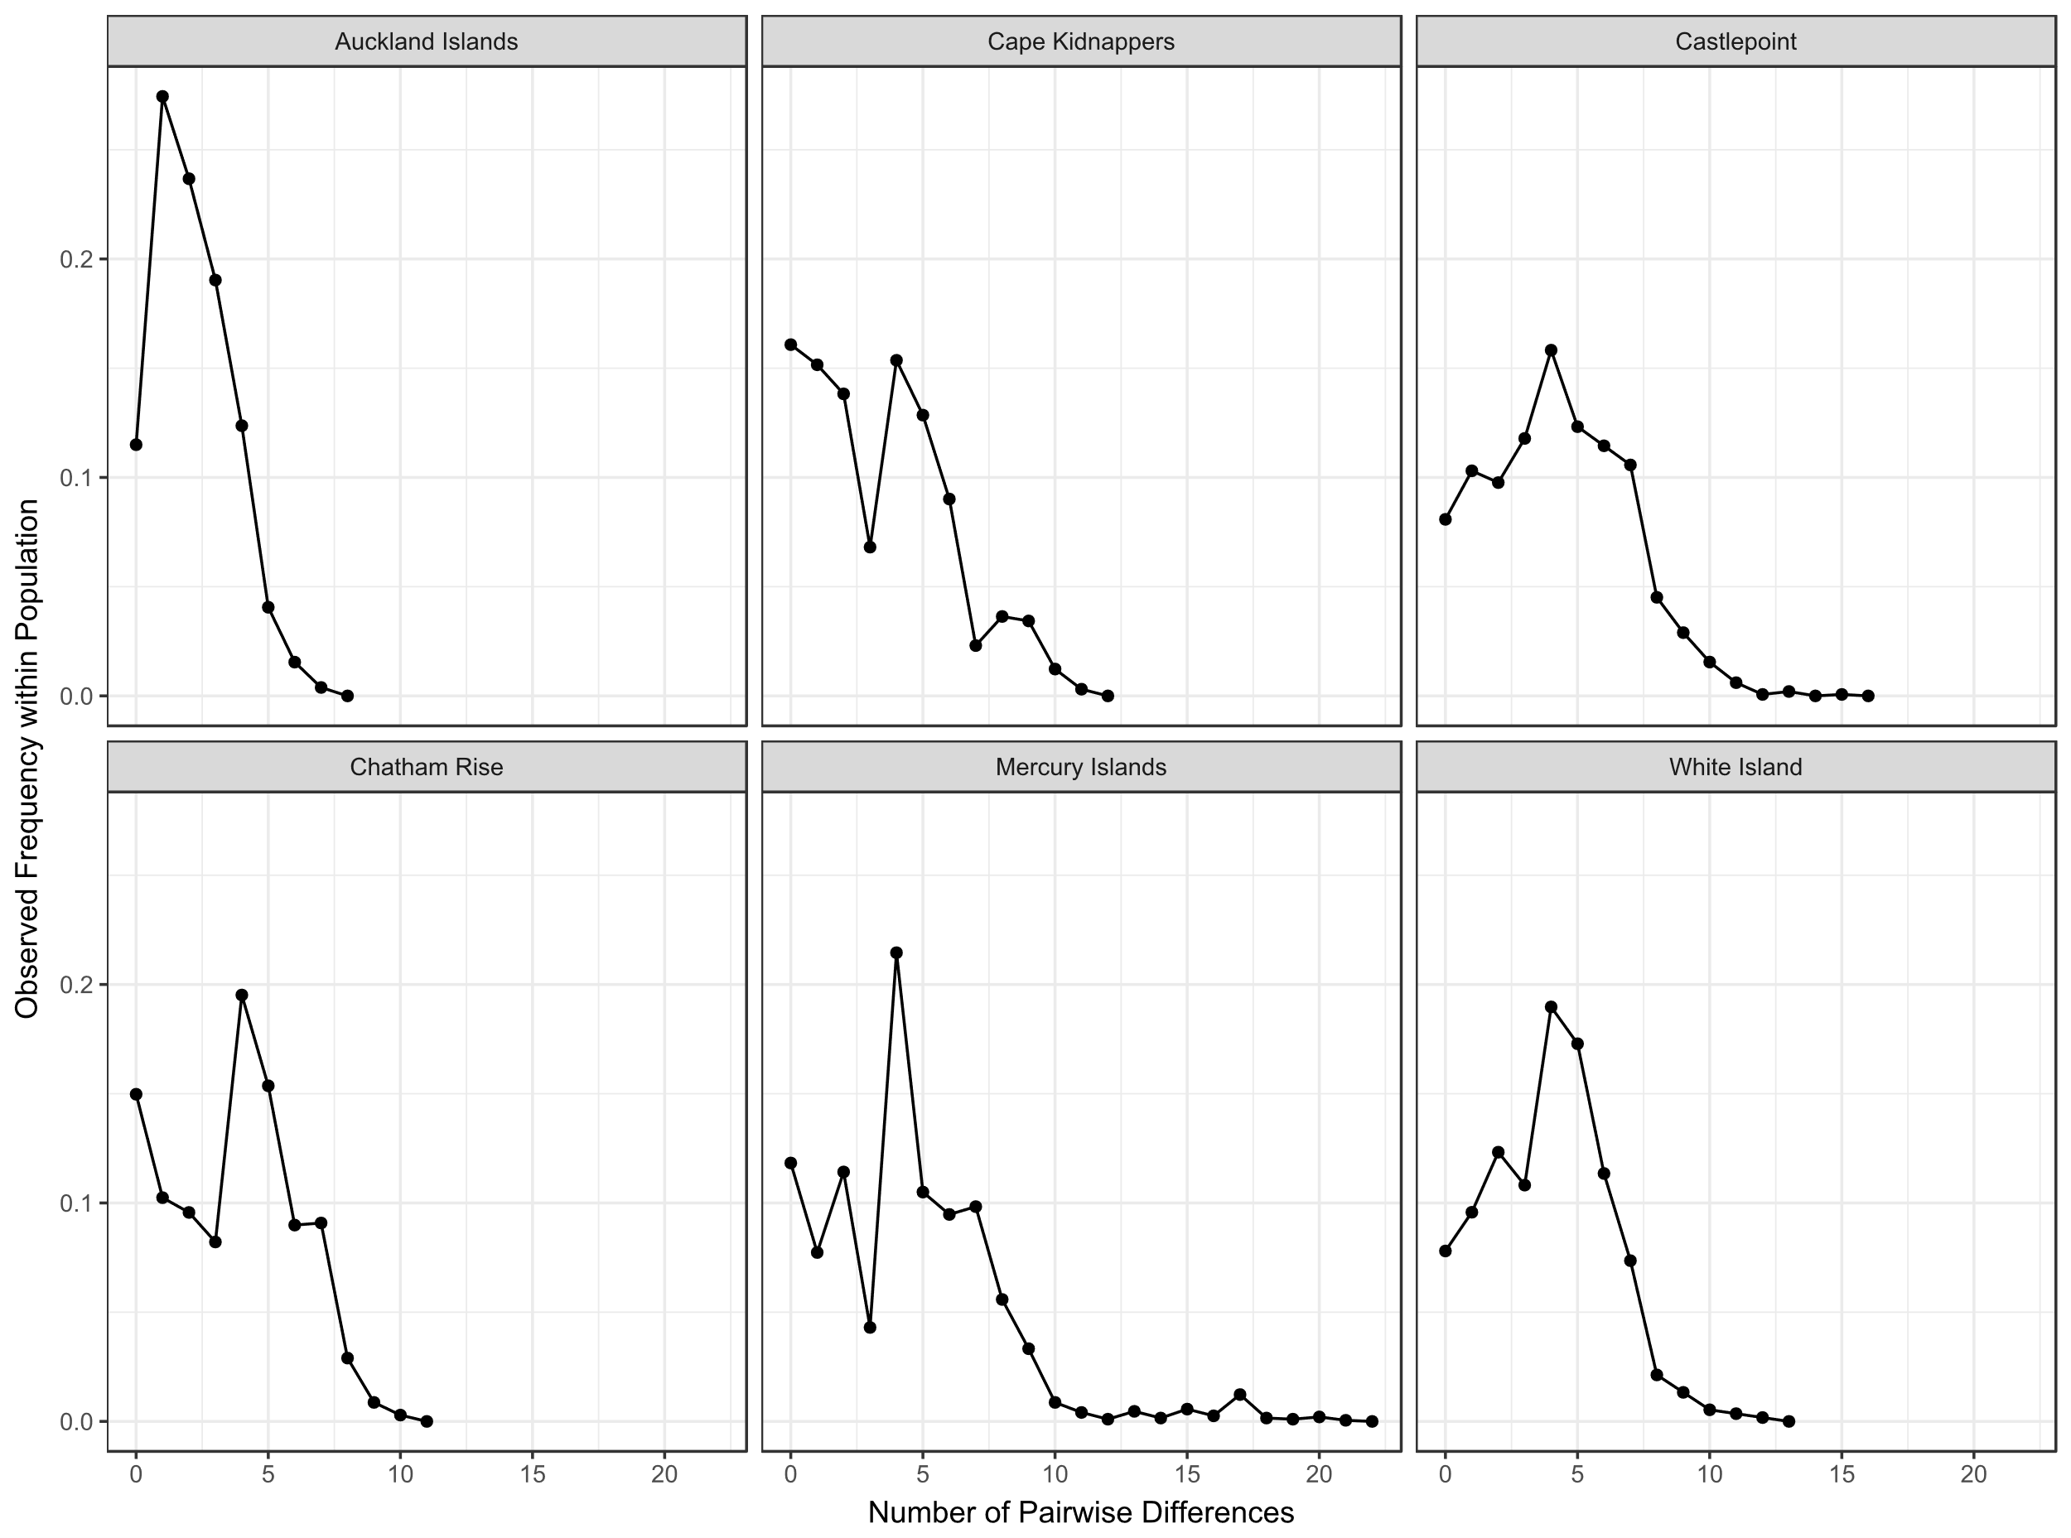
Figure S1: Isolation by distance graphs for NZ scampi populations. A: All sample sites considered, B: Auckland Islands site removed. The correlation coefficient and p-value (obtained via Mantel test) are displayed.

Figure S2: Mismatch distribution plots for each sampling site.

