Submission to Separation Science and Technology

Supplementary Material

Extraction of nobiletin and tangeretin with antioxidant activity from peels of Citrus poonensis using liquid carbon dioxide and ethanol entrainer

Ryunosuke Mitaniª, Hiroyuki Tashiroª, Eito Aritaª, Kento Ono ª, Masashi Haraguchiª, Shinichi Tokunagaª, Tanjina Sharmin^{a,b}, Taku Michael Aida^{a,b} and Kenji Mishima^{a,b}*

List of contents
Table 1S. The time course of methanol gradient for HPLC analysis.

Table 2S. List of extracted components from Citrus Poonesis using ethanol and liquid CO₂ with ethanol entrainer (X_{EtOH} = 0.13).

Table 3S. Extraction yield of nobiletin and tangeretin from Citrus poonesis using liquid CO₂ with ethanol entrainer with and without ultrasonic irradiation.
Figure 1S. Comparison of extraction yields of nobiletin and tangeretin obtained from extraction of Citrus poonensis with: (A) liquid CO₂ with ethanol at 0 min, (B) ethanol extraction for 60 min, (C) liquid CO₂ with ethanol for 60 min. (A) indicates the extraction yields obtained during the heating and pressurization period (14 minutes) to 25 ^{º}C and 10 MPa. (C) gives the extraction yields obtained after 60 min extraction after achieving 25 ^{º}C and 10 MPa. The mole fraction of ethanol for (A) changed with pressurization of CO₂, giving a final mole fraction of 0.13 at 25 ^{º}C and 10 MPa which is equal to the mole fraction for (C).

Table 1S. The time course of methanol gradient for HPLC analysis.

Time [min] | 0 | 25 | 40 | 50 | 60 | 65 | 75
Methanol [vol%] | 25 | 40 | 60 | 90 | 90 | 5 | 5

Table 2S. List of extracted components from Citrus Poonesis using ethanol and liquid CO₂ with ethanol entrainer (X_{EtOH} = 0.13).

No. | Retention Time [min] | Peak Name | Structure | Area [%] | Height
1 | 34.32 | Hesperidin | 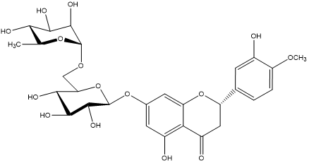 | 20.4806 | 197971
2 | 51.21 | Nobiletin | 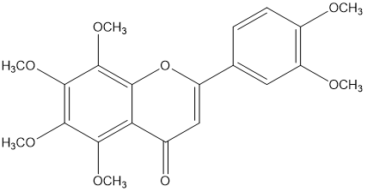 | 35.239 | 347217
3 | 52.84 | Tangeretin | 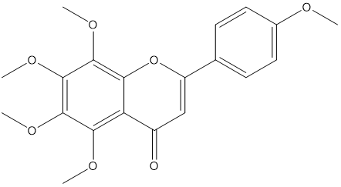 | 30.2911 | 305333

Table 3S. Extraction yield of nobiletin and tangeretin from Citrus Poonesis using liquid CO₂ with ethanol entrainer with and without ultrasonic irradiation.
Extraction conditions |  |  |  |  |  | Yield ^{c}
T [^{º}C] | P [MPa] | t [min] | X_{EtOH} ª [-] | UI Power ^{b} [%] |  | Nobiletin  [mg/g-dry peel] |  | Tangeretin  [mg/g-dry peel]
25 | 0.1 | 10 | 1 |  |  | 5.1 | 3.5
25 | 0.1 | 20 | 1 |  |  | 5.3 | 3.6
25 | 0.1 | 30 | 1 |  |  | 5.3 | 3.6
25 | 0.1 | 60 | 1 |  |  | 5.4 | 3.7
25 | 0.1 | 120 | 1 |  |  | 5.3 | 3.7
5 | 10 | 60 | 0.13 |  |  | 4.3 | 2.9
20 | 10 | 60 | 0.13 |  |  | 4.5 | 2.9
25 | 10 | 60 | 0.13 |  |  | 6.7 | 4.4
25 | 8 | 60 | 0.13 |  |  | 4.4 | 2.9
25 | 10 | 60 | 0.13 |  |  | 6.7 | 4.4
25 | 14 | 60 | 0.13 |  |  | 5.6 | 3.6
25 | 10 | 60 | 0 |  |  | 5.0 | 3.3
25 | 10 | 60 | 0.06 |  |  | 5.2 | 3.5
25 | 10 | 60 | 0.13 |  |  | 6.7 | 4.4
25 | 10 | 60 | 0.26 |  |  | 6.0 | 3.9
25 | 10 | 60 | 0.39 |  |  | 5.7 | 3.8
25 | 10 | 60 | 1 |  |  | 5.4 | 3.7
25 | 10 | 60 | 0.13 | 25 |  | 5.2 | 3.6
25 | 10 | 60 | 0.13 | 30 |  | 4.5 | 3.6
25 | 10 | 60 | 0.13 | 40 |  | 5.0 | 3.4
ª Mole fraction of ethanol in liquid CO₂, ^{b} Ultrasonic irradiation nominal maximum power output (500 W) at a frequency of 20 kHz, ^{c} mg equivalent standard / g-dry peel.

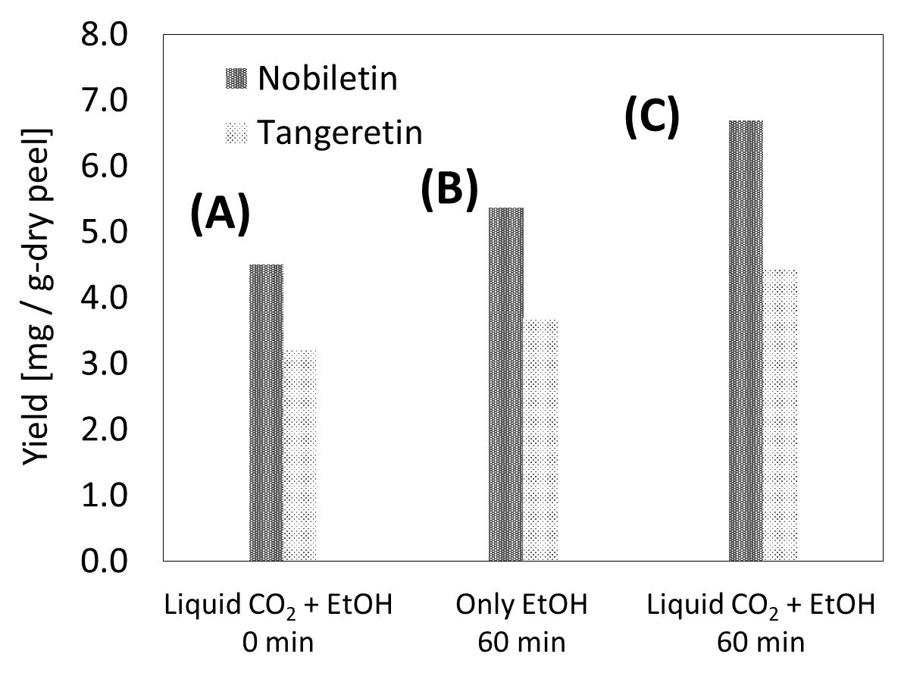
Figure 1S. Comparison of extraction yields of nobiletin and tangeretin obtained from extraction of Citrus poonensis with: (A) liquid CO₂ with ethanol at 0 min, (B) ethanol extraction for 60 min, (C) liquid CO₂ with ethanol for 60 min. (A) indicates the extraction yields obtained during the heating and pressurization period (15 minutes) to 25 ^{º}C and 10 MPa. (C) gives the extraction yields obtained after 60 min extraction after achieving 25 ^{º}C and 10 MPa. The mole fraction of ethanol for (A) changed with pressurization of CO₂, giving a final mole fraction of 0.13 at 25 ^{º}C and 10 MPa which is equal to the mole fraction for (C).

