Supplementary table 1: Detailed databases search history
S.N. |  | Search terms | citations
PubMed
1 |  | chemical and drug induced liver injury OR chemical and drug induced liver injury, chronic | 28220
2 |  | anti-tuberculous therapy induced liver injury OR anti-tuberculosis drug-induced liver injury OR att hepatotoxicity OR Hepatotoxicity OR Liver injury OR drug induced acute liver injury OR drug-induced liver injury OR drug-induced liver condition OR drug-induced liver disease OR drug induced liver disorders OR drug-induced liver failure OR drug-induced liver damage OR drug-induced hepatotoxicity OR drug-induced hepatic injury OR drug-induced hepatitis OR drug-induced cholestasis OR idiosyncratic liver condition OR idiosyncratic liver disease OR idiosyncratic liver disorder OR toxic hepatitis OR toxic liver condition OR toxic liver disease OR toxic liver disorders | 138545
3 |  | reintroduction of anti-tubercular drugs OR reintroduction of anti-tubercular therapy OR att reintroduction guidelines OR reintroduction of rifampicin OR reintroduction of isoniazid OR reintroduction of pyrazinamide | 298
4 | (1 OR 2) AND 3 |  | 19
Embase
1 | 1 | ‘chemical and drug induced liver injury’ OR ‘chemical and drug induced liver injury, chronic’ | 8
2 | 2 | 'anti-tuberculous therapy induced liver injury' OR 'anti-tuberculosis drug-induced liver injury' OR 'att hepatotoxicity' OR hepatotoxicity OR 'liver injury' OR 'drug induced acute liver injury' OR 'drug-induced liver injury’ OR ‘drug-induced liver condition’ OR ‘drug-induced liver disease’ OR ‘drug induced liver disorders’ OR ‘drug-induced liver failure’ OR ‘drug-induced liver damage’ OR ‘drug-induced hepatotoxicity’ OR ‘drug-induced hepatic injury’ OR ‘drug-induced hepatitis’ OR ‘drug-induced cholestasis’ OR ‘idiosyncratic liver condition’ OR ‘idiosyncratic liver disease' OR 'idiosyncratic liver disorder' OR 'toxic hepatitis' OR 'toxic liver condition' OR 'toxic liver disease' OR 'toxic liver disorders' | 96886
3 |  | ‘reintroduction of anti-tubercular drugs’ OR ‘reintroduction of anti-tubercular therapy’ OR ‘att reintroduction guidelines’ OR ‘reintroduction of rifampicin’ OR ‘reintroduction of isoniazid’ OR ‘reintroduction of pyrazinamide’
4 | (1 OR 2) AND 3 |  | 5
Scopus
1 | 1 | “chemical and drug induced liver injury” OR ”chemical and drug induced liver injury, chronic” | 2,519  2673
2 | 2 | “anti-tuberculous therapy induced liver injury” OR “anti-tuberculosis drug-induced liver injury” OR “att hepatotoxicity” OR hepatotoxicity OR “liver injury” OR “drug induced acute liver injury” OR “drug-induced liver injury” OR “drug-induced liver condition” OR “drug-induced liver disease” OR “drug induced liver disorders” OR “drug-induced liver failure” OR “drug-induced liver damage” OR “drug-induced hepatotoxicity” OR “drug-induced hepatic injury” OR “drug-induced hepatitis” OR “drug-induced cholestasis” OR “idiosyncratic liver condition” OR “idiosyncratic liver disease” OR “idiosyncratic liver disorder” OR “toxic hepatitis” | 219,356
3 | 3 | “toxic liver condition” OR “toxic liver disease” OR “toxic liver disorders” | 264
4 | 4 | “reintroduction of anti-tubercular drugs” OR “reintroduction of anti-tubercular therapy” OR “anti-tubercular therapy reintroduction guidelines” OR “reintroduction of rifampicin” OR “reintroduction of isoniazid” OR “reintroduction of pyrazinamide” | 22
5 | (1 OR 2 OR 3) AND 4 | ( "anti-tuberculous therapy induced liver injury" OR "anti-tuberculosis drug-induced liver injury" OR "att hepatotoxicity" OR hepatotoxicity OR "liver injury" OR "drug induced acute liver injury" OR "drug-induced liver injury" ) OR ( "toxic liver condition" OR "toxic liver disease" OR "toxic liver disorders" ) OR ( "chemical and drug induced liver injury" OR "chemical and drug induced liver injury, chronic" ) AND ( "reintroduction of anti-tubercular drugs" OR "reintroduction of anti-tubercular therapy" OR "anti-tubercular therapy reintroduction guidelines" OR "reintroduction of rifampicin" OR "reintroduction of isoniazid" OR "reintroduction of pyrazinamide" ) | 10
Web of Science
1 | 1 | (‘chemical and drug induced liver injury’ OR ‘chemical and drug induced liver injury, chronic’)  Timespan: All years. Databases: WOS, KJD, RSCI, SCIELO.  Search language=Auto | 27,769
2 | 2 | ('anti-tuberculous therapy induced liver injury' OR 'anti-tuberculosis drug-induced liver injury' OR 'att hepatotoxicity' OR hepatotoxicity OR 'liver injury' OR 'drug induced acute liver injury' OR 'drug-induced liver injury’ OR ‘drug-induced liver condition’ OR ‘drug-induced liver disease’ OR ‘drug induced liver disorders’ OR ‘drug-induced liver failure’ OR ‘drug-induced liver damage’ OR ‘drug-induced hepatotoxicity’ OR ‘drug-induced hepatic injury’ OR ‘drug-induced hepatitis’ OR ‘drug-induced cholestasis’ OR ‘idiosyncratic liver condition’ OR ‘idiosyncratic liver disease' OR 'idiosyncratic liver disorder' OR 'toxic hepatitis' OR 'toxic liver condition' OR 'toxic liver disease' OR 'toxic liver disorders')  Timespan: All years. Databases: WOS, KJD, RSCI, SCIELO.  Search language=Auto | 184,913
3 | 3 | (‘reintroduction of anti-tubercular drugs’ OR ‘reintroduction of anti-tubercular therapy’ OR ‘att reintroduction guidelines’ OR ‘reintroduction of rifampicin’ OR ‘reintroduction of isoniazid’ OR ‘reintroduction of pyrazinamide’)  Timespan: All years. Databases: WOS, KJD, RSCI, SCIELO.  Search language=Auto | 43
4 | (1 OR 2) AND 3 | #3 AND #4  Timespan: All years. Databases: WOS, KJD, RSCI, SCIELO.  Search language=Auto | 20
LILACS
1 | 1 | reintroduction of rifampicin OR reintroduction of isoniazid OR reintroduction of pyrazinamide | 15
CENTRAL (Cochrane library)
1 | 1 | chemical and drug induced liver injury | 353
2 | 2 | antitubercular agents | 1522
3 | 1 AND 2 | 41 trials, 1 review | 42
Clinical trial.gov
1 | 1 | reintroduction of anti-tubercular drugs | 2
ScienceDirect
1 | 1 | reintroduction of anti-tubercular drugs | 30

Supplementary table 2: Description of ATT reintroduction regime used in included studies

Study ID | Tahaoglu 2001 | Sharma 2010 | Zuberi 2014 | Meena 2016
Group: 1 Sequential regimen |  | Day 1- R (maximum dosage)  Day 8 - H (maximum dosage)  Day 15 - Z (maximum dosage) | Day 1- R (maximum dosage)  Day 8 - H (maximum dosage)  Day 15 - Z (maximum dosage) | Group A:  Day 1- R (maximum dosage)  Day 8- H (maximum dosage)
Group B:
Day 1- H (maximum dosage)
Day 8- R (maximum dosage)
 |  |  |  | Pyrazinamide was added if they tolerated the above regimen in 3 weeks
Number of patients with recurrence of ATT induced hepatitis after reintroduction of anti-TB drugs with total patients |  | 6/59 | 18/162 | 3/22
Group: 2 Incremental regimen | Drug regimens not containing Z were started gradually as follows  Day 1, S 1000 mg/day and E 1500 mg/day  Day 3, S 1000 mg/day, E 1500 mg/day and H 100 mg/day  Day 6, S 1000 mg/day, E 1500 mg/day and H 200 mg/day  Day 9, S 1000 mg/day, E 1500 mg/day and H 300 mg/day  Day 12: S 1000 mg/day, E1500 mg/day, H 300 mg/day and R 150 mg/day  Day 15, S 1000 mg/day, E 1500 mg/day, H 300 mg/day and R 300 mg/day;  Day 18, S 1000 mg/day, E 1500 mg/day, H 300 mg/day and R 450 mg/day | Day 1 - H 100 mg/day, maximum dosage from day 4  Day 8 - R -150 mg/day, maximum dosage from day 11  Day 15 - Z 500 mg/day from, maximum dosage from day 18 | Day 1 - H=100 mg/day, maximum dose from day 4  Day 8 - R=150 mg/day, maximum from day 11  Day 15 - Z=500 mg/day, maximum from day 18
Number of patients with recurrence of ATT induced hepatitis after reintroduction of anti-TB drugs with total patients | 0/20 | 5/58 | 16/163
Group: 3 Concomitant regimen | Retreated with the same drug regimen as previously, i.e.,  H 300 mg/day,  R 600 mg/day,  Z 1500 mg/day  E 1500 mg/day | H, R, and Z at maximum dosages from day 1 |  | H and R at full dosages from day 1
Number of patients with recurrence of ATT induced hepatitis after reintroduction of anti-TB drugs with total patients | 6/25 | 8/58 |  | 4/10
H: isoniazid, R: Rifampicin, Z: Pyrazinamide, E: Ethambutol, S: Streptomycin

Supplementary Table 3: Odd ratio of the direct and indirect comparisons
ATT regimens | Comparison | Odds ratio with 95% CrI | P value
Incremental vs Concomitant | Direct | 0.17 (0.0044, 2.2) | 0.979
 | Indirect | 0.18 (0.00075, 41)
Sequential vs Concomitant | Direct | 0.45 (0.041, 3.8) | 0.018
 | Indirect | 5.3×10⁻¹³ (4.4×10⁻⁴¹, 0.056)
Sequential vs Incremental | Direct | 1.2 (0.17, 8.7) | 0.031
 | Indirect | 5.4×10¹⁰(2.8, 1.7×10³⁶)

Supplementary Table 4: Critical interpretation of analyzed ATT regimens
Regimen | Risk of ATT Hepatitis | Delay in initiation of ATT | Recognition of Culprit agent
Concomitant | Highest risk | No delay | Not possible
Sequential | Low risk | Some delay | Possible
Incremental | Lowest risk | Maximum delay | Possible

-: Least risk/chance
+ : Some risk
++: High risk

Supplementary Figure 1: Direct comparisons between the various reintroduction regimens

Supplementary Figure 2: Odd ratio of the direct comparisons with taking a regimen as standard

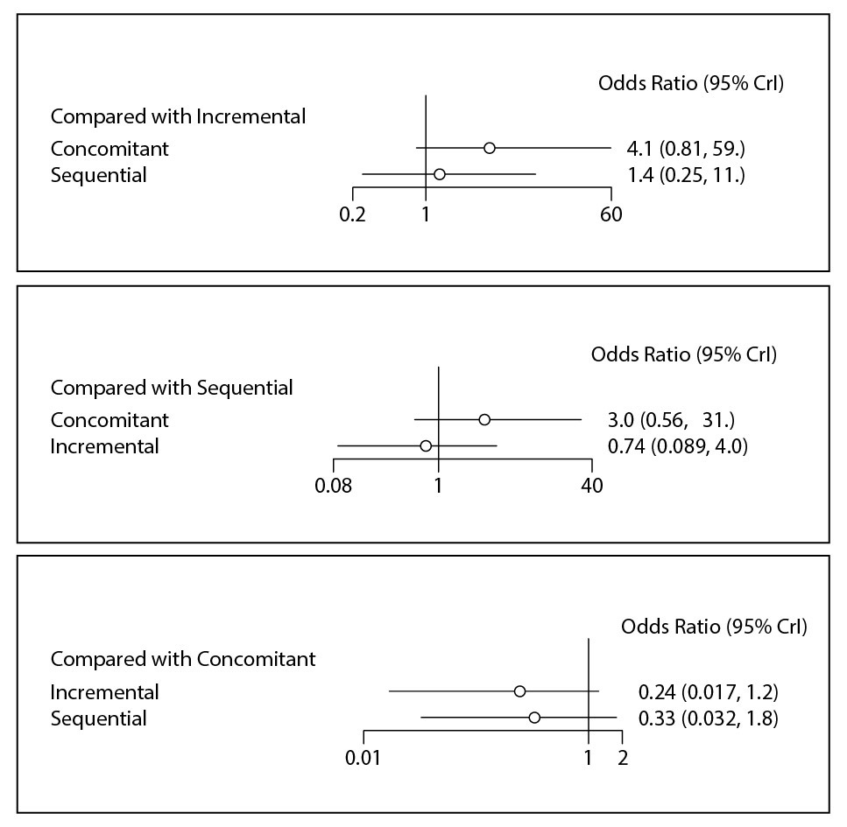

Supplementary Figure 3: The Gelman Rubin Plot of the variation in the Shrink factor with modelling

Supplementary Figure 4: The SUCRA plot for all three reintroduction regimens

Supplementary Figure 5: Pairwise meta-analysis providing comparison between all three regimens in all possible combinations

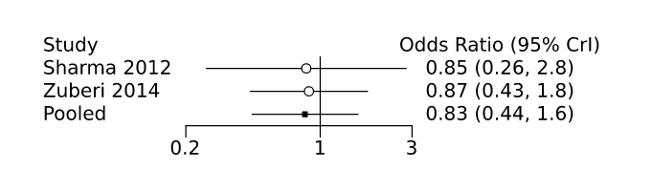
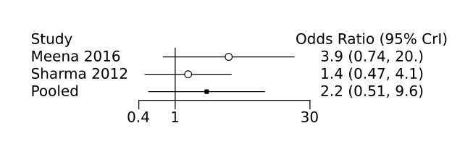
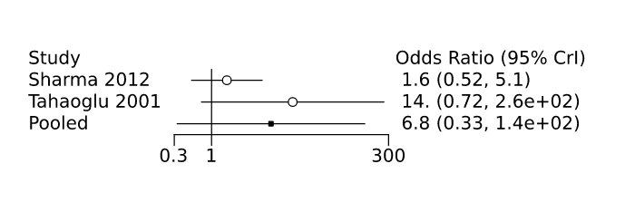
Incremental vs Sequential
Concomitant vs Sequential
Concomitant vs Incremental
Supplementary Figure 6: Pairwise meta-analysis comparing staggered regimen with concomitant reintroduction; A: random effect model and B: Fixed effect model

