Supplementary Figure 1-a: Overall survival curve for patients grouped according to existence of end-stage renal disease (ESRD).

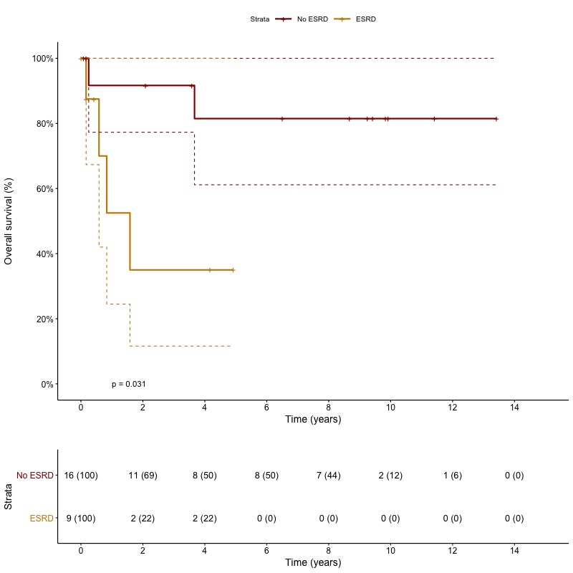

Supplementary Figure 1-b: Overall survival for patients grouped according to highest pT-stage of bladder cancer.

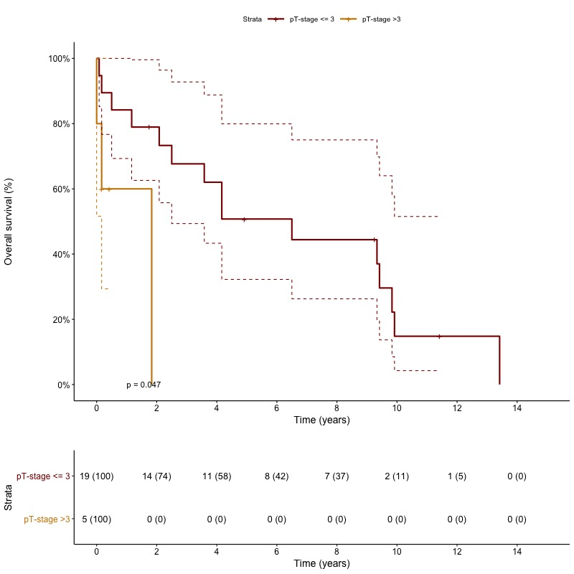

Supplementary Figure 1-c: Cancer-specific survival for patients grouped according to highest pT-stage of bladder cancer.

