Supplementary Information
DEVELOPMENT AND ASSESMENT OF NANO-TECHNOLOGIES FOR CANCER TREATMENT: CYTOTOXICITY AND HYPERTHERMIA LABORATORY STUDIES.
Iliana E. Medina-Ramírez^{1*}, María Alejandra Díaz de León Olmos¹, Martín Humberto Muñoz Ortega¹, Juan Antonio Zapien², Israel Betancourt^{3,} Nathaly Santoyo-Elvira¹
- Centro de Ciencias Básicas/ Departamento de Química/Universidad Autónoma de Aguascalientes/ Aguascalientes, México
- Department of Materials Science and Engineering, City University of Hong Kong, Hong Kong, SAR PR China.
- Instituto de Investigaciones en Materiales, Universidad Nacional Autónoma de México, Ciudad de México, ZP 04510, Mexico

- Evaluation of the behavior of MNMs and MNMs interacting with HepG2 cells under the influence of an Alternating Magnetic Field (AMF)
1.1 Solenoid coil design
In order to induce hyperthermia, a solenoid coil was designed to generate a uniform high frequency (0.1 Teslas) alternating magnetic field (AMF) when an electric current is passed through it. The dimensions of the solenoid coil were adjusted to fit a 96-well plate inside it (6cm radius and 19cm in length). The AMF should concentrate inside the solenoid coil. Based on these data, the number of loops needed to generate the AMF with the above mentioned characteristics was calculated (Tippens et al, 2007), as shown below:
$$N=\frac{LB\sqrt{2}}{µI}$$
Where N is the number of turns, L the length of the solenoid, B the magnetic field that it is intended to generate, √2 due to a biphasic power supply, μ the permeability of the core and finally I the current Applying this equation, a total of 2,138 loops of copper wire are needed for the construction of the solenoid. In accordance to the electric conduction capacity of our material, it was decided to use a copper wire of 16.81 Ω in order to avoid overheating.
Magnetic field measurements were made by using a Gaussometer (FW BELL model 5100). The measurements indicate a field of 0.75 mT inside the solenoid and 11.2 mT outside.
1.3 Evaluation of the heating capacity of MNMs under the influence of an AMF (high frequency).
In order to evaluate the heating capacity of MNMs under the influence of an AMF, the materials were subjected to a higher frequency (14.6 mT, using a copper solenoid coil composed of four loops with an outer diameter of 44 mm, which operated with an alternating current at a power of 8.3 amperes, a voltage of 30 volts and a frequency of 156 kHz) magnetic field. The thermal capacity of the MNMs was evaluated using two different concentrations: (5 and 10 mg / ml) in PSS. MNMs were placed in glass test tubes and suspended in PSS; after, the suspensions were exposed to the AMF for15 minutes (as shown in figure 2S). The generated data were processed and stored by the Pasco Capstone program for further analysis.

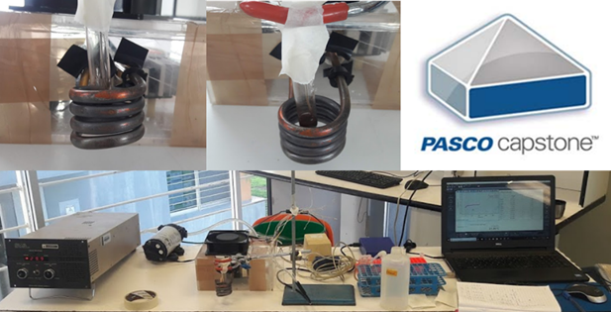
Fig 1S. Determination of the thermal capacity of the MNMs by means of the application of a magnetic field produced by a solenoid.

- SEM-EDX Characterization
Different MNMs were synthesized: Fe₃O₄and CoFe₂O₄. After, the materials were functionalized with citrate or glycine. Naked and surface modified MNMs were characterized by SEM-EDX analysis. The micrographs are presented in Figure 4S. It can be clearly seen that surface functionalization favors disaggregation of the materials. EDX analysis demonstrates the purity of the materials.
It is important to remark that the atomic composition of naked and surface modified materials is the same. The lack of the presence of carbon is due to the experimental procedure followed by SEM analysis. Due to the magnetic nature of the materials, they were glued to the substrate using carbon paste, thus this element was subtracted from the elemental analysis.
A | B
C | D
E | F
G | H
I | J
K | L
Fig 2S. SEM-EDX micrographs of naked and surface modified MNMs. A, B) Fe₃O₄ (M); C, D) Fe₃O₄-Citrate (MC); E, F) Fe₃O₄-Gly (MG); G, H) CoFe₂O₄ (F), I, J) CoFe₂O₄-Cit (FC); K, L) CoFe₂O₄-Gly (FG).
- Magnetic Properties
For this type of superparamagnetic (SP) behavior a model of superparamagnetic NPs (NP's + SP) can be adjusted (Ferrari et al. 1997) in which the magnetization M (H, T) is expressed as:

Where H is the applied field, T the temperature of measurement, μ the magnetic moment per particle, L the Langevin function, KB the Boltzmann constant, and f (μ) a log-normal particle size distribution function. From this model, for Fe3O4 NP´s we observe an average magnetic moment of <µ> = 4158 µB (Bohr magneton) and 3898 µB for Fe3O4-cit. These values of magnetic moment correspond to a radius of nanoparticle of 2.7 and 2.6 nm, respectively, which are congruent with those calculated in Table 1. Results are schematically presented in Fig 4S
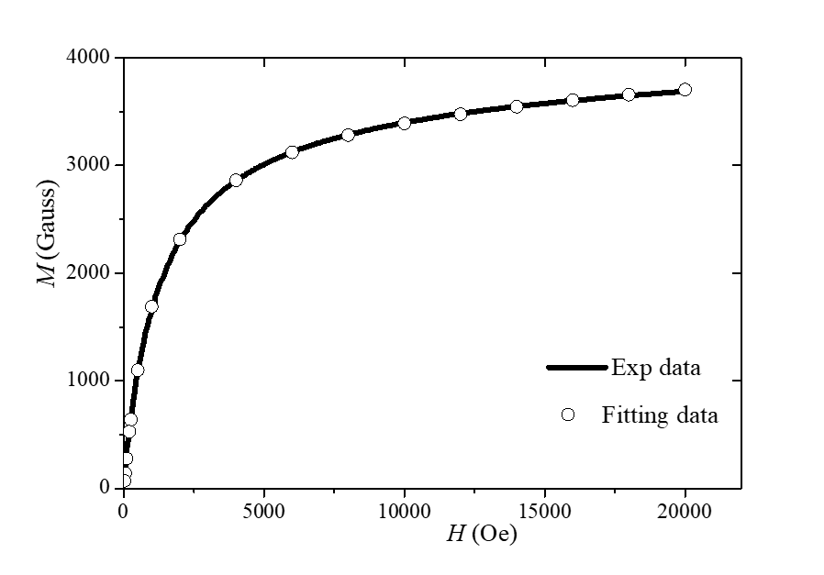

Figure 3S. Fitting data (open circles) obtained from the SP model of Ferrari et al, compared with experimental data (solid line) for Fe₃O₄ NP´s. Excellent agreement is manifested

- Evaluation of the Interaction of MNMs with an AMF
The MNMs were exposed to an AMF, and after, their behavior was analyzed by optical microscopy. A dose of 0.5 mg/mL of MNMs was employed and subjected to an AMF for 60 minutes. MNMs were used as control groups. Also, MNMs interacting with HepG2 cells were exposed to an AMF and their behavior analyzed by optical microscopy. Our results are schematically re3presented in Figure 5SA and 5SB.
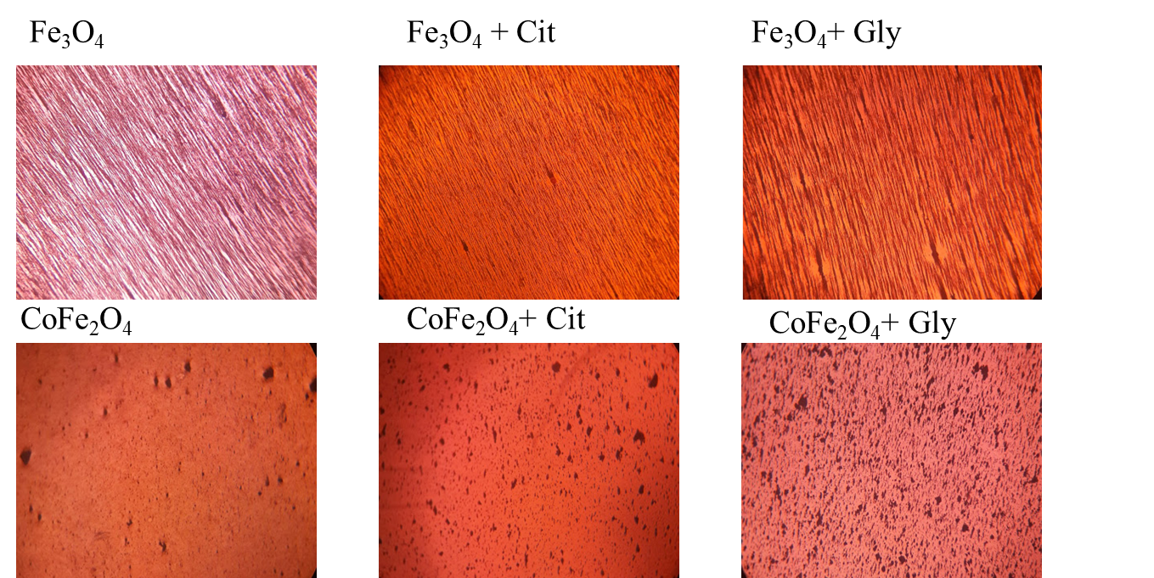

Figure 4SA. Optical microscopy analysis of the Interaction of MNMs with an AMF
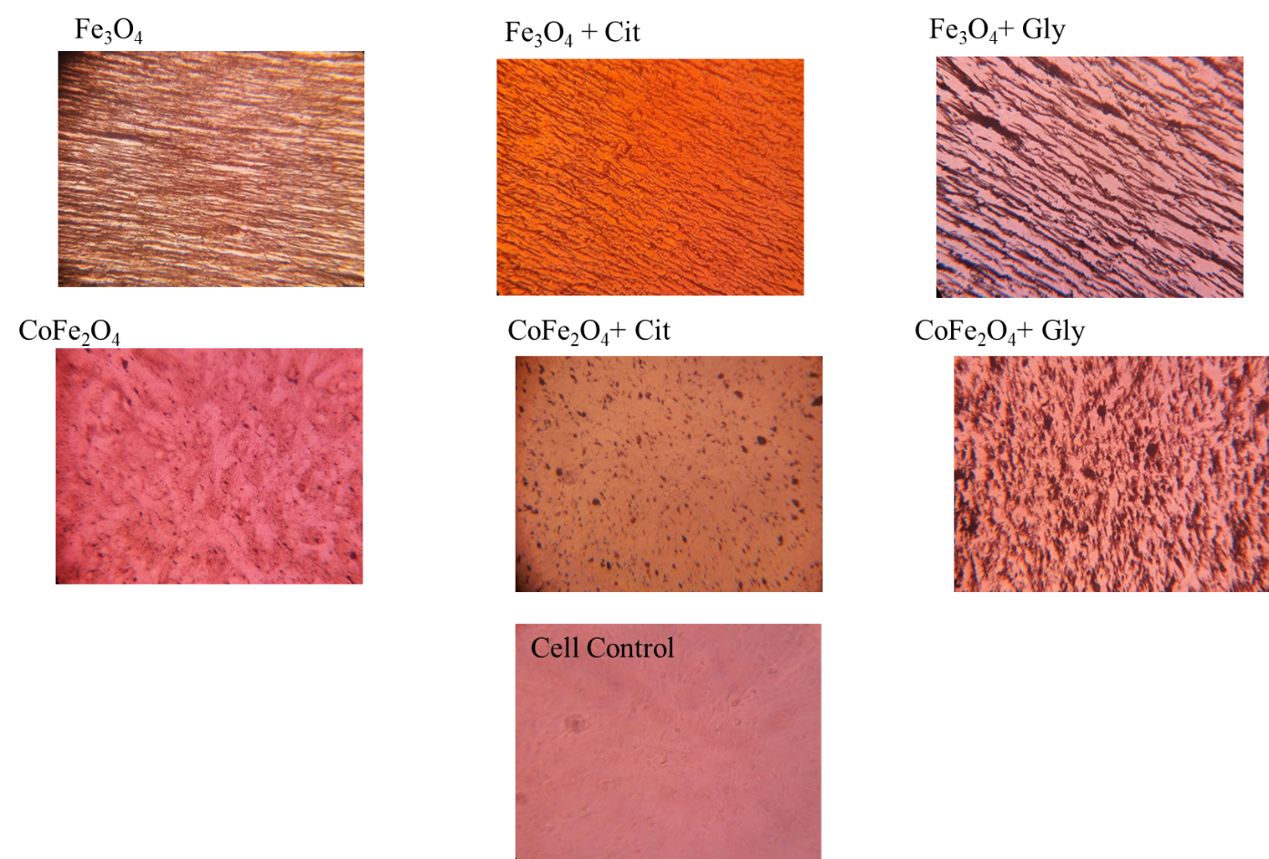
Figure 4SB. Optical microscopy analysis of the Interaction of MNMs with HepG2 cells under the influence of an AMF
- Optical microscopy study of the interaction of MNMs and HepG2 cells
The MNMs under study interacted with HepG2 cells at different doses. Observing the interaction of MNMs using optical microscopy, facilitates the selection of an appropriate dose of MNMs for their safe application as hyperthermia agents. It is important to avoid the use of doses that exhibit precipitation, since agglomeration of the materials might cause biological response from the host organism.
Naked materials present agglomeration at low doses, whereas citrate functionalized materials can be used at higher doses. For magnetite, optical microscopy analysis, show an alignment of the materials within the cell membrane of the cells. HepG2 cells are clearly delimited by magnetite, making very simple to observe the characteristic HepG2 cell morphology (Figure 6S)

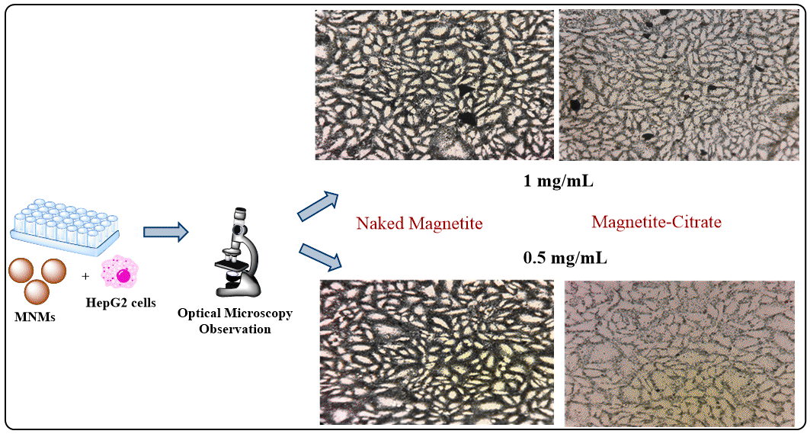
Figure 5S. Optical microscopy analysis of the interaction of MNMs and hepG2 cells. At a concentration of 1 mg/mL agglomeration of the materials is observed for both, naked and citrate functionalized materials. At a dose of 0.5 mg/mL citrate functionalized materials do not exhibit agglomeration.

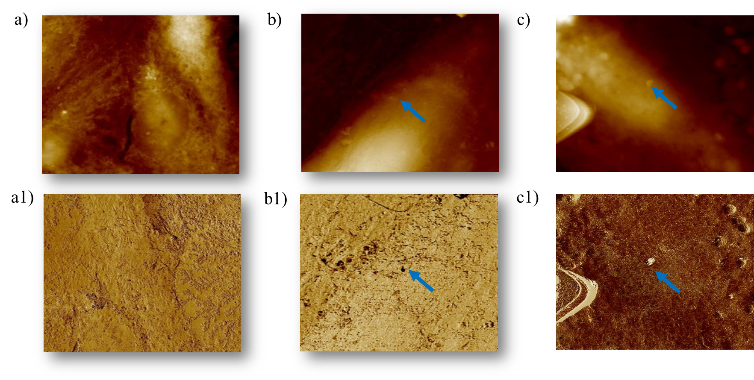

Figure 6SA. Evaluation of the interaction of HepG2 cells and MNMs (MC, MG). a, a1: control group (2D morphology, phase image); b, b1: MC interacting with HepG2 cells; c, c1: MG interacting with HepG2 cells.
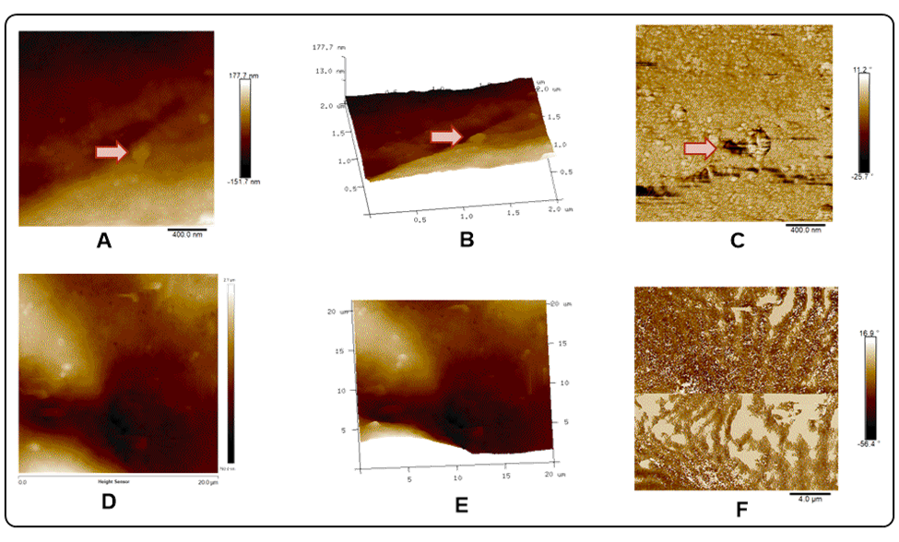
Figure 6B. AFM study of the interaction of MNMs and HepG2 cells (A: 2D image; B: 3D image, C: phase image). Top: MC materials can be identified around the cell membrane. Down: MG materials occupy all HepG2 cells surface.

