**SUPPLEMENTARY MATERIALS**

**Supplementary Table S1. Adverse events and adverse drug reactions**

|  |  |  |
| --- | --- | --- |
|  | Weeks 0 to 52 | Weeks 52 to 104 |
|  | Event (number/person-month) | Event (number/person-month) |
|  | 300.16 | 175.21 |
| Adverse events | 220 (0.733) | 88 (0.502) |
| Adverse drug reactions | 121 (0.403) | 40 (0.228) |
| Serious adverse events | 27 (0.090) | 10 (0.057) |
| Serious adverse drug reactions | 19 (0.063) | 4 (0.023) |

**Supplementary Table S2. Odds ratios for adjustment factors in AI in responders (logistic regression analysis using response as an event)**

|  |  |  |  |  |  |  |  |
| --- | --- | --- | --- | --- | --- | --- | --- |
|  |  | Model included EQ-5D | | Model included K6 | | Model included HAQ-DI | |
|  |  | Odds ratio | p-value | Odds ratio | p-value | Odds ratio | p-value |
| Sex | Female | 0.677 | 0.3066 | 0.707 | 0.3540 | 0.745 | 0.4325 |
|  | Male | reference |  | reference |  | reference |  |
| Age (years) | ≥20, <40 | reference | 0.8279 | reference | 0.8664 | reference | 0.6249 |
|  | ≥40, <60 | 0.907 | - | 0.866 | - | 0.838 | - |
|  | ≥60 | 1.109 | - | 1.021 | - | 1.139 | - |
| Weight (kg) | <60 | reference | 0.1349 | reference | 0.2415 | reference | 0.2642 |
|  | ≥60, <80 | 0.622 | - | 0.677 | - | 0.645 | - |
|  | ≥80 | 0.262 | - | 0.340 | - | 0.411 | - |
| Disease duration (years) | <1 | reference | 0.0575 | reference | 0.0438 | reference | 0.0404 |
| ≥1, <10 | 0.480 | - | 0.462 | - | 0.452 | - |
| ≥10 | 0.477 | - | 0.468 | - | 0.489 | - |
| Income | <300 mil yen | reference | 0.2255 | reference | 0.1840 | reference | 0.2040 |
|  | ≥300 <500 mil yen | 1.697 | - | 1.776 | - | 1.747 | - |
|  | ≥500 <700 mil yen | 0.882 | - | 1.079 | - | 0.996 | - |
|  | ≥700 mil yen | 1.588 | - | 1.954 | - | 1.787 | - |
| Academic background | Junior high or high school | reference | 0.0300 | reference | 0.0814 | reference | 0.0899 |
|  | Professional school | 2.652 | - | 2.171 | - | 2.073 | - |
|  | University | 1.603 | - | 1.530 | - | 1.617 | - |
| Job type | Official work | reference | 0.0935 | reference | 0.1993 | reference | 0.2131 |
|  | Sales and selling | 1.291 | - | 1.132 | - | 1.187 | - |
|  | Labour | 2.406 | - | 2.013 | - | 1.980 | - |
|  | House worker | 2.349 | - | 2.011 | - | 2.038 | - |
| Use of MTX | Yes | reference | 0.1517 | reference | 0.2300 | reference | 0.1300 |
|  | No | 1.526 | - | 1.412 | - | 1.557 | - |
| AI (per 10% unit) | | 1.172 | 0.0085 | 1.090 | 0.0993 | 1.122 | 0.0481 |
| EQ-5D* | | 1.565 | 0.0005 | - | - | - | - |
| K6* | | - | - | 0.938 | 0.0156 | - | - |
| HAQ-DI* | | - | - | - | - | 0.571 | 0.0128 |

* Coefficients per 1 unit were displayed.

Abbreviations: AI, activity impairment; EQ-5D, EuroQol 5 Dimension; K6, 6-item Kessler psychological distress scale; HAQ-DI, Health Assessment Questionnaire Disability Index; MTX, methotrexate

**Supplementary Table S3. Study investigators and institutions**

|  |  |
| --- | --- |
| Institutions | Investigators |
| Faculty of Medicine and Graduate School of Medicine, Hokkaido University | Shinsuke Yasuda |
| Sagawa Akira Rheumatology Clinic | Akira Sagawa |
| School of Medicine, Sapporo Medical University | Yuki Takahashi |
| Yoshida Orthopaedic Clinic | Masaaki Yoshida |
| Hikarigaoka Spellman Hospital | Yasuhiko Hirabayashi |
| Osaki Citizen Hospital | Osamu Takai |
| Tohoku University School of Medicine | Tomonori Ishii |
| Japanese Red Cross Fukushima Hospital | Masayuki Miyata |
| School of Medicine and Medical Sciences, University of Tsukuba | Yuya Kondo |
| Inoue Hospital | Hiroshi Inoue |
| Isesaki Fukushima Hospital | Kimihiko Takeuchi |
| Japan Community Healthcare Organization Saitama Medical Center | Kouji Nishimura |
| Saitama Medical University Saitama Medical Center | Koichi Amano |
| Chibaken Saiseikai Narashino Hospital | Norihiko Watanabe |
| Kohnodai Hospital, National Center for Global Health and Medicine | Hiroshi Kaneko |
| Graduate School of Medicine and Faculty of Medicine, The University of Tokyo | Keishi Fujio |
| Itabashi Chuo Medical Center | Hitomi Haraoka |
| Juntendo University School of Medicine | Naoto Tamura |
| Keio University School of Medicine | Yuko Kaneko |
| Kyorin University Faculty of Medicine | Kazuhito Fukuoka |
| School of Medicine, Teikyo University | Hajime Kono |
| Setagaya Rheumatic Clinic | Tomohiko Yoshida |
| Showa University School of Medicine | Nobuyuki Yajima |
| St. Luke's International Hospital | Chisun Yanaoka |
| Toho University Ohashi Medical Center | Hideto Kameda |
| Tokyo Medical and Dental University | Hitoshi Kohsaka |
| Tokyo Medical University | Tetsuji Sawada |
| Tokyo Women’s Medical University | Eiichi Tanaka |
| National Hospital Organization Sagamihara National Hospital | Shigeto Touma |
| National Hospital Organization Yokohama Medical Center | Atushi Ihata |
| Yokohama City University Medical Center | Shigeru Ohno |
| Yokohama Minami Kyousai Hospital | Haruko Ideguchi |
| Niigata Rheumatic Center | Satoru Ito |
| School of Medicine, Niigata University | Naoki Kondo |
| Toyama Prefectural Central Hospital | Hiroshi Fujinaga |
| University of Toyama, Faculty of Medicine | Hirofumi Taki |
| Kanazawa Medical University | Yoshimasa Fujita |
| National Hospital Organization Tsuruga Medical Center | Chikara Kubota |
| Marunouchi Hospital | Hideshi Yamazaki |
| Shizuoka Welfare Hospital | Seiji Tsuboi |
| Graduate School of Medical Sciences, Nagoya City University | Taio Naniwa |
| National Hospital Organization Nagoya Medical Center | Masao Katayama |
| National Hospital Organization Nagoya Medical Center | Yosuke Hattori |
| Mamoru Hand Clinic | Mamoru Matsumoto |
| Yura Clinic | Shigeto Yura |
| Graduate School of Medicine and Faculty of Medicine, Kyoto University | Masao Tanaka |
| Graduate School of Medicine and Faculty of Medicine, Kyoto University | Ran Sasai |
| Japanese Red Cross Kyoto Daiichi Hospital | Wataru Fukuda |
| National Hospital Organization Utano Hospital | Hidetoshi Yanagita |
| Graduate School of Medicine, Osaka University | Toru Hirano |
| Graduate School of Medicine, Osaka University | Kousuke Ebina |
| Japanese Red Cross Osaka Hospital | Masanori Katayama |
| Kansai Medical University | Yoshio Ozaki |
| National Hospital Organization Osaka Minami Medical Center | Yukihiko Saeki |
| Osaka City University Graduate School of Medicine and Faculty of Medicine | Kentaro Inui |
| Osaka City University Graduate School of Medicine and Faculty of Medicine | Shinsuke Yamada |
| Osaka Medical College | Toru Takeuchi |
| Tenri Hospital | Kazuhiro Hata |
| Amagasaki Co-op Hospital | Satoru Kashiwagi |
| Hyogo College of Medicine | Shinichiro Tsunoda |
| Iwata Rheumatic Clinic | Yasuo Iwata |
| Kohnan Kakogawa Hospital | Kazuko Shiozawa |
| Shirahama Hamayu Hospital | Tatsuya Koike |
| Faculty of Medicine, Tottori University | Masako Hayashibara |
| Okayama Saiseikai General Hospital | Masahiro Yamamura |
| Okayama University Medical School | Ryuichi Nakahara |
| Tokushima University Faculty of Medicine | Jun Kishi |
| Graduate School of Medicine and Faculty of Medicine, Kagawa University | Hiroaki Dobashi |
| Utazu Hospital | Masayuki Inoo |
| Dohgo Spa Hospital | Yasuaki Okuda |
| Japanese Red Cross Matsuyama Hospital | Shinichi Mizuki |
| Bay Side Misato Medical Center | Takahito Kimata |
| Kochi Medical School, Kochi University | Norio Terada |
| Graduate School of Medical Sciences, Kyushu University | Hiroaki Niiro |
| University of Occupational and Environmental Health, Japan | Kazuyoshi Saito |
| Sasebo Chuo Hospital | Yukitaka Ueki |
| Japanese Red Cross Kumamoto Hospital | Katuhiko Sakuma |
| Kumamoto Shinto General Hospital | Tadashi Nakamura |
| Graduate School of Medicine and Faculty of Medicine , Oita University | Kouji Ishii |
| Shiminnomori Hospital | Toshihiko Hidaka |
| Japanese Red Cross Kagoshima Hospital | Hideo Ootsubo |

**Supplementary Figure S1. Changes in functional and patient-reported outcomes from baseline to Week 104 (overall population)**



Data are shown as the mean + SD

*P*-values were calculated with student's t-test for change from baseline of each measurement. *p< 0.001.

Abbreviations: AI, Acitivity Impairment; CDAI, Clinical Disease Activity Index; DAS28-ESR, disease activity score in 28 joints using the erythrocyte sedimentation rate; EQ-5D, EuroQol 5 Dimension; HAQ-DI, Health Assessment Questionnaire Disability Index; K6, six-item Kessler psychological distress scale; SDAI, Simplified Disease Activity Index; WFun, Work Functioning Impairment Scale; OWI, Overall Work Impairment

**Supplementary Figure S2. Discontinuation rate of responders vs non-responders**

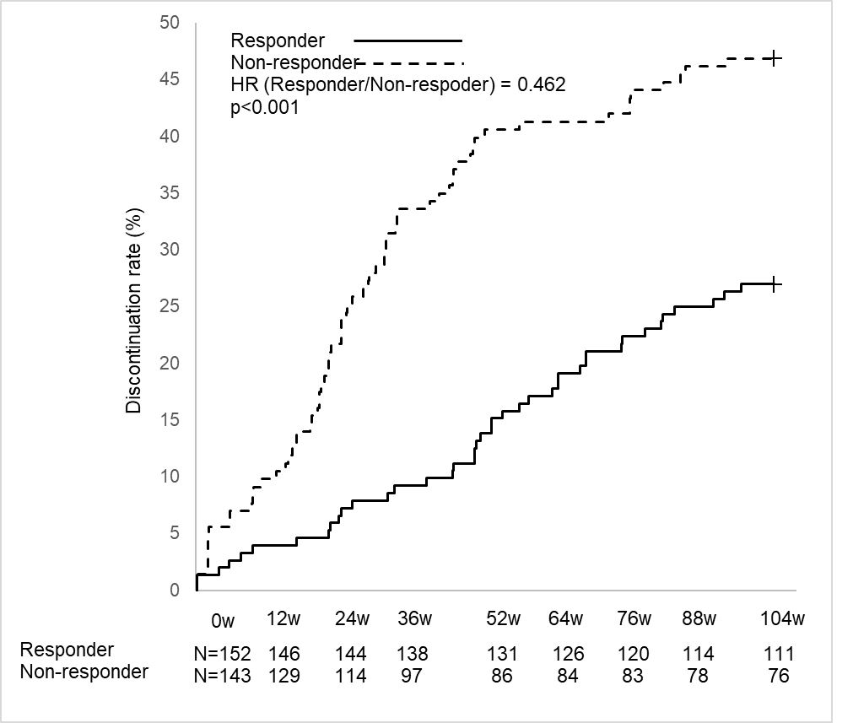

Abbreviation: HR, hazard ratio

**Supplementary Figure S3. Receiver operating characteristics curve for response in activity impairment**

**a: EQ-5D**

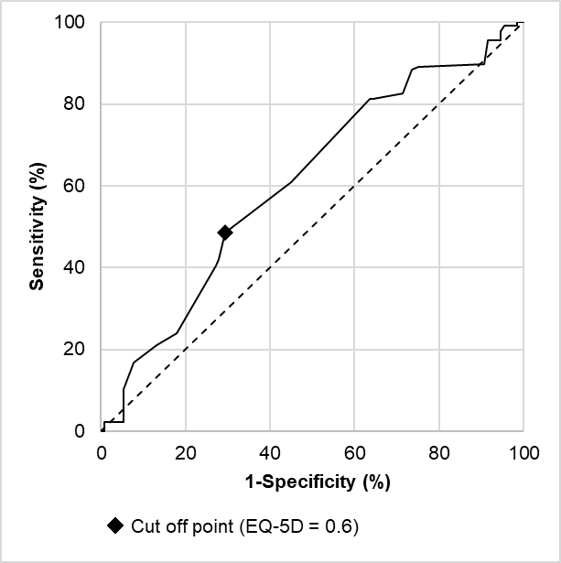

**b: HAQ-DI**

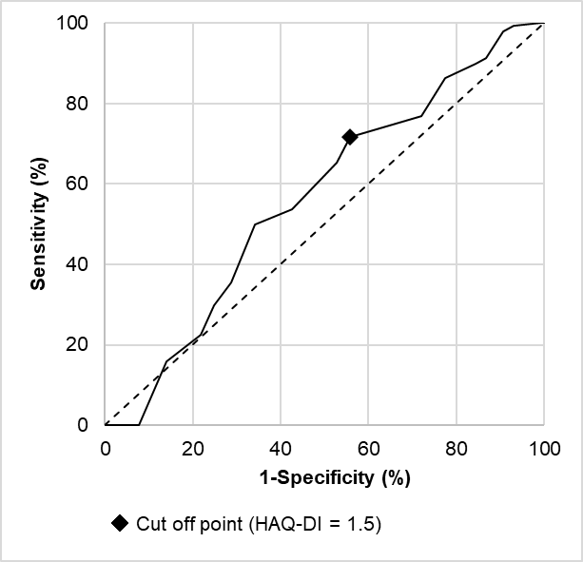

Abbreviations: EQ-5D, EuroQol 5 Dimension; HAQ-DI, Health Assessment Questionnaire Disability Index

**Supplementary Figure S4. EQ-5D utility value**

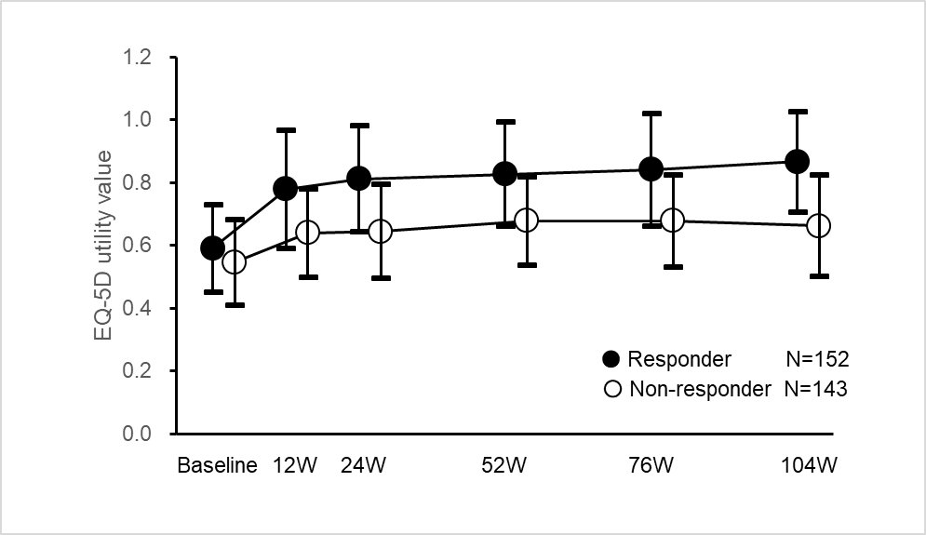

Abbreviation: EQ-5D, EuroQol 5 Dimension