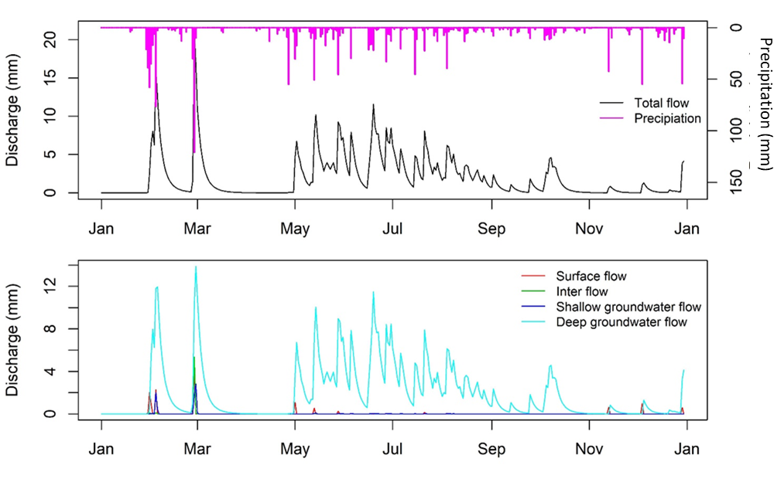
Figure S1: Comparison of daily observed and simulated flows for an average year (2004) and partition of flows via different pathways in the Waitangi catchment
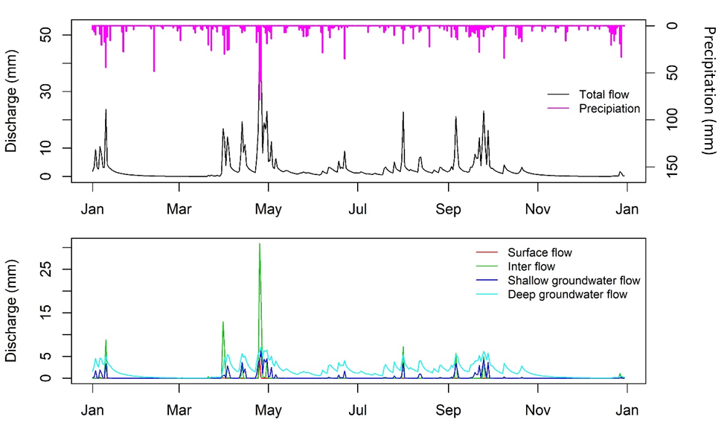
Figure S2: Comparison of daily observed and simulated flows for an average year (2010) and partition of flows via different pathways in the Aparima catchment

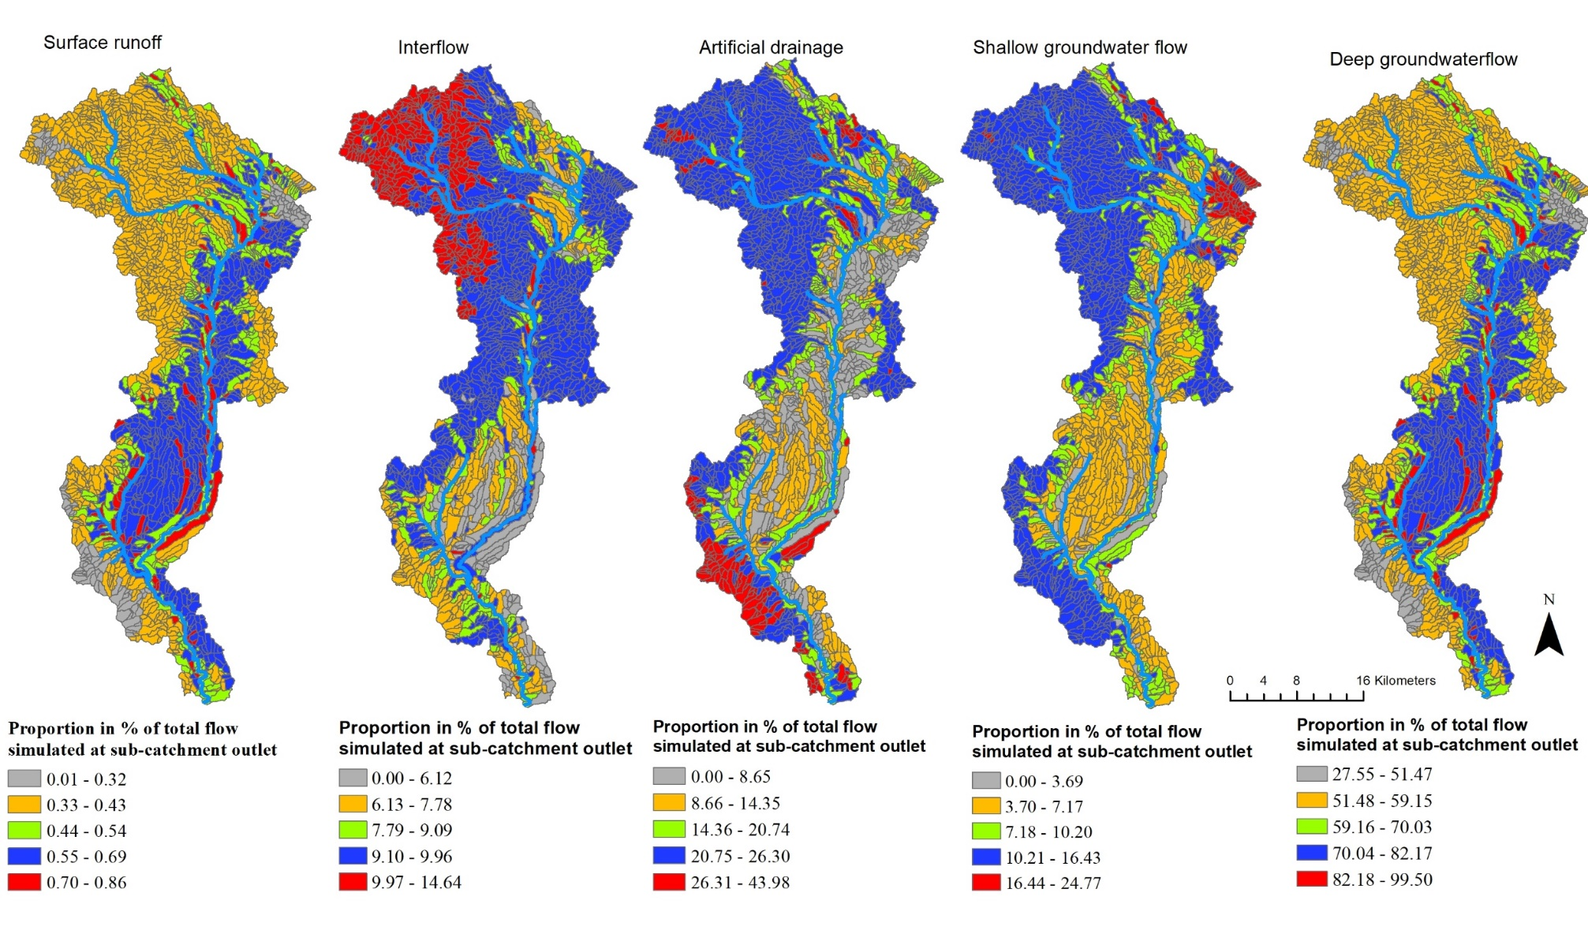
Figure S3. Estimated flow contribution (percentage of total simulated) to the Aparima catchment outlet. Blue lines indicate surface drainage network.
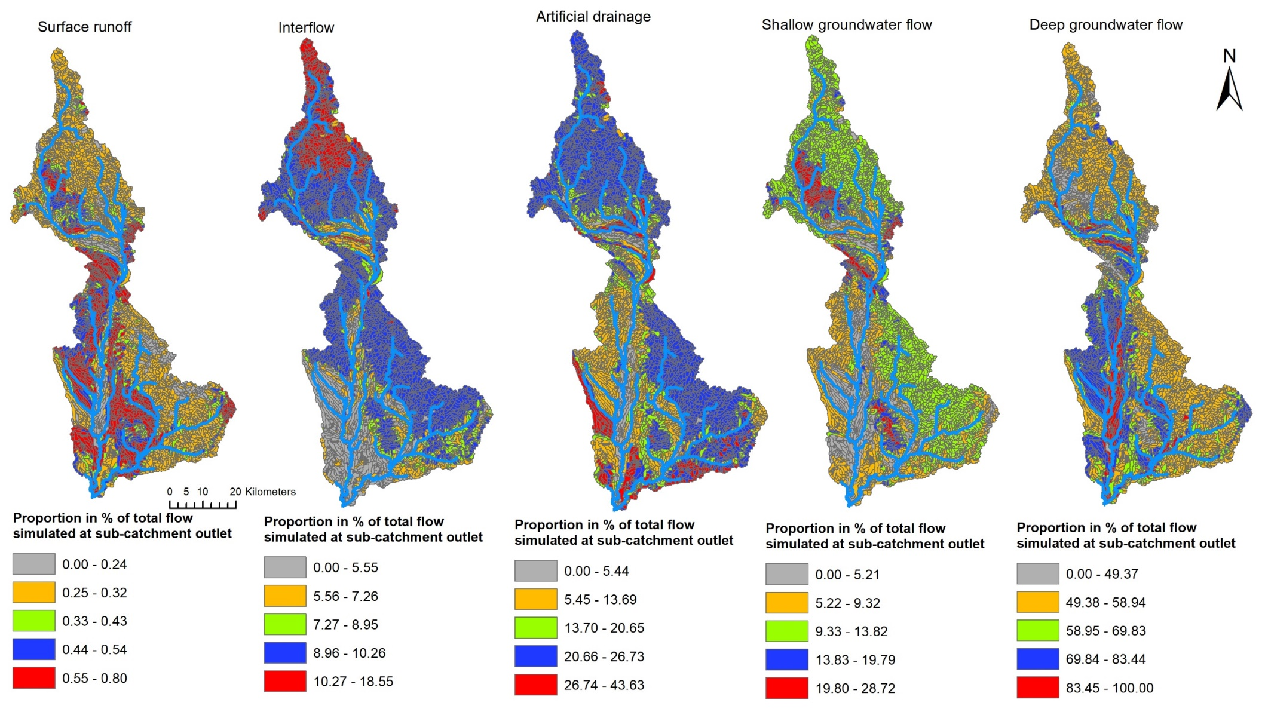
Figure S4. Estimated flow contribution (percentage of total flow simulated) to the Oreti catchment outlet. Blue lines indicate surface drainage network.
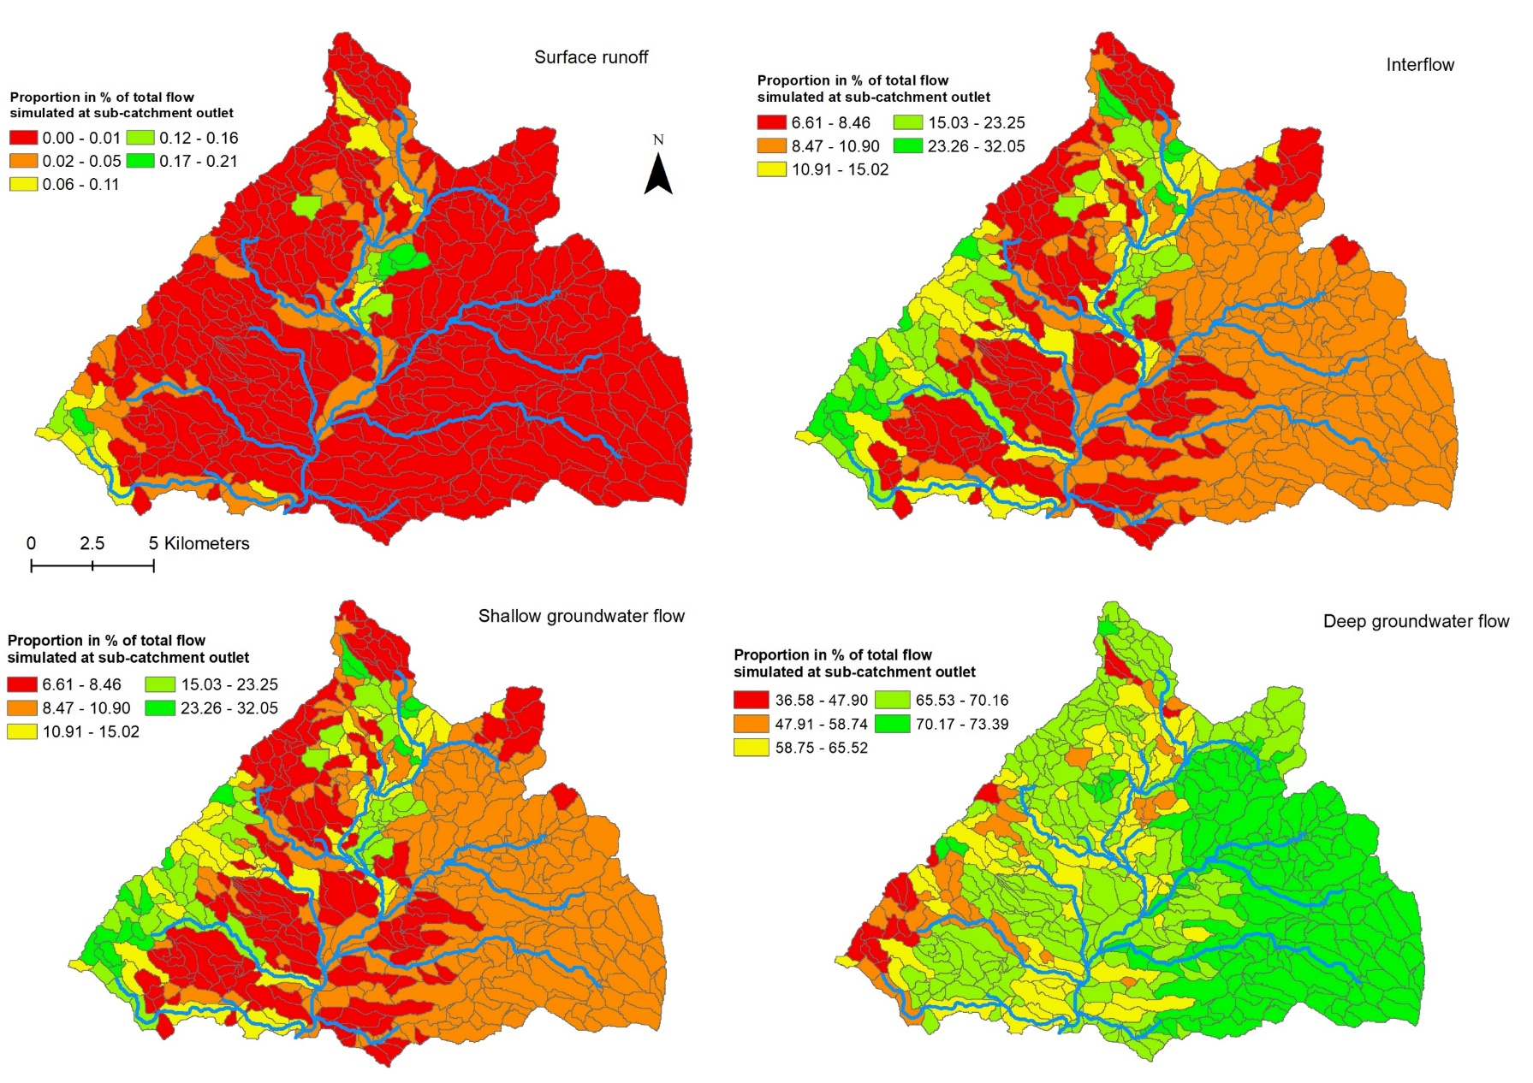
Figure S5. Estimated flow contribution (percentage of total flow simulated) to the Waiotapu catchment outlet. Blue lines indicate surface drainage network.
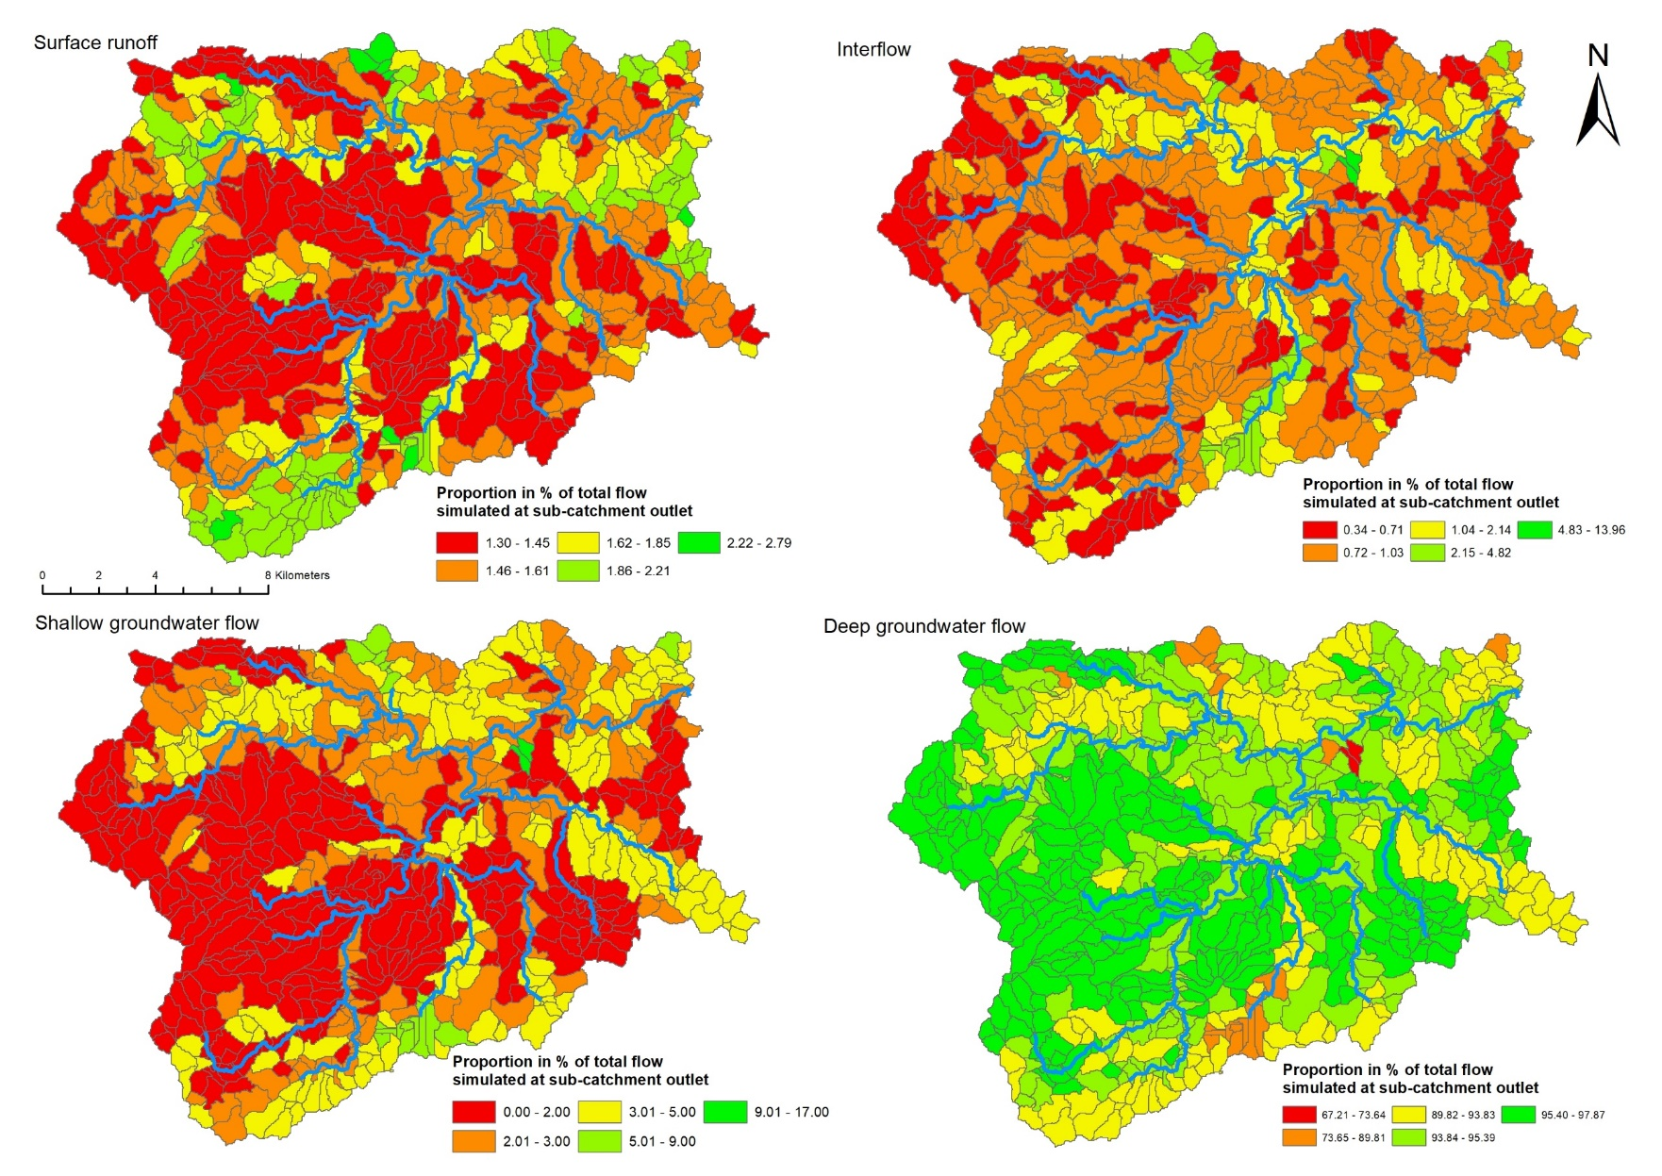
Figure S6. Estimated flow contribution (percentage of total flow simulated) to the Waitangi catchment outlet. Blue lines indicate surface drainage network.

