Table S1 Primers for qRT-PCR analysis
Gene | Primer Sequence （5'-3'）
 | Forward | Reverse
7JZ58T | CTGGTTTCATCGGTTCATGG | CCTTCTTCATATTTGCTGGGT
P831EU | CAACTCCCAATTACGTCCCT | GTGAATGGCGACTTGATCTC
DJQ4R3 | AATCTGCTTCCTCTGTTTCC | GTGGTTCTGATGTTGGTAGTG
NBHN08 | CCAATAATCAACTACCTTTCCC | CATTCCAATCACAACTTCAACC
NV8XP7 | CTGATGATGCTAACACTGTC | GCAATATACGCTTTACCTCTC
RBR1AL | CTTACCGCTCTTAACATTCCT | AATCTTGTGCTCTACTCCAG
B6E5H4 | CCACTTCTTTCAACACTAGG | CTTTCTTAATCTCTTGGCTCC
1WY37S | GAACTCTTCAAACTCTTTCTCC | GAACTTTCTTGATCTCTTGGCT
QPL1HC | TATTCTTCACACTCCATACTCC | AACGCCTAACTCCATAACAG
DZ16HD | ATTCATCAAGAGTTTCCGCA | GATTATCACCTTCCCTTCTTTCC
PGZW4I | TTCCAACTCTTCACGAAACC | GGTAAATGCTACTCTCACGA
J3K16K | ATGACCTTCTAAGAGCTTGTG | GAGATCAACTTCATCTTCAGAG
ADTW6E | TGGAAGATGACCTTCTAAGAG | CTCTCCTCGCTTTATATTTGGT
1LQ424 | ATAGGGTTCCTCTATTGGCTG | AACAATCATCTCCACTTCTTCC
4RT82Q | CAAGAACGCAGCATAGAACAG | GACTCTGTTCCTGTCTCCTC
Actin | GTCATCGTCATCCTCTTCTC | CATTCCTGTTCCATTGTCAC

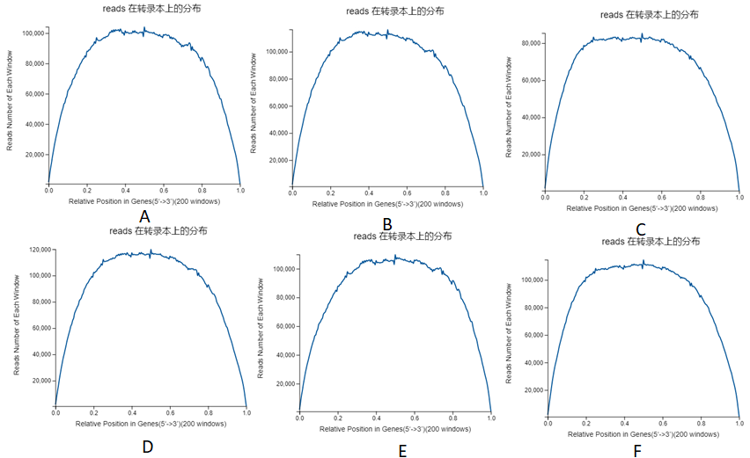
Fig. S1 Random reads distribution of ZH8 and ZH9. A Random reads distribution of ZH8-1. B Random reads distribution of ZH8-2. C Random reads distribution of ZH8-3. D Random reads distribution of ZH9-1. E Random reads distribution of ZH9-2. F Random reads distribution of ZH9-3.

Fig. S2 Reads coverage of ZH8 and ZH9. A Reads coverage of ZH8-1. B Reads coverage of ZH8-2. C Reads coverage of ZH8-3. D Reads coverage of ZH9-1. E Reads coverage of ZH9-2.
F Reads coverage of ZH9-3.
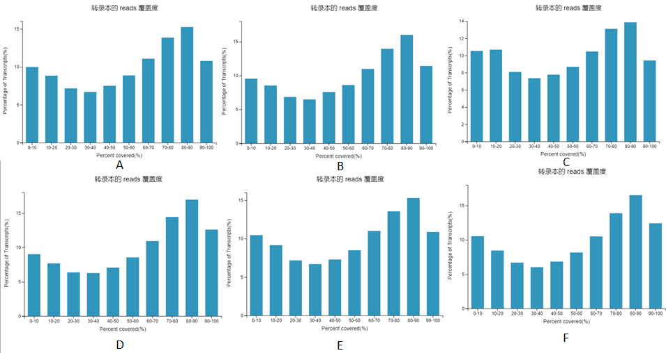

Fig. S3 Up-regulated statistics and Down-regulated statistics of KEGG Enrichment. A Up-regulated statistics of KEGG pathway. B down-regulated statistics of KEGG pathway

