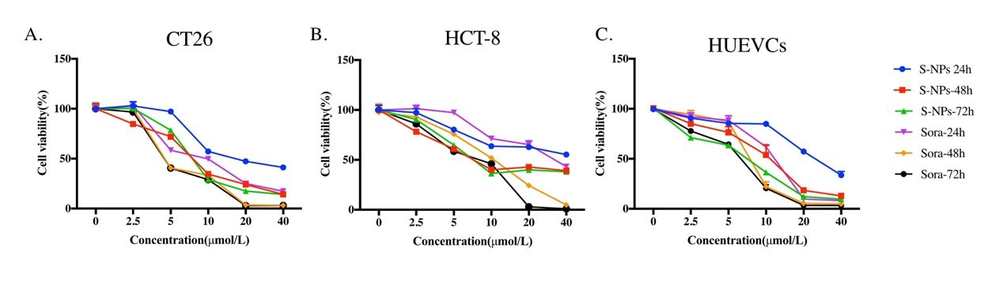
Supplementary Figure 1. Viability of CT26 and HCT-8 cells and HUVECs after treatment with free sorafenib or sorafenib-loaded nanoparticles (S-NPs) for 24, 48, or 72 h. Data are mean ± SD of three independent experiments (each conducted in triplicate).

