Supplementary Information

Genetic diversity of Procambarus clarkii populations based on mitochondrial DNA and microsatellite markers in different areas of Guangxi, China

Yizhi Zhong^{a,b}, Zhangsheng Tangª, Liming Huangª, Dapeng Wang^{a,*}, Zhuanling Lu^{a,*}

ªGuangxi Academy of Fishery Sciences/Guangxi Key Laboratory of Aquatic Genetic Breeding and Healthy Aquaculture, Nanning Guangxi 5300021, China
^{b}Guangxi Nanning Yanleshang Biotechnology Co. LTD, Nanning Guangxi 530004, China

Supplementary Table S1 The primers information of microsatellite detection
Locus | Primer sequence (5’-3’) | Product size (bp) | Repeat motif
PclG-02 | F: CTCCCCATGCACTCTGGCTCTGT | 216-224 | (GATA)₃GAGAA(GATA)₅
 | R:TGGCGAATTTTGCCTGTTTCTGTC
PclG-04 | F: TATATCAGTCAATCTGTCCAG | 170-290 | (TCTA)₃ … (TCTA)₂ … (TCTA)₂₉ … (TCTA)₂
 | R: TCAGTAAGTAGATTGATAGAAGG
PclG-07 | F: CCTCCCACCAGGGTTATCTATTCA | 100-160 | (TCTA)₈
 | R: GTGGGTGTGGCGCTCTTGTT
PclG-08 | F: ACGATAAATGGATAGATGGATGAA | 148-220 | (GATA)₁₆
 | R: CCGGGTCTGTCTGTCTGTCA
PclG-10 | F: TGCTCACGCAAACTTGTATTCAGT | 90-176 | (TAGA)₂TA(TAGA)₁₆
 | R: CAATGGTCCTTGATTTGGTGTTCT
PclG-17 | F: GTCGGGAACCTATTTACAGTGTAT | 156-190 | (TCTA)₁₄
 | R: AAGAGCGAAGAAAGAGATAAAGAT
PclG-28 | F: CTCGGCGAGTTTACTGAAAT | 210-270 | (GATA)₂₂(GA)₅
 | R: AGAAGAAAGGGATATAAGGTAAAG
PclG-29 | F: GAAAGTCATGGGTGTAGGTGTAAC | 95-165 | (TATC)₉
 | R: TTTTTGGGCTATGTGACGAG

Supplementary S2 Hardy-Weinberg equilibrium analysis for each locus based on microsatellite
Populations Locus | NN | DT | RS | LZ | LB
PclG02 | 0.3572* | -0.0340** | -0.1791** | -0.0378** | 0.0191**
PclG04 | -0.4234 | -0.7421** | -0.7934** | -0.8898** | -0.9293**
PclG07 | -0.0863** | 0.0033** | -0.2836* | -0.1939** | -0.8010**
PclG08 | 0.8385** | 0.5000** | 0.1645 | 0.8998** | 0.7619**
PclG10 | -1.0000** | -0.8796** | -1.000** | -0.7074** | -0.9142**
PclG17 | 0.3806 | -0.5136** | -0.1357* | -0.0745** | -0.5067**
PclG28 | -0.4467** | -0.4456* | -0.1208* | -0.0601 | -0.1469**
PclG29 | 0.1273 | -0.0119 | -0.3731** | -0.1383 | -0.5897**
Note: Statistics by Chi-square test for Hardy-Weinberg equilibrium. *: significant deviation, p < 0.05; **: extremely significant deviation, p < 0.01.

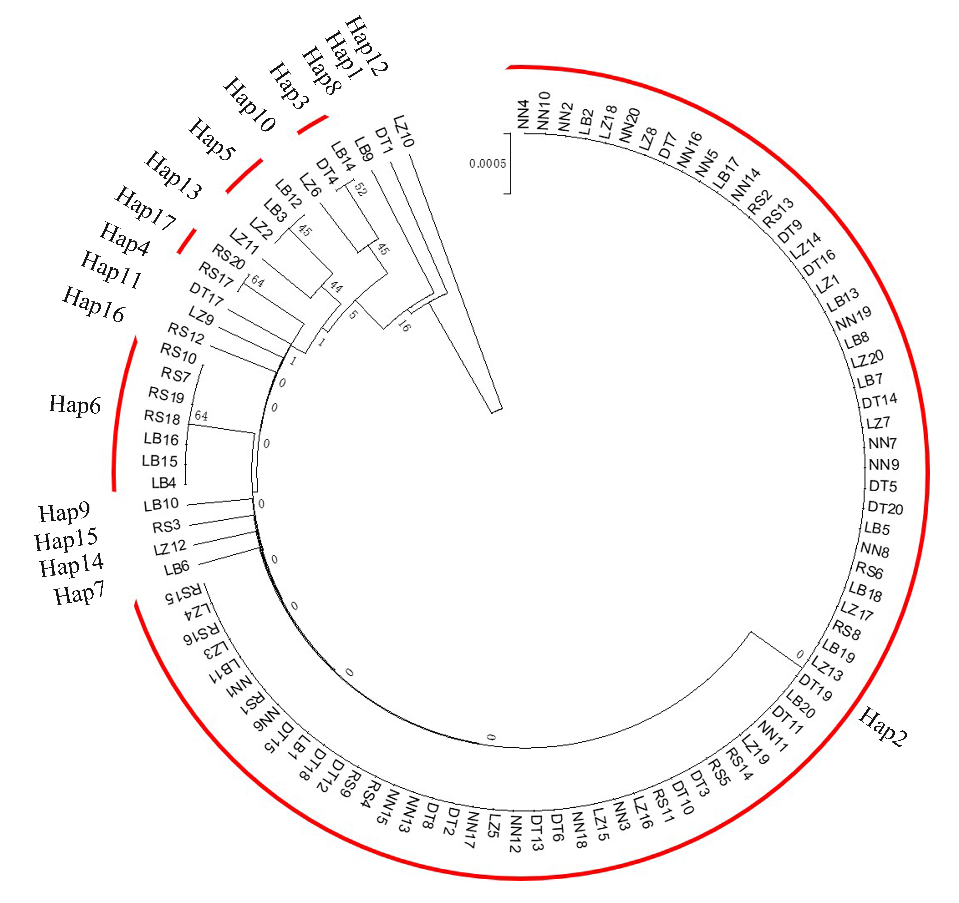
Supplementary Figure S1 The UPGMA tree of 100 individuals based on CytB sequences.

