- rpoB His445Tyr (position 49 C→T)

- rpoB Asp435 Val (position 19 A→T)

- rpoB Ser450Leu (position 64 C→T)

- rpoB Leu452Pro (position 67 T→C)

- katG Ser315Thr (position 135 G→C)

- katG Ser315Asn (position 143 G→A)

- katG Trp328Arg (position 564 T→C) (reverse strand)

- katG Gln461Pro (position 169 A→C) (reverse strand)

- inhA promoter -15 C→T (position 126)

- oxyR-ahpC -77T→G (position 116)

- oxyR-ahpC -72 C→T (point mutation 120)

- oxyR-ahpC -48 G→A (point mutation 141)

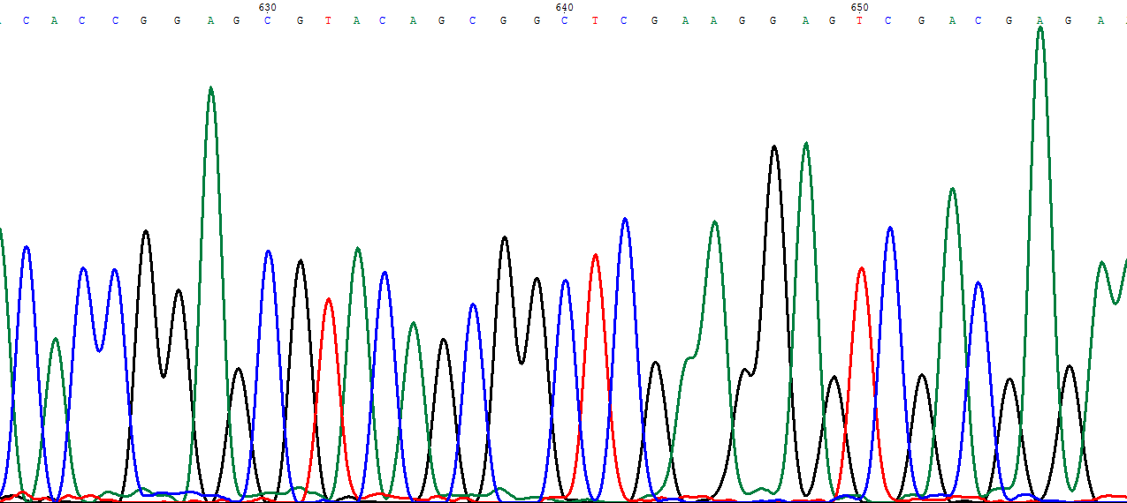
- pncA ∆T416 (position 641, Thymine has been delated)

Figure S1. Chromatogram of mutations found in rpoB, katG, inhA, oxyR-ahpC and pncA genes (a-n).

