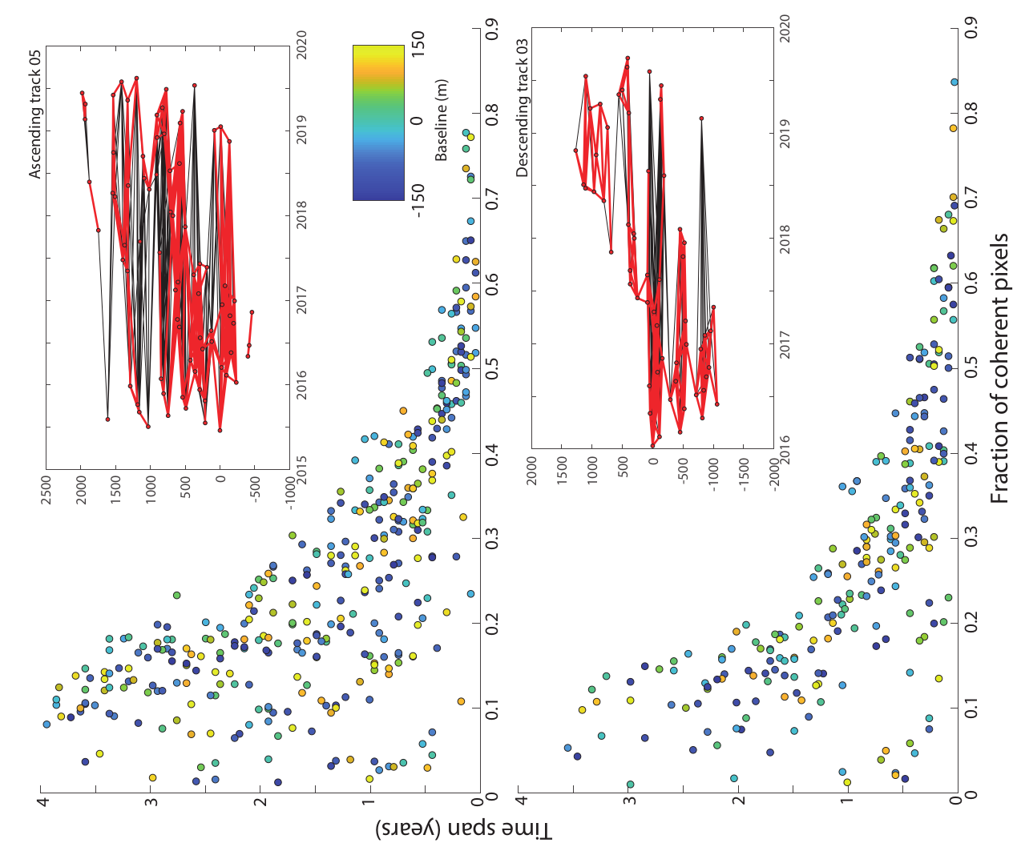

Figure S1. Perpendicular baselines and scatterplots showing the number of coherent pixels versus time span for CSK ascending and descending datasets. The black lines in the baseline plots show all of the interferograms formed with the red lines highlighting the interferograms which remained after the culling of noisy images as described in the main text. The scatterplots show the fraction of coherent pixels in each interferogram vs the timespan of the interferogram colour coded by baseline.

