All-Silicon Zeolite Supported Pt Nanoparticles for Green On-Board Inert Gas Generation System
Wenqi Zhao ª, Yitong Dai ª, Xinxin Cheng ª, Sanshu Xu ^{b}, Yongsheng Guo ª* and Wenjun Fang ª
ª Department of Chemistry, Zhejiang University, Hangzhou 310058, China; ^{b} Nanjing Engineering Institute of Aircraft Systems, AVIC, Nanjing 210000, China

Fig. S1. Pt particle sizes of (a) Pt/Si-Beta, (b) Pt/Si-ZSM-5, (c) Pt/SBA-15.

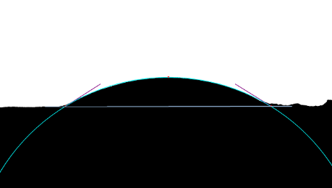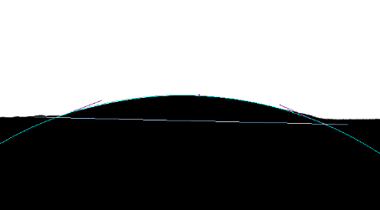
a. CA≈31.6° b. CA≈27.2°
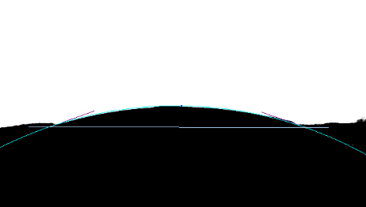
c. CA≈18.9°
Fig. S2. Water contact angle date of (a) Si-Beta, (b) Si-ZSM-5, (c) SBA-15.

Table S1 The values of T₅₀ and T₉₈ for combustion of methylcyclohexane on Pt/Si-Beta with various space velocity.
Space Velocity (min⁻¹) | Activity (℃)
 | T₅₀ | T₉₈
250 | 143 | 157
500 | 150 | 166
1000 | 159 | 173

Table S2 The values of T₅₀ and T₉₈ for combustion of methylcyclohexane on Pt/Si-Beta with various relative humidity in feed gas.

Relative Humidity | Activity (℃)
 | T₅₀ | T₉₈
0% | 150 | 166
50% | 151 | 167
90% | 151 | 167

Table S3 The composition of aviation kerosene RP-3.
Compounds | C | H | Mass fraction/%
Nonane | 9 | 20 | 0.04
Cyclohexane, 1,1,3,5-tetramethyl-, cis- | 10 | 20 | 0.02
Cyclohexane, propyl- | 9 | 18 | 0.04
Octane, 2,6-dimethyl- | 10 | 22 | 0.02
Cyclooctane, 1-methyl-3-propyl- | 12 | 24 | 0.04
Cyclohexane, 1,1,2,3-tetramethyl- | 10 | 20 | 0.13
Cyclohexane, 1-ethyl-2,3-dimethyl- | 10 | 20 | 0.15
Nonane, 2-methyl- | 10 | 22 | 0.08
Nonane, 3-methyl- | 10 | 22 | 0.06
m-Menthane, (1S,3R)-(+)- | 10 | 20 | 0.09
Cyclohexane, 1-ethyl-2,3-dimethyl- | 10 | 20 | 0.32
3-Hexene, 3-ethyl-2,5-dimethyl- | 10 | 20 | 0.32
m-Menthane, (1S,3R)-(+)- | 10 | 20 | 0.10
3-Hexene, 3-ethyl-2,5-dimethyl- | 10 | 20 | 0.17
Decane | 10 | 22 | 2.35
Triallylsilane | 9 | 16 | 0.12
Ethylidenecyclooctane | 10 | 18 | 0.05
1-Ethyl-2-heptafluorobutyryloxycyclohexane | 12 | 15 | 0.16
Cyclopentene, 1,3-dimethyl-2-(1-methylethyl)- | 10 | 18 | 0.15
Undecane, 5-methyl- | 12 | 26 | 0.07
Decane, 4-methyl- | 11 | 24 | 1.06
Cyclohexane, (1-methylpropyl)- | 10 | 20 | 0.10
Cyclohexane, butyl- | 10 | 20 | 0.75
Cyclohexane, 1,1,3-trimethyl- | 9 | 18 | 0.23
1-Decanol, 2-hexyl- | 16 | 34 | 0.22
Cyclohexane, 1,1-dimethyl-2-propyl- | 11 | 22 | 0.43
cis,cis,cis-1-Isobutyl-2,5-dimethylcyclohexane | 12 | 24 | 0.31
Cyclohexane, 1,1,3-trimethyl- | 9 | 18 | 0.42
Naphthalene, decahydro-, trans- | 10 | 18 | 2.88
Tridecane, 7-methyl- | 14 | 30 | 0.54
Decane, 2-methyl- | 11 | 24 | 1.64
Decane, 3-methyl- | 11 | 24 | 1.04
Naphthalene, decahydro-2-methyl- | 11 | 20 | 0.39
Cyclohexane, 1-ethyl-2-propyl- | 11 | 22 | 0.71
Cyclohexane, 1-ethyl-1-methyl- | 9 | 18 | 0.73
Undecane | 11 | 24 | 16.76
trans-Decalin, 2-methyl- | 11 | 20 | 3.32
Undecane, 5-methyl- | 12 | 26 | 0.96
Naphthalene, decahydro-2-methyl- | 11 | 20 | 0.30
trans-4a-Methyl-decahydronaphthalene | 11 | 20 | 4.68
Cyclohexane, pentyl- | 11 | 22 | 2.19
Cyclopentane, hexyl- | 11 | 22 | 0.66
Cyclohexane, 1,2,4,5-tetraethyl-, (1.alpha.,2.alpha.,4.alpha.,5.alpha.)- | 14 | 28 | 0.87
Cyclohexane, 1,2,4,5-tetraethyl-, (1.alpha.,2.alpha.,4.alpha.,5.alpha.)- | 14 | 28 | 1.42
Undecane, 6-methyl- | 12 | 26 | 1.27
Undecane, 4-methyl- | 12 | 26 | 0.73
Undecane, 2-methyl- | 12 | 26 | 2.05
8-Hexadecyne | 16 | 30 | 0.96
Undecane, 3-methyl- | 12 | 26 | 1.22
Naphthalene, decahydro-2,6-dimethyl- | 12 | 22 | 1.46
Cyclohexane, 1-ethyl-1-methyl- | 9 | 18 | 1.40
Cyclohexane, (1,3-dimethylbutyl)- | 12 | 20 | 1.27
Dodecane | 12 | 26 | 19.26
Naphthalene, decahydro-2,6-dimethyl- | 12 | 22 | 0.38
Undecane, 2,6-dimethyl- | 13 | 28 | 3.29
Naphthalene, decahydro-2,6-dimethyl- | 12 | 22 | 0.22
Tetradecane, 2,6,10-trimethyl- | 17 | 36 | 0.20
Cyclohexane, 2-butyl-1,1,3-trimethyl- | 13 | 26 | 1.05
cis, cis-3-Ethylbicyclo[4.4.0]decane | 12 | 22 | 0.67
Bicyclo[4.1.0]heptane, 3-methyl-7-pentyl- | 13 | 24 | 0.43
Cyclohexane, (4-methylpentyl)- | 12 | 24 | 1.14
Cyclopentane, 1-pentyl-2-propyl- | 13 | 26 | 0.42
cis,cis-1,6-Dimethylspiro[4.5]decane | 12 | 22 | 0.21
Dodecane, 4-methyl- | 13 | 28 | 0.39
Dodecane, 2-methyl- | 13 | 28 | 1.90
Dodecane, 3-methyl- | 13 | 28 | 0.74
1-Decene, 4-methyl- | 11 | 22 | 2.61
Bicyclo[2.2.2]octane, 2-methyl- | 7 | 14 | 0.19
6-Tridecene, 7-methyl- | 14 | 28 | 0.24
Cyclohexane, 1,2,4,5-tetraethyl-, (1.alpha.,2.alpha.,4.alpha.,5.alpha.)- | 14 | 28 | 0.23
Tridecane | 13 | 28 | 7.67
Cyclohexane, 1-(cyclohexylmethyl)-3-methyl-, cis- | 14 | 26 | 0.07
1,1'-Bicyclohexyl | 12 | 22 | 0.23
Heptylcyclohexane | 14 | 26 | 0.12
Tridecane, 4-methyl- | 14 | 30 | 0.03
Tridecane, 2-methyl- | 14 | 30 | 0.06
Tetracosane | 24 | 50 | 0.02
Hexadecane, 2,6,10,14-tetramethyl- | 20 | 42 | 0.05
Tetradecane | 14 | 30 | 0.04

