Supplementary Material Section I: A urine patch simulation model exercise to evaluate different soil sampling designs

Quantifying paddock-scale nutrient losses of animal grazed paddocks is much harder to measure than losses under non-grazed land, due to the inherent spatial and temporal variability of urine patches (Lilburne et al. 2012). Urine patches are generally randomly deposited, and vary in abundance with both the type of animal, stocking intensity, and the length of time spent grazing (Moir et al. 2011).
Based on the approach of Lilburne et al. (2012) an in-house simulation tool was developed that spatially simulates urine patch distribution across a virtual paddock given a specification of paddock dimensions, urine patch size, frequency and nutrient leaching load for both urine and non-urine areas. Urine patches are assumed to be circular, with the specified N load assumed to leach vertically and evenly under the urine and non-urine areas. All urine patches are assumed to be independent and are randomly located, with N leached from areas of urine patches receiving double or triple deposits increased proportionally.
To test a sampling design the user specifies the number of simulated paddocks to be generated. The tool then samples each simulated paddock with a given sampling design, where the sampler size, number and layout are specified by the user. Where a sampler partially intersects with a urine patch, the intersecting part gets the urine leaching load, whilst the rest of the sampler gets the non-urine leaching load. The tool compares the calculated virtual paddock leaching losses with the virtually sampled estimate of paddock leaching losses, with error statistics generated from the specified number of replicate simulations.
For this experiment the simulation tool was used during the design stage to guide the efficacy of different sampling approaches. A 20 m x 12 m wide virtual paddock was established, with a urine patch distribution similar to that expected to occur during the field trial. The virtual paddock contained 1209 randomly simulated 0.6 m diameter urine patches, representing the estimated deposition by 8 cows over 14 days grazing, with each cow depositing an average of 10.8 urinations per day. Simulated leaching was set to vary randomly for different urine patches within the range of 40–80 kg N ha⁻¹ year⁻¹, whilst leaching from non-urine areas was estimated at 20 kg N ha⁻¹ year⁻¹. The leachate sampling device area was set as a 3 cm diameter circle, with the number of devices and their spatial location varied under different simulation runs. For each simulation run the sampling design was tested against a minimum of 100 virtual paddocks.
Figure S1 shows an example virtual paddock with urine patches randomly distributed, and a transect of 20 sampling devices as red dots across the centre of the paddock. Figure S2 shows a comparison of results testing the efficacy of a single 20 sampler transect compared with three replicated sampler transects of 20 samplers each. This example showed that when using a single transect the simulation indicates that 90% of the replicate runs were within 30 kg N ha⁻¹ year⁻¹ of the true mean, whilst using 3 transects 90% of the replicates were within 15 kg N ha⁻¹ year⁻¹ of the true mean.
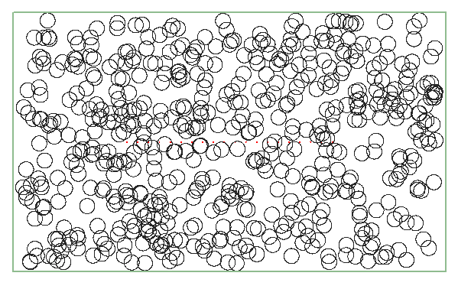
Figure S1 An example of a virtual paddock showing urine patches as black circles randomly distributed, with a transect of 20 sampling devices as red dots across the paddock centre.
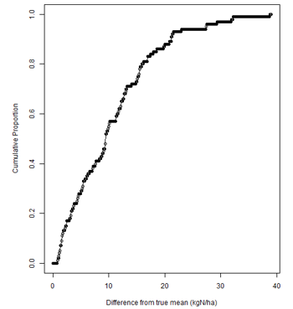 | 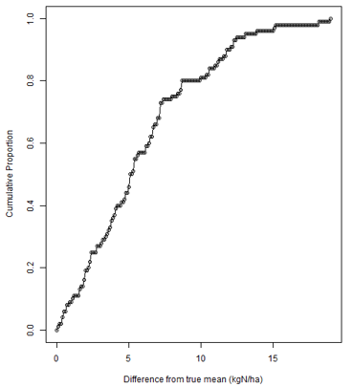

Figure S2 Results of two simulation runs where the sampling efficiency of either using a single transect of 20 samplers (left pane) is compared against using 3 replicate transects of 20 samplers each (right-hand pane). The graph shows the cumulative difference of each of the 100 replicated paddocks for each simulation run. Using a single transect the simulation indicates that 90% of the replicate runs were within 30 kg N ha⁻¹ year⁻¹ of the true mean, whilst using 3 transects 90% of the replicates were within 15 kg N ha⁻¹ year⁻¹ of the true mean.

Supplementary Material Section II: A water balance model to estimate drainage

A modelling approach was used to devise a water balance as an indication of how much drainage was likely to have occurred between catch crop sowing (May 2017) and the end of the trial period (January 2018), given drainage is the main vector for N leaching loss. Below is a description of how this was performed. Daily soil water content (SWCd) was calculated as:
$${SWC}_{d}={SWC}_{d-1}+R-T-E-D$$
where R is rainfall, T is transpiration, E is evaporation and D is drainage. Drainage was calculated as:
$$D= max\left\{0,\left({SWC}_{d-1}+R-T-E\right)-DUL\right\}$$
where DUL is the drained upper limit of the profile.
T was calculated as PET × Cover. E was calculated as PET × (1-Cover) × FS. PET is Priestley Taylor potential evapotranspiration calculated with an alpha coefficient of 1.3 (Priestley & Taylor 1972). Fs is a factor that accounts for bare soil having a lower evaporation that crop canopies. Cover was assumed to follow a sigmoidal pattern following sowing:
$$Cover=\frac{1}{1+e^{-(Tt-X_{o})/b}}$$
where Tt is the daily mean temperature accumulation from sowing, Xo and b were assumed to have values of 150 and 800, respectively, for both crops. Figure S4 shows the resultant cover patterns that were used for the fodder beet and catch crops.
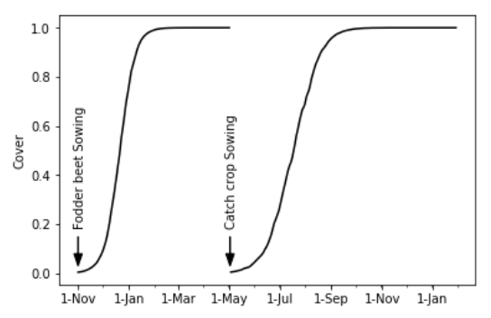Figure S4 Patterns of crop covers estimated for water balance calculations.

Initial soil water content (SWCd-1 on the day of fodder beet sowing) and DUL were not known so a series of SWC_{d} calculations were run to see what impact variation in these parameters would have on SWC_{d} on the day the catch crops were sown. A range of DUL (50–200 mm) and initial SWC (30%–100% of DUL) were used and Figure S5 shows, that regardless of the value assumed for these the SWCd on the day of catch crop sowing was close to DUL (value of 1=DUL). Thus, assuming a SWCd-1 = DUL could safely assumed for estimating drainage under the catch crop.
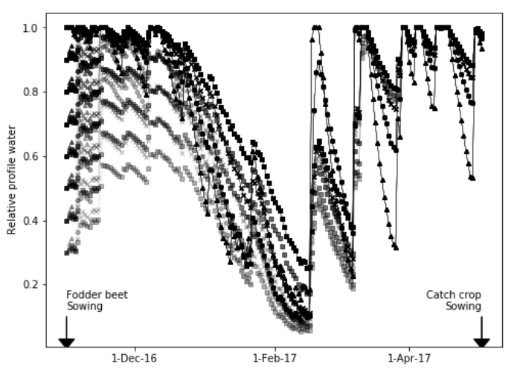
Figure S5 Soil water content relative to drained upper limit for a range of calculations assuming different drained upper limit and initial soil water contents.

Finally a set of SWCd calculations was run over the duration of the catch crop with a range of DUL (50–200 mm) and Fs (0.2–1.0) parameters. The grey range in the Figure S6 below shows the variation from differences in DUL and Fs which were minimal in this case. Substantial drainage accumulated (approx. 450 mm) following the sowing of the catch crop until the end of October.
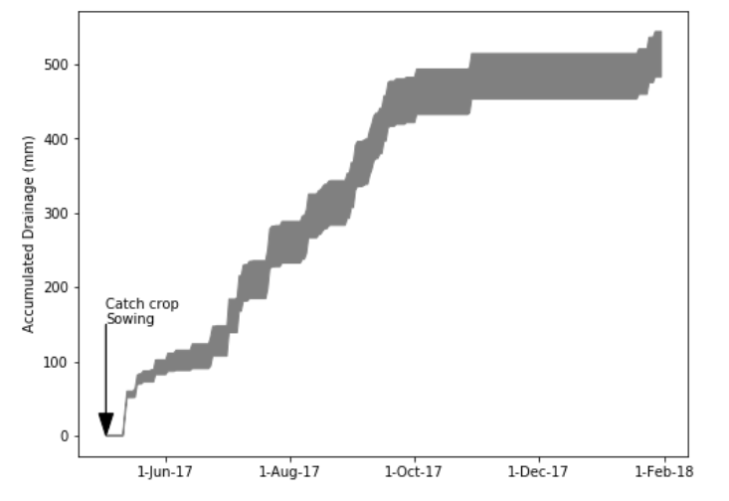
Figure S6 Accumulated drainage estimated under catch crops sown on 1 May 2017 at Hamilton, New Zealand. The grey shading represents a range of drainages estimated assuming differing parameters in the soil water balance equations.

References
Lilburne L, Carrick S, Webb T, Moir J 2012. Computer-based evaluation of methods to sample nitrate leached from grazed pasture. Soil Use and Management 28(1): 19-26.
Moir JL, Cameron KC, Di HJ, Fertsak U 2011. The spatial coverage of dairy cattle urine patches in an intensively grazed pasture system. Journal of Agricultural Science 149: 473-485.
Priestley CHB, Taylor R 1972. On the assessment of surface heat flux and evaporation using large-scale parameters. Monthly weather review 100(2): 81-92.

